Document Of DeepLearning Task

Task 1 : Deep Prediction Analysis

🔹 selected samples :
  - sample 1
  - sample 5
  - sample 15

🔹 Conceptual Explanation
Each input sample is passed through neural network
layer by layer to combute
z = w.x + b “feed forwored”
These values are transformed by activation functions,this
allowing the network to build abstract feature
representations until reaching the output layer
in output layer , there is softmax function that converts
the final layer’s row scores into probabilities .
The predicted class is the one with the highest
probability

🔹 Role of the Adam Optimizer
Adam optimizer improves prediction accuracy by combining
momentum-based gradient smoothing with adaptive per-parameter
learning rates, allowing the neural network to converge efficiently to
well optimized weights that generalize effectively to unseen test
samples.

🔹 Result
For samples 1, 5, and 15, the model was able to extract relevant
Features during the forward pass.
The ReLU activation preserved important signals, while the Softmax
layer assigned the highest probability to the predicted class.
The Adam optimizer contributed to effective weight updates during
training, resulting in accurate predictions.

1.Sample 1
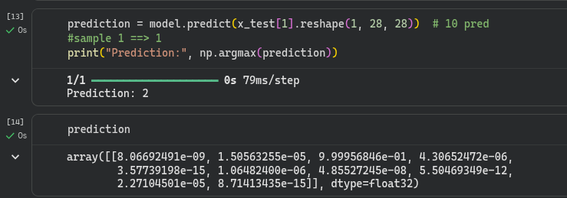
Sample 1 Predicted Label: 2 True Label: 2

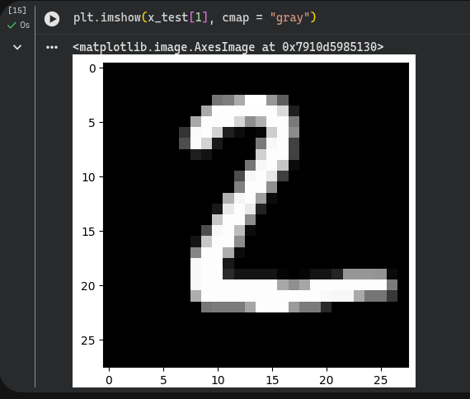

2.sample 5

Sample 5 Predicted Label: 1 True Label: 1

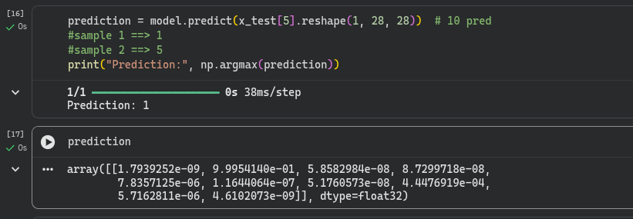

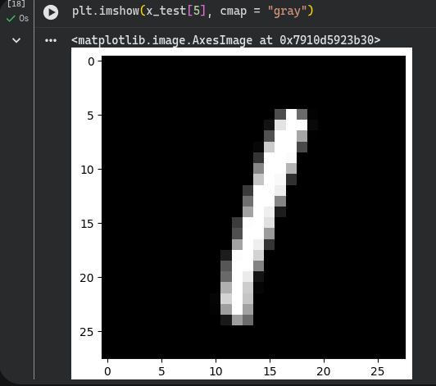

3.sample 15

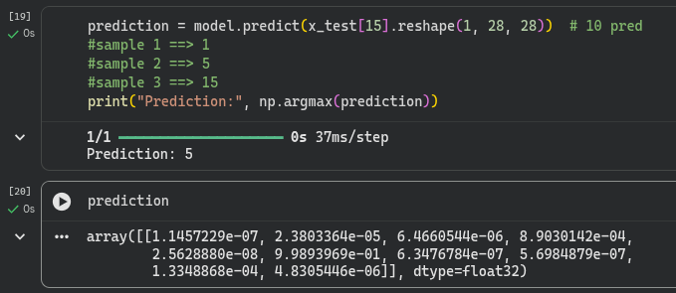
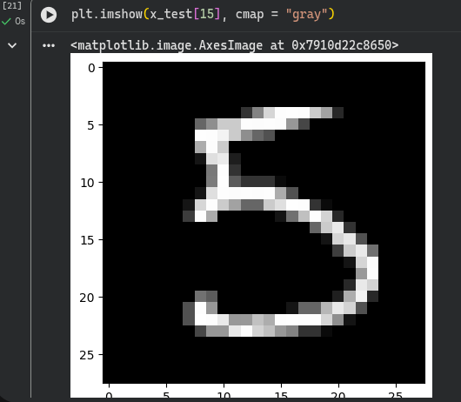
Sample 15 Predicted Label: 5 True Label: 5

Task 2 : Custom Image Generalization Test
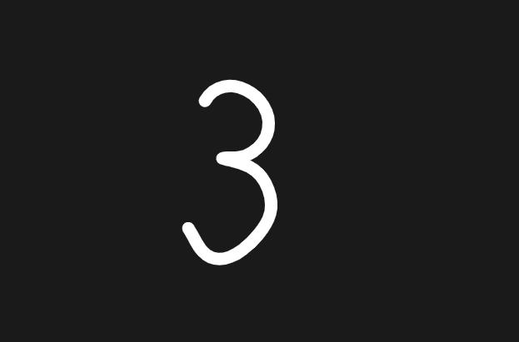
The used image :

The result is :
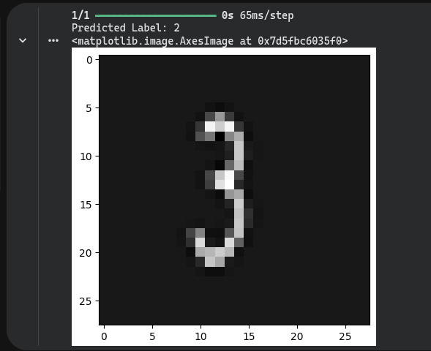

Explanation

Did the model correctly classify the digit?
- no the handwritten is 3 but , the model predicted 2

Why did the model fail?
- The handwritten image does not perfectly match the distribution of the training data
- LThe model was trained on clean, standardized MNIST digits, so even small differece can confuse it.

Noise and Preprocessing Effects
- Although the image was:
1.Converted to grayscale
2.Resized to 28*28
3.Normalized to [0,1]
- There is still:
1.Blurring from resizing
2.Loss of fine details
3.Pixel-level noise

Task 3:Epoch-Based Learning Curve Exploration
I trained the same model using Adam optimizer with:
- 5 epochs
- 10 epochs
- 20 epochs
Below is the interpretation of what happened

1.Train 5 Epochs :
Observations :
- Training loss decreases rabidly (0.4 > 0.04)
- Validation loss decreases initiaily ,then increases at the last
- Training acc. > 0.98
- validation acc. > 0.97
- The model is learning meaningful patterns very quickl
- Adam helps the model converge fast in the first few epochs
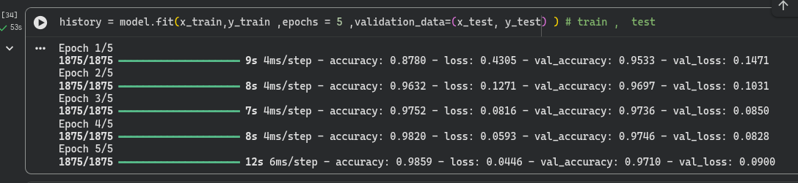
- early signs of overfitting at epoch 5

loss curve
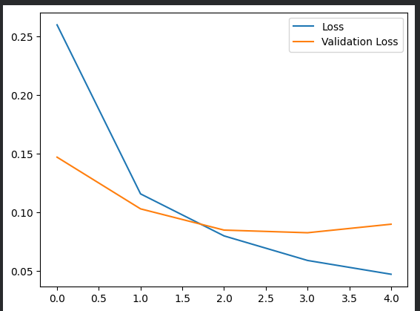

2. Train 10 Epochs :
Observations :
- Training loss decreases rabidly (0.4 > 0.015)
- Validation loss decreases initiaily ,then increases
- Training acc. > 0.99
- validation acc. > 0.97
- Overfitting begins around epoch 5–6
- The Adam optimizer accelerated and stabilized convergence through adaptive learning rates, but it did not prevent overfitting
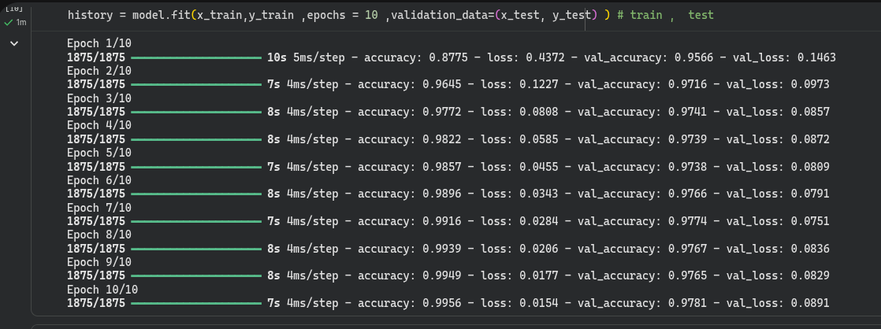
loss curve
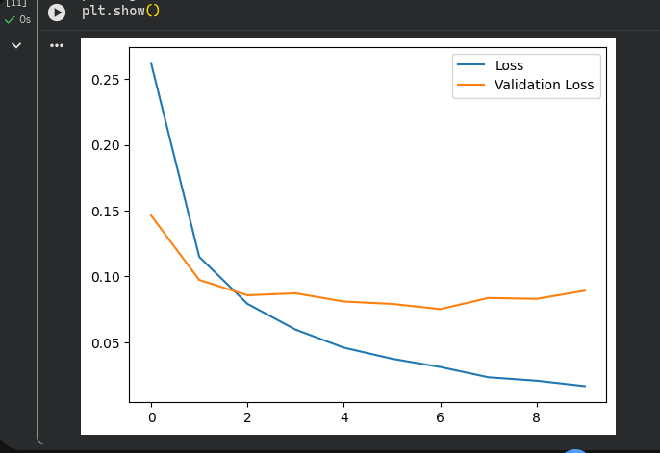

3.Train 20 Epochs :
Observations :
- Training loss becomes extremelly small (0.8 > 0.0046)
- Validation loss increased after epoch 12
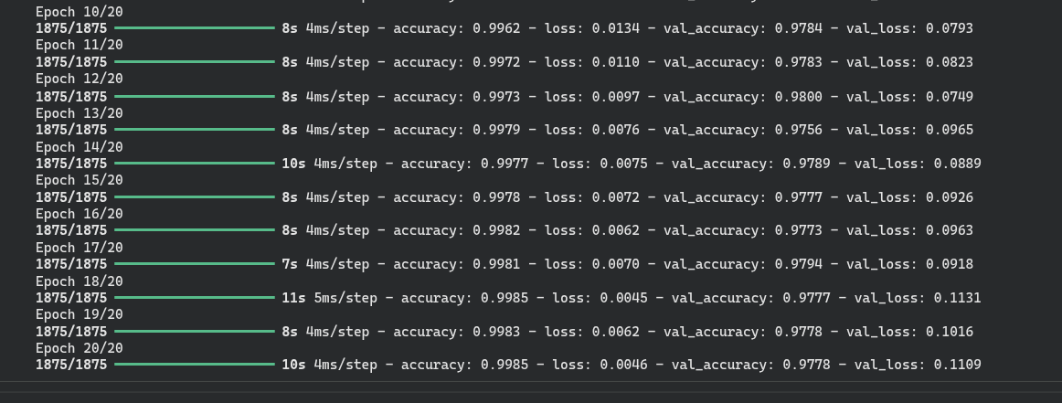
- Training acc. > 0.99
- validation acc. > 0.97

- Overfitting begins at epoch 6, where training loss continues to decrease while validation loss stops improving and starts to increase.
- Increasing epochs no longer helps

loss curve
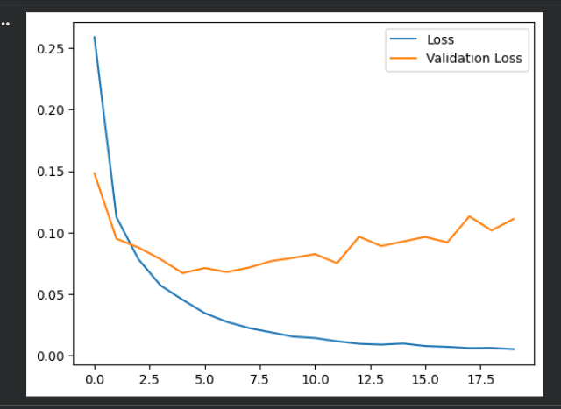

Task 4 : EarlyStopping Behavior Analysis
At which epoch did training stop? At epoch 8 with best
val_loss at epoch 5 ~ 0.064
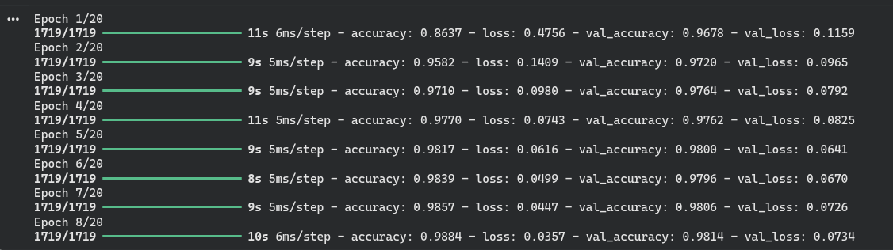

Why does validation loss control this decision?
- Training loss measures how well the model fits the training data
- Validation loss measures how well the model generalizes to unseen data
After epoch 5:
- Training loss kept decreasing
- Validation loss stopped improving and began increasing
so , Validation loss is therefore the earliest and most reliable indicator of overfitting, which is why EarlyStopping monitors it instead of training loss

What happens if you increase patience to 5?
Increasing patience delays stopping but does not prevent overfitting, it only allows more memorization.
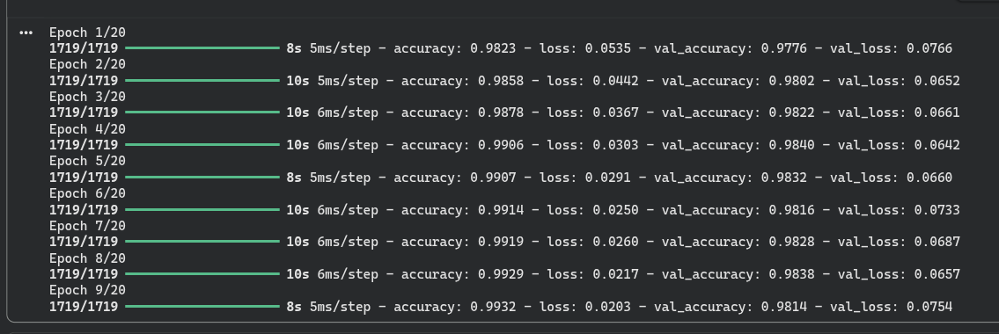
Would a different optimizer (e.g., SGD) change the EarlyStopping pattern?
Optimization is slower and more conservative
The model does not overfit early ,Validation loss keeps decreasing
Since validation loss improved at every epoch, EarlyStopping had no reason to stop training.

Optimizer | Convergence | Overfitting | EarlyStopping
Adam | Very fast | Early > epoch 6 | Triggered
SGD | Slow & smooth | none | Not triggered

Using SGD slowed convergence and prevented early overfitting, causing validation loss to improve continuously and preventing EarlyStopping from triggering.

Task 5 : Dropout Ablation Study
No Dropout :
The ablation study demonstrates that removing Dropout leads to strong overfitting, as the model rapidly minimizes training loss while validation loss increases early.
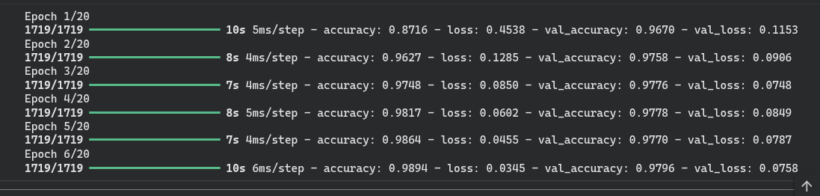

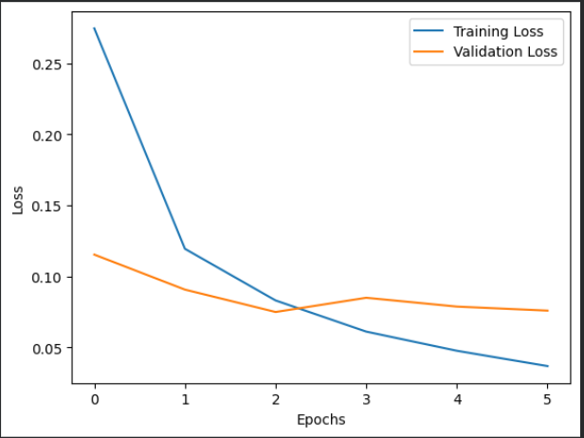
Dropout 0.1 :
Dropout with a rate of 0.1 significantly stabilizes validation performance by preventing neuron co-adaptation and encouraging independent feature learning.
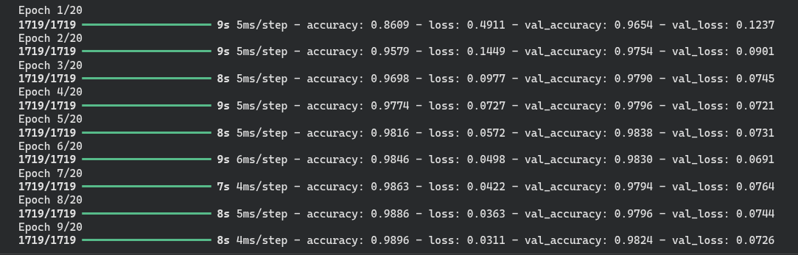
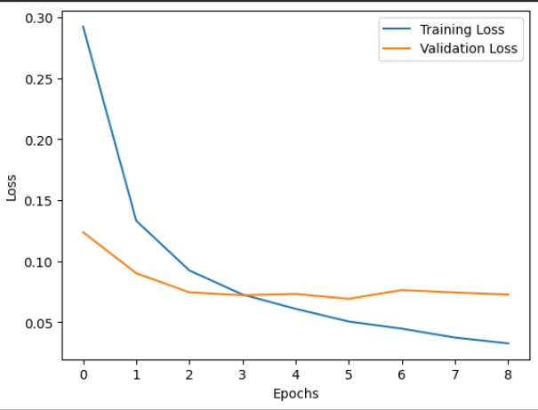
Dropout 0.3 : Increasing Dropout to 0.3 overly constrains the network, slowing learning and reducing performance, indicating underfitting
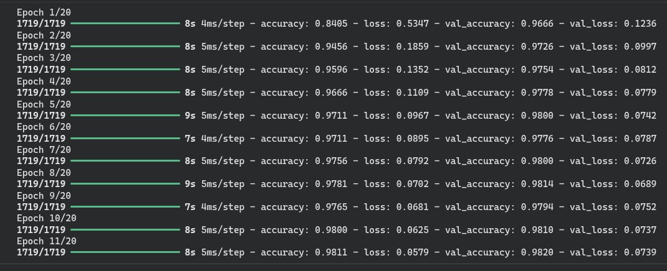

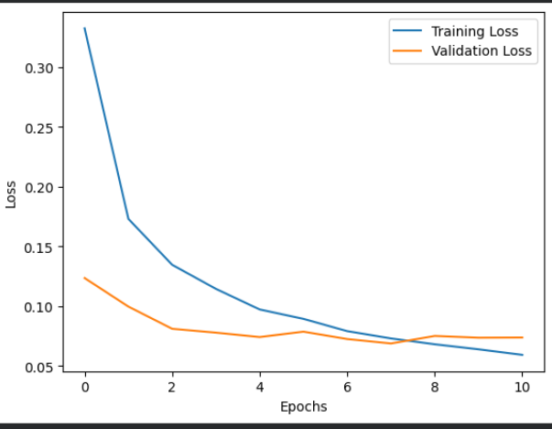
These results confirm that moderate Dropout promotes robust and generalizable representations.

Task 6 : L2 Regularization Experiment
L2 > 0.01:
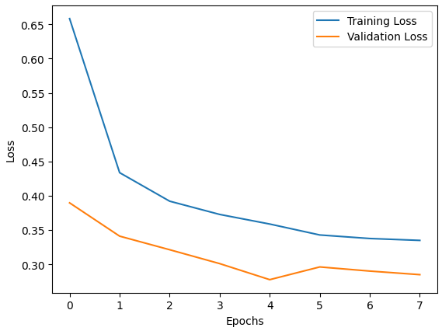
L2 > 0.001:
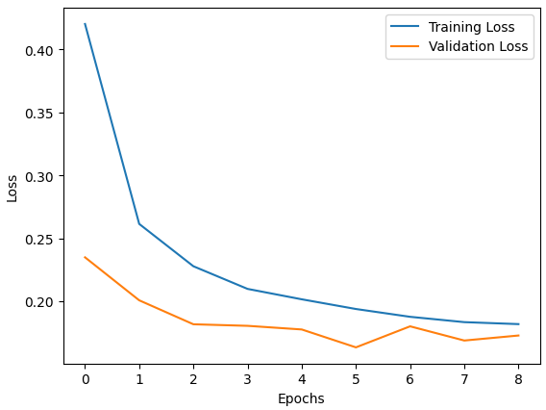

L2 > 0.0001:
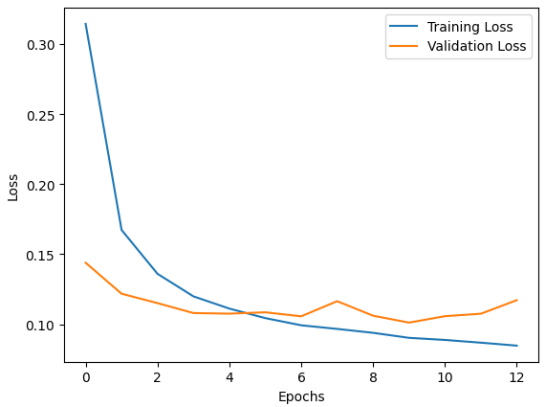

L2 regularization penalizes large weight values, encouraging the network to learn smoother and more distributed representations.
A small L2 value (0.0001) provides insufficient constraint, allowing overfitting to persist, while a large value (0.01) overly restricts learning and leads to underfitting.
A moderate L2 strength (0.001) achieves the best balance, stabilizing validation loss and improving generalization by limiting weight magnitude without sacrificing learning capacity.

Task 7: Optimizer Comparison
SGD : SGD updates weights using a fixed learning rate, leading to slow but stable convergence and often better generalization.
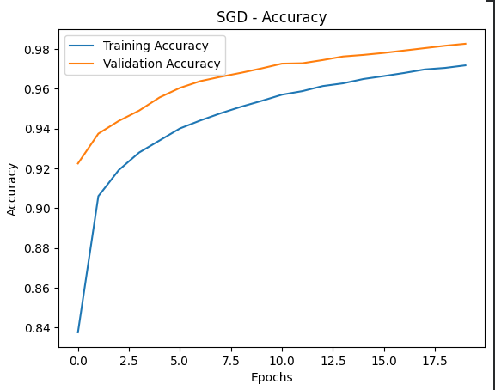
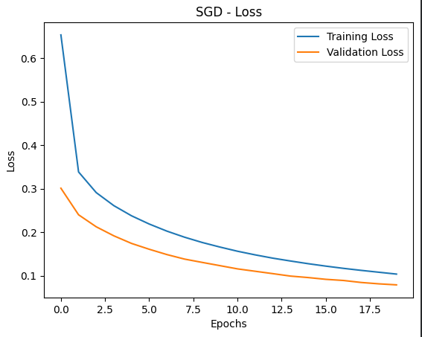

SGD+Momentum :
SGD with momentum accelerates convergence by accumulating past gradients, reducing oscillations and speeding up learning.

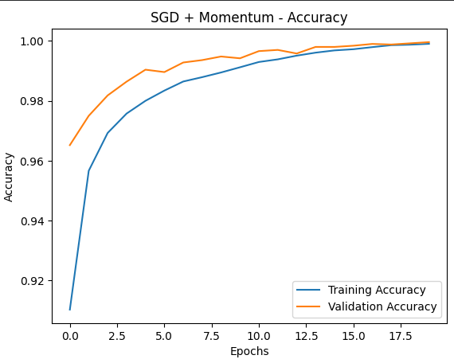

Adam :
Adam adapts the learning rate for each parameter, enabling very fast and efficient convergence on complex loss landscapes.
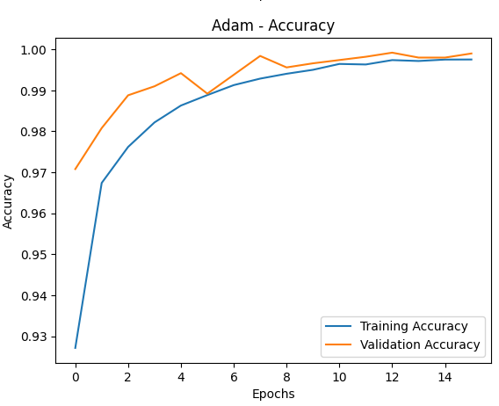
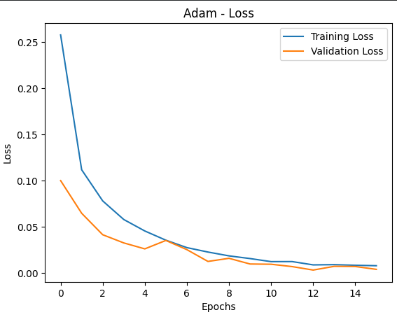

Adamw:
AdamW improves upon Adam by decoupling weight decay from gradient updates, resulting in more stable training and better generalization.
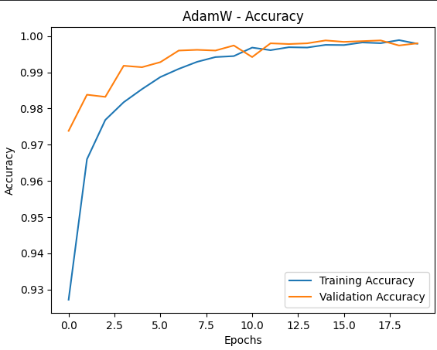
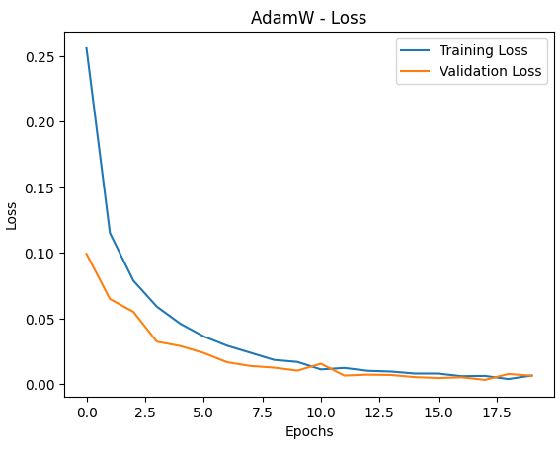

Optimizer Comparison (SGD, SGD + Momentum, Adam, AdamW)
SGD learns slowly but generalizes well, Momentum speeds it up, Adam learns fast, and AdamW learns fast while generalizing best.
Optimizer | Convergence Speed | Stability | Generalization
SGD | Slow | High | Good
SGD + Momentum | Medium | Higher | Good
Adam | Very Fast | High | Moderate
AdamW | Fast | Very High | Best

Explain why Adam often outperforms classical optimizers
Adam often outperforms classical optimizers because it combines adaptive learning rates with momentum, allowing each parameter to update efficiently and converge faster on complex, noisy loss landscapes with minimal hyperparameter tuning

Task 8 : Batch Size & Gradient Noise
Batch size = 8 :
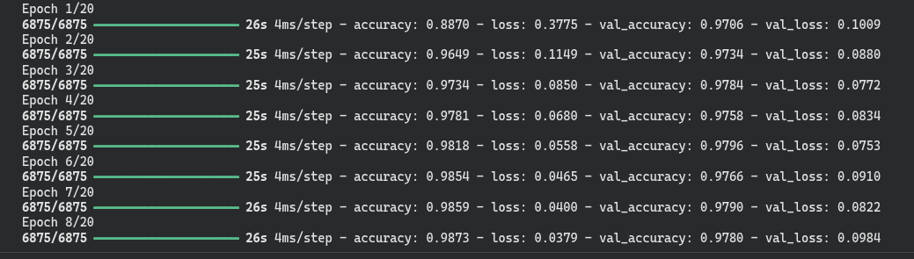

Batch size = 32 :
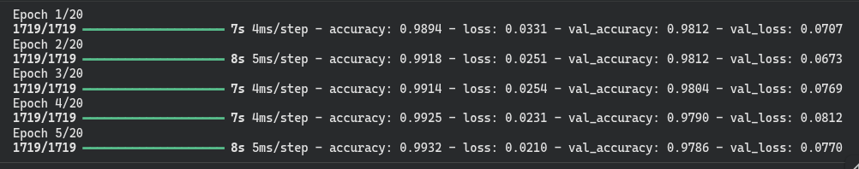
Batch size = 128 :
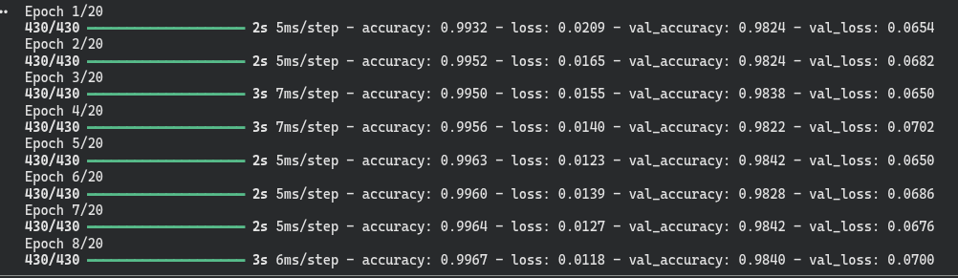
Why Smaller Batches Introduce Gradient Noise?
As a small batch size computes gradients from very few samples, which introduces high gradient noise, leading to noisy loss curves but helping the model escape local minima and improve generalization.
When Gradient Noise Is Beneficial?
it can be beneficial by helping the optimizer escape local minima and improve generalization.
Why Larger Batches Converge Faster but Generalize Worse ?
because their gradients are accurate and stable, but they generalize worse because they converge to sharp, fragile solutions. “مش هيقدر يحاكي الواقع "
finally , These results demonstrate that batch size controls the trade-off between optimization efficiency and generalization through gradient noise.

Task 9 : Activation Function Swap (ReLU vs Tanh vs GELU)
ReLU :
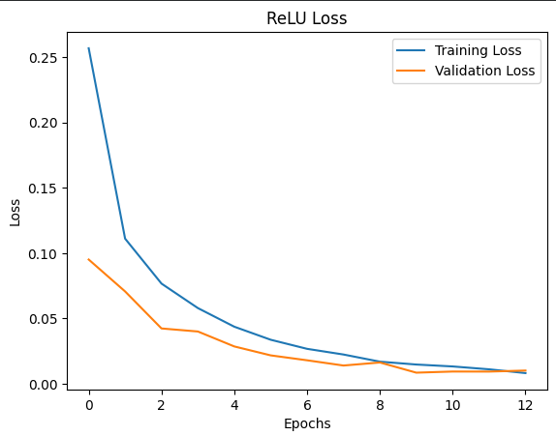
Training and validation loss decrease quickly and smoothly with a small gap.
This indicates strong gradient flow and stable learning without vanishing gradients.

Tanh :
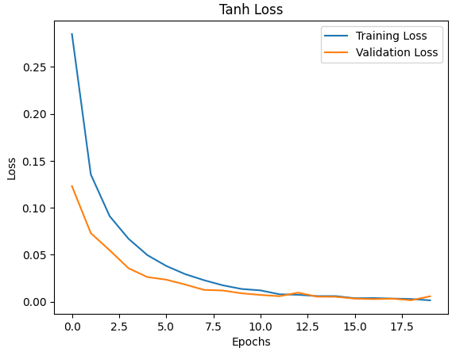
Loss decreases smoothly but more slowly.
This behavior reflects weaker gradient flow due to saturation, which slows learning.

Softsign :
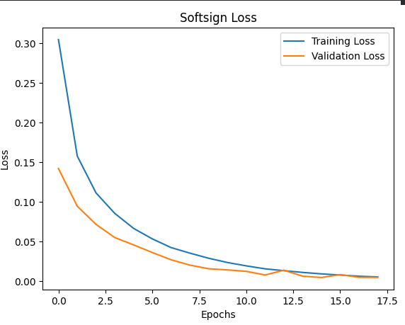
Loss decreases steadily but at a slower rate than ReLU and GELU.
Similar to Tanh but saturates more gradually, giving slightly better gradient flow.

GELU:
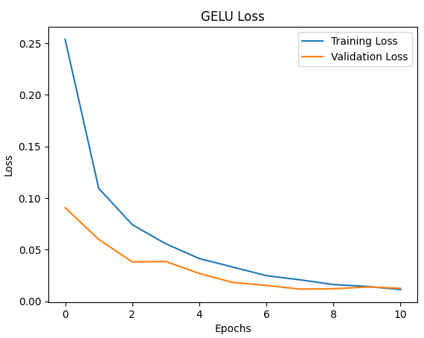
Provides smooth, probabilistic activation that maintains stable gradient flow

Training and validation loss drop rapidly and closely track each other

Which activations risk vanishing gradients?
Tanh and Softsign
Why does GELU perform well in Transformers?
Because its smooth loss curves indicate stable gradient flow, which scales well to deep architectures.

Why does ReLU remain preferred for MLPs and CNNs?
Because its loss decreases fastest with minimal instability

Task 10 : Weight Inspection & Model Capacity Analysis
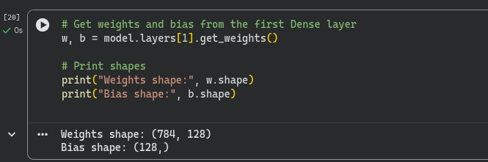

Why the number of parameters is so large ?
The input image has 28×28=784 features, and the first Dense layer contains 128 neurons, resulting in 784×128 weights plus 128 bias terms. Since every neuron is connected to every input feature, the number of parameters becomes very large.

How high model capacity increases overfitting risk?
A model with many parameters has high capacity, meaning it can represent very complex functions. While this allows the model to fit the training data extremely well, it also increases the risk of memorizing noise and specific training examples, leading to poor generalization on unseen data.

How Dropout, L2, and EarlyStopping mitigate overfitting differently?
Dropout reduces overfitting by randomly disabling neurons during training, forcing the network to learn redundant and robust representations. L2 regularization penalizes large weights, encouraging smoother models that are less sensitive to noise. EarlyStopping prevents overfitting by stopping training once validation performance stops improving, limiting how much the model can memorize the training data.

