Design and Implementation of IS: Assignment Bonus

UML

System Name: ParkWise

Semester: A – 2025-2026

Submitted by Group: CodeConcept

Link to the conversation with the LLM (in addition to the csv file uploaded to Moodle)

GitHub Repository URL: https://github.com/aya3rabas/bonus-code-concept.git

Assumptions:
This is an optional section for essential assumptions; Please provide concise information aimed at clarifying key aspects for the exercise evaluator; Ensure that the content does not replicate details already presented in the system description narrative.

1.1.a. The Final Use Case Diagram:
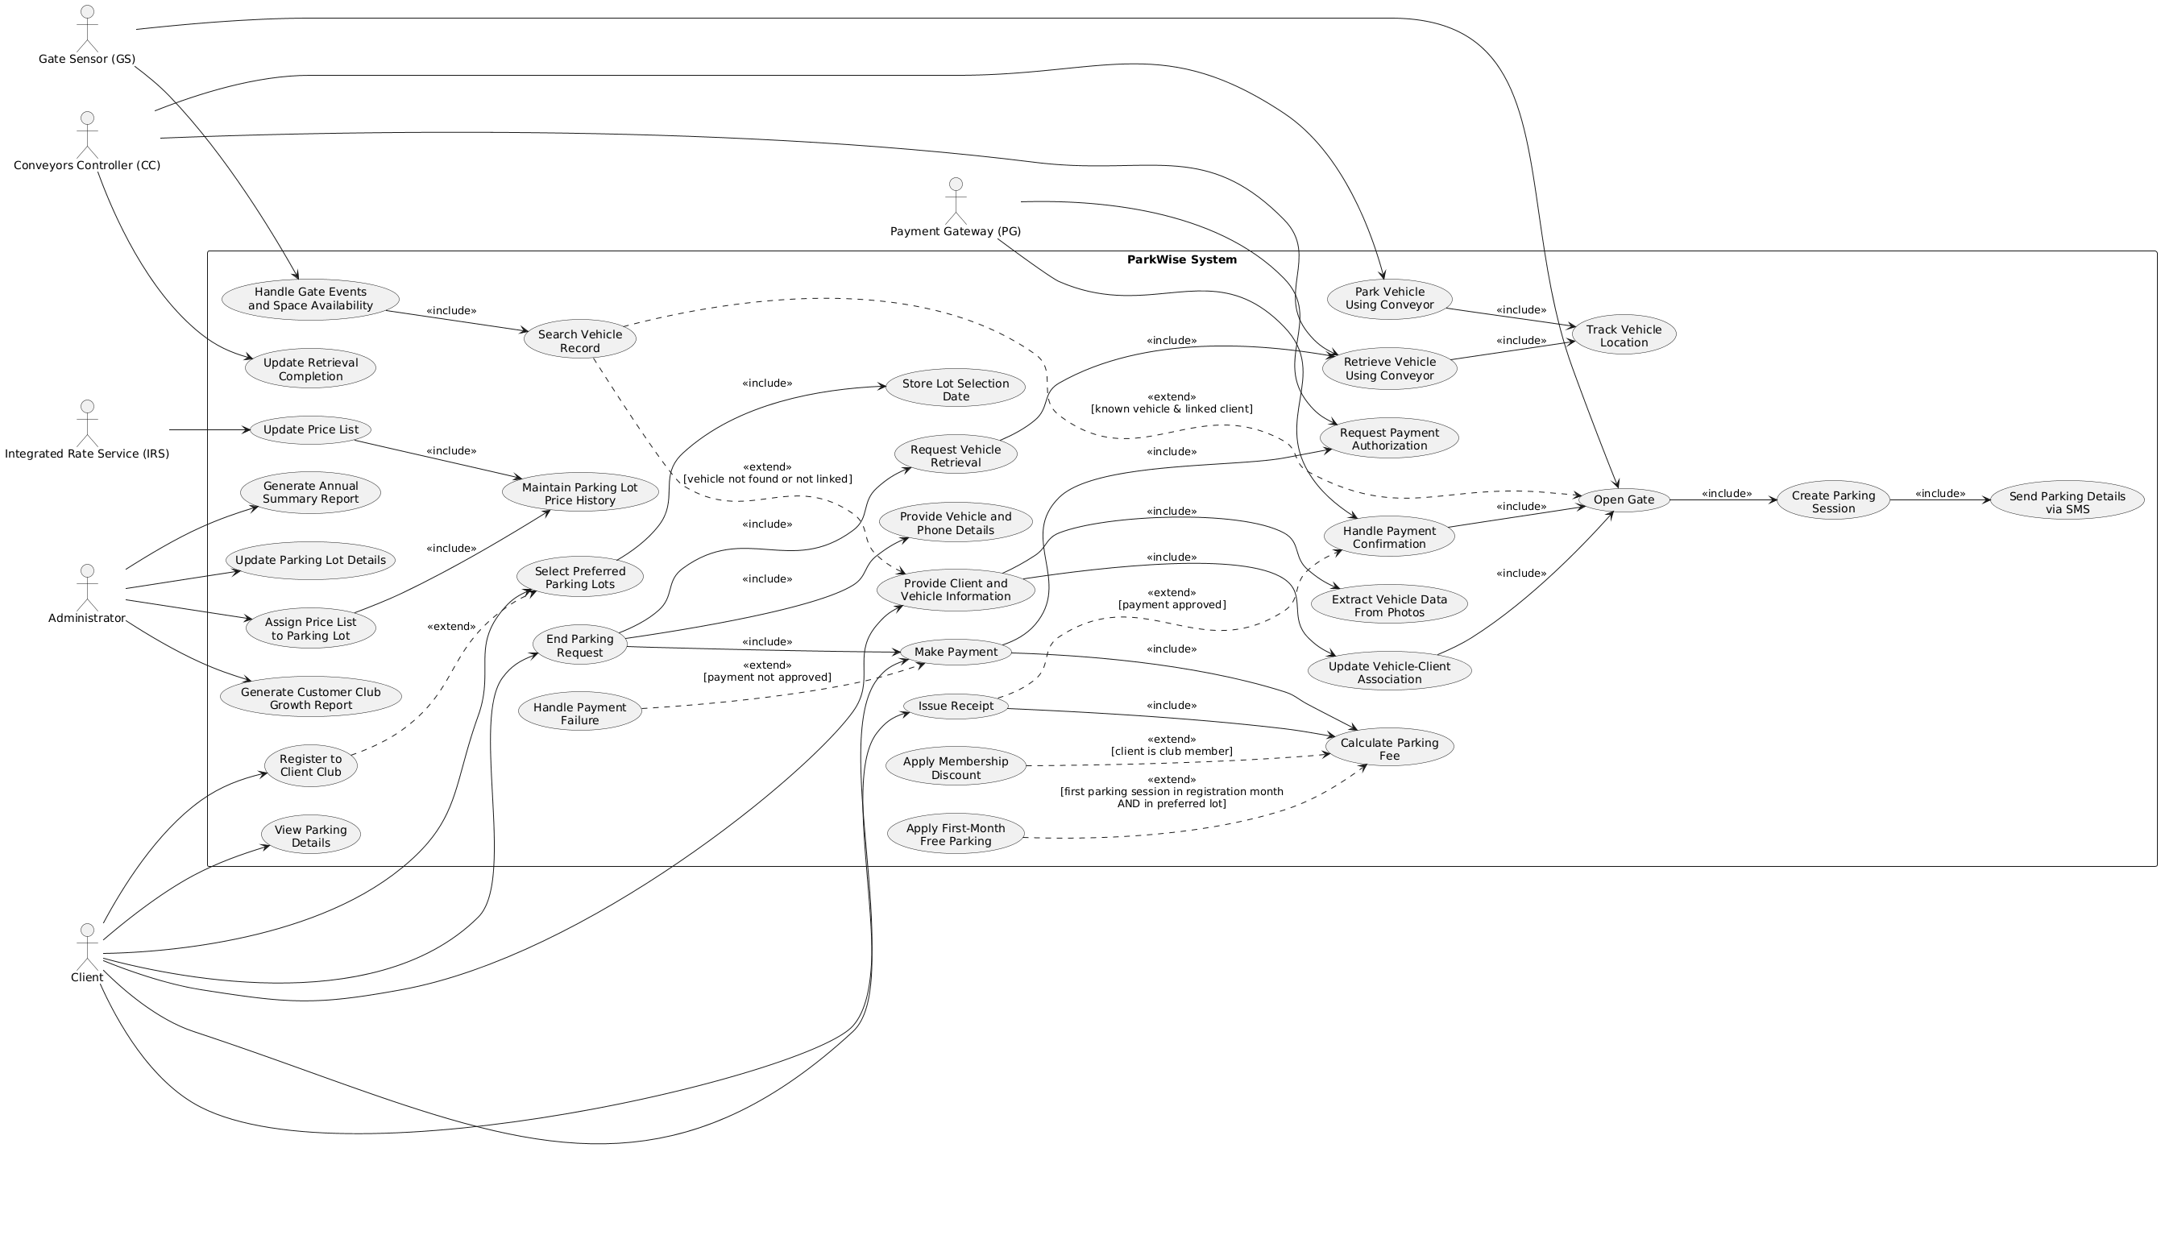
Verify readability of the figure.

1.1.b. The Final Descriptions of the Use Cases:
Make sure the descriptions are short and concisely describe the responsibilities of the various use cases.

Manage Parking Lot (including spaces and conveyors)
- The Administrator manages the details about parking lots, parking spaces, and conveyors in the system.

Send Vehicle Arrival\ Departure Data
- The system receives vehicle arrivals and departures from the Gate Sensor (GS).
- <<Include>> Search DB for Vehicle
- If the vehicle is found: <<Extend>> Manage Parking Session

Search DB for Vehicle
- The System searches the received vehicle number in the database.
- If the vehicle is found, the system returns the client’s details.

Provide Client Details
- The client provides the required details, including first name, last name, mobile phone number, and three photos of the vehicle.
- <<Include>> Extract Vehicle’s Details.

Extract Vehicle’s Details
- The system automatically extracts the vehicle’s details from the provided photos: number, type (as text), color, size (small, medium, or large), and weight (in kg). The extraction photo-to-text module distinguishes among four predefined colors – white, black, silver, and blue – while all other colors are categorized as other.
- <<Include>> Manage Parking Session.

Manage Parking Session
- <<Include>> Send Instructions to Open Barriers.
- The system updates the entry/exit time of the parking session.
- The System increases/ decreases the number of available parking spaces.

Send Instructions to Open Barriers
- The system sends a signal to the Gate Sensor (GS) to open the barrier.

Request to Move Vehicle
- The system sends the conveyors’ controller a request to move a vehicle to or from a parking space.
- The system waits.
- <<Include>> Update conveyor’s Final Location

Update conveyor’s Final Location
- The conveyors’ controller updates the system on the final location of the operating conveyor.

View Parking Details
- The client enters his or her phone number.
- The client received information on their current parking session.

Request Parking End
- The Client requests to end the parking session.
- <<Include>> Request Payment
- <<Include>> Request to Move Vehicle

Request Payment
- The system calculates the total payment based on the parking time and rates.
- <<Extend>> Get Discount/ Free Parking Benefit
- The system notifies the client accordingly.
- <<Include>> Request to Handle Payment

Get Discount/ Free Parking Benefit
- If the client is a club member, the system automatically applies a discount for the session.
- If the client is a club member, this is their first parking session in the month of registration, and they park in one of the parking lots they selected, the system marks the parking session as free.

Request to Handle Payment
- The system sends a request to the external Payment Gateway (PG) with the client details and the payment amount.

Approve Payment
- The system is notified by the Payment Gateway (PG) that the payment is approved.
- <<Include>> Manage Parking Session

Get an SMS with Parking Details
- The system sends an SMS to the client with the parking session details.

Issue a Receipt
- The system issues a receipt at the client’s request. The receipt shows the details of the client, the vehicle, and the parking session, as well as the overall number of hours, the price rate (according to the parking duration), and the final amount.

Import Price Lists
- The system receives parking price lists from the Integrated Rate Service (IRS), in JSON format. The system saved the data.

Adapt a Price List to a Parking lot
  - The administrator can choose an existing price list to adapt to a parking lot. The adaptation date is saved in the system.

Generate Annual Summary Report
- The Administrator requests an annual summary report for a requested year.
- The system compiles and sends statistics on incomes, vehicle entries, and overall performance for each parking lot. The statistics are presented in both PDF and XML formats.

Join to the Member Club
- The Client registers as a Club Member through the system.
- The system records the client’s registration date.
- <<Include>> Choose Parking Lots

Choose Parking Lots
- The client can select preferred parking lots (the selection dates are stored for audit purposes).

Generate Customer Club Growth Report
- The Administrator requests a report summarizing member club growth.
- The report includes new memberships, cancellations, and overall active members for each month in the current year.

1.1.c. UML Class Diagram:
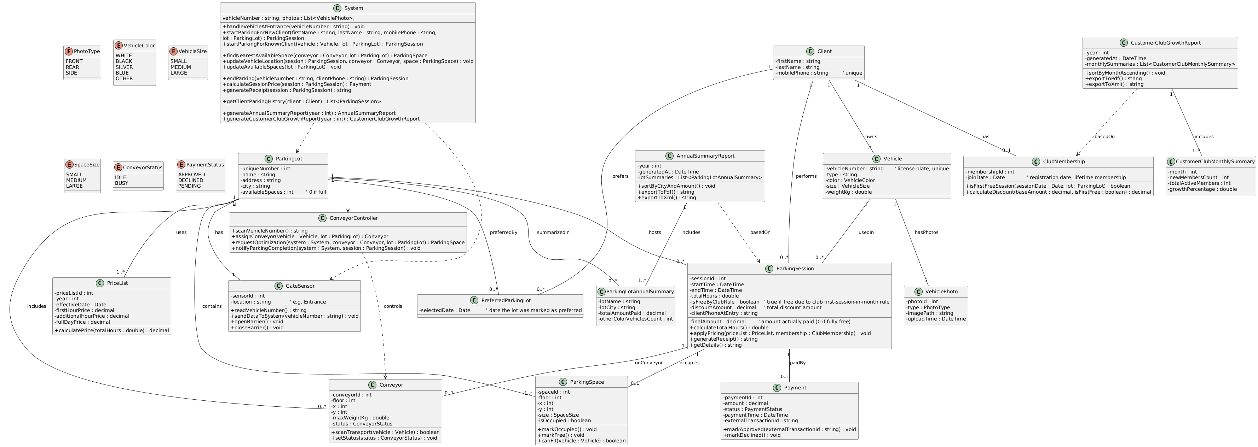
This section will not be checked again and is intended to understand the context.
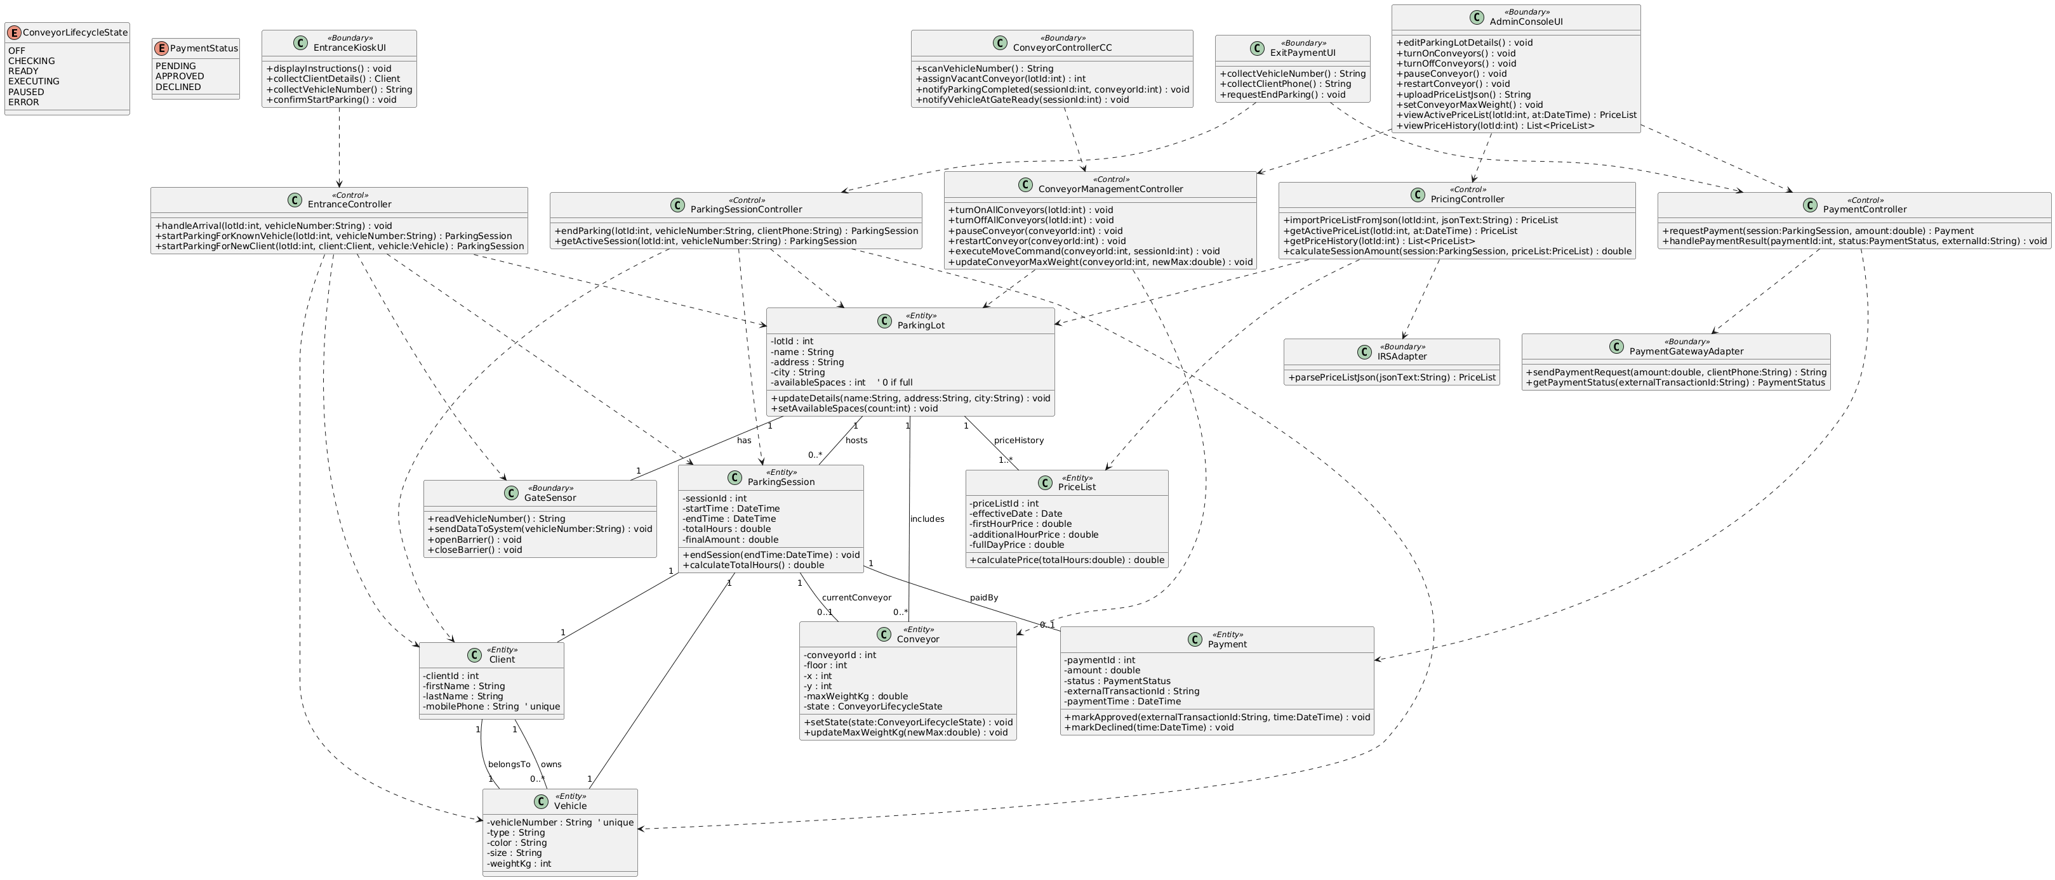

2.1 The Final Statechart Diagram:
Verify readability of the figure.
Model:

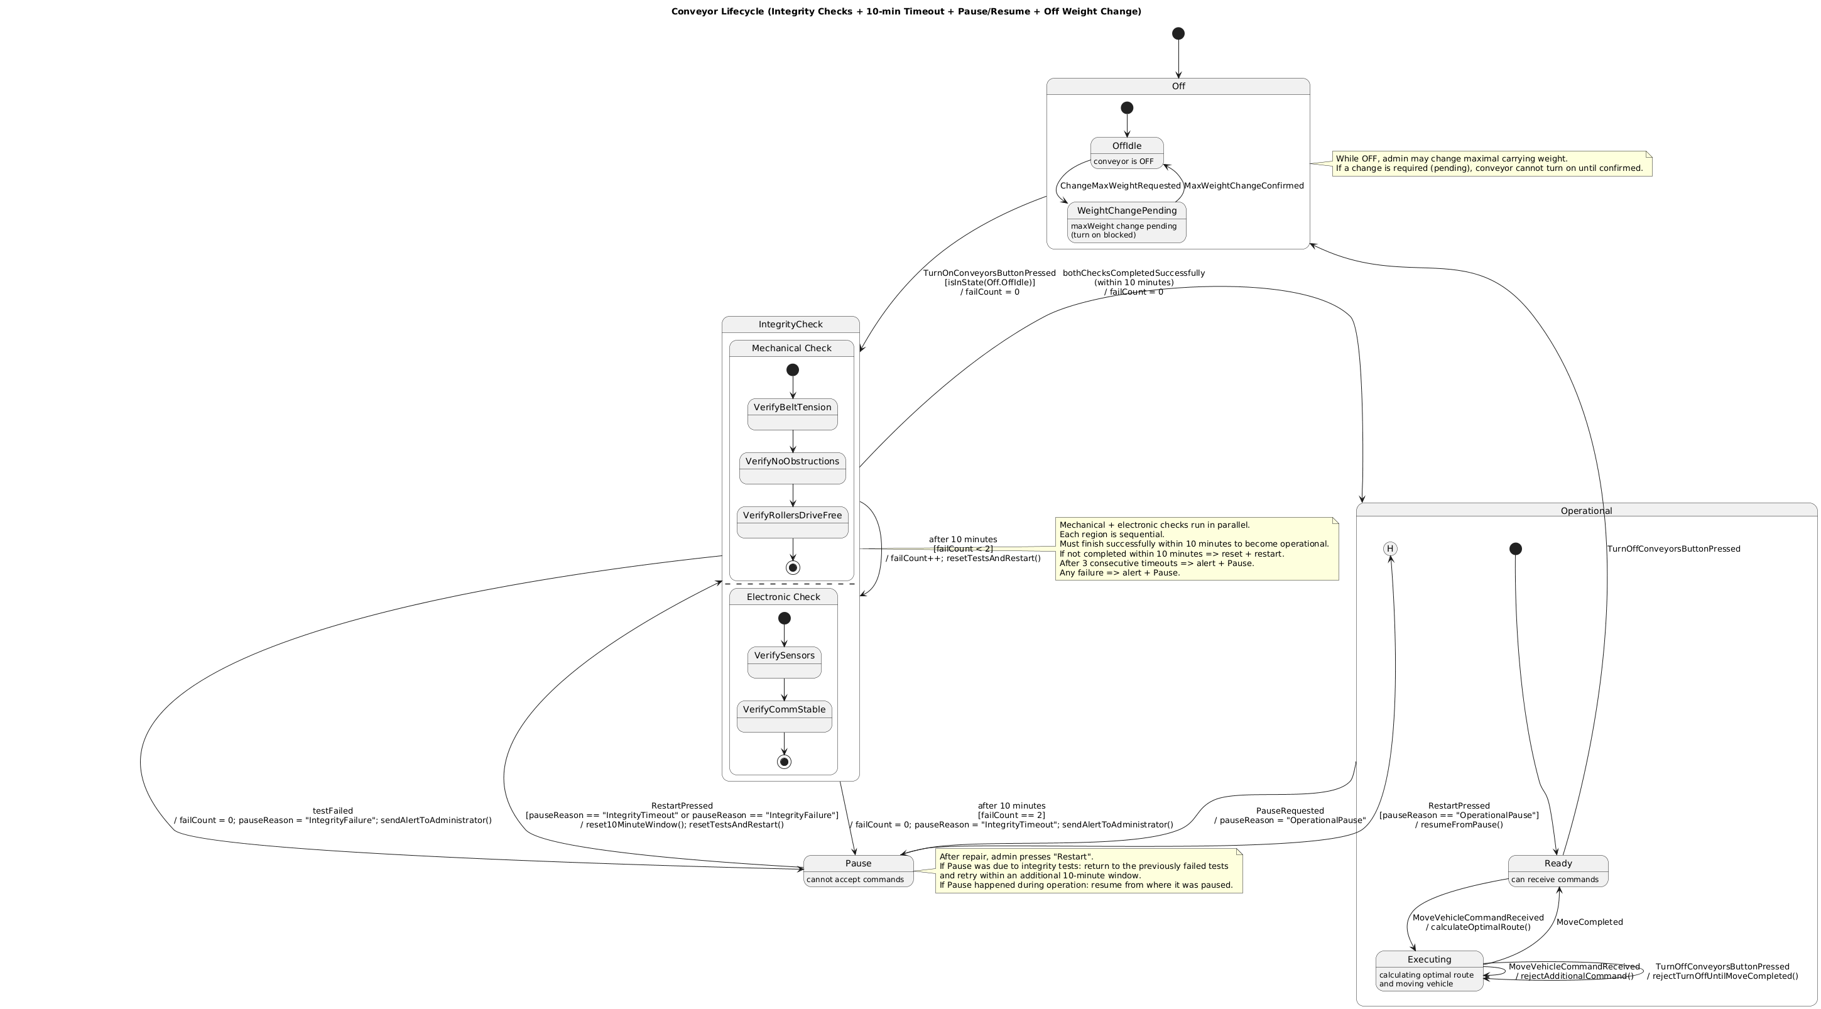

Description of the model:
Event / Variable | Description
Off | The conveyor is powered off. During this state, the administrator may change the maximal carrying weight. The conveyor cannot be turned on while a weight change is pending.
OffIdle | A substate of Off in which the conveyor is idle and ready to be activated, provided no pending configuration changes exist.
WeightChangePending | Indicates that a change to the maximal carrying weight was requested while the conveyor is off. The conveyor remains blocked from startup until the change is confirmed.
TurnOnConveyorButtonPressed | Event triggered when the administrator presses the “Turn On Conveyors” button to activate the conveyor.
IntegrityCheck (composite state) | A startup validation phase executed when the conveyor is turned on. It consists of mechanical and electronic checks that run in parallel and must complete successfully within 10 minutes.
MechanicalCheck | A sequential validation process that verifies the mechanical readiness of the conveyor.
VerifyBeltTension | Confirms that the conveyor belt tension is within acceptable operational limits.
VerifyNoObstructions | Ensures that no physical obstructions are present along the conveyor path.
VerifyRollersDriveFree | Verifies that the rollers and drive components rotate freely without resistance.
ElectronicCheck | A sequential validation process that verifies the electronic readiness of the conveyor.
VerifySensors | Ensures that all conveyor sensors operate correctly and provide valid readings.
VerifyCommStable | Confirms stable communication between the conveyor and the central controller.
IntegrityTimeout | Indicates that either the mechanical or electronic check was not completed within the allowed 10-minute time window.
failCount | A counter that tracks consecutive integrity check timeouts or failures.
Pause | A non-operational state entered after three consecutive integrity check timeouts or after a test failure. In this state, the conveyor cannot accept commands.
RestartPressed | Event triggered when the administrator presses the restart button after performing a repair. The conveyor resumes the integrity checks from the point of failure with an additional 10-minute window.
Operational | The conveyor is fully operational and able to process movement commands.
Ready | A substate of Operational in which the conveyor is idle and ready to receive vehicle movement commands.
Executing | A substate of Operational in which the conveyor is calculating the optimal route and moving a vehicle. During this state, additional commands and shutdown requests are blocked.
MoveVehicleCommandReceived | Event triggered when the system sends a command to move a vehicle.
MoveCompleted | Event indicating that the conveyor has successfully completed the vehicle movement operation.
PauseRequested | Event that pauses the conveyor while idle or during command execution.
TurnOffConveyorButtonPressed | Event triggered when the administrator presses the “Turn Off Conveyors” button, causing the conveyor to shut down after completing any active command.

2.2 Design Class Diagram of
Verify readability of the figure. For each diagram, the relevant screenshots must be presented (the titles can be reproduced if needed).
Screenshot:

Diagram:

3.1.a Design Class Diagram of
Verify readability of the figure. For each diagram, the relevant screenshots must be presented (the titles can be reproduced if needed).
Screenshot:
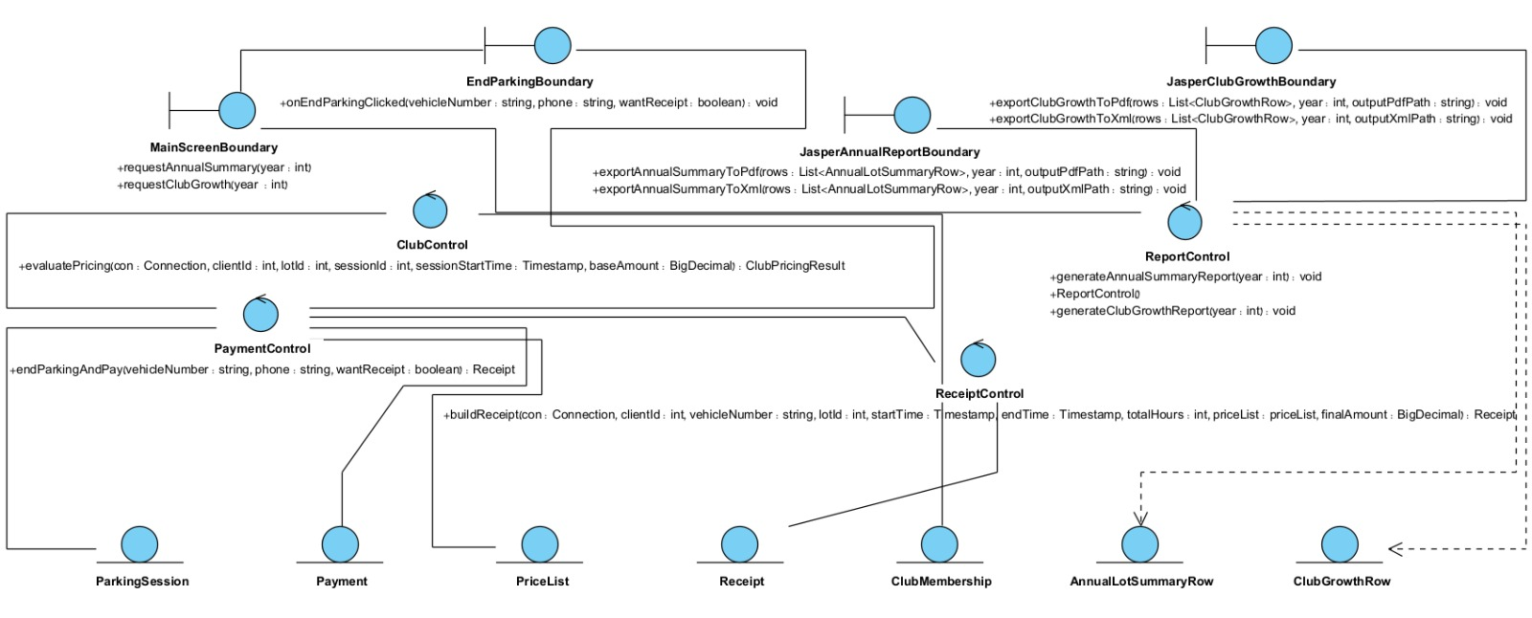
Diagram:

3.1.b Sequence Diagram of :
Verify readability of the figure.
