

Faculty of Engineering and Technology
Electrical and Computer Engineering Department

ENCS4380
HW_2

Prepared by
Aya Dahbour 1201738

Section number: 1

Question#1
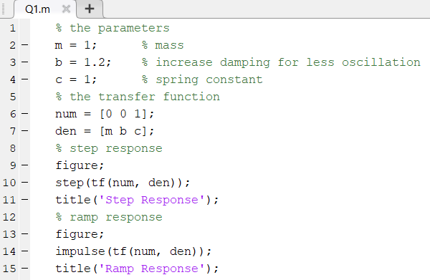
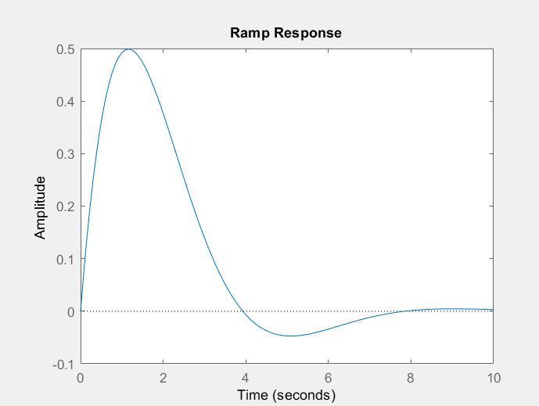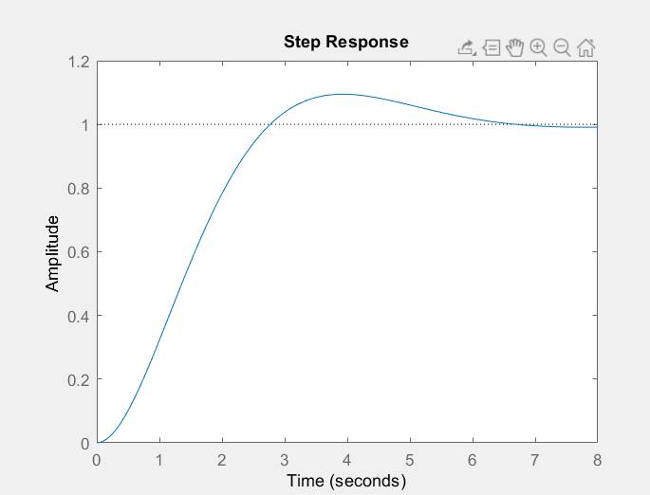

The nature of behavior in a system will be determined by the damping ratio B/M. Increased damping is ideal in that it reduces the overshoot in step responses, smoothens the responses to ramp inputs and also stabilizes the system - ultimately lowering the frequency response peak. Smaller damping may cause oscillations on both responses and gives a smaller peak which means that system stability may be compromised. The damping coefficient is determined by balancing the reaction speed with the system stability.

Question#2
- Concept of Operation
Smartphone accelerometers use MEMS technology with colorful seeing mechanisms similar as capacitive, piezoresistive, and piezoelectric to descry direct acceleration and stir. Capacitive accelerometers, generally set up in smartphones, calculate on changes in capacitance due to movement, while piezoelectric detectors descry subtle changes in pressure.

- Technology Used in Manufacturing
Manufacturing involves the use of capacitive, piezoelectric, and piezoresistive technologies for accelerometers. Gyroscopes, on the other hand, employ MEMS technology, microscale wobbling structures, and the Coriolis effect.

- Stationary and Dynamic Characteristics
stationary characteristics (perceptivity, range, resolution, noise, and frequency response) are pivotal for both accelerometers and gyroscopes. Capacitive accelerometers are popular in smartphones, piezoelectric detectors capture subtle changes, and piezoresistive detectors balance perceptivity and responsiveness. Gyroscopes partake stationary characteristics with accelerometers.

- Simple Interface for measures
Accelerometers and gyroscopes give precious data through stoner-friendly APIs or software libraries. inventors can fluently interact with these detectors using standard programming languages and protocols. The flawless integration of detector data into operations, similar as pedometers, gesture recognition, and stoked reality, is eased by accessible and well- proved interfaces. This stoner-friendly approach enhances the overall experience for inventors using detector capabilities on smartphones.

Question#3
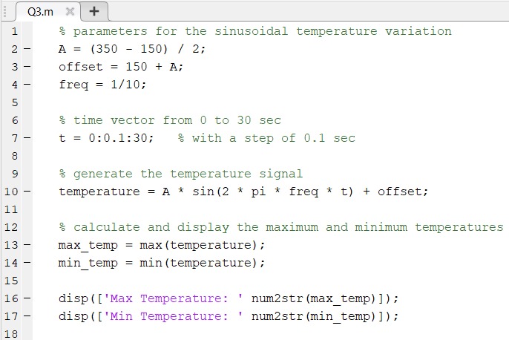
- After run this code in MATLAB I got these results:
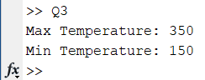
Question#4
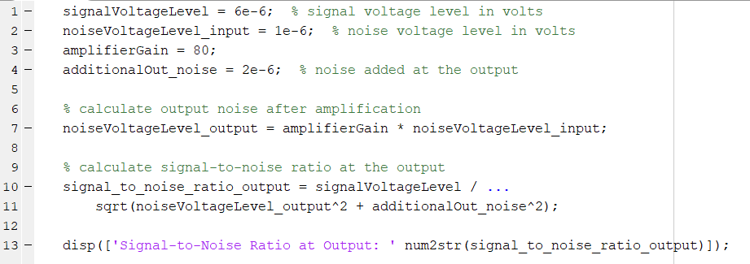
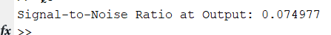
Question#5
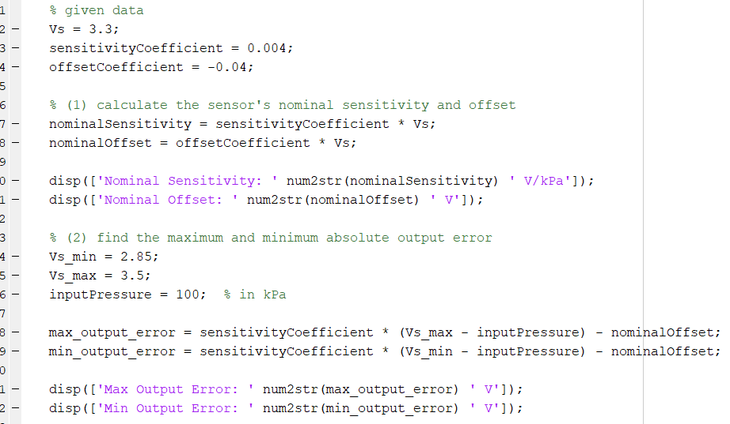
- The code output:
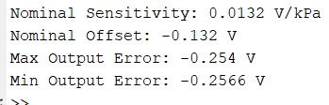
Question#6
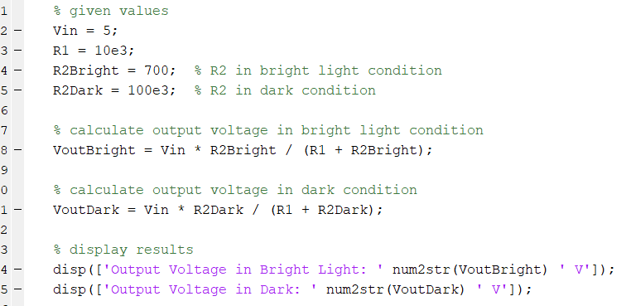
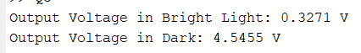
Question#7
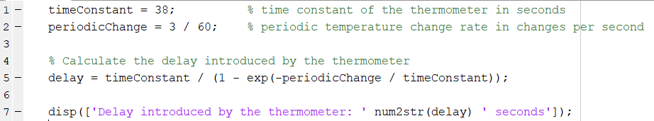
- The code output:
Question#8
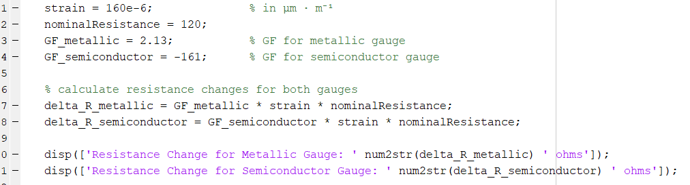
- These are the values that resulted:
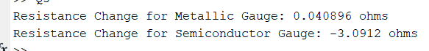
Question#9
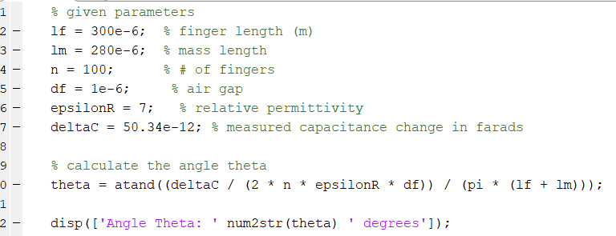

Question#10
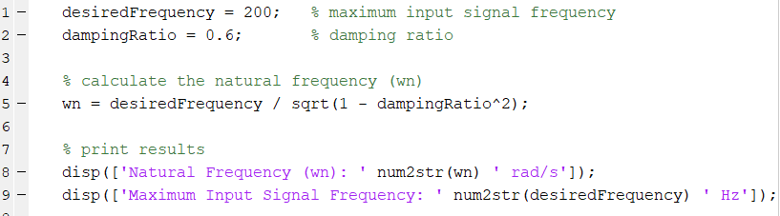

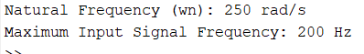
Question#11
I didn't know exactly which program you wanted the solution on, but I used tinkercad.
