

Faculty of Engineering and Technology
Electrical and Computer Engineering Department

ENCS4380
HW#3 Arduino Part 1

Prepared by
Aya Dahbour 1201738

Section number: 1

Q1) Based on What we did in class Using Timer Library, do the same functions as in Examples 4-6 without using the Timer Library and Delay function.
- Example 4:

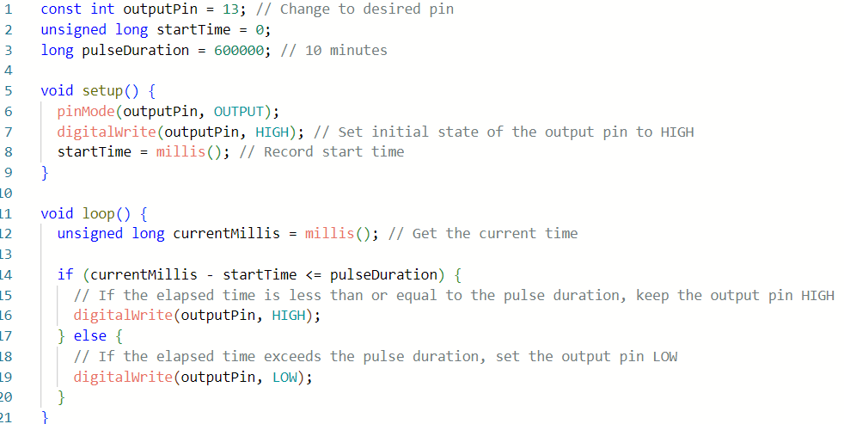
- Example 5:

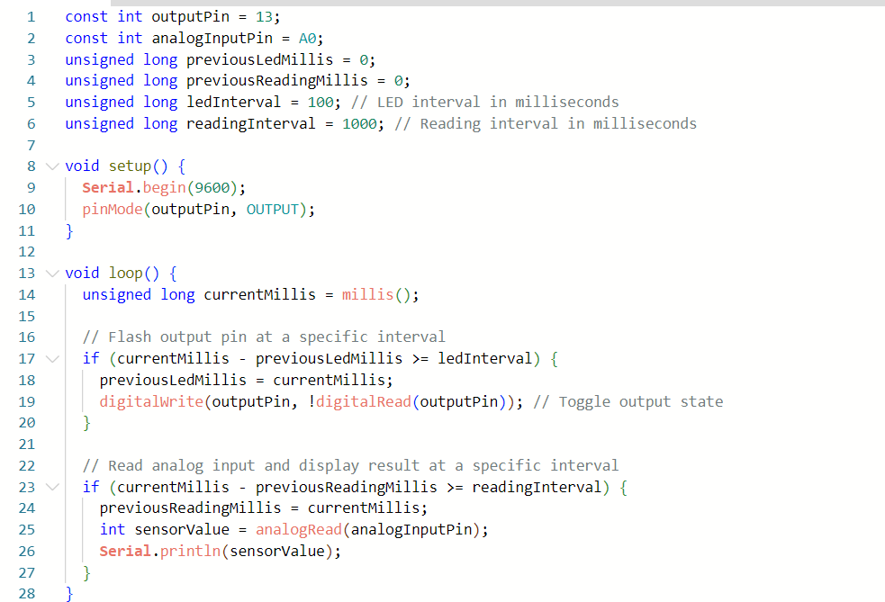
- Example 6:
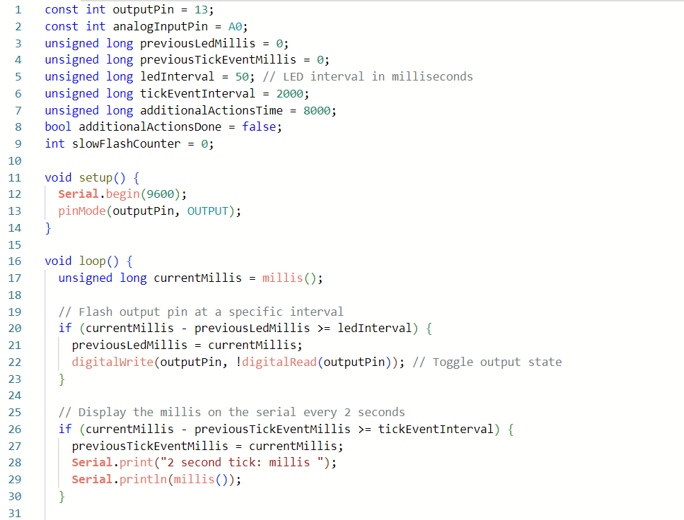
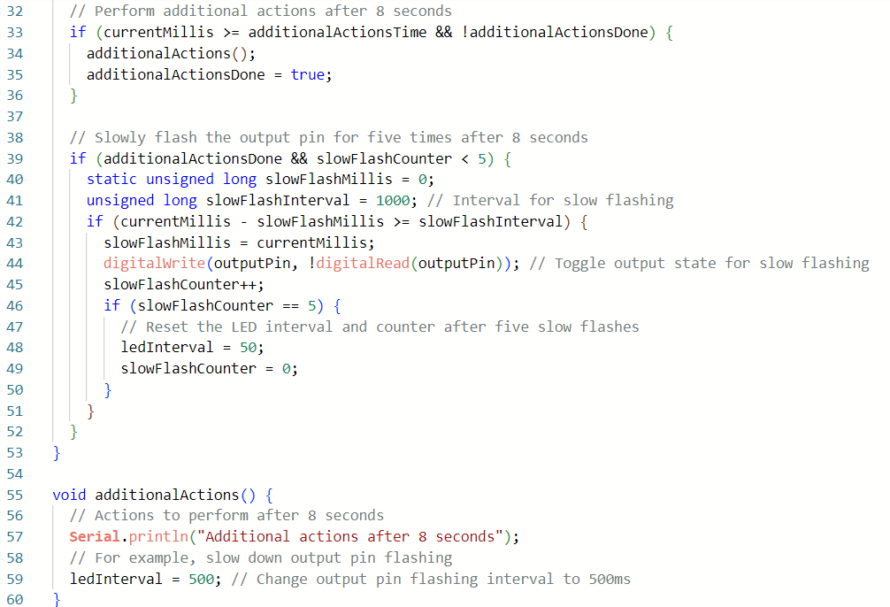
Q2) In this question I built Arduino sketch without using the LiquidCrystal.h library to display text on a 16x2 LCD. It first shows "ENCS4380: 2023" on the first row and "My Name &ID" on the second row. After a 5-second delay, it updates the display with "The mission is DONE" scrolling the text from left to right on the second row. This loop repeats indefinitely.

- As showed in the figures below (using wokwi online website):
- The Simulation:
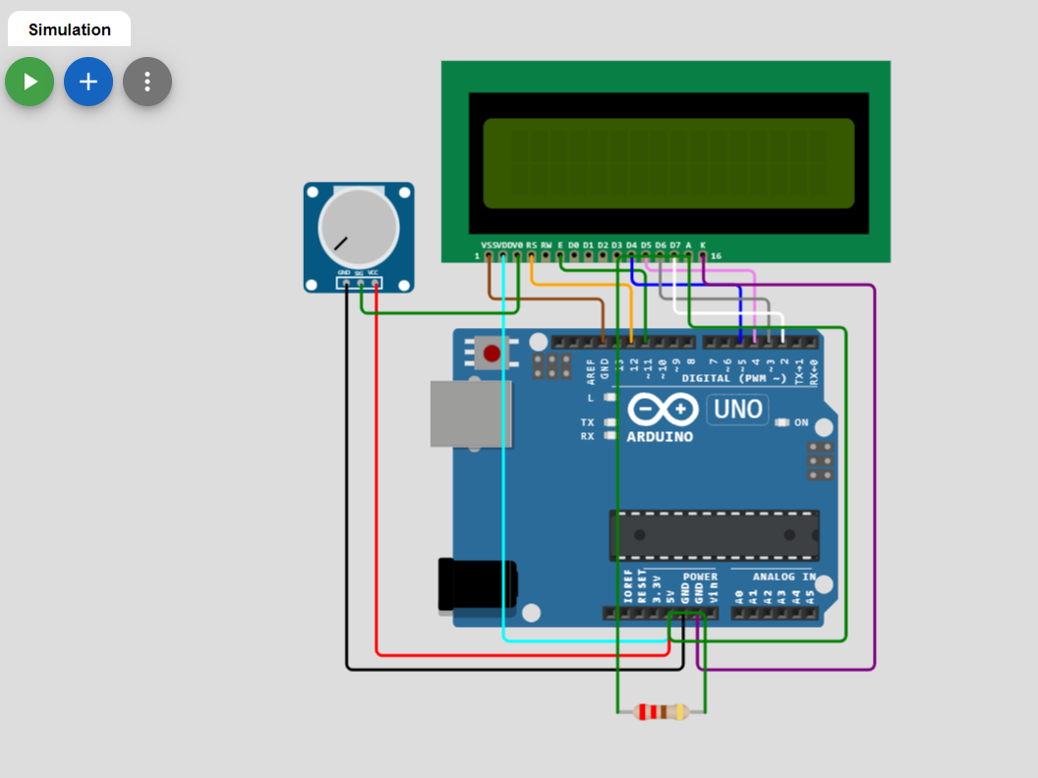
- The code:
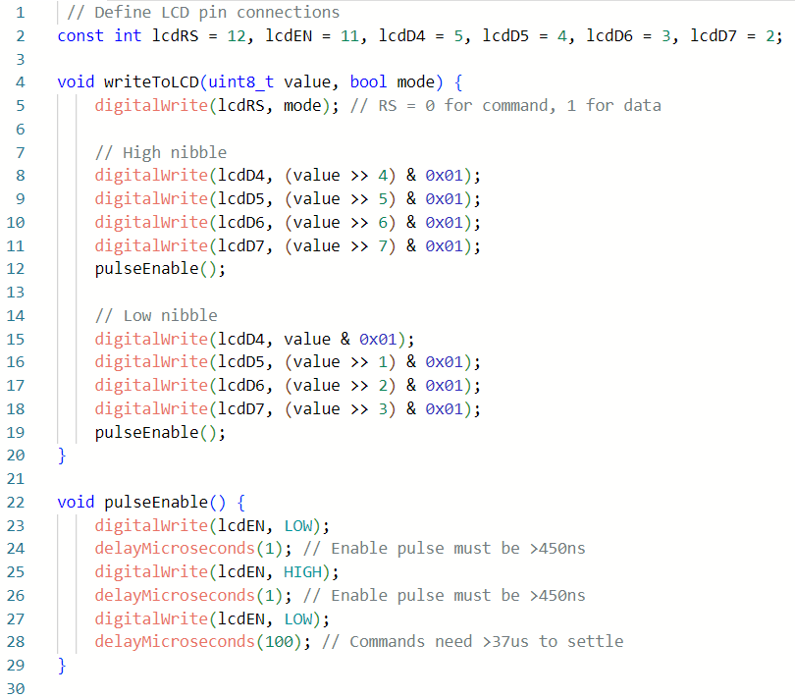
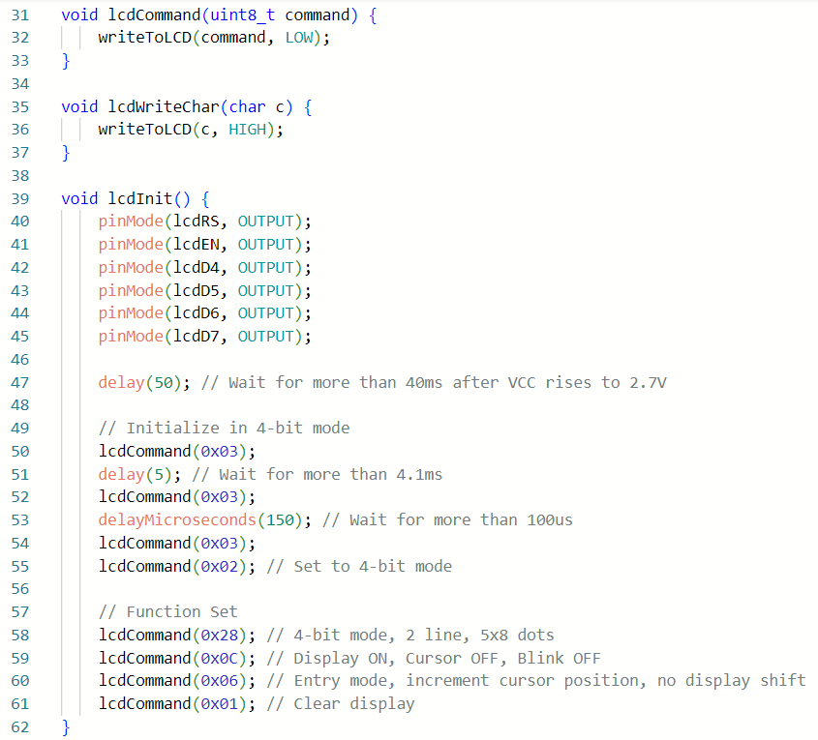
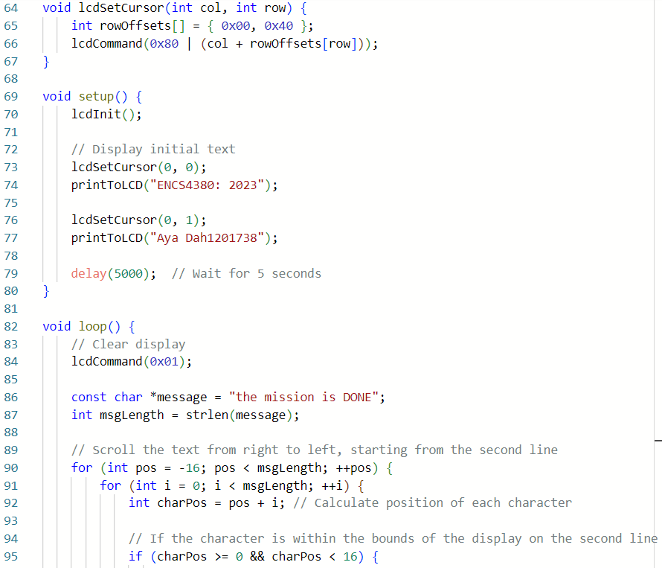

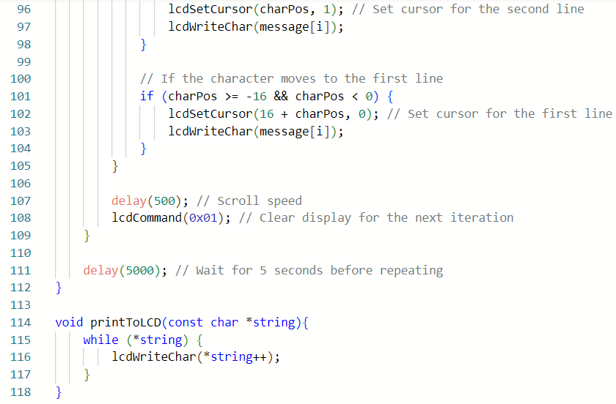

- The output:
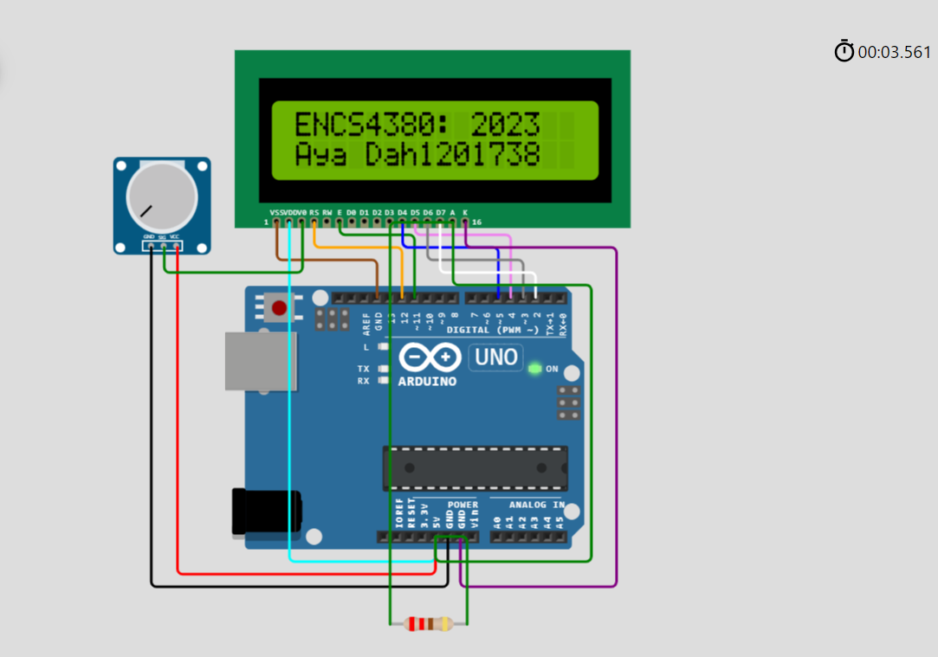
- After 5 second it clears the screen then print “the mission is done” and moving the sentence as follow:

