

Department of Electrical & Computer Engineering
ENCS5343 Computer Vision
Assignment#2
Arabic Handwritten Text Identification Using Local Feature Extraction Techniques

Prepared By:
Aya Dahbour 1201738
Yasmeen Kamal 1201146

Instructor: Dr. Aziz Qaroush

Section: 2

Date: 15/12/2024

Introduction and Objective

This assignment presented one of the known applications regarding the application of computer vision in the field of identifying and retrieving handwritten texts that are in Arabic. The main objective is to make them accessible, and thus, to have an early stage of recognition by making use of the improvement of computer-capture function. One of the algorithms known as Scale-Invariant Feature Transform (SIFT) and the other one called Oriented FAST and Rotated BRIEF (ORB) were compared in order to prove whether they are able to recognize Arabic handwriting. Among the different qualities, its accuracy, the speed of the algorithm, the transformation data that they can manage, and their key points detecting accuracy are the main focus of the comparison.

Methods Used
In this part, we followed a structured approach to implement and evaluate the SIFT and ORB techniques:
- Feature Extraction:
In this step, two different methods are used to extract features. SIFT is a method that is very frequently used for the detection and description of local features in images. It is invariant to scaling, rotating, and enjoying partial illumination. On the other hand, ORB is a computationally efficient option to FAST- for a keypoint localization unit that combines the BRIEF descriptor to get high-speed performance. Apart from that, both methods (ORB and SIFT) were prevalently used in object recognition and image matching, thus are perfect for handwritten text recognition evaluation.

- Clustering:
Then, to process the extracted descriptors, MiniBatch K-Means clustering is applied. These descriptors are then clustered into 100 clusters, as part of a visual vocabulary to make the data tractable and organized for later steps.

- Feature Vectors:
The visual vocabulary obtained by clustering is used to build histograms of visual words for each single image. The histograms give the distribution of different visual words contained in the images and are used as feature vectors for classification.

- Classification:
To identify the handwritten text, we used many different machine learning classifiers so we could identify the method with the best performance. First, we trained a Gradient Boosting Classifier and a Random Forest Classifier with the SIFT features. The Random Forest Classifier gave an accuracy rate of 23.98%, while the Gradient Boosting Classifier gave 19.76% in terms of accuracy. With this information, we stuck to the Random Forest Classifier to carry out further tests.

We therefore tested the performance of the Random Forest Classifier based on the ORB features; still, the accuracy considerably dropped and registered only 15.38%. To improve the results, we went further in using a Support Vector Machine (SVM) classifier. The SVM showed a much better performance compared to all the above classifiers evaluated and became the best choice for the task of Arabic handwritten text identification.

- Robustness Testing:
As a last step, robustness testing involves assessing the performance of the algorithms under challenging conditions. Images are transformed by scaling, rotation, and adding noise in order to test the reliability of the feature extraction methods in view of such modifications.

Results

SIFT
An example processed image that display its features by SIFT:
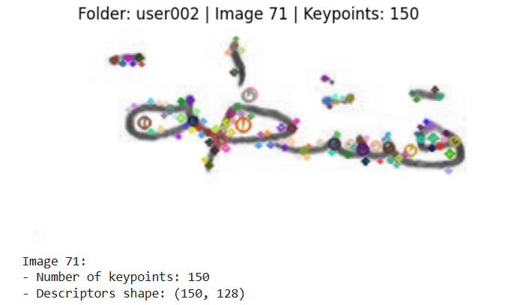
Then after applied the rest steps we achieved these results:
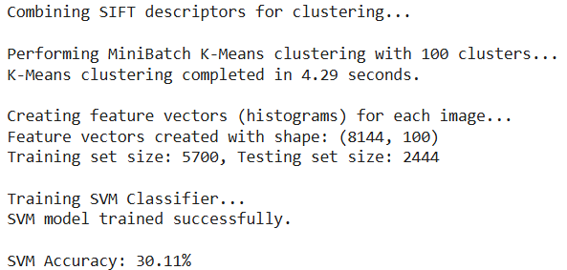
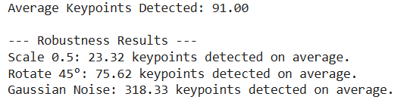
With some additional outputs just to make sure the solution is correct and get more accurate results. Such as displaying a table showing the Metrics for each user and displaying some images after applying the transformation to them as the follow:
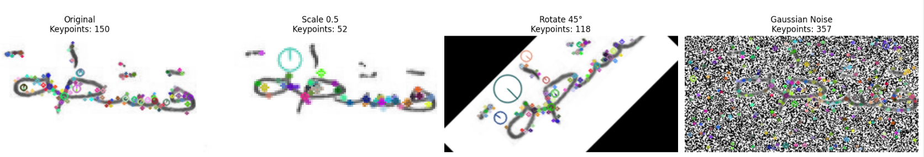

ORB
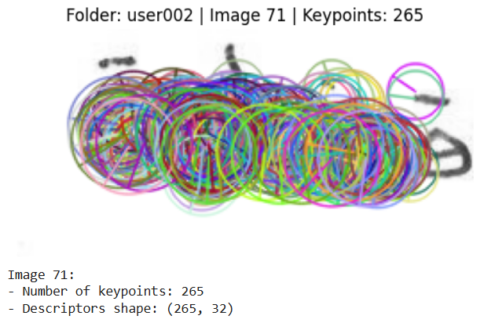
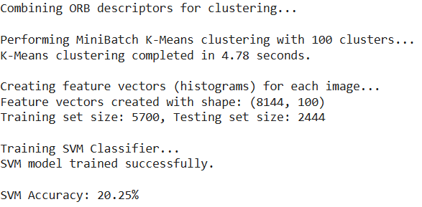
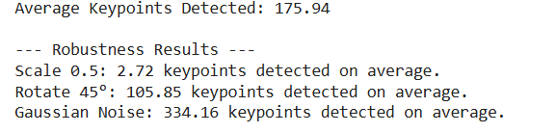

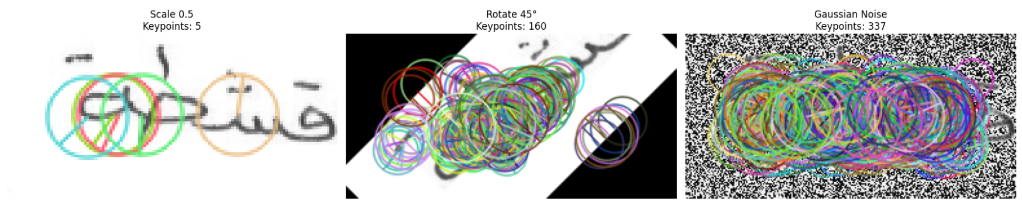

Discussion

Feature Extraction and Keypoints Detection:
From the results, SIFT and ORB behave differently in keypoint detection. SIFT identifies fewer keypoints—for example, 150 in one of the original images—but creates more detailed descriptors with a shape of (150, 128). ORB, on the other hand, detects many more keypoints—for example, 265 in the same image—with much smaller descriptors (shape: (265, 32)). This suggests that SIFT prioritizes quality and precision of features, whereas ORB emphasizes efficiency and quantity.

Clustering and Feature Vector Creation:
Both algorithms use MiniBatch K-Means clustering to group descriptors into 100 different clusters, hence creating the visual vocabulary. The time taken for clustering is slightly less in the case of SIFT (4.29 seconds) compared to ORB (4.78 seconds), which might be due to the smaller number of descriptors being dealt with in SIFT. The resulting feature vectors have the same size (8144, 100) for both algorithms, so the classifier gets the same type of input.

Classification Performance:
The SVM classifier with an RBF kernel has been used and tested on a dataset that got split into 70% for training (5,700 samples) and 30% for testing (2,444 samples). This division was done to ensure that the model the necessary data to learn the patterns during the training while providing a separate dataset for evaluating the performance of the model. On the results page, SIFT gives an accuracy of 30.11% while ORB scores 20.25%. This fact that SIFT provides features that outperform ORB in handwritten text identification is relevant, probably, SIFT is able to locate key points and compute descriptors with the highest quality. In spite of the fact that the size of the training set is significant, the rather high possibility of error strongly implies that while SIFT is, to some extent, better, there are still missing points in the feature extraction step or other classification methods that are not used and therefore are necessary to achieve higher accuracies with smaller training sets.

Robustness to Transformations:
When evaluating robustness under transformation, namely scaling, rotation, and noise addition, test results show certain strengths and weaknesses:

- Scaling (0.5):
SIFT detects, on average, 23.32 keypoints, while ORB detects only 2.72 keypoints. This would appear to indicate that SIFT is way more resistant to scaling transformation.

- Rotation (45°):
SIFT detects an average of 75.62 keypoints, whereas ORB detects 105.85 keypoints. From this, it would seem that ORB handles rotations way better, probably because the algorithm relies on oriented keypoints.

- Gaussian Noise:
Under noise addition, ORB detects an average of 334.16 keypoints, whereas SIFT detects 318.33 keypoints, which shows that ORB is slightly more resistant under noisy conditions.

