
Faculty of Engineering and Technology
Department of Electrical and Computer Engineering

ENCS5399 - Control Systems
Assignment

Prepared By:
Aya Dahbour 1201738

Instructor: Dr. Mahran Quraan

Question 1:
Code:
clc;
clear;
close all;
% Define transfer function G(s) = 2 / (s*(s+3))
num = 2;
den = conv([1 0], [1 3]); % s*(s+3) = s^2 + 3s
% Create transfer function
G = tf(num, den);
% Create unity feedback system
sys = feedback(G, 1);
% Plot step response
figure;
step(sys);
title('Step Response of Unity Feedback System');
xlabel('Time (sec)');
ylabel('Amplitude');
grid on;
% Display poles for verification
disp('Poles of the closed-loop system:');
disp(pole(sys));
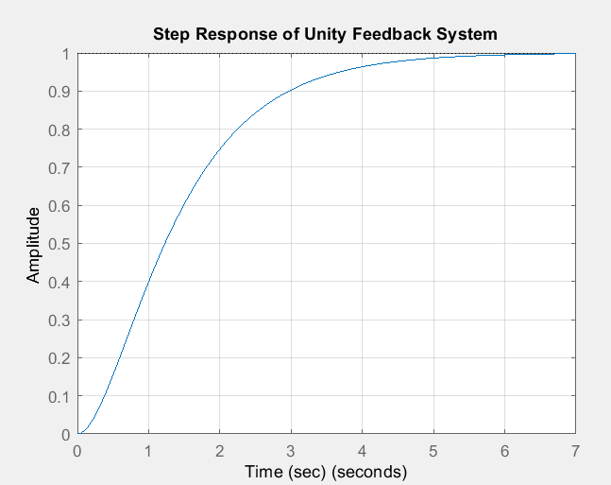
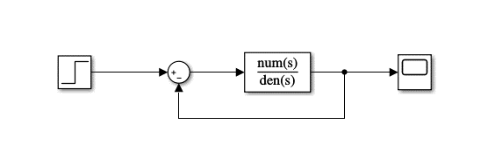

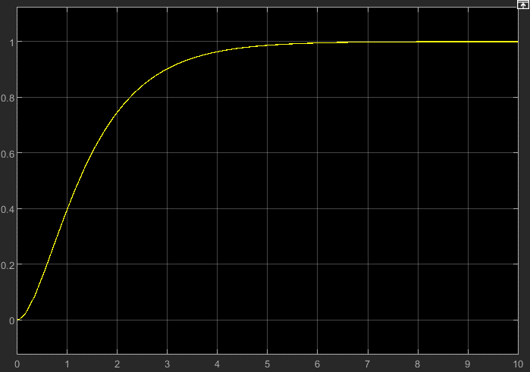

Question 2:
Code:
clc;
clear;
close all;

%% Define the system
num = 9;
den = conv([1 0], [1 2]); % s(s+2) = s^2 + 2s

G = tf(num, den);

% Closed-loop system with unity feedback
sys = feedback(G, 1);

%% Plot Step Response
figure;
step(sys);
title('Step Response');
xlabel('Time (sec)');
ylabel('Amplitude');
grid on;

%% Step Response Characteristics
info = stepinfo(sys);

fprintf('Rise Time (Tr): %.4f sec\n', info.RiseTime);
fprintf('Settling Time (Ts): %.4f sec\n', info.SettlingTime);
fprintf('Peak Time (Tp): %.4f sec\n', info.PeakTime);
fprintf('Overshoot (OS): %.2f%%\n', info.Overshoot);

%% Poles, damping ratio and natural frequency
poles = pole(sys);
disp('Poles:');
disp(poles);

wn = abs(poles(1)); % natural frequency
zeta = -real(poles(1))/wn; % damping ratio

fprintf('Natural Frequency (wn): %.4f rad/s\n', wn);
fprintf('Damping Ratio (zeta): %.4f\n', zeta);

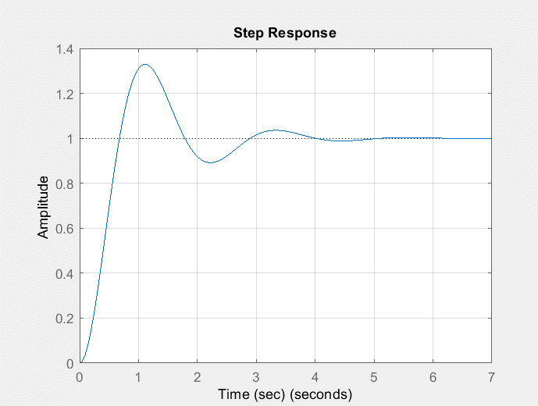
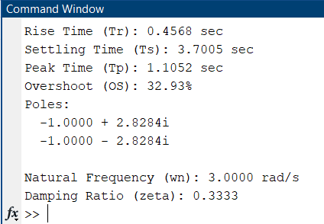

Question 3:
clc;
clear;

% Given uncompensated settling time
Ts_uncomp = 0.9434;

% Required compensated settling time
Ts_comp = 1.05 * Ts_uncomp;
fprintf('Target compensated settling time: %.4f sec\n', Ts_comp);

% PI controller design (trial values)
Kp = 0.01;
Ki = 0.1;
fprintf('Designed PI controller gains: Kp = %.4f, Ki = %.4f\n', Kp, Ki);
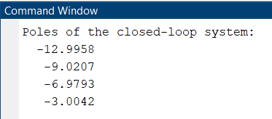

Question 4:
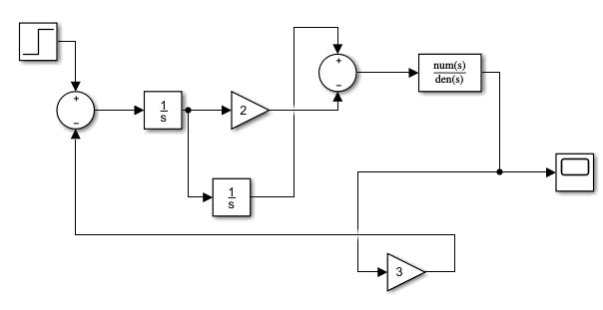
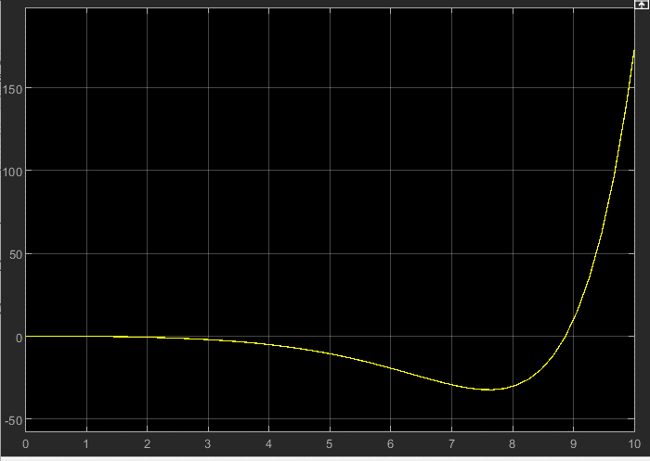
Question 5:
clc;
clear;
close all;

%% Task 1: Root Locus Plot
disp('--- Root Locus ---');
num = 1;
den = conv(conv([1 2],[1 10]),[1 15]);
G = tf(num, den);
figure;
rlocus(G);
title('Root Locus of G(s)');
grid on;

%% Task 2: Desired Pole and Gain Calculation
disp('--- Desired Pole & Gain ---');
OS_percent = 7;
OS = OS_percent/100;
Ts = 0.9434;

zeta = -log(OS) / sqrt(pi^2 + (log(OS))^2);
wn = 4 / (zeta * Ts);
sigma = zeta * wn;
wd = wn * sqrt(1 - zeta^2);
desired_pole = -sigma + 1j*wd;

fprintf('Damping ratio: %.4f\n', zeta);
fprintf('Natural frequency: %.4f rad/s\n', wn);
fprintf('Desired dominant pole: %.4f %+ .4fj\n', real(desired_pole), imag(desired_pole));

G_at_s = evalfr(G, desired_pole);
K = abs(-1 / G_at_s);
fprintf('Calculated gain K: %.4f\n', K);

%% Task 3: PI Controller Design
disp('--- PI Controller Design ---');
Ts_uncomp = 0.9434;
Ts_comp = 1.05 * Ts_uncomp;
fprintf('Target compensated settling time: %.4f sec\n', Ts_comp);

Kp = 0.01;
Ki = 0.1;
fprintf('Designed PI controller gains: Kp = %.4f, Ki = %.4f\n', Kp, Ki);

%% Task 4: Step Response for both systems
disp('--- Step Responses ---');
G_open = K * G;
sys_uncomp = feedback(G_open, 1);
figure;
step(sys_uncomp);
title('Uncompensated System Step Response');
grid on;

Gc = tf([Kp Ki], [1 0]);
G_comp_open = series(Gc, G_open);
sys_comp = feedback(G_comp_open, 1);
figure;
step(sys_comp);
title('Compensated System Step Response');
grid on;

figure;
step(sys_uncomp, sys_comp);
title('Comparison: Uncompensated vs Compensated');
legend('Uncompensated','Compensated');
grid on;

1.
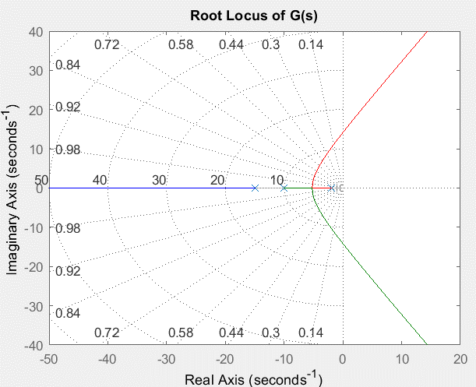
2.

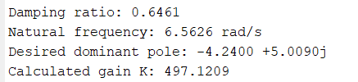

3.
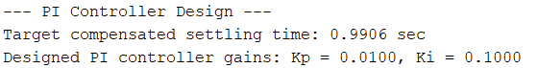

4.
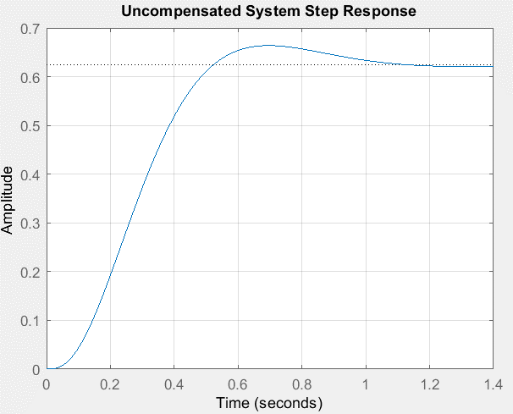

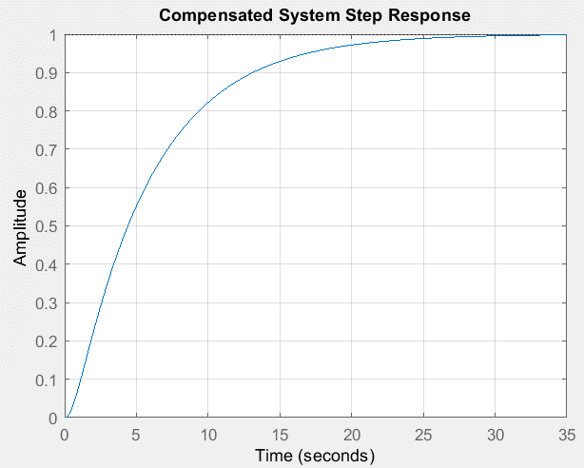

5.
- Compensated System:
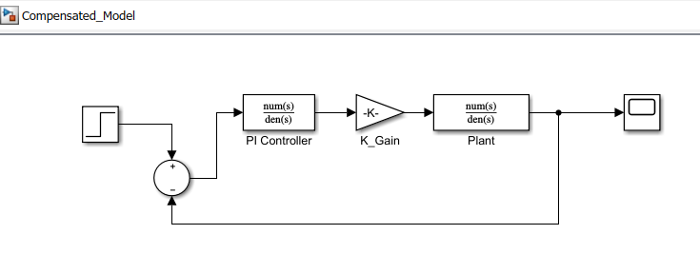
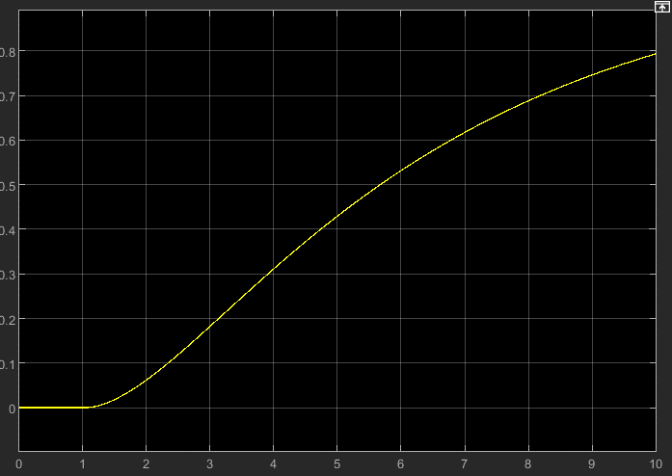

- Uncompensated System:

