**Part 1:**

a.

* Sound1

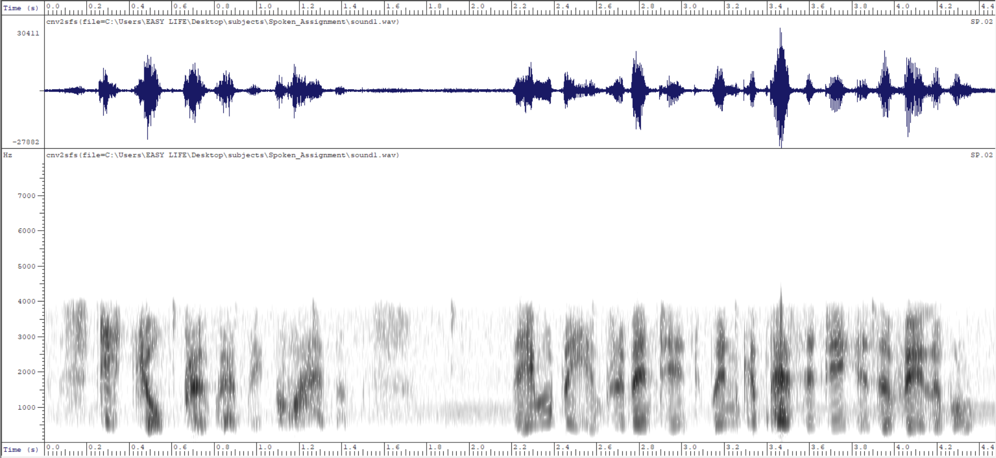

As shown in the figure, the frequency range for the sound1 displayed in the spectrogram would be roughly from 0 Hz to 4000 Hz.

* Sound2

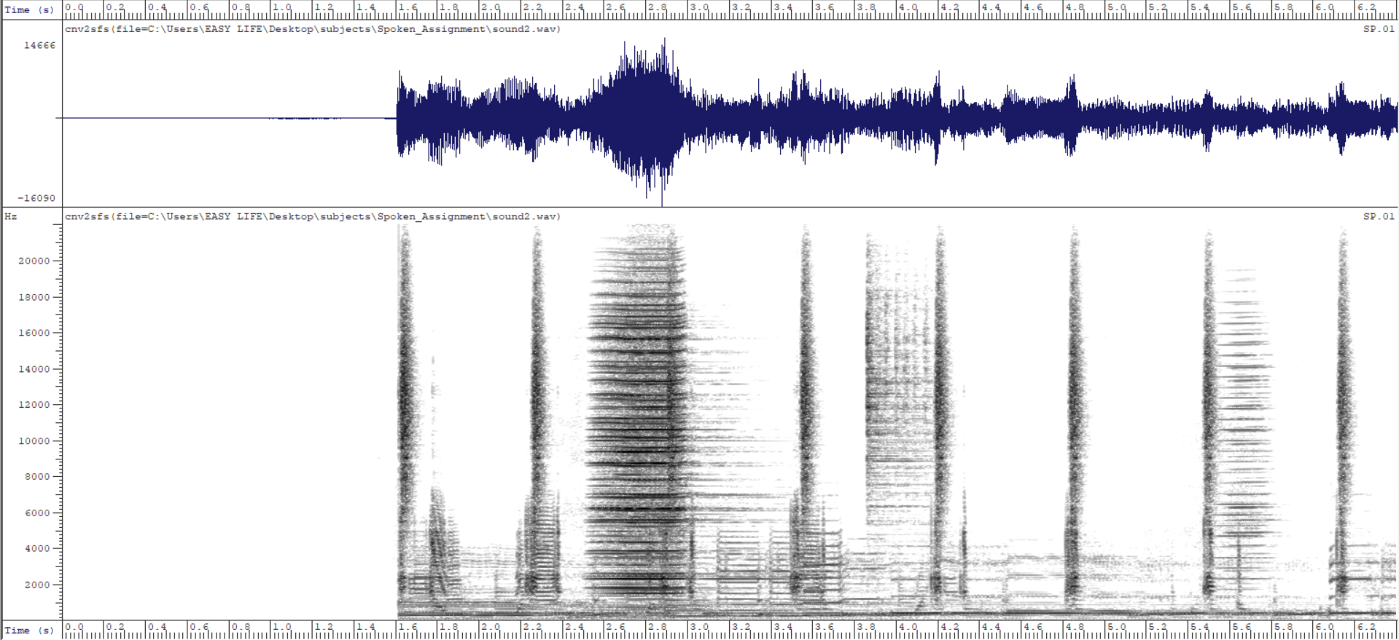

As for sound2, the estimated frequency range for the sound in this spectrogram is approximately from 0 Hz to 2500 Hz.

b.

* Sound3

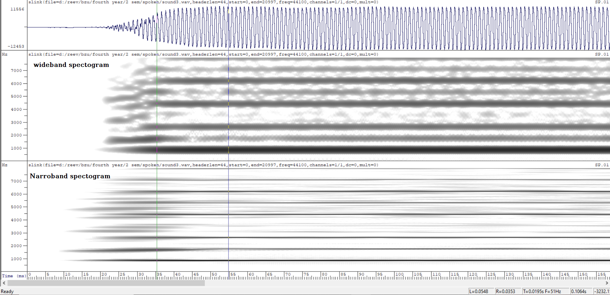

Wide-band Spectrogram: Because of its broad, blended frequency bands, it has poorer frequency resolution and is best suited for studying quick temporal changes rather than specific frequency content.

Narrow-band Spectrogram: High frequency resolution with clear, identifiable harmonic lines is ideal for extensive inspection of frequency components and harmonic analysis.

* Sound4

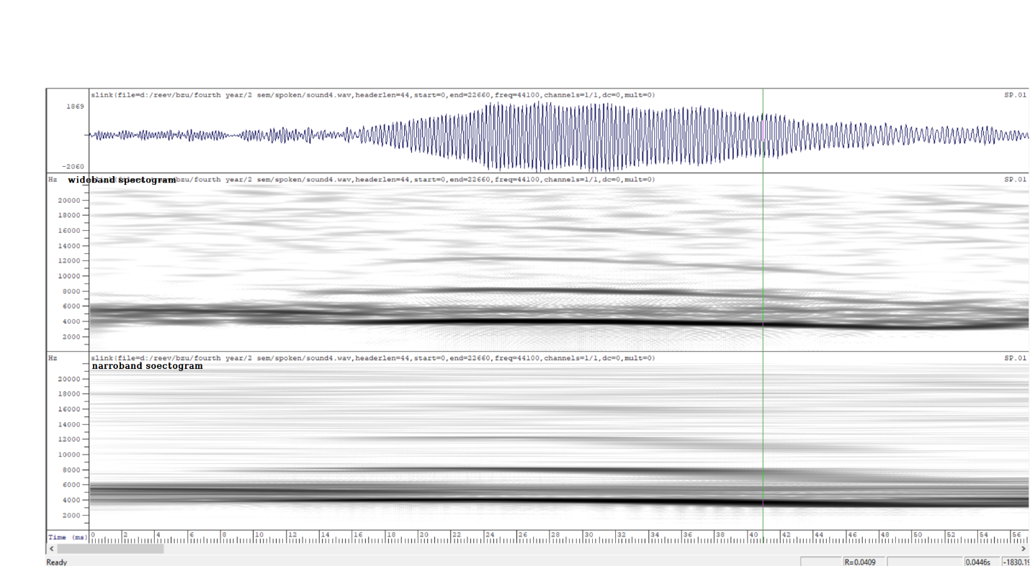

Wide-band Spectrogram: Similarly demonstrates reduced frequency resolution with a focus on temporal dynamics, which is good for capturing fast changes in sound.

Narrow-band Spectrogram: High frequency resolution with well-defined harmonic structures, perfect for detailed frequency analysis and complex sound tests.

* In the two pictures, narrow-band spectrograms provide comprehensive frequency insights, whereas wide-band counterparts excel at following fast temporal occurrences.

c. 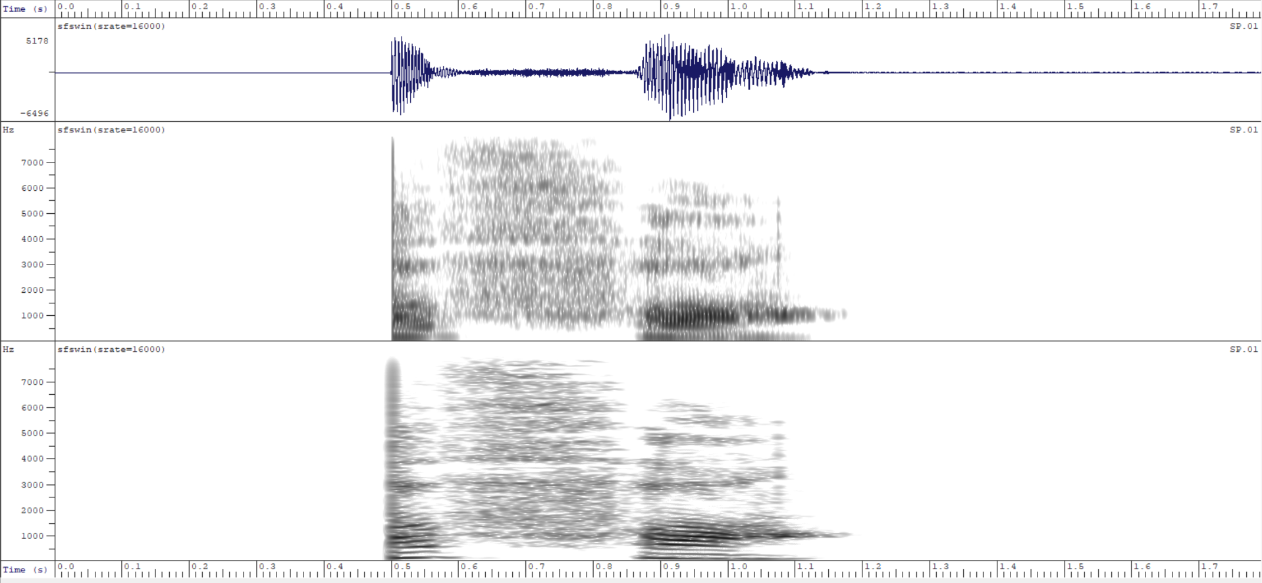

1. **Waveform**

* Voiced Parts: Display a consistent, periodic rhythm that suggests a constant shaking of the vocal cords.
* Unvoiced Parts: Show an erratic, lower-amplitude pattern that reflects the absence of vocal cord vibration.

1. **Narrow-band Spectrogram**

* Voiced Parts: Exhibit a distinct tonal structure with clearly defined harmonic lines.
* Unvoiced Parts: Show a broader, more dispersed appearance that is characteristic of noise-like sounds, with energy dispersed across a wider frequency range.

**Part4:**

|  |  |  |
| --- | --- | --- |
| **Phoneme** | **Start Time** | **End Time** |
| **/k/** | 0 | 35 |
| **/ə/** | 35 | 72 |
| **/p/** | 72 | 136 |
| **/æ/** | 136 | 215 |
| **/s/** | 215 | 295 |
| **/ɪ/** | 295 | 329 |
| **/t/** | 329 | 410 |
| **/i/** | 410 | 510 |

**Part 6:**

In creating a new word from the phonemes extracted from "capacity" to form "cats" (K AE T S) which is contained in file “cats.wav”, the resulting speech quality may have a few comments and potential areas for improvement as the following:

1. **Quality:**

* Transitions: The spliced phonemes may have sharp transitions, which disrupt the fluidity of speech.
* Intonation: The rhythm and pitch may not be consistent with a natural pronunciation of "cats", making it sound unnatural.

1. **Improvements:**

* Smoothing: Use cross-fading techniques at phoneme boundaries to make the sounds mix more naturally.
* Adjusting Pitch and Duration: Use audio editing software to adjust the pitch and duration of phonemes to better resemble the natural qualities of the word "cats".
* Noise Reduction: Apply noise reduction algorithms to remove any background noise or artifacts.

**Part7:**

After applying this part to achieve the “Generation of vowel sounds using the source-filter model”, We obtained the expected results for each of the required vowels. It was also described and attached sequentially to each of the audio files. The “low” files, which depicts the sound after it has been passed through a band bass filter, has its own frequencies, with 200 subtracted from either side. As for the “high” files, reflects an addition of 200. And the las, the “output” represents the results of the combined signal.

-all files (.wav)