Query 1 – Top 5 Customers by Deposit Value
-- Business Question:
-- Which customers have the highest total deposited amount
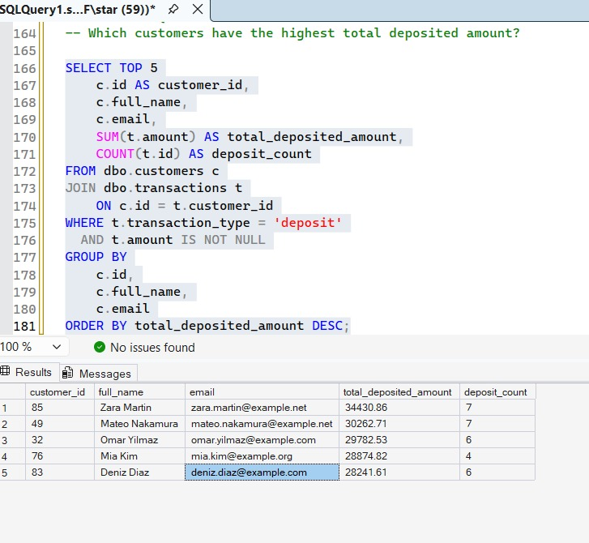

Business Query 2: Monthly Deposit vs Withdrawal Flow
-- Business Question:
-- How do monthly deposits and withdrawals affect net liquidity?
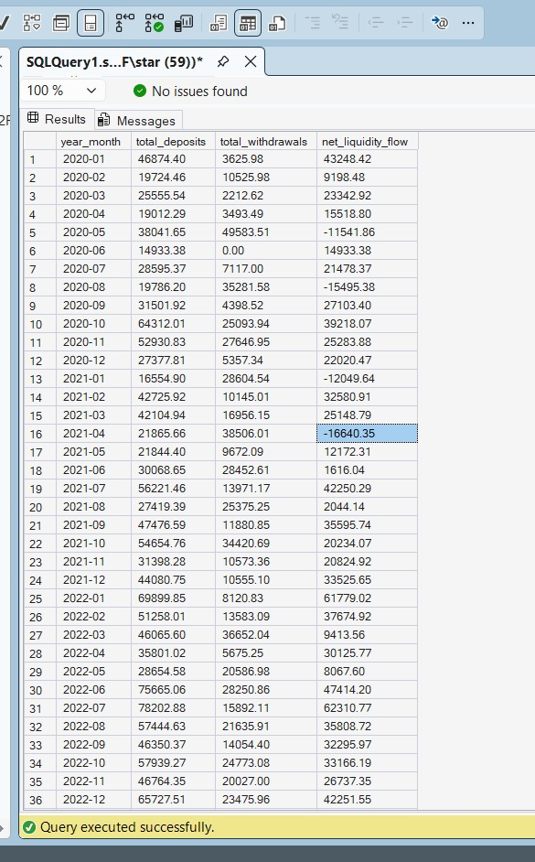

Business Query 3: Bill Payment Analysis
-- Business Question:
-- Which bill categories generate the highest payment value?
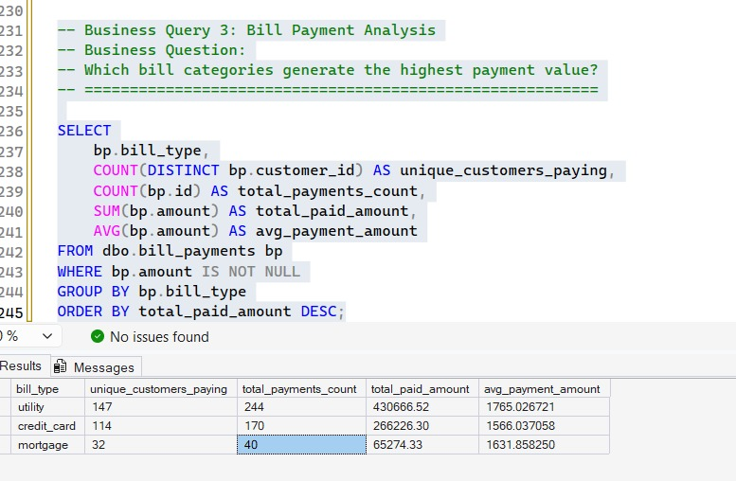

Business Query 4: Customer Support Performance
-- Business Question:
-- Which support issues are most common and how effectively
-- are they being resolved?


Business Query 5: Customer Financial Activity
-- Business Question:
-- Which customers have the highest combined deposit
-- and investment activity?



