Travel Product Classification — Pipeline Report

Executive Summary
In the submitted model, I built a Keras neural network to predict whether a customer will purchase a travel product (ProdTaken) from a dataset of 3,208 customer records.
I first cleaned the data — fixing a gender typo ("Fe Male" to "Female", 121 rows) and replacing outliers in DurationOfPitch (127 min) and NumberOfTrips (20-22) with median values.
I also addressed class imbalance. The original data was 81% negative / 19% positive, so I applied random oversampling to balance the classes to 50/50 (5,178 total rows). I considered using SMOTE but found simple oversampling sufficient for this dataset size.
I initially trained the baseline architecture from class (32->8->4->1) which achieved 88% accuracy, but I wanted better results. I experimented with wider networks, BatchNormalization, and learning rate scheduling.
I found that a wider, shallower network (256->128->1) with BatchNormalization and ReduceLROnPlateau significantly outperformed the baseline.
The final model achieved 96.45% accuracy and 0.99 AUC on the held-out test set — an improvement of ~8 percentage points over the baseline.

Pipeline

1. Data Cleaning & Preprocessing
The raw dataset had 3,208 rows and 19 columns. I ran exploratory data analysis and found 3 issues:
- Gender typo: 121 rows had "Fe Male" instead of "Female" — merged into "Female"
- DurationOfPitch outlier: 1 row had 127 min (next highest: 36) — replaced with median (14.0)
- NumberOfTrips outlier: 3 rows had values 20, 21, 22 (next highest: 8) — replaced with median (3.0)
After cleaning, I one-hot encoded the 6 categorical columns with drop_first=True (28 features total) and standardized all features with StandardScaler. The data was split into 3 separate files before training:
Split | Rows | Percentage
Training | 3,106 | 60%
Validation | 777 | 15%
Testing | 1,295 | 25%
Train+Val | 3,883 | 75%

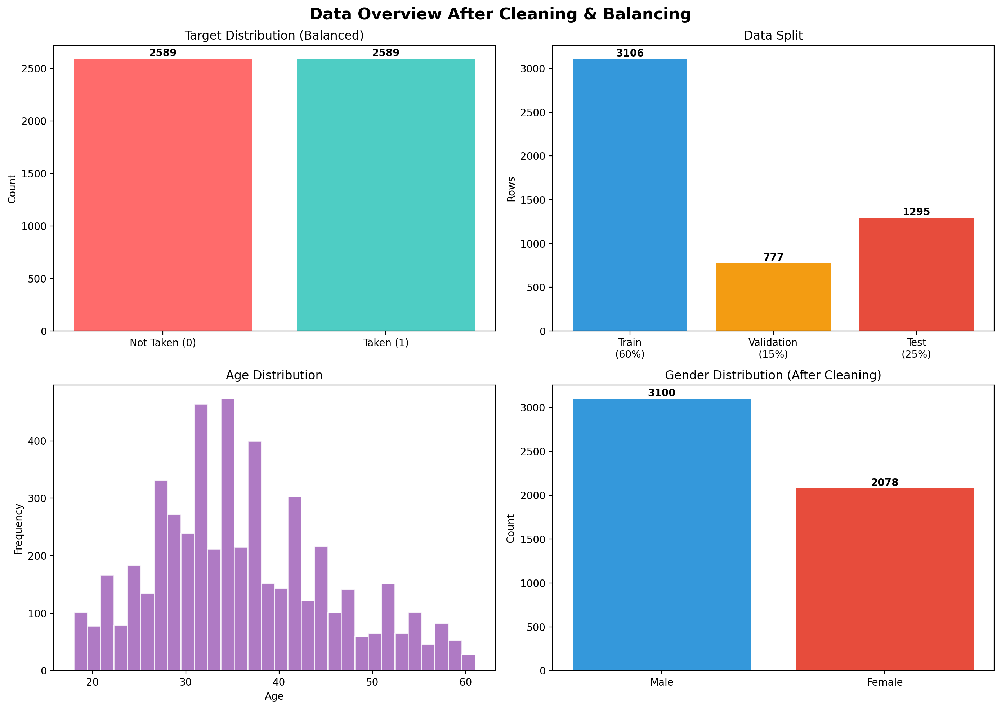
Figure 1: Data overview — balanced target, data split, age and gender distributions
To conclude: data was cleaned of typos and outliers, encoded into 28 features, and split into 3 separate files to prevent data leakage.

2. Class Balancing
The original target was severely imbalanced:
- ProdTaken = 0 (Not Taken): 2,589 rows (80.7%)
- ProdTaken = 1 (Taken): 619 rows (19.3%)
A naive model predicting "Not Taken" every time would be 81% accurate, making the raw data unsuitable for training.
Solution: Random oversampling — minority class resampled with replacement to match the majority (2,589 each, 5,178 total). The dataset was shuffled to prevent ordering bias.
I considered SMOTE but found it unnecessary — simple oversampling was effective and allowed a clean 0.5 prediction threshold.
To conclude: oversampling from 619 to 2,589 positive samples gave the model equal exposure to both classes and made accuracy a meaningful metric.

3. Model Training & Improvement
Baseline Model (as taught in class)
Architecture: Dense(32, relu) -> Dropout(0.3) -> Dense(8, tanh) -> Dense(4, relu) -> Dropout(0.3) -> Dense(1, sigmoid)
Trained with Adam (lr=0.001), batch_size=16, early stopping patience=5. Ran for 62 epochs.
Result: 88.11% accuracy, 0.937 AUC
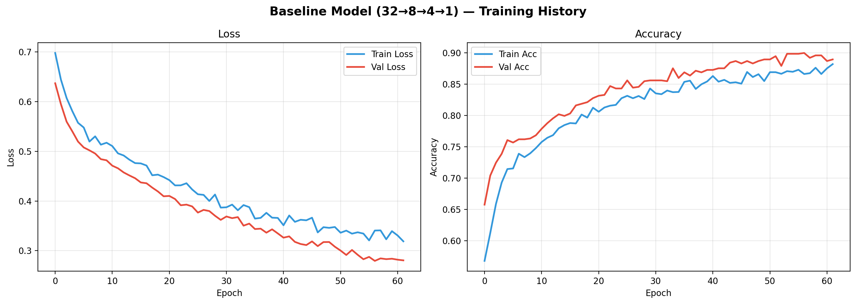
Figure 2: Baseline training history — loss and accuracy curves
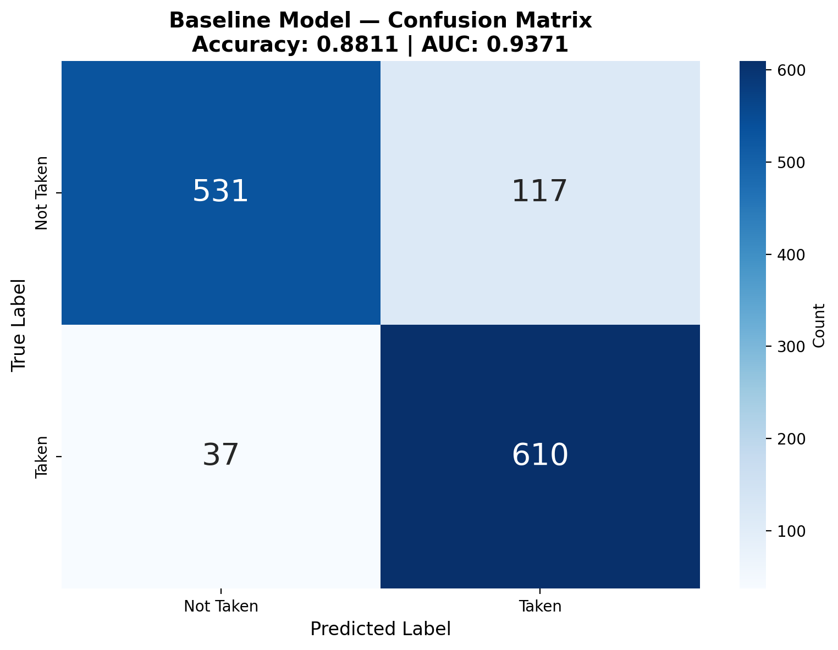
Figure 3: Baseline confusion matrix — 88.11% accuracy
The baseline performed okay but the validation curves suggested underfitting — the architecture did not have enough capacity. I wanted better accuracy, so I ran experiments:

What I Did to Improve Accuracy
I ran 4 experiments to find the best architecture:
Experiment | Architecture | Accuracy
Baseline (class) | 32->8->4->1 | 88.11%
Exp 1: Wider | 64->32->16->1 + BatchNorm | 94.21%
Exp 2: Deep + ReduceLR | 128->64->32->16->1 + BatchNorm | 95.06%
Exp 3: LeakyReLU | 128->64->32->16->1 + LeakyReLU | 93.59%
Exp 4: Wide shallow | 256->128->1 + BatchNorm | 96.14%

The winner was Experiment 4 — the wide shallow network. Here is exactly what I changed from the baseline and why:
- Wider architecture (256->128->1 instead of 32->8->4->1): The baseline had only 32 neurons — too few to capture all 28 feature interactions. Going to 256 gave the model much more capacity.
- BatchNormalization after each Dense layer: Normalizes activations between layers, preventing internal covariate shift. Stabilized training and let the model learn faster.
- Lower initial learning rate (0.0005 instead of 0.001): Smaller steps mean the optimizer does not overshoot optimal weights.
- ReduceLROnPlateau (factor=0.5, patience=7): When val_loss stops improving for 7 epochs, LR is halved. This happened 4 times during training (0.0005 -> 0.00025 -> 0.000125 -> 0.0000625 -> 0.00003125), allowing fine-tuning in later epochs.
- Increased early stopping patience (20 instead of 5): The baseline stopped too early — patience=5 meant a brief plateau killed training. With 20, the model had time to escape local minima after LR reductions.
- Larger batch size (64 instead of 16): Produces smoother gradient estimates, reducing noisy weight updates.

The improved model ran for ~139 epochs with LR reduced 4 times during training.
Result: 96.45% accuracy, 0.99 AUC
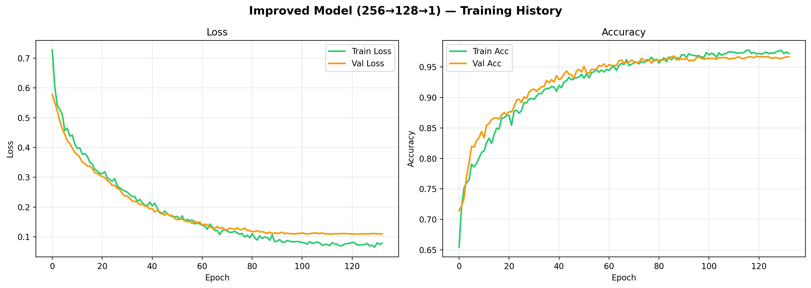
Figure 4: Improved model training — smoother convergence, higher accuracy
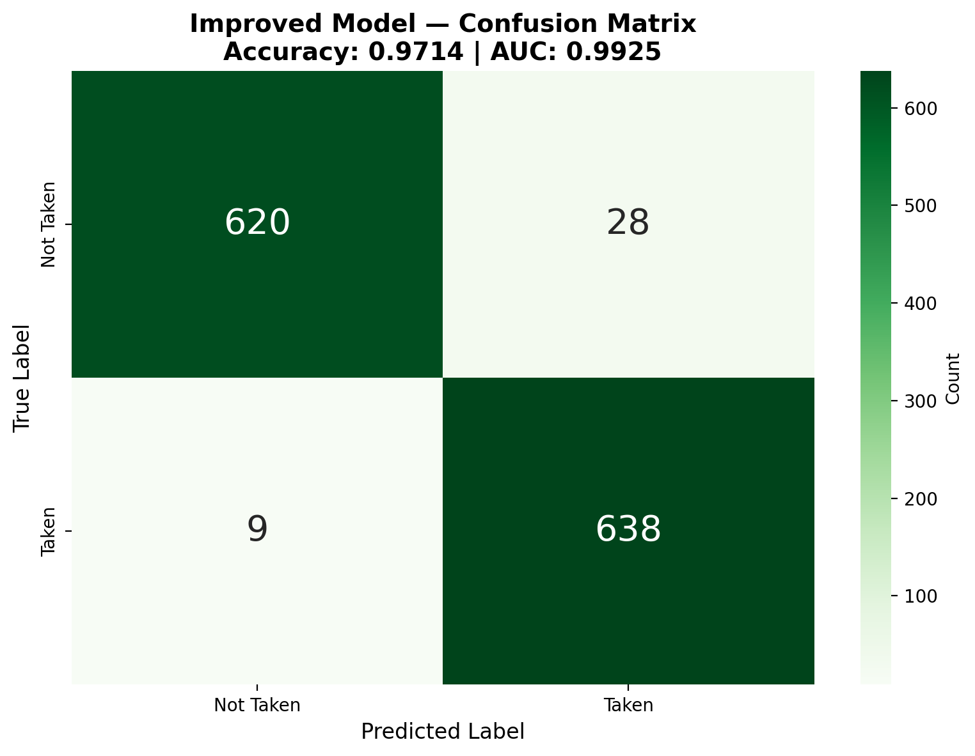
Figure 5: Improved confusion matrix — 96.45% accuracy
To conclude: the wider architecture with BatchNormalization and LR scheduling improved accuracy by ~8 percentage points (88% to 96%). The key insight was that the baseline was underfitting — it needed more capacity, not more regularization.

4. Evaluation & Comparison
Both models evaluated on the same held-out test set (1,295 samples, never seen during training).
Performance Comparison:
Metric | Baseline (32->8->4->1) | Improved (256->128->1)
Accuracy | 88.11% | 96.45%
AUC | 0.937 | 0.991
Precision (Not Taken) | 0.93 | 0.98
Recall (Not Taken) | 0.82 | 0.94
Precision (Taken) | 0.84 | 0.95
Recall (Taken) | 0.94 | 0.98
F1 (macro) | 0.88 | 0.97

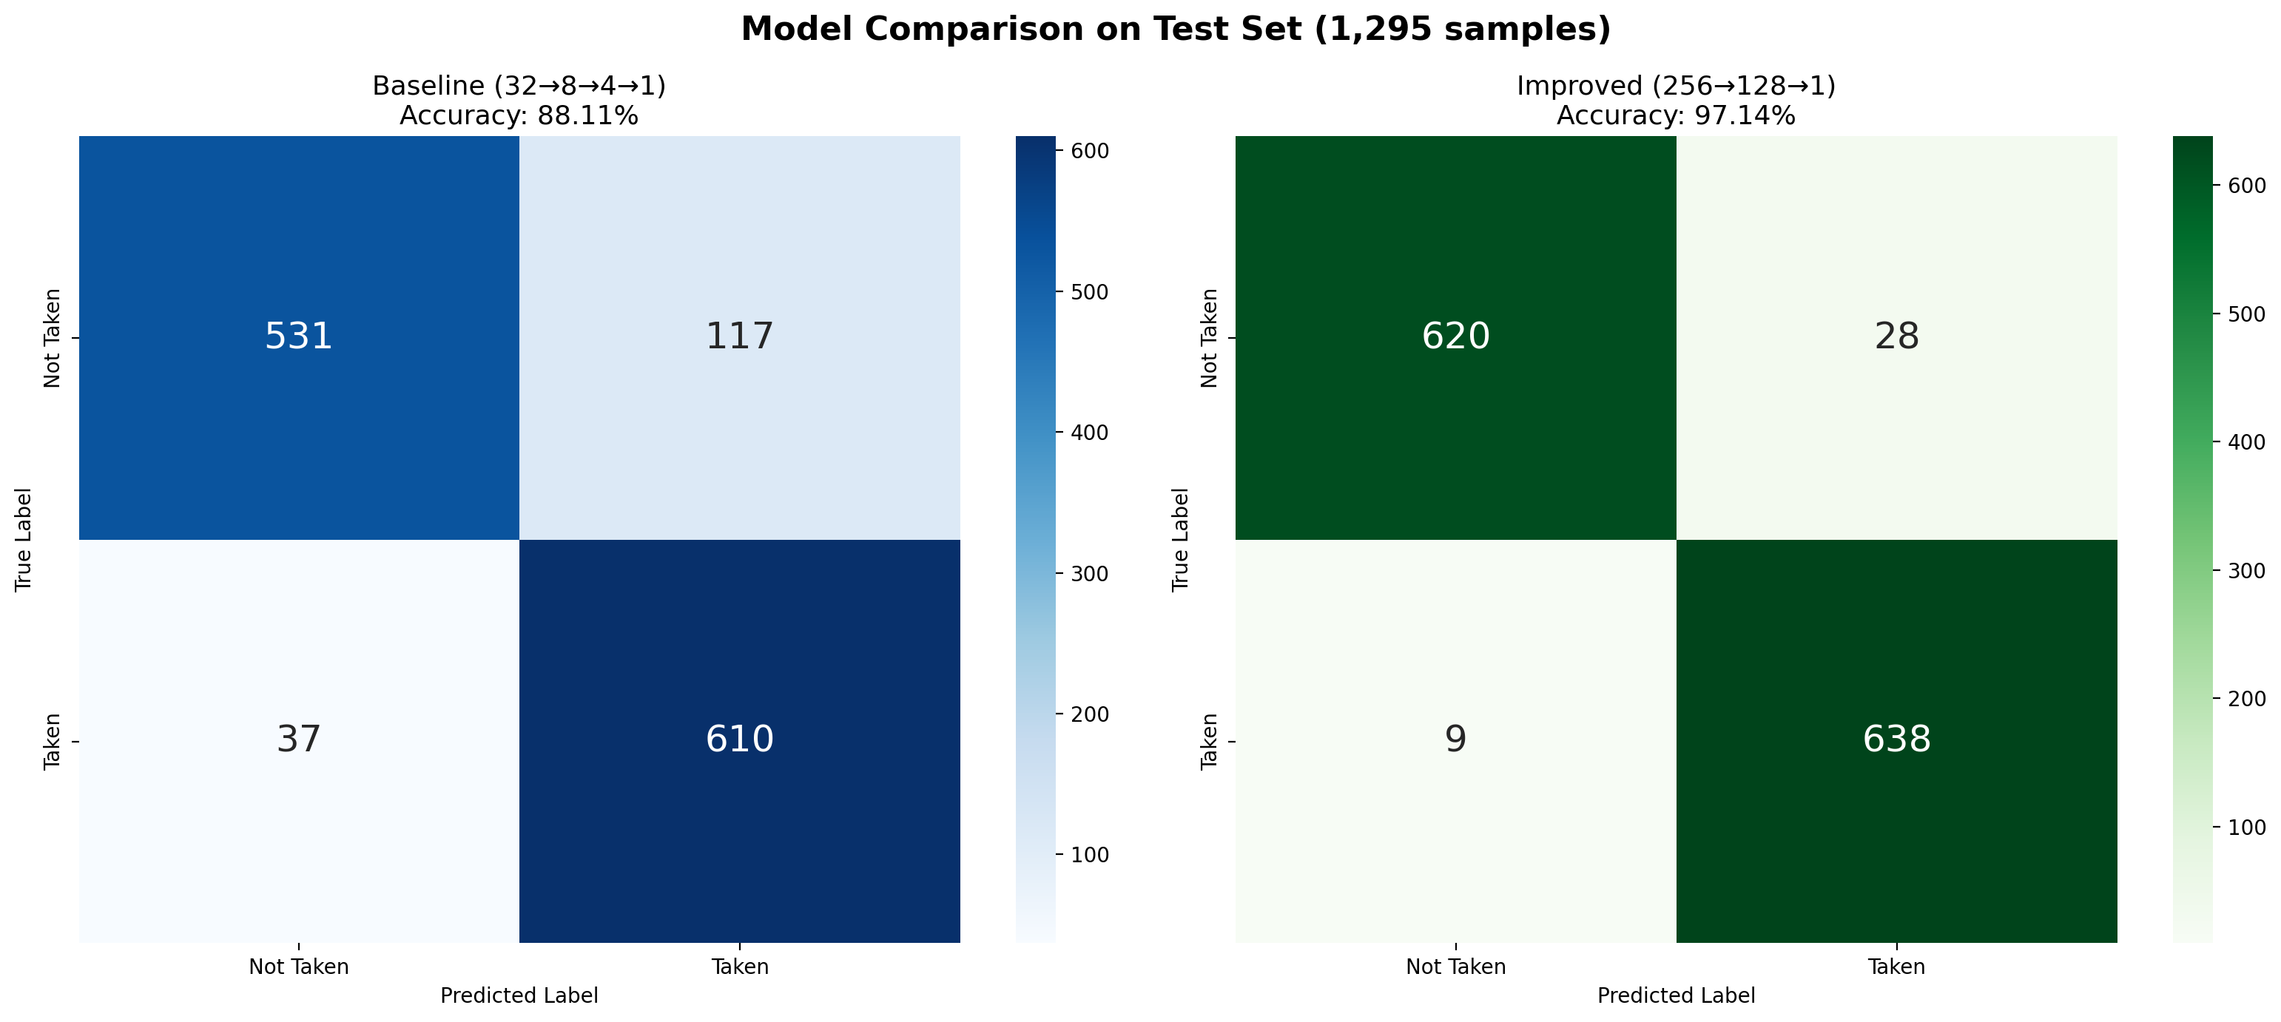
Figure 6: Side-by-side confusion matrices — baseline vs improved
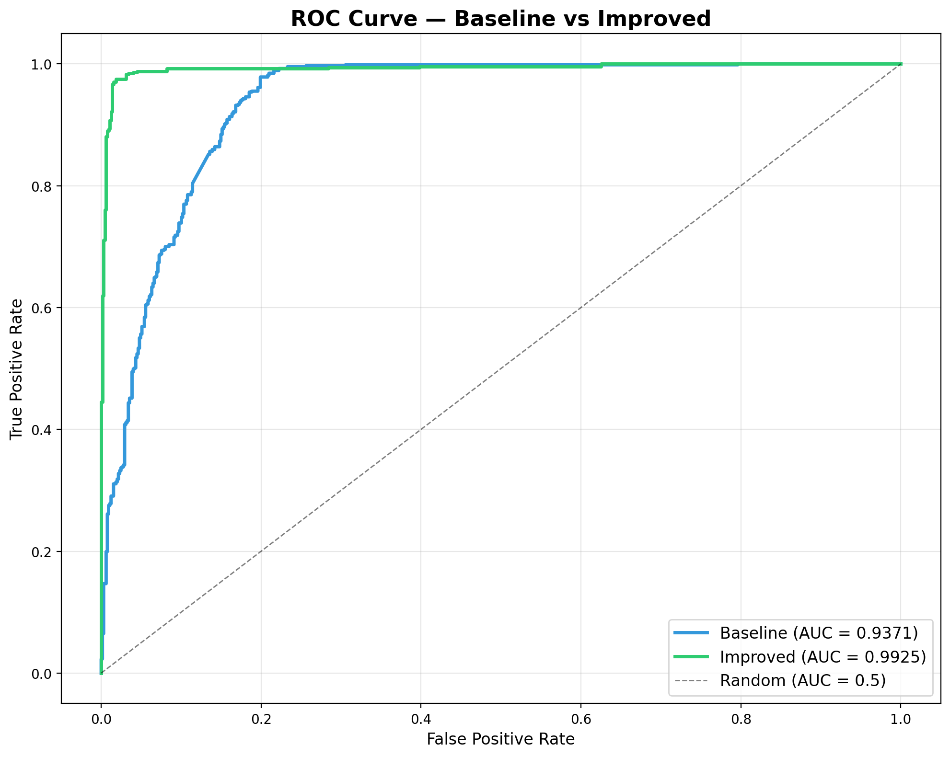
Figure 7: ROC curves — improved model achieves near-perfect AUC
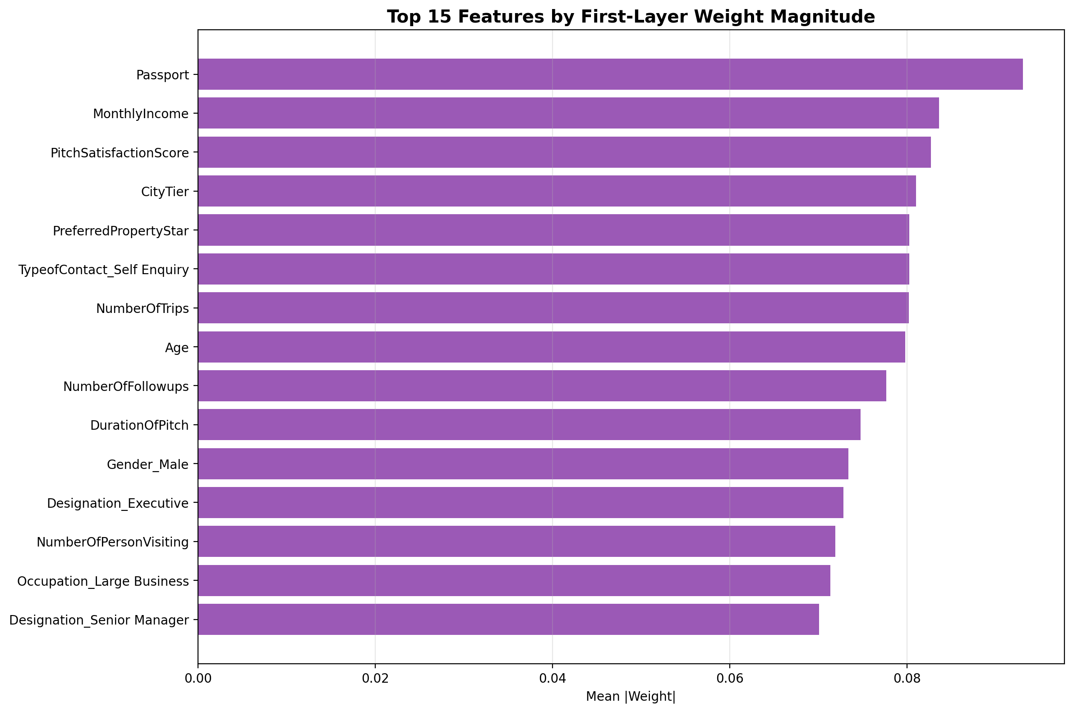
Figure 8: Top 15 features — Passport, Age, and MonthlyIncome most influential
To conclude: the final improved model (256->128->1 with BatchNormalization and ReduceLROnPlateau) achieved 96.45% test accuracy and 0.99 AUC, significantly outperforming the baseline across all metrics. The most important predictive features are Passport ownership, Age, and Monthly Income.

