 Translated from Arabic to English - www.onlinedoctranslator.com

Syrian Arab Republic
Ministry of Higher Education and
Scientific Research
Syrian Private University
Faculty of Engineering
Department of Communications
and Networks Engineering
Syrian Arab Republic
Ministry of Higher Education and Scientific Research
Syrian Private University
College of Engineering
Department of EngineeringAContactAT and networks

Facial recognition and multiple authentication attendance system

numbers:
Aya Alkurdi

supervision:
Dr. Khassan Ahmad
Engineer Mohamed Osman

Supervisor's Approval
I certify that the preparation of this project entitled
Attendance system with identity recognition and multiple authentication
Prepared by the student:
Mohammed Mazhar Al-Shouli
Under my supervision in the Department of Software Engineering and Information Systems at the Faculty of Information Engineering, and it is part of the requirements for obtaining a degree in Software Engineering and Information Systems.

Academic Rank:..........................

the name:.............................

the signature:.......................

the date:.............................

Table of Contents
Summary 5
Chapter One 8
the introduction 8
the introduction 9
Project Problem 1 10
Project importance2. 10
Project objectives 10
Chapter Two: 11
Reference study and basic concepts 11
introduction 12
• Deep neural networks (CNN) 13
Summary 16
Chapter Three: 17
Analytical study of the proposed system 17
introduction 18
Description of the proposed system 18
System objectives 19
System scope(System Scope) 19
Parties interacting with the system(Actors) 20
Job requirements(Functional Requirements) 21
Non-functional requirements(Non-Functional Requirements) 21
Usage scenarios(Use Case Scenarios) 22
) hardware) components of the proposed system 23
Figure 1 Camera 24
Figure 2 Rasperre py 24
Figure 3 HDMI to Micro 24
Figure 4 adapter 24
Figure 5 detailed hardware data sheet 25
Chapter Four 42
Project Structure and Design 42
introduction 43
1. System Architecture 43
2. Input layer(Input Layer) 44
3. Processing Layer 44
4. Authentication Layer 45
5. Decision-making layer (Decision Layer 45
6. Output layer ((Output Layer) 46
7. Data flow design (Data Flow Design 46
8. User interface design (User Interface Design 47
9. Advantages of the proposed design 47
Chapter Summary 47
Chapter Five 48
Practical implementation and testing structure 48
1. Chapter Introduction 49
2. The practical implementation environment (Implementation Environment) 49
3. System Implementation Architecture 50
4.2 Facial Recognition Phase 51
4.3 PIN Code Verification Phase 51
4.4 Decision-making phase 51
4.5 Output Control 51
5. System Testing Methodology 52
6. Test Cases 52
6.2 Facial Recognition Failure Test Case 52
7. Performance Testing 53
8. Accuracy Testing 53
9. Security Testing 53
10. Test results 53

Summary
يقدم مشروعنا تصميم وتنفيذ نظام الي عالي الأمان لتسجيل الحضور والتحكم بالوصول يعتمد على المصادقة متعددة العوامل (MFA)يدمج النظام التعرف على الوجوه كعامل حيوي بيومتري مع الرقم السري الشخصي (PIN)كعامل معرف لضمان امان قوي وموثوق تم بناء النظام على منصةOpenCV خوارزميةLBPH Raspberry pI
للتعرف على الوجوه في الوقت الفعلي عند التعرف الناجح على الوجه يطلب المستخدم من النظام ادخال رقم سري مكون 4ارقام عبر واجهة مستخدم رسومية تم تطويره باستخدام النهج ثنائي الطبقات الى التخفيف من المخاطر الأمنية الشائعة مثل هجمات الانتحال باستخدام الصور او مقاطع الفيديو تشمل واجهة العتاد وحدة الكاميرا لاقتناء الصور ومخرجات يتم التحكم فيها عبرGPIOلقفل الكتروني ونظام
يمثل المشروع حلا قابلا للتطوير وفعال من حيث التكلفة للتحكم الامن بالوصول في البيئات الحساسة ويظهر التكامل الفعال بين الرؤية الحاسوبية ,الأنظمة المدمجة ,بروتوكولات الأمان متعددة الطبقات.

Our project presents the design and implementation of a high-security automated attendance and access control system utilizing Multi-Factor Authentication (MFA). The system integrates Face Recognition as a biometric factor with a Personal Identification Number (PIN) as a knowledge factor to ensure robust security. The system is built on a Raspberry Pi platform, utilizing the OpenCV library and the LBPH (Local Binary Patterns Histograms) algorithm for real-time facial recognition. Upon successful face identification, the system prompts the user for a 4-digit PIN via a graphical user interface (GUI) developed with Tkinter. This dual-layer approach mitigates common security risks such as spoofing attacks using photos or videos. The hardware interface includes a Raspberry Pi Camera Module for image acquisition and GPIO-controlled outputs for an electronic lock and an alarm system. The project demonstrates a scalable and cost-effective solution for secure access control in sensitive environments, showcasing the effective integration of computer vision, embedded systems, and multi-layered security protocols.

Chapter One

the introduction

the introduction
The world has witnessed significant advancements in artificial intelligence and cybersecurity technologies, and smart access control systems have become among the most important modern applications..
This project relies on facial recognition and multiple authentication to improve security and reduce unauthorized access.
With the rapid development in information technology and artificial intelligence, traditional security systems such as keys and access cards are no longer sufficient to provide a high level of protection, due to the possibility of them being lost, stolen, or misused..
Therefore, researchers and developers have turned to adopting smart systems that rely on biological characteristics.(Biometrics) such as facial recognition and fingerprinting.

This project aims to design and implement an intelligent access control system based on facial recognition with support for multi-factor authentication via code entry.PIN, in order to increase the level of security and reduce the possibility of unauthorized access.

1Project problem
Traditional access control systems suffer from several problems such as
Easy to lose or have keys stolen
Password sharing capability
Low level of security
Inability to genuinely verify user identity

Project importance2.
The importance of the project lies in
Increased security level
Reducing human intervention
Reliance on artificial intelligence technologies
Its suitability for use in sensitive locations such as universities, laboratories, and institutions

Project objectives
Designing a smart and secure entry system
Using facial recognition technology
Applying the concept of multi-factor authentication
Reduce hacking attempts
Create a simple and easy user interface

Chapter Two:

Reference study and basic concepts

introduction
Access control systems are a crucial area of ​​information security, and they have seen significant development in recent years due to advancements in artificial intelligence and computer vision technologies. Many previous studies have relied on the use of biometrics.Biometrics, such as fingerprinting, iris scanning, and facial recognition, are used to improve the accuracy of user identity verification and reduce hacking incidents.
This reference study aims to review the most important previous research and systems that have addressed facial recognition and multi-factor authentication, analyze their strengths and weaknesses, and indicate the position of the proposed system among them.
Traditional access control systems
Traditional access control systems relied on methods such as:
Mechanical keys
• Magnetic cards
• Passwords
Numerous studies have indicated that these systems suffer from significant security problems, such as:
• Keys are easily lost or stolen
• Ability to share passwords
• Weak ability to genuinely verify user identity
Therefore, it has become necessary to move to smarter systems based on living characteristics.
Facial recognition in security systems
Facial recognition is one of the most widely used biometric technologies, due to its ease of application and the fact that it does not require direct user interaction..
Many studies have used different facial recognition techniques, most notably:
• Haar Cascade for Face Discovery
• Eigenfaces
• Fisherfaces
• Local Binary Pattern Histogram (LBPH)

• Deep neural networks (CNN)
Some studies have shown that the algorithmLBPH is characterized by its simplicity and speed of execution, making it suitable for systems with limited resources such as the Raspberry Pi, which is what was adopted in this project.
Multi-factor authentication(Multi-Factor Authentication)
Much recent research has focused on the concept of multi-factor authentication, where these systems rely on more than one method to verify the user's identity, such as:
• Something the user knows (password or PIN)
• Something the user owns (card or phone)
• Something that represents the user (face or fingerprint)
Studies have shown that using more than one authentication factor significantly reduces the chances of a breach compared to using only one.
Integrating facial recognition with multi-factor authentication
Some studies have explored integrating facial recognition with other authentication methods, such as:
• Facial recognition + password
• Facial recognition + OTP code
• Facial recognition + fingerprint

The results showed that this integration achieves a balance between ease of use and a high level of security, especially in sensitive environments such as laboratories and educational institutions..
The system proposed in this project relies on integrating facial recognition with a code.PIN, which enhances security without complicating the user experience
Comparison between previous studies and the proposed systemh--
Standard | Previous studies | Proposed system
type of authentication | One factor often | Multi-factor authentication
facial recognition | Yes | Yes
Pin/otp | always | Yes
Working on specific devices | No, always | Yes
Physical lock control | rare | Yes
User interface | Limited | graphical interface

The proposed system's position within previous studies
A review of previous studies reveals that the proposed system is characterized by the following::
• Effective integration of facial recognition and two-factor authentication
• Applicability on low-cost devices
• Ease of use
• Potential for future expansion
Thus, the system helps to bridge a gap present in some previous systems that focused on only one aspect of the problem.N

Summary
This chapter reviews a range of previous studies and research related to access control systems, facial recognition, and multi-factor authentication. These studies demonstrated the importance of integrating multiple security technologies, which is the approach adopted by the system proposed in this project, making it an effective and practical system.Y

Chapter Three:

Analytical study of the proposed system

introduction
This chapter aims to provide a comprehensive analytical study of the proposed system, by analyzing the problem it addresses, identifying its objectives, analyzing its functional and non-functional requirements, and identifying the parties interacting with the system.(Actors) and different usage scenarios.
This analysis helps in clearly understanding how the system works before moving on to the design and implementation phase.
System problem
Traditional access control systems suffer from numerous security challenges, as they often rely on a single verification method such as a password or card, making them vulnerable to hacking or misuse..
Furthermore, some biometric systems that rely on only one factor, such as facial recognition, may be insufficient if they are circumvented using images or recordings..
Hence the need arose to design a more secure system based on multiple authentication factors, so that access is only allowed after verifying the user's identity using more than one method.

Description of the proposed system
The proposed system is an intelligent access control system based on:
• Facial recognition as a primary authentication factor
• Enter a PIN code as an additional authentication factor
• Control of electronic lock and security alarm
The system works by capturing a photo of the user via the camera, then analyzing the face and comparing it to pre-stored data. If recognition is successful, the user is prompted to enter a code.Enter the PIN; if it is correct, the lock will unlock; otherwise, the alarm will sound.

System objectives
The proposed system aims to achieve the following::
• Enhancing the security level of access control systems
• Reduce the likelihood of unauthorized access
• Reliance on artificial intelligence and biometric technologies
• Implementing the concept of multi-factor authentication
• Providing a reliable and easy-to-use system
• Potential for future expansion and development

System scope(System Scope)
The scope of the proposed system includes the following::
• Registering authorized users
• Storing facial data
• Real-time facial recognition
• PIN code verification
• Electronic lock control
• Activate an alarm in case of failure
• Display a graphical user interface
The system in its current version does not include:
• Recognizing emotions
• Integration with cloud systems
• Authentication using fingerprint or iris

Parties interacting with the system(Actors)
Several parties interact with the proposed system, namely:
1. Authorized user
The person authorized to enter using their face and codePIN.
2. The system
The program responsible for data processing and decision-making.
3. Electronic lock
The device responsible for opening or closing the door.
4. Alarm system
It is used to trigger an alert in case of authentication failure.

Job requirements(Functional Requirements)
The functional requirements of the system can be defined as follows::
• FR1: The system must capture an image of the user via the camera.
• FR2: The system must detect the face in the image.
• FR3: The system must recognize the face and compare it with the stored data.
• FR4: The system must request a PIN code if facial recognition is successful.
• FR5: The system must verify the PIN code.
• FR6: The system should unlock if authentication is successful.
• FR7: The system should trigger an alarm when authentication fails.
• FR8 should specify the number of PIN entry attempts

Non-functional requirements(Non-Functional Requirements)
The system's non-functional requirements include the following::
• Performance: Response speed during facial recognition
• Accuracy: High accuracy in user recognition
• Security: Protecting user data
• Reliability: The system operates stably
• Usability: Easy and simple interface
• Scalability: The ability to add new authentication methods

Usage scenarios(Use Case Scenarios)
3.9.1 Successful Entry Scenario
1. The user stands in front of the camera.
2. His face is recognized
3. A PIN code is required.
4. The code is verified.
5. The lock is opened.
Facial recognition failure scenario
• The PIN entry interface is not displayed
• Entry denied
3.9.3 PIN Entry Failure Scenario
• After a certain number of attempts
• The alarm is activated
• The system is temporarily shut down
Limitations and challenges
The proposed system faces some challenges, such as:
• Facial recognition is affected by lighting
• Camera quality
• Angle of image capture
• Possibility of error in identification
These challenges were taken into account during the design of the system.or

) hardware) components of the proposed system
Hardware components: 1.
camera1.1
Raspirre py.1.2.
adapter.1.3
HDMI to Macro Link 1.4
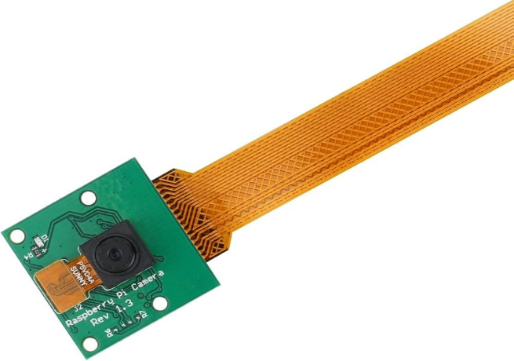
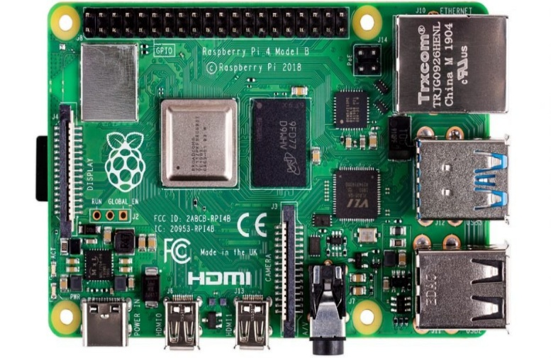

Figure1camera

Figure2 Rasperre py
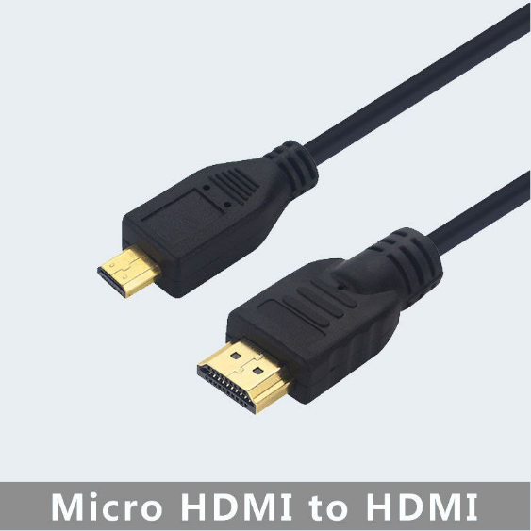
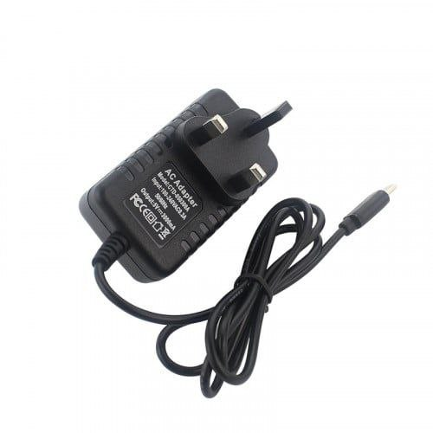

Figure3HDMI to Micro

Figure4 adapter
Detailed Hardware Data Sheets:
Raspberry Pi 4 Model B:
• Processor: Broadcom BCM2711, Quad core Cortex-A72 (ARM v8) 64-bit SoC @ 1.5GHz.
• Memory: 2GB, 4GB or 8GB LPDDR4-3200 SDRAM.
• GPIO: Standard 40 pin GPIO header.
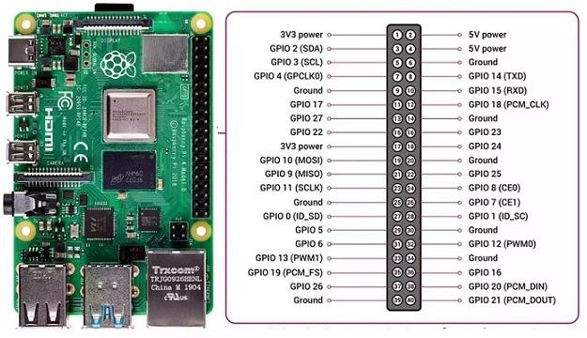

Figure5 detailed hardware data sheet

import time
import cv2
import tkinter as tk
from PIL import Image, ImageTk
from picamera2 import picamera2

#----------------CONFIG----------------
MODEL_PATH = "lbph_model.yml"
LABELS_PATH = "labels.txt"
CASCADE_PATH = "/usr/share/opencv4/haarcascades/haarcascade_frontalface_alt2.xml"

UNKNOWN_THRESHOLD = 65
RECOGNIZE_STREAK = 10

PIN_CODE = "0000"
MAX_TRIES = 3

LOCK_PIN = 17
ALARM_PIN = 27

UNLOCK_SECONDS = 5
ALARM_SECONDS = 10

FOURCH_CONVERSION = "RGBA2BGR"
# ----------------------------------------

try:
from gpiozero import DigitalOutputDevice
lock_out = DigitalOutputDevice(LOCK_PIN, active_high=True, initial_value=False)
alarm_out = DigitalOutputDevice(ALARM_PIN, active_high=True, initial_value=False)
except Exception:
lock_out = None
alarm_out = None

def lock_on():
if lock_out:
lock_out on()

def lock_off():
if lock_out:
lock_out.off()

def alarm_on():
if alarm_out:
alarm_out.on()

def alarm_off():
if alarm_out:
alarm_out.off()

def load_labels(path):
labels = {}
with open(path, "r", encoding="utf-8") as f:
for line in f:
idx, name = line.strip().split(",", 1)
labels[int(idx)] = name
return labels

def to_bgr(frame):
if frame is None:
return None
if len(frame.shape) == 3 and frame.shape[2] == 4:
if FOURCH_CONVERSION == "RGBA2BGR":
return cv2.cvtColor(frame, cv2.COLOR_RGBA2BGR)
return cv2.cvtColor(frame, cv2.COLOR_BGRA2BGR)
if len(frame.shape) == 3 and frame.shape[2] == 3:
return cv2.cvtColor(frame, cv2.COLOR_RGB2BGR)
return frame

DoorApp class:
def __init__(self, root):
self.root = root
self.root.title("Face + PIN Door Access")
self.face_cascade = cv2.CascadeClassifier(CASCADE_PATH)
if self.face_cascade.empty():
raise RuntimeError("Haar cascade not loaded")

self.labels = load_labels(LABELS_PATH)

self.recognizer = cv2.face.LBPHFaceRecognizer_create()
self.recognizer.read(MODEL_PATH)

self.picam2 = Picamera2()
cfg = self.picam2.create_preview_configuration(main={"size": (640, 480)})
self.picam2.configure(cfg)
self.picam2.start()
time.sleep(1)

self.state = "FACE"
self.streak_name = None
self.streak_count = 0
self.tries_left = MAX_TRIES
self.pin_input = ""

self.header = tk.Label(root, text="Welcome", font=("Arial", 22, "bold"))
self.header.pack(pady=10)

self.sub = tk.Label(root, text="Look at the camera", font=("Arial", 14))
self.sub.pack(pady=2)

self.video_label = tk.Label(root)
self.video_label.pack(pady=10)

self.status = tk.Label(root, text="", font=("Arial", 16, "bold"))
self.status.pack(pady=6)

self.pin_frame = tk.Frame(root)

self.pin_title = tk.Label(self.pin_frame, text="Enter 4-digit PIN", font=("Arial", 16, "bold"))
self.pin_title.grid(row=0, column=0, columnspan=3, pady=8)

self.pin_display = tk.Label(self.pin_frame, text="___", font=("Consolas", 24))
self.pin_display.grid(row=1, column=0, columnspan=3, pady=8)

self.try_label = tk.Label(self.pin_frame, text="Tries left: 3", font=("Arial", 12))
self.try_label.grid(row=2, column=0, columnspan=3, pady=4)

buttons = [
(1,3,0),(2,3,1),(3,3,2)
(4,4,0),(5,4,1),(6,4,2)
(7, 5, 0), (8, 5, 1), (9, 5, 2)
("C",6,0),("0",6,1),("OK",6,2)
]

for t,r,c in buttons:
tk.Button(self.pin_frame, text=t, width=6, height=2,
command=lambda x=t: self.on_key(x)).grid(row=r,column=c,padx=6,pady=6)

self.root.protocol("WM_DELETE_WINDOW", self.on_close)
lock_off()
alarm_off()
self.update_frame()

def update_pin_display(self):
masked = "*" * len(self.pin_input) + "_" * (4 - len(self.pin_input))
self.pin_display.config(text=masked)
self.try_label.config(text=f"Tries left: {self.tries_left}")

def on_key(self, key):
if self.state != "PIN":
return
if key == "C":
self.pin_input = ""
self.update_pin_display()
elif key == "OK":
self.check_pin()
elif key.isdigit() and len(self.pin_input) < 4:
self.pin_input += key
self.update_pin_display()
if len(self.pin_input) == 4:
self.check_pin()

def check_pin(self):
if self.pin_input == PIN_CODE:
self.state = "ENTER"
self.header.config(text="Enter")
self.sub.config(text="Door unlocked")
self.status.config(text="ACCESS GRANTED", fg="green")
self.pin_frame.pack_forget()
lock_on()
self.root.after(UNLOCK_SECONDS*1000, self.reset)
else:
self.tries_left -= 1
self.pin_input = ""
self.update_pin_display()
if self.tries_left <= 0:
self.state = "ALARM"
self.header.config(text="Denied")
self.status.config(text="ACCESS DENIED", fg="red")
alarm_on()
self.root.after(ALARM_SECONDS*1000, self.reset)

def reset(self):
lock_off()
alarm_off()
self.state = "FACE"
self.tries_left = MAX_TRIES
self.pin_input = ""
self.pin_frame.pack_forget()
self.header.config(text="Welcome")
self.sub.config(text="Look at the camera")
self.status.config(text="", fg="black")

def update_frame(self):
raw = self.picam2.capture_array()
frame = to_bgr(raw)
if frame is None:
self.root.after(30, self.update_frame)
return

if self.state == "FACE":
gray = cv2.cvtColor(frame, cv2.COLOR_BGR2GRAY)
gray = cv2.equalizeHist(gray)
faces = self.face_cascade.detectMultiScale(gray,1.2,5,minSize=(60,60))
if len(faces):
x,y,w,h = max(faces, key=lambda f:f[2]*f[3])
roi = gray[y:y+h, x:x+w]
roi = cv2.resize(roi,(200,200))
roi = cv2.equalizeHist(roi)
label, dist = self.recognizer.predict(roi)
if dist <= UNKNOWN_THRESHOLD:
name = self.labels[label]
self.streak_count += 1
cv2.rectangle(frame,(x,y),(x+w,y+h),(0,255,0),2)
if self.streak_count >= RECOGNIZE_STREAK:
self.state = "PIN"
self.header.config(text=f"Hello {name}")
self.sub.config(text="Enter PIN")
self.pin_frame.pack(pady=10)
else:
self.streak_count = 0
cv2.rectangle(frame,(x,y),(x+w,y+h),(0,0,255),2)

rgb = cv2.cvtColor(frame, cv2.COLOR_BGR2RGB)
img = Image.fromarray(rgb)
imgtk = ImageTk.PhotoImage(image=img)
self.video_label.imgtk = imgtk
self.video_label.configure(image=imgtk)
self.root.after(30, self.update_frame)

def on_close(self):
self.picam2.stop()
lock_off()
alarm_off()
self.root.destroy()

if __name__ == "__main__":
root = tk.Tk()
DoorApp (root)
root.mainloop()

Chapter Four

Project Structure and Design

introduction
This chapter aims to clarify the general structure of the proposed system and its design mechanism, by presenting the system's architectural structure, explaining the relationships between its software and hardware components, and describing the data flow mechanism within the system..
This design helps in understanding how the system works as a whole before moving on to the practical implementation phase.

1. System Architecture
The proposed system is based on a layered structure.(Layered Architecture), where the system is divided into several layers, each layer having a specific function, which facilitates future development, maintenance and expansion.
The overall structure of the system consists of the following layers:
1. Input layer
2. Curing layer
3. Authentication layer
4. Decision-making layer
5. Output layer

2.Input layer(Input Layer)
The input layer represents the starting point in the system, and includes all the means by which data is entered..
Input layer components:
• Camera: To capture a user image
• PIN input interface: to receive the second authentication code
layer function:
• Capturing raw data
• Sending data to the processing layer

3. Processing Layer
This layer is one of the most important layers of the system, as it is where data is analyzed and processed..
Curing layer components:
• OpenCV Library
• Face detection algorithm
• Facial recognition algorithm (LBPH)
layer function:
• Image processing
• Face detection
• Extracting properties
• Comparing the face with the stored data

4. Authentication Layer
This layer is used to verify the user's identity using more than one authentication factor.
Components of the authentication layer:
• Facial verification unit
• Code verification unitPIN
Layer function:
• Verify the accuracy of facial data
• Verify the code is correctPIN
• Send verification results to the decision-making layer

5Decision-making layerDecision Layer
This layer is responsible for making the final decision on whether to allow or deny entry.
Layer function:
• Merging authentication results
• Determining the success or failure of the login process
• Sending commands to the output layer

6Output layer ((Output Layer)
This layer is used to implement the decision made by the system.
Output layer components:
• Electronic lock
• Alarm system
• Result display interface
Layer function:
• Unlock upon successful authentication
• Alarm activates upon failure
• Display messages to the user

7Data flow design (Data Flow Design
The data flow in the system goes through the following stages:
1. Capture a photo of the user
2. Image processing
3. Facial recognition
4. Request for entryPIN
5. CheckingPIN
6. Decision-making
7. Implementing the decision

8User interface design (User Interface Design
The user interface is designed to be:
• Simple and easy to use
• Clear to the user
• Contains warning and guidance messages

9Advantages of the proposed design
• Flexible and expandable design
• Clear separation between components
• Easy addition of new authentication methods
• Suitable for devices with limited resources

KhChapter 1
This chapter presents the structure and design of the proposed system, illustrating its architectural framework and the interaction mechanisms of its various components. This design serves as the foundation for the following chapter, which deals with system implementation.

Chapter Five

Practical implementation and testing structure

1. Chapter Introduction

This chapter aims to illustrate how the proposed system can be implemented practically, explain the tools and techniques used in the development process, and present the methodology for testing, validating, and verifying the system's efficiency..
This chapter helps to link the theoretical aspect with the practical aspect, and to demonstrate the system's applicability in reality..

2. The practical implementation environment (Implementation Environment)
The proposed system was implemented using a software and hardware environment appropriate to the nature of the system, and includes:
2.1 Hardware Environment
• Digital camera for capturing user photos
• Processing unit (personal computer or Raspberry Pi)
• Electronic lock
• Alarm unit (Buzzer)
2.2 Software Environment
• Operating system: Linux or Windows
• Programming language: Python
• Libraries used:
• OpenCV for image processing
• NumPy for calculations
• Tkinter for building user interface
• Local database for storing user data

3. System Implementation Architecture
The system was implemented according to a standard architecture.(Modular Design), where it is divided into independent units, each unit has a specific function, which facilitates the development, testing and maintenance process.
Main units of the system:
• Image capture unit
• Image processing unit
• Facial recognition unit
• PIN code verification module
• Decision-making unit
• Lock and alarm control unit
4. Steps for the practical implementation of the system
4.1 User Registration
• Capture multiple photos for each user
• Storing images in the database
• Training the facial recognition model

4.2 Facial Recognition Phase
• Capture a real-time image
• Face detection using OpenCV
• Comparing the face with the stored models
• Determining the degree of conformity

4.3 PIN Code Verification Phase
• Displaying the PIN input interface
• Code validation
• Determine the number of attempts allowed

4.4 Decision-making phase
• Successful identification + valid PIN → Entry granted
• One employee failed → refused entry

4.5 Output Control
• Unlocking the electronic lock
• Alarm activates upon failure
• Display a message to the user

5. System Testing Methodology
A testing methodology based on realistic scenario testing was adopted to verify the system's performance in different situations..

6. Test Cases
6.1 Successful Entry Test Status
• Authorized user
• A well-known face
• Valid PIN code
Expected result: The lock will open.

6.2 Facial Recognition Failure Test Case
• Unregistered user
Expected outcome: Refused entry
6.3 Incorrect PIN Test Case
• Correct face
• Incorrect PIN
Expected result: Access denied and alarm triggered after a specified number of attempts.
6.4 Test case: Repeated attempts
• Entering the wrong PIN multiple times
Expected result: System temporarily locked and alarm activated

7. Performance Testing
The system's performance was evaluated in terms of:
• Fast facial recognition
• Total response time
• System stability during operation
The results showed that the system operates with an acceptable response time within the limits of available capabilities..

8. Accuracy Testing
• The tests showed good accuracy in facial recognition.
• Accuracy was affected by lighting factors and camera quality
• Results improved after training the model with a larger number of images

9. Security Testing
• The system was tested against incorrect PIN entry attempts.
• Preventing unauthorized entry
• Reduced chances of breaches compared to single-agent systems

10. Test results
The test results showed the following::
• The system's success in achieving its goals
• Stability during operation
• Clear effectiveness of multi-factor authentication
• Easy system to use
11. Challenges during implementation
Implementing the system faced some challenges, most notably:
• Improved facial recognition accuracy
• Dealing with different lighting conditions
• Adjusting response time

Chapter Six
Future prospects and references

1. Introduction to Future Prospects
Although the proposed system has achieved its primary objectives in access control using facial recognition and multiple authentication, the ongoing development of artificial intelligence and information security technologies opens the door to future improvements and expansions that could increase the system's efficiency, flexibility, and reliability.

2. Development of facial recognition algorithms
Important future prospects include:
Replacing the algorithmLBPH uses algorithms based on deep learning, such as:
•Convolutional Neural Networks (CNN)
•FaceNet
•DeepFace
• Improved recognition accuracy in low-light conditions
• Reducing the error rate in cases of facial similarity
3. Adding new biometric authentication methods
The system can be developed to include:
• Fingerprint
• Iris of the eye
• Voice recognition
This leads to:
• Promoting the concept of multi-factor authentication
• Increased security level
4. Integration with cloud systems (Cloud Integration
It is possible to link the system with cloud servers in the future in order to:
• Centralized storage of user data
• Manage multiple entry points from one location
• Data backup
5. User interface development
• Improved graphic design of the interface
• Support for smartphone applications
• Adding instant notifications for administrators when hacking attempts occur
6. Improved security level
Future improvements include:
• Encryption of facial data and symbolsPIN
• Adding a fraud detection system (Anti-Spoofing)
• Supports 3D facial recognition
7. Expanding the areas of system application
The system can be used in the future for:
• Educational institutions
• Companies and factories
• Sensitive laboratories
• Smart homes
• Airports and government buildings
8. Better support for real-time work
• Improved processing speed
• Reduce response time
• Continuous 24/7 support
9. Summary of future prospects
These future prospects represent real opportunities to develop the proposed system and transform it from a prototype into a fully integrated system suitable for commercial and applied use, while maintaining a high level of security and ease of use..
the reviewer(References)
1.Jain, A. K., Ross, A., & Prabhakar, S. (2004).
An Introduction to Biometric Recognition. IEEE Transactions on Circuits and Systems for Video Technology.
2.Viola, P., & Jones, M. (2001).
Rapid Object Detection using a Boosted Cascade of Simple Features. IEEE Conference on Computer Vision and Pattern Recognition.
3.Ahonen, T., Hadid, A., & Pietikäinen, M. (2006).
Face Description with Local Binary Patterns: Application to Face Recognition. IEEE Transactions on Pattern Analysis and Machine Intelligence.
4.Bishop, CM (2006).
Pattern Recognition and Machine Learning. Springer.
5.OpenCV Documentation.
Face Recognition using OpenCV.
https://docs.opencv.org
6.Stallings, W. (2017).
Cryptography and Network Security: Principles and Practice. Pearson Education.
7.Schneier, B. (2015).
Applied Cryptography. John Wiley & Sons.
8.Daugman, J. (2004).
How Iris Recognition Works. IEEE Transactions on Circuits and Systems for Video Technology.
9.ISO/IEC 24745.
Information technology - Security techniques - Biometric information protection.

