Ayaan Khan – A20505209

CS481 Spring 2026 Programming Assignment #01
Due: Sunday, February 22, 2026, 11:59 PM CST
Points: 200

Instructions:
- Place all your deliverables (as described below) into a single ZIP file named:

LastName_FirstName_CS481_Programming01.zip

- Submit it to Blackboard Assignments section before the due date. No late submissions will be accepted.

Objectives:
- (50 points) Perform basic word frequency distribution analysis for a text corpus.
- (50 points) Calculate probability of a sentence.
- (50 points) Language Model word prediction.

Deliverables:
Your submission should include:

- Make sure your code is sufficiently commented! NO Jupyter Notebook files!
- Part A: Python code file(s). Your py file should be named:

cs481_P01A_AXXXXXXXX.py

where AXXXXXXXX is your IIT A number (this is REQUIRED!). If your solution uses multiple files, makes sure that the main (the one that will be run to solve the problem) is named that way and others include your IIT A number in their names as well.
- Part B: Python code file(s). Your py file should be named:

cs481_P01B_AXXXXXXXX.py

where AXXXXXXXX is your IIT A number (this is REQUIRED!). If your solution uses multiple files, makes sure that the main (the one that will be run to solve the problem) is named that way and others include your IIT A number in their names as well.
- Part C: Python code file(s). Your py file should be named:

cs481_P01C_AXXXXXXXX.py

where AXXXXXXXX is your IIT A number (this is REQUIRED!). If your solution uses multiple files, makes sure that the main (the one that will be run to solve the problem) is named that way and others include your IIT A number in their names as well.

- this document with your results and conclusions. You should rename it to:

LastName_FirstName_cs481_Programming01.doc or pdf
MS WORD or PDF formats only, please.

Part A [50 pts]:
Use Python’s NLTK package along with the corpora:

- Brown,
- Reuters,

to:
- [10 pts] obtain the word frequency distribution (after removing all stop words; use the stopwords corpora for that purpose) for BOTH corpora,
- [10 pts] display a top ten (ranks 1 through 10) words for BOTH corpora on screen (also place them in the table below)

Top 10 words
Brown | Reuters
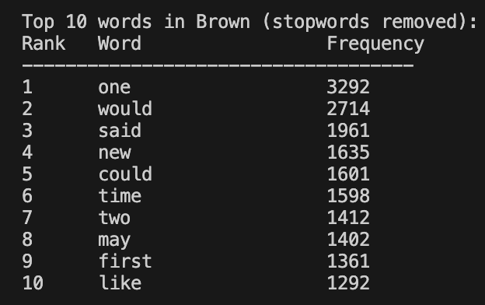 | 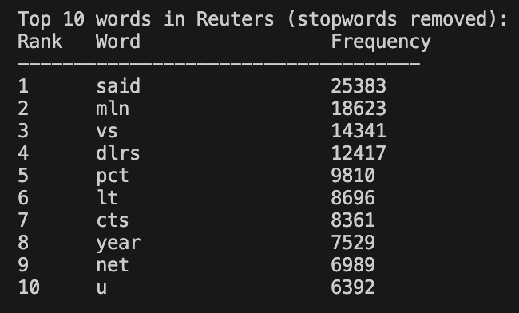

- [15 pts] generate log(rank) vs log(frequency) plots for the first 1000 (ranks 1 through 1000) words for BOTH corpora (you can use the matplotlib package or some other plotting package / tool). Place BOTH plots in the table below.

log(rank) vs log(frequency) plots
Brown | Reuters
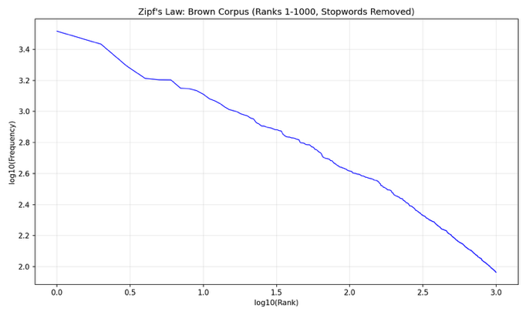 | 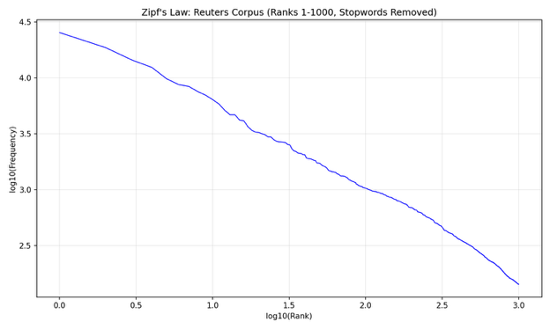
Did you observe anything interesting when comparing all plots? Write your comments below:
Both plots exhibit an approximately linear relationship between log(rank) and log(frequency), which is consistent with Zipf's Law. This law states that the frequency of a word is inversely proportional to its rank, producing a roughly straight line on a log-log plot. The Brown corpus plot shows a smoother, more gradual decline, reflecting its balanced mix of genres (fiction, news, academic, etc.). The Reuters corpus shows a steeper initial drop-off followed by a sharper decline at higher ranks, likely because Reuters is domain specific (financial news) with a smaller set of very high frequency domain terms ("said", "mln", "dlrs", "pct") that dominate the distribution. Both plots show deviation from a perfect straight line at the extremes, the highest-ranked words are slightly above the trend line and the lowest-ranked words curve downward, which is a well known characteristic of natural language distributions.

- [15 pts] use frequency counts obtained earlier to calculate the unigram occurrence probability for the TWO (“technical” and not technical) words. Use lowercasing first! Display all relevant counts and probability on screen for BOTH corpora (also: enter final values in the table below). It can be zero for some words.

“technical” / seldom used in casual conversation word: “equilibrium”
Brown | Reuters
Count: 13  Total words: 509,267  P("equilibrium"): 0.0000255269 | Count: 6  Total words: 871,516  P(“equilibrium”): 0.0000068846
Non- technical / casual / daily-use word: “coffee”
Brown | Reuters
Count: 78  Total words: 509,267  P(“coffee”): 0.0001531613 | Count: 672  Total words: 871,516  P(“coffee”): 0.0007710702

Part B [50 pts]:
Use Python’s NLTK package along with the Brown corpus for the following tasks:

- [1 pts] Ask the user to enter a sentence S from a keyboard.
- [1 pts] Apply lowercasing to S.
- [45 pts] Calculate P(S) assuming a 2-gram language model (assume that probability of any bigram starting or ending a sentence is 0.25)
- [3 pts] Display the sentence S, list all the individual bigrams and their probabilities, and the final probability P(S) on screen. It is fine if it is zero.

Part C [50 pts]:
Use Python’s NLTK package along with the Brown corpus (after removing all stop words; use the stopwords corpora for that purpose) for the following tasks:

- [1 pts] Start by asking the user for initial word/token W1. Apply lowercasing to W1 (and all future entries). If the word is NOT in the corpus offer two options:
  - ask again
  - QUIT
- [45 pts] Assuming a 2-gram language model, a menu with TOP 3 “most likely to follow W1” words (according to the W1, NEXT WORD probability estimate). For example, if the user started with W1 = “good”, the following could be displayed (NOTE: I made up this selection and corresponding probability estimates):

good …

Which word should follow:
- morning P(good morning) = 0.25
- evening P(good evening) = 0.15
- afternoon P(good afternoon) = 0.14
- QUIT

Repeat (and add subsequent word choices to the “sentence”) until user selects (4) and QUITs.

If the user picks a number other than 1,2,3, and 4, assume user choice is (1).

Part D [50 pts]:
Make some more or less sophisticated (expected to improve the model performance) modifications (adding back stopwords, extending the list of stopwords, changing the N from 2 to 3, you name it) to your language model in part C.

Use the perplexity measure to compare both (part C and part D models). Your test set is made of sentences. Show all formula(s) and details.

1) this is good
2) this is bad
3) I am good
4) I am bad
5) good afternoon
6) good day

============================================================
PERPLEXITY COMPARISON: Model C vs Model D
============================================================

Formulas:
MLE (Model C): P(w2|w1) = count(w1, w2) / count(w1)
Laplace (Model D): P(w2|w1) = (count(w1, w2) + 1) / (count(w1) + V)
P(S) = P(w1|<s>) * prod(P(wi|wi-1)) * P(</s>|wn)
PP(S) = P(S) ^ (-1/N), where N = number of words
Sentence boundary bigrams: P = 0.25 (assumed)

============================================================
Sentence: "this is good"
============================================================

--- Model C (Stopwords removed, No smoothing) ---
P(this|<s>) = 0.2500000000
P(is|this) = 0.0000000000
P(S) = 0.000000000000000e+00
Perplexity = INFINITY (zero-probability bigram)

--- Model D (Stopwords kept, Laplace smoothing) ---
P(this|<s>) = 0.2500000000
P(is|this) = 0.0096179299
P(good|is) = 0.0003976538
P(</s>|good) = 0.2500000000
P(S) = 2.390379247220364e-07
Perplexity = 161.1305

============================================================
Sentence: "this is bad"
============================================================

--- Model C (Stopwords removed, No smoothing) ---
P(this|<s>) = 0.2500000000
P(is|this) = 0.0000000000
P(S) = 0.000000000000000e+00
Perplexity = INFINITY (zero-probability bigram)

--- Model D (Stopwords kept, Laplace smoothing) ---
P(this|<s>) = 0.2500000000
P(is|this) = 0.0096179299
P(bad|is) = 0.0000596481
P(</s>|bad) = 0.2500000000
P(S) = 3.585568870830545e-08
Perplexity = 303.2592

============================================================
Sentence: "I am good"
============================================================

--- Model C (Stopwords removed, No smoothing) ---
P(i|<s>) = 0.2500000000
P(am|i) = 0.0000000000
P(S) = 0.000000000000000e+00
Perplexity = INFINITY (zero-probability bigram)

--- Model D (Stopwords kept, Laplace smoothing) ---
P(i|<s>) = 0.2500000000
P(am|i) = 0.0045867513
P(good|am) = 0.0000247366
P(</s>|good) = 0.2500000000
P(S) = 7.091276878050369e-09
Perplexity = 520.5053

============================================================
Sentence: "I am bad"
============================================================

--- Model C (Stopwords removed, No smoothing) ---
P(i|<s>) = 0.2500000000
P(am|i) = 0.0000000000
P(S) = 0.000000000000000e+00
Perplexity = INFINITY (zero-probability bigram)

--- Model D (Stopwords kept, Laplace smoothing) ---
P(i|<s>) = 0.2500000000
P(am|i) = 0.0045867513
P(bad|am) = 0.0000247366
P(</s>|bad) = 0.2500000000
P(S) = 7.091276878050369e-09
Perplexity = 520.5053

============================================================
Sentence: "good afternoon"
============================================================

--- Model C (Stopwords removed, No smoothing) ---
P(good|<s>) = 0.2500000000
P(afternoon|good) = 0.0000000000
P(S) = 0.000000000000000e+00
Perplexity = INFINITY (zero-probability bigram)

--- Model D (Stopwords kept, Laplace smoothing) ---
P(good|<s>) = 0.2500000000
P(afternoon|good) = 0.0000243956
P(</s>|afternoon) = 0.2500000000
P(S) = 1.524724939620893e-06
Perplexity = 809.8494

============================================================
Sentence: "good day"
============================================================

--- Model C (Stopwords removed, No smoothing) ---
P(good|<s>) = 0.2500000000
P(day|good) = 0.0037546934
P(</s>|day) = 0.2500000000
P(S) = 2.346683354192743e-04
Perplexity = 65.2789

--- Model D (Stopwords kept, Laplace smoothing) ---
P(good|<s>) = 0.2500000000
P(day|good) = 0.0000975824
P(</s>|day) = 0.2500000000
P(S) = 6.098899758483572e-06
Perplexity = 404.9247

============================================================
SUMMARY TABLE
============================================================
Sentence PP (Model C) PP (Model D)
------------------------------------------------------------
this is good INFINITY 161.1305
this is bad INFINITY 303.2592
I am good INFINITY 520.5053
I am bad INFINITY 520.5053
good afternoon INFINITY 809.8494
good day 65.2789 404.9247

============================================================
CONCLUSIONS
============================================================

Model C (stopword removal, no smoothing) produces INFINITE perplexity for most
test sentences because common function words like "is", "am", "this", and "I"
are stopwords and get removed from the training corpus. Bigrams containing
these words have zero probability, making P(S) = 0 and PP = infinity.

Model D (stopwords retained, Laplace smoothing) produces FINITE perplexity for
ALL sentences. Two key improvements contribute:

1. Keeping stopwords preserves natural bigram chains that connect function
words to content words (e.g., "this is", "is good", "I am").

2. Laplace smoothing ensures every bigram has non-zero probability by adding
a count of 1 to all bigrams: P(w2|w1) = (count + 1) / (count(w1) + V).
This handles unseen bigrams gracefully.

Model D is clearly superior for these test sentences. Lower perplexity
indicates a better model — the model assigns higher probability to natural
sentences. The test sentences are simple, everyday phrases that rely heavily
on function words (stopwords), which Model C cannot model at all.

This demonstrates that aggressive stopword removal, while useful for tasks
like information retrieval, can be harmful for language modeling where
capturing the full sequential structure of language is essential.

