SUBMISSION SCREENSHOT:
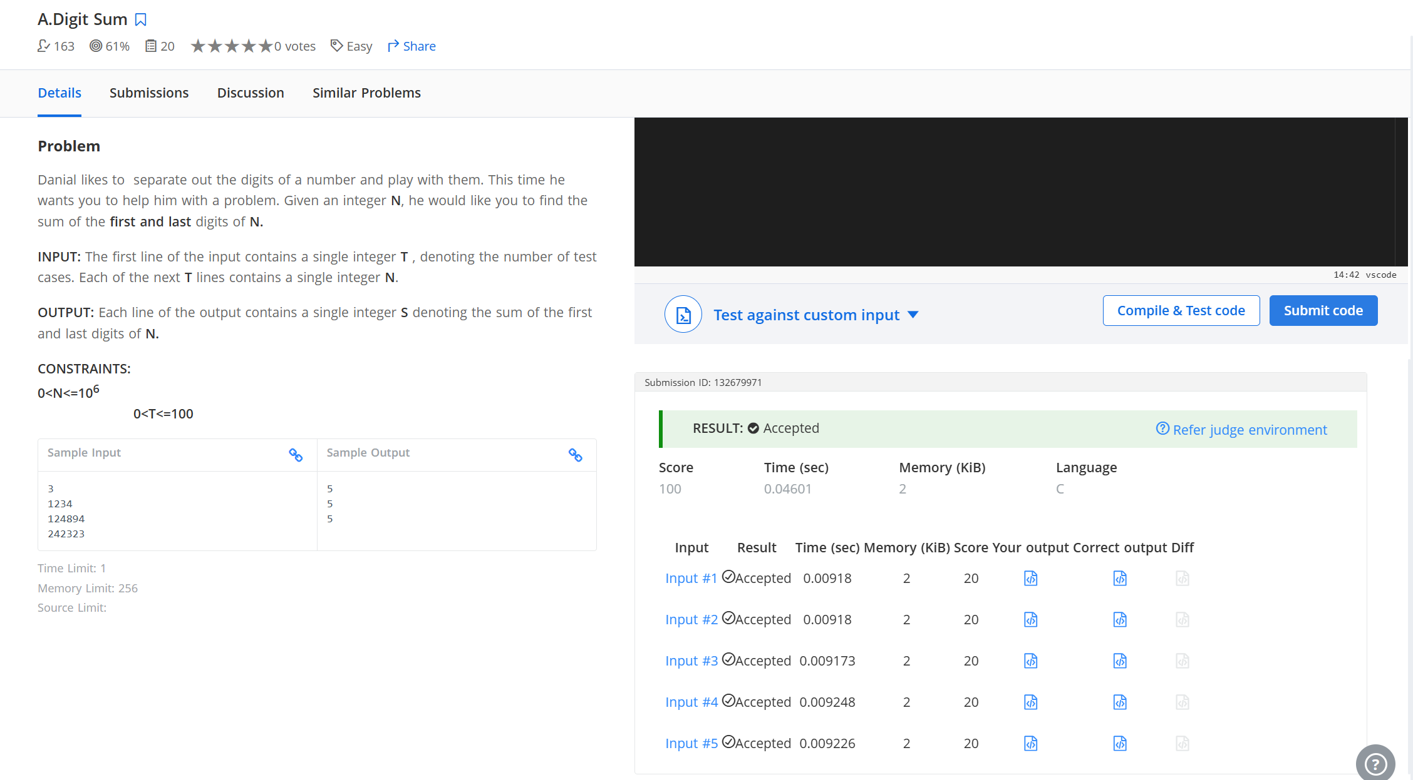
CODE:
#include <stdio.h>
int main(){
int T;
if (scanf("%d", &T) == 1) {
while (T--) {
int N;
scanf("%d", &N);
int last = N % 10;
int first = N;
while (first >= 10) {
first /= 10;
}
printf("%d\n", first + last);
}
}
}
LINK:
https://www.hackerearth.com/problem/algorithm/digit-sum-4/

