SUBMISSION SCREENSHOT:
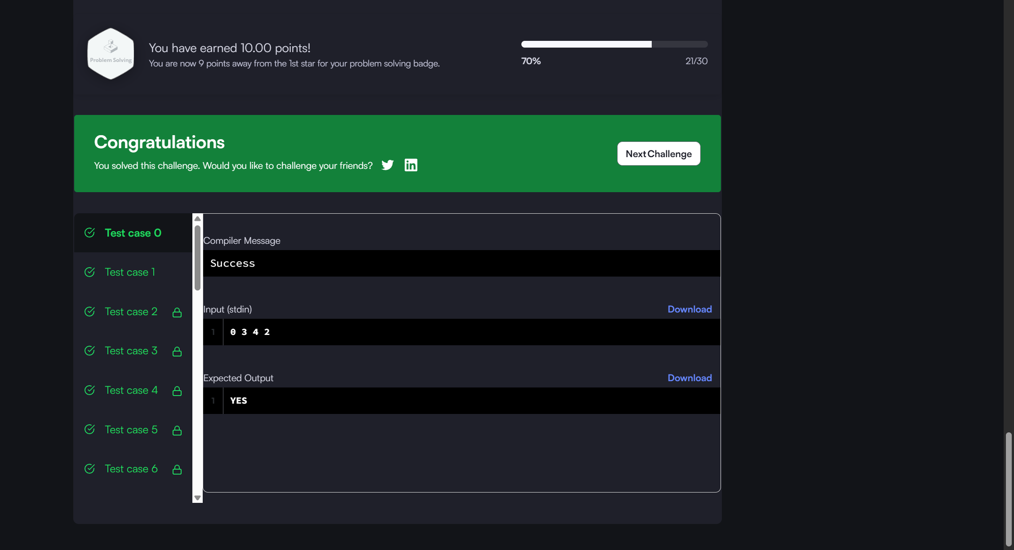
CODE:
if (v1 > v2 && (x2 - x1) % (v1 - v2) == 0) { (LINE 50)
return "YES";
} else {
return "NO";
}
LINK:
https://www.hackerrank.com/challenges/kangaroo/problem

