SUBMISSION SCREENSHOT:
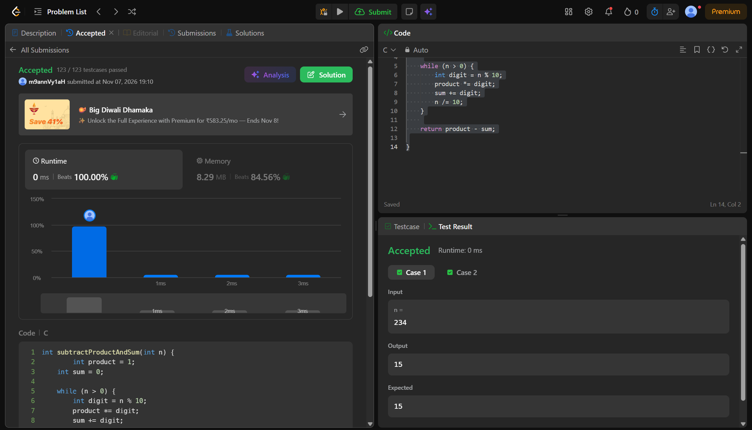
CODE:
int subtractProductAndSum(int n) {
int product = 1;
int sum = 0;

while (n > 0) {
int digit = n % 10;
product *= digit;
sum += digit;
n /= 10;
}

return product - sum;

}

LINK:
https://leetcode.com/problems/subtract-the-product-and-sum-of-digits-of-an-integer/submissions/2191291743/

