SUBMISSION SCREENSHOT:
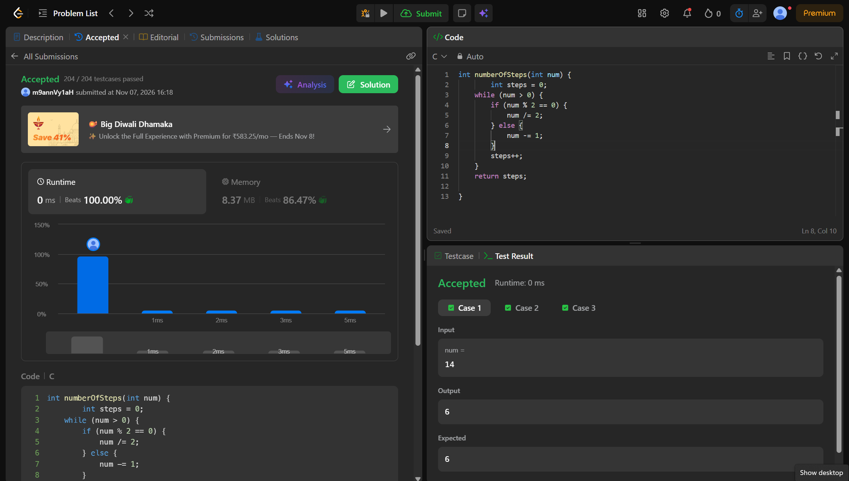
CODE:
int numberOfSteps(int num) {
int steps = 0;
while (num > 0) {
if (num % 2 == 0) {
num /= 2;
} else {
num -= 1;
}
steps++;
}
return steps;
}
LINK:
https://leetcode.com/problems/number-of-steps-to-reduce-a-number-to-zero/

