SUBMISSION SCREENSHOT:
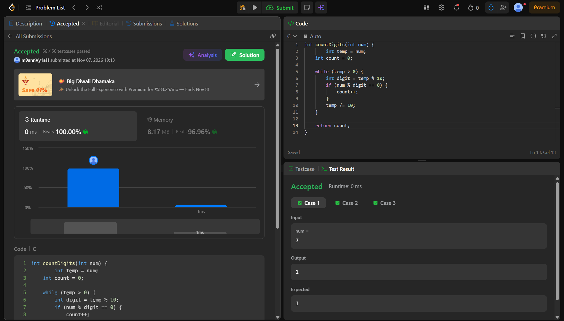
CODE:
int countDigits(int num) {
int temp = num;
int count = 0;

while (temp > 0) {
int digit = temp % 10;
if (num % digit == 0) {
count++;
}
temp /= 10;
}
return count;
}
LINK:
https://leetcode.com/problems/count-the-digits-that-divide-a-number/

