SUBMISSION SCREENSHOT:
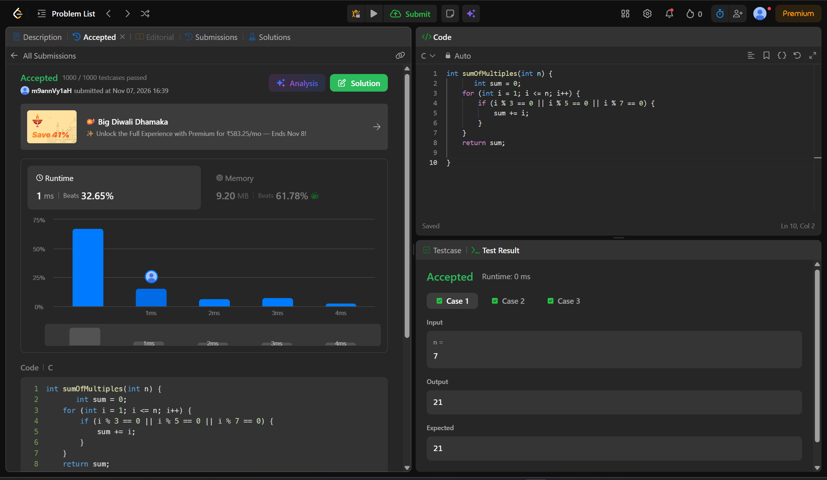
CODE:
int sumOfMultiples(int n) {
int sum = 0;
for (int i = 1; i <= n; i++) {
if (i % 3 == 0 || i % 5 == 0 || i % 7 == 0) {
sum += i;
}
}
return sum;

}
LINK:
https://leetcode.com/problems/sum-multiples/submissions/2191226696/

