SUBMISSION SCREENSHOT:
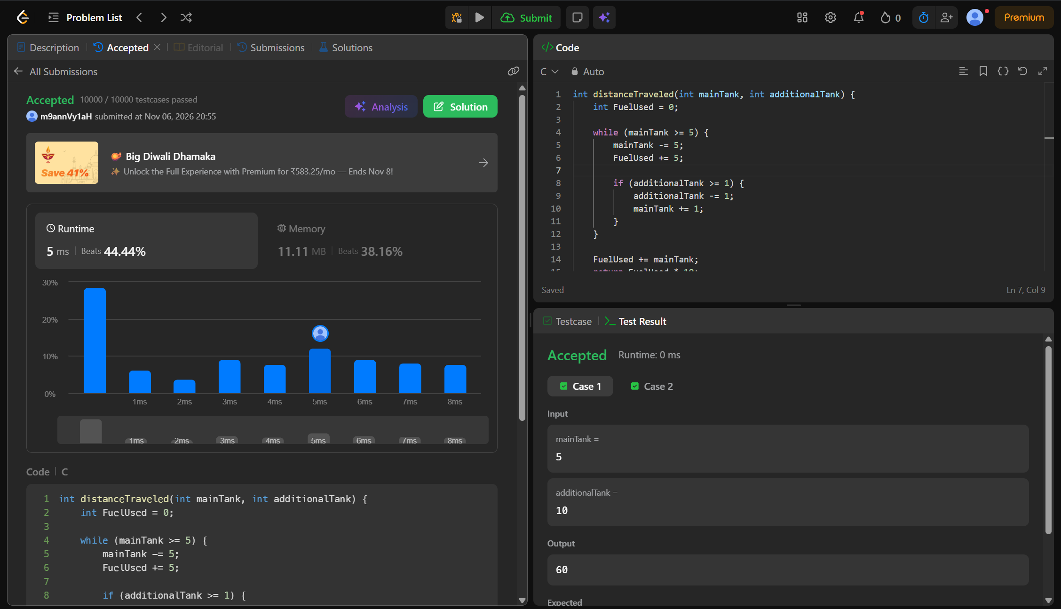
CODE:
int distanceTraveled(int mainTank, int additionalTank) {
int FuelUsed = 0;

while (mainTank >= 5) {
mainTank -= 5;
FuelUsed += 5;
if (additionalTank >= 1) {
additionalTank -= 1;
mainTank += 1;
}
}

FuelUsed += mainTank;
return FuelUsed * 10;
}
LINK:
https://leetcode.com/problems/total-distance-traveled/

