SUBMISSION SCREENSHOT:
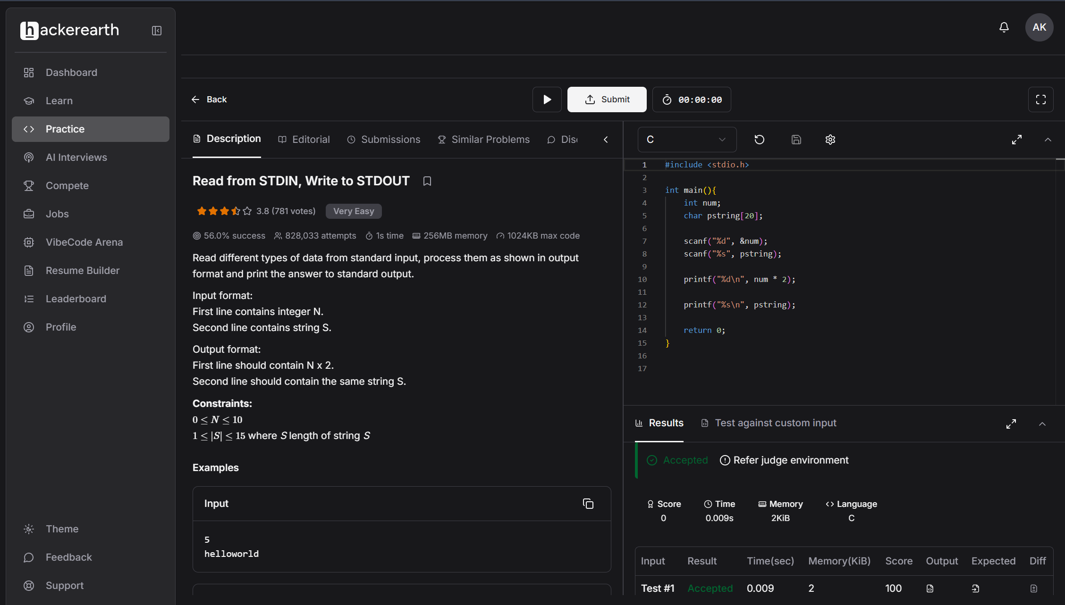
CODE:
#include <stdio.h>

int main(){
int num;
char pstring[20];

scanf("%d", &num);
scanf("%s", pstring);

printf("%d\n", num * 2);

printf("%s\n", pstring);

return 0;
}
LINK:
https://www.hackerearth.com/practice/basic-programming/input-output/basics-of-input-output/practice-problems/algorithm/io-exercise/

