SUBMISSION SCREENSHOT:
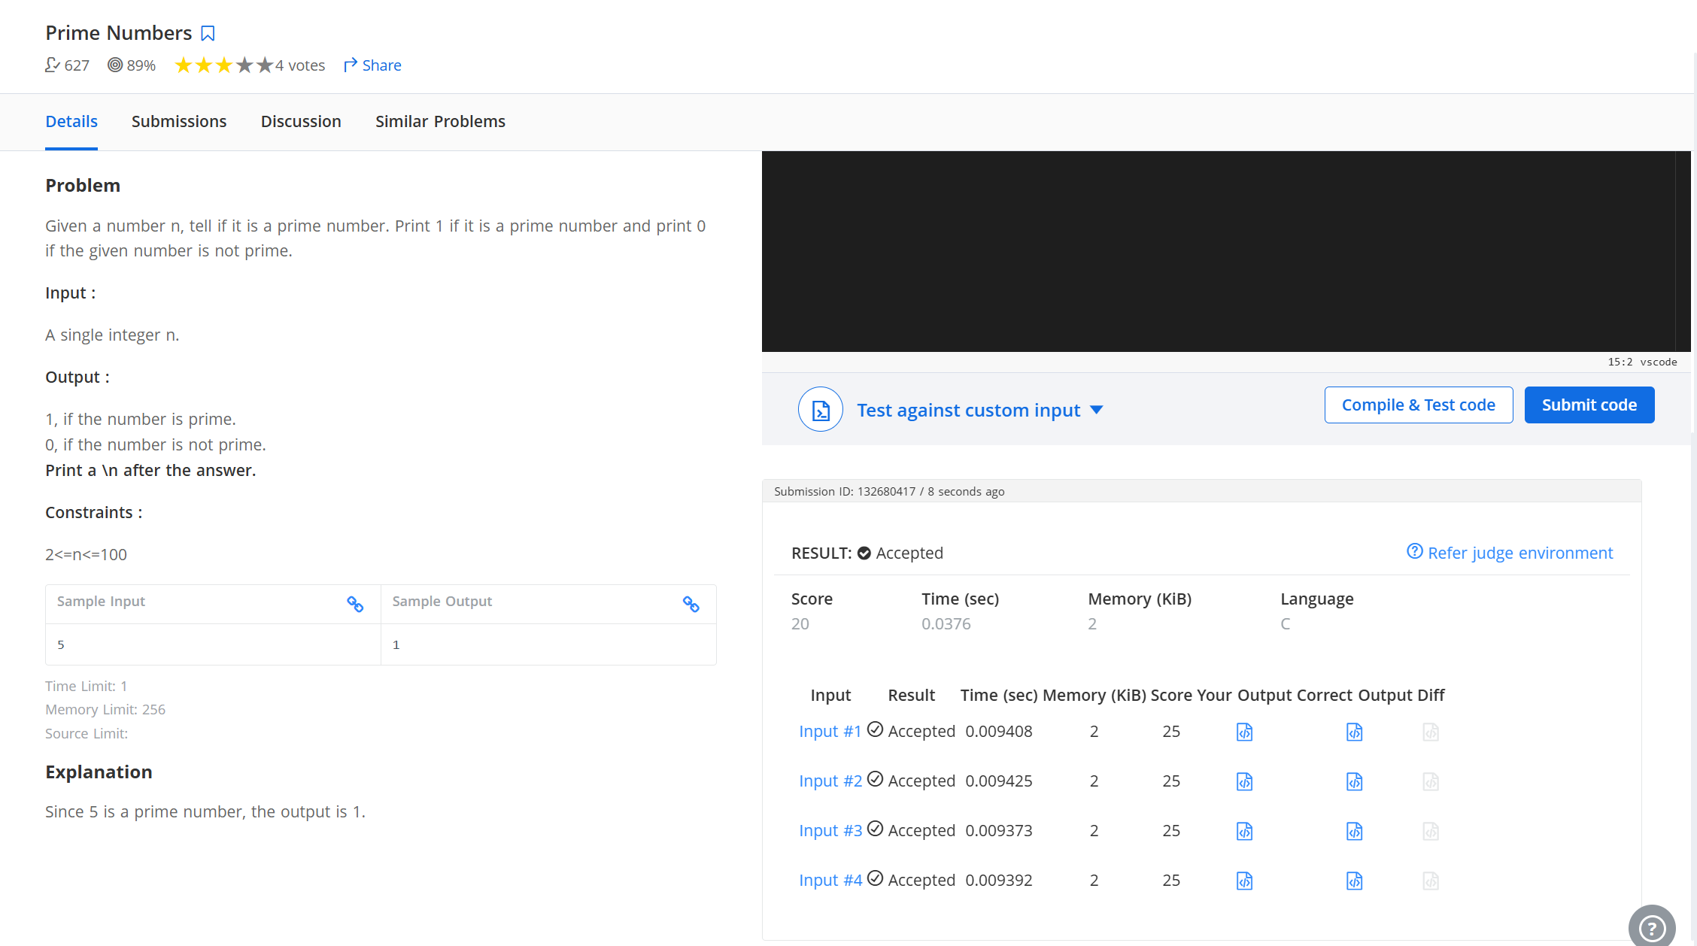
CODE:
#include <stdio.h>
int main(){
int num;
scanf("%d", &num);
int isPrime = 1;
for (int i = 2; i * i <= num; i++) {
if (num % i == 0) {
isPrime = 0;
break;
}
}
printf("%d\n", isPrime);
}
LINK:
https://www.hackerearth.com/problem/algorithm/prime-numbers/

