Fluttering and Tumbling of a Falling Coin: A 2D Quasi-Steady Model with a Preliminary SPH Study
Ayaan Bilal
International Young Physicists’ Tournament (IYPT) 2026, Problem 12: “Autumn Coin”

Abstract
A coin sinking through water does not fall straight. Depending on how heavy it is, it can flutter from side to side, tumble over and over in one direction, or move irregularly between the two, much like an autumn leaf. This paper looks at how these motions depend on the dimensionless moment of inertia I* = ρ_{s}h/(ρ_{f}L), the linear rotational damping μ₁, and the release angle θ₀.
I use a two-dimensional quasi-steady model of a falling elliptical plate, following Andersen, Pesavento and Wang (2005), and sort each simulated drop into steady, fluttering, tumbling or mixed motion. With μ₁ = 0.20 the model switches from fluttering to tumbling at I*_{c} ≈ 1.21 (h/L = 0.075, θ₀ = 20°), which is inside the experimental value of 1.20 ± 0.10. With μ₁ = 0.01 the threshold drops by about 19% to 0.97, so the damping term clearly matters. In 50-drop ensembles, the scatter in landing position grows from 15 mm at I* = 0.80 to 714 mm at I* = 3.50.
The quasi-steady model has no fluid viscosity, so I also wrote a 2D SPH solver. It shows the expected trend of viscous damping, but it over-predicts cylinder drag by about five times and is not grid-converged. I therefore treat the SPH results as qualitative only.

1. Introduction
When a thin coin or plate sinks in water, the flow around its edges pushes it toward a broadside orientation. This is the Munk moment, (m₁₁ − m₂₂)uv (Field et al., 1997; Belmonte et al., 1998; Pesavento & Wang, 2004; Andersen et al., 2005a,b). As the tilted coin slides sideways, vortices shed from its edges create a circulation and a lift force that stops the slide. What happens next depends on how the coin’s own inertia compares with the inertia of the water it displaces. A light coin turns back and flutters. A heavier one rotates past the vertical and tumbles in one direction. Near the boundary between the two, the motion can be irregular.
For an elliptical cross-section with chord L = 2a and thickness h = 2b, the motion is controlled by these dimensionless groups:
I* = ρ_{s}h / (ρ_{f}L), β = h/L, Re = ρ_{f}⟨|V|⟩L / μ, St = fL / ⟨|V|⟩ (1)
The velocity and time scales are:
U_{t} = √((ρ_{s}/ρ_{f} − 1) g h), U₀ = U_{t}/√2, τ₀ = a/U₀ (2)
Defining inertia as I/(mR²) would not work here. For any uniform disk or ellipse it equals a constant (1/4 or 1/2), so it says nothing about density or thickness. The model is also two-dimensional, which strictly describes a long plate or card rather than a disk. I use it as a first approximation for a coin and come back to this in Section 5.

2. Method

2.1 The quasi-steady model
The coin cross-section is an ellipse with semi-axes a = L/2 and b = h/2. Per unit span, its area is A = πab, its mass is m = ρ_{s}A, the mass of displaced fluid is m_{f} = ρ_{f}A, and its moment of inertia is I_{solid} = m(a² + b²)/4. The added-mass terms from potential flow (Lamb, 1932; Andersen et al., 2005a) are:
m₁₁ = πρ_{f}b², m₂₂ = πρ_{f}a², I_{a} = πρ_{f}(a² − b²)² / 8 (3)
Adding these to the coin gives M_{u} = m + m₁₁, M_{v} = m + m₂₂ and I_{tot} = I_{solid} + I_{a}. The state is q = [X, Y, θ, u, v, ω], where (u, v) is the velocity in the body frame. This is a three-degree-of-freedom system (X, Y, θ) written as six first-order equations. Following Andersen et al. (2005b):
dX/dt = u cosθ − v sinθ, dY/dt = u sinθ + v cosθ, dθ/dt = ω (4)
M_{u} du/dt = M_{v} v ω − ρ_{f} Γ v − F_{u} − (m − m_{f}) g sinθ (5)
M_{v} dv/dt = −M_{u} u ω + ρ_{f} Γ u − F_{v} − (m − m_{f}) g cosθ (6)
I_{tot} dω/dt = (m₁₁ − m₂₂) u v − τ (7)
The angle of attack is α = atan2(−v, u). The circulation, drag and rotational torque are:
Γ = −C_{T} L uv/|V| + ½ C_{R} L² ω, C_{T} = 1.2, C_{R} = π (8)
C_{D}(α) = C_{D0} − C_{D1} cos 2α, (F_{u}, F_{v}) = ½ ρ_{f} L C_{D}(α) |V| (u, v), C_{D0} = 1.4, C_{D1} = 1.0 (9)
τ = ½ C_{τ} ρ_{f} L⁴ |ω| ω + (π/8) ρ_{f} L³ U_{char} μ₁ ω, C_{τ} = 0.07854, μ₁ = 0.20 (10)
Here U_{char} = U₀ = √((ρ_{s}/ρ_{f} − 1) g h/2). I use ρ_{f} = 998 kg/m³, μ = 10⁻³ Pa·s and g = 9.81 m/s².

2.2 Integration and regime classification
I integrate the equations with the SciPy DOP853 solver (rtol = 10⁻⁹, atol = 10⁻¹¹, output step 0.001 s). The start of each run is discarded as a transient: times below max(20τ₀, 0.2 t_{end}) and the first 20% of the fall height. The rest is accepted only if it is stationary, meaning it is at least 30τ₀ long, covers at least two cycles, and the oscillation amplitude changes by no more than 15% between the middle and last thirds. Otherwise the run is labelled “undetermined”. Accepted runs are classified as follows:
- Steady: the standard deviation of θ is below 1°.
- Tumbling: net rotation of at least 720°, with either no reversal larger than 180° or a spin ratio |⟨ω⟩|/⟨|ω|⟩ of at least 0.70.
- Fluttering: peak-to-peak θ below 300° and net rotation below 360°.
- Mixed: everything else, meaning irregular reversals.

2.3 The SPH solver
To test the effect of viscosity I wrote a 2D weakly compressible SPH solver in C++20. It uses a Wendland C² kernel (smoothing length 1.3 dx), a Tait equation of state (γ = 7, c₀ = 10 U_{max}), Morris laminar viscosity, and ghost boundary particles (Akinci et al., 2012) with Adami et al. (2012) pressure extrapolation. Time stepping is kick–drift–kick with Picard iteration for the coupling to the rigid body. I also built a desktop visualizer and a browser version (visualizer.html), which matched the Python model in my checks.

3. Results from the quasi-steady model

3.1 Two example drops and an energy check
Fluttering drop. L = 20 mm, h = 1.5 mm, ρs = 9000 kg/m³ (I* = 0.676), θ0 = 15°, fall height 0.800 m. The coin takes 10.45 s to fall at a mean speed of 0.235 m/s (Re ≈ 4690), with a mean vertical descent speed of 0.077 m/s (giving ⟨|V|⟩/Ut = 0.683 relative to the terminal velocity Ut = 0.343 m/s). Its angle oscillates in a steady cycle with a peak-to-peak amplitude of 107.1° (standard deviation 35.3°) at 3.11 Hz (St = fL/⟨|V|⟩ ≈ 0.265), and it lands with a net sideways drift of +13.6 mm.
Tumbling drop. L = 24 mm, h = 1.8 mm, ρs = 17,964 kg/m³ (I* = 1.35), θ0 = 20°, fall height 0.960 m. Because I* = 1.35 exceeds the critical threshold I*c = 1.213, the coin executes continuous unidirectional tumbling, completing 12.9 full revolutions (net rotation −4638°) over 6.07 s with a mean speed of 0.438 m/s (Re ≈ 10,500) and drifting −1.82 m sideways.
As an energy check, kinetic energy, buoyant potential energy and the work lost to viscous dissipation add up to the available potential energy drop within 1.1 × 10⁻⁵ % on the reference drop, and within 0.12% across the high-inertia sweeps (Figure 1). This tests the accuracy of the integration. It does not test the physics of the model.
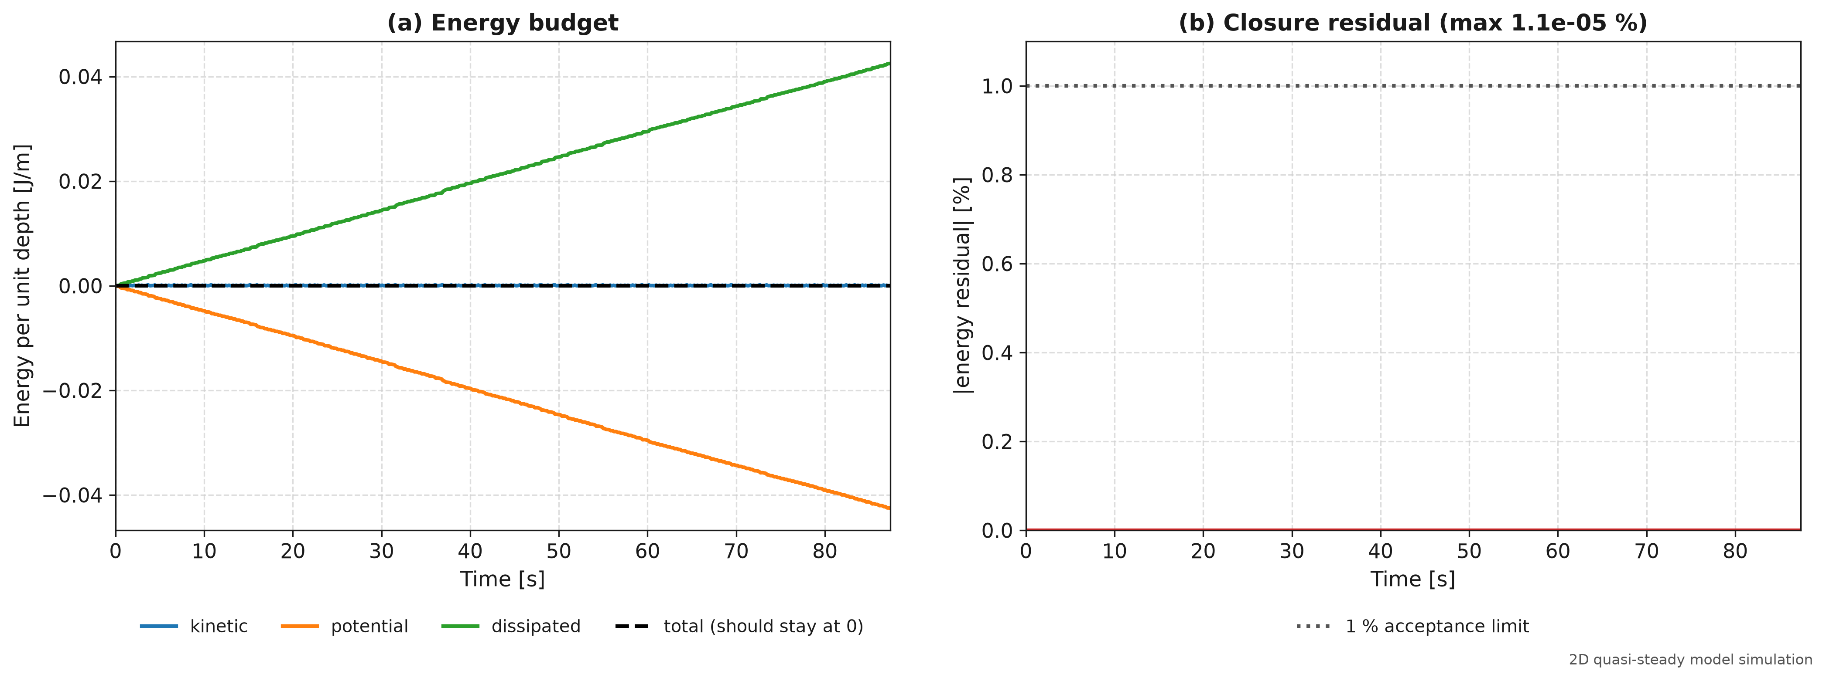
Figure 1. Energy budget for a falling plate in the quasi-steady model: kinetic energy T(t), buoyant potential energy V_{pot}(t) and cumulative dissipated work W_{diss}(t).

3.2 The flutter-to-tumble threshold and the damping coefficient
The parameter that matters most in the model is the linear rotational damping μ₁. I located the flutter-to-tumble threshold I*_{c} by bisection for μ₁ between 0 and 0.20 (Table 1 and Figure 2). The threshold rises steadily with μ₁. With no linear damping it is 0.951, about 21% below the experimental midpoint of 1.20. With μ₁ = 0.01 it is 0.967 (−19%). Coins in that range would tumble when they should flutter.
With μ₁ = 0.20, the baseline value from Andersen et al. (2005b), the threshold is 1.213. That is 1.1% above the experimental midpoint and well inside its uncertainty of ±0.10. The damping coefficients in models like this are calibrated against data, so this agreement is a consistency check, not an independent prediction.
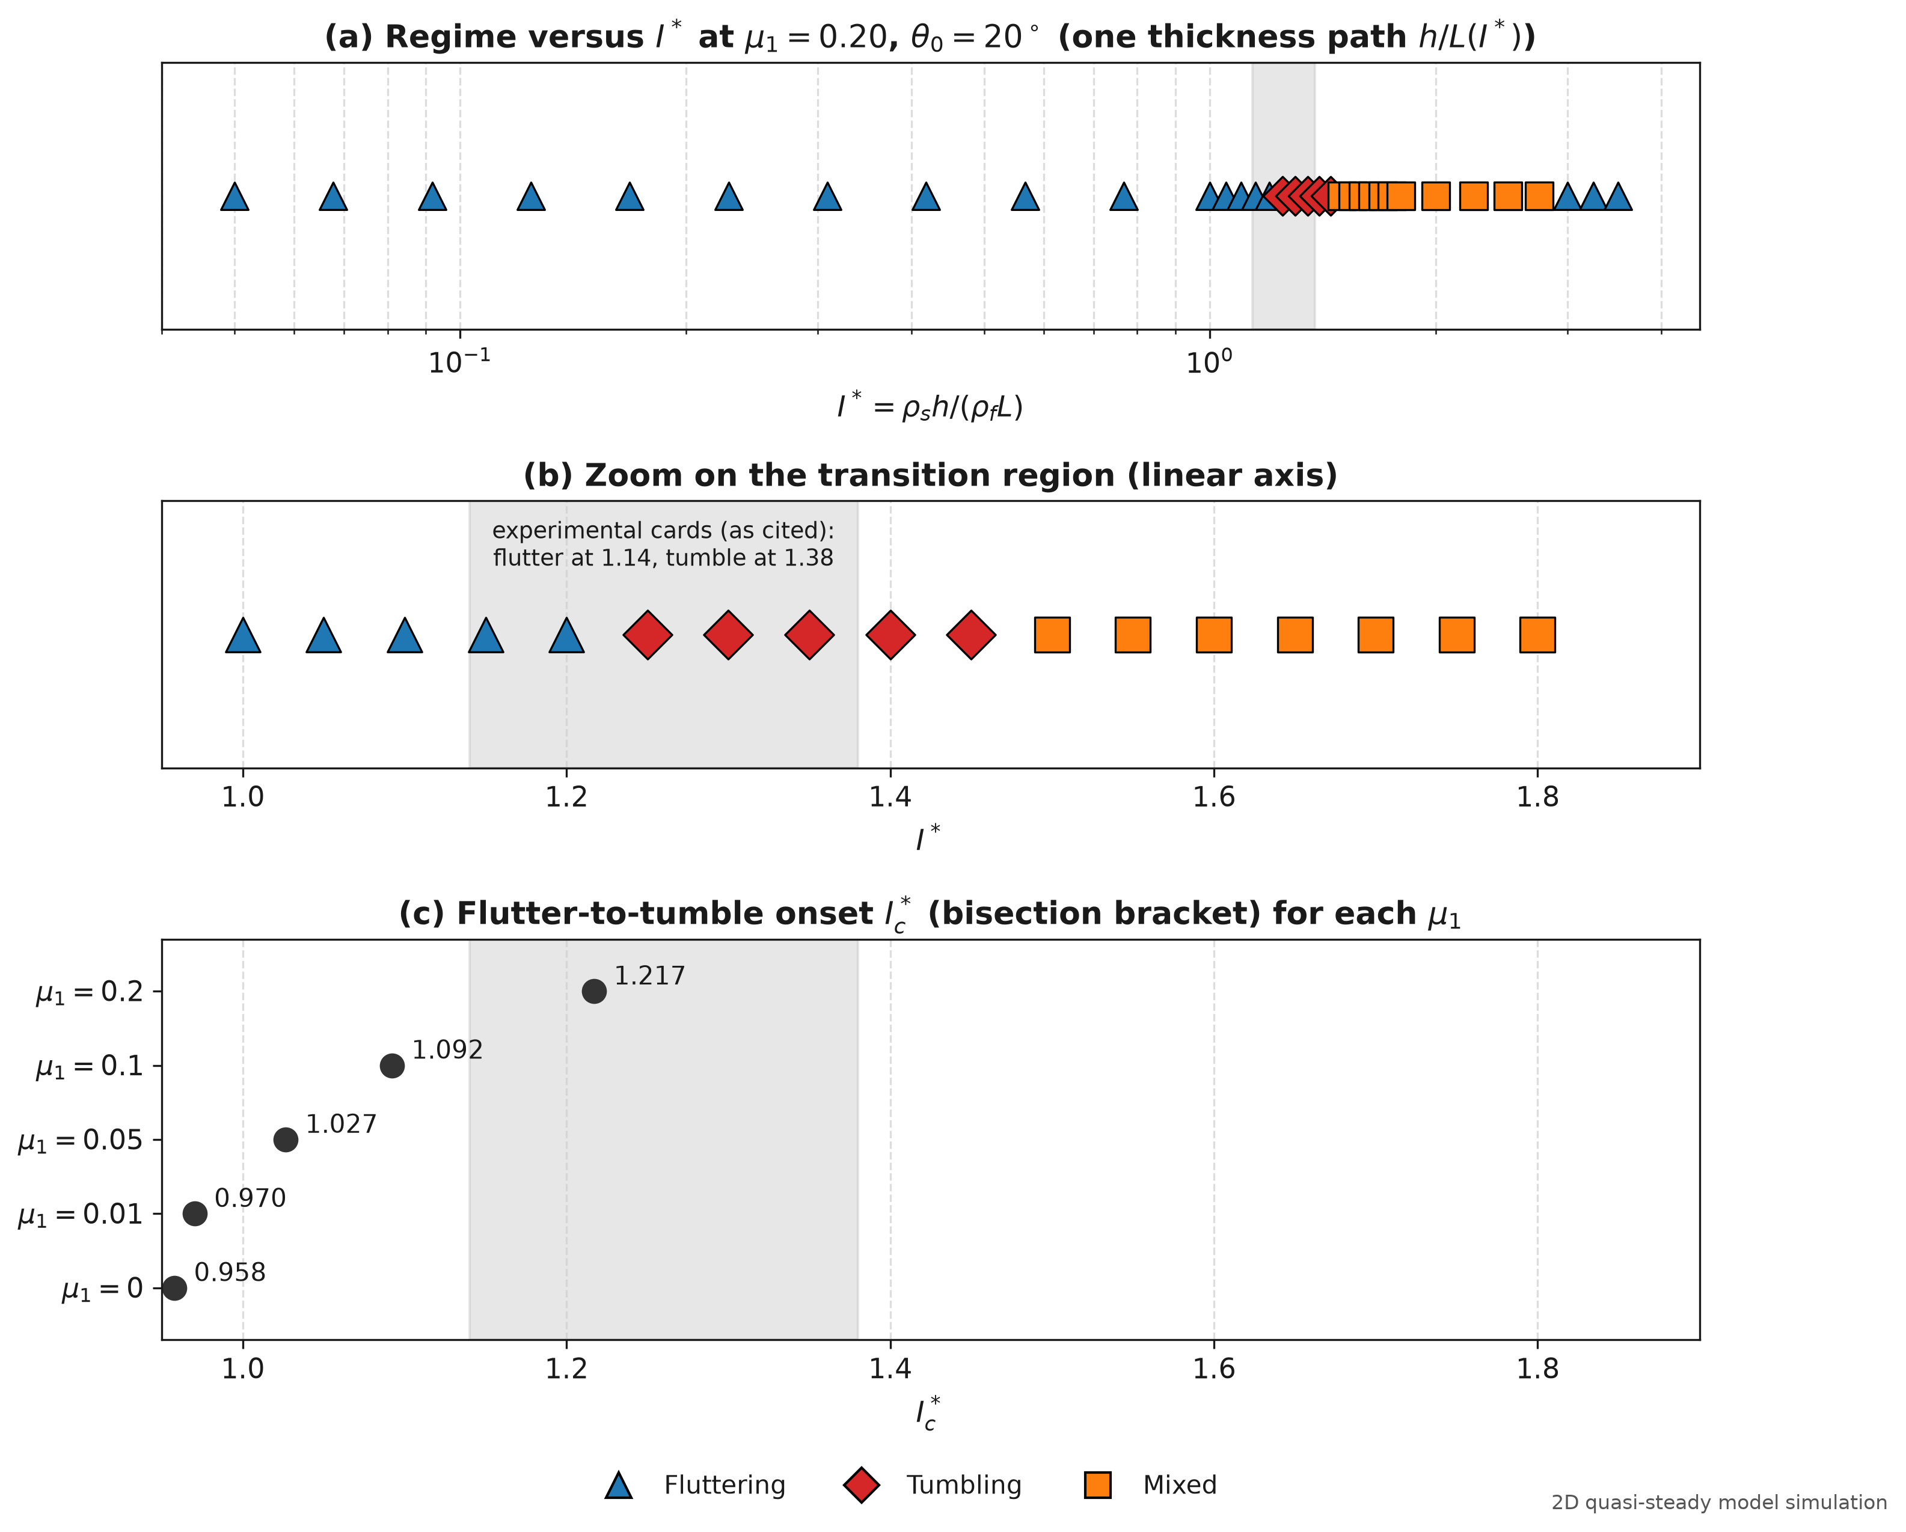
Figure 2. (a) Regimes over I* from 0.05 to 3.50 at μ₁ = 0.20. (b) Zoom on the transition, I* from 0.95 to 1.90. (c) Shift of the threshold with μ₁, compared with the experimental bracket [1.10, 1.30] of Andersen et al. (2005b).
Table 1. Bisection result for the flutter-to-tumble threshold at different linear damping μ₁ (θ₀ = 20°, h/L = 0.075).
Damping μ₁ | Threshold I*_{c} | Lower bound | Upper bound | Bracket width | Shift vs. 1.20
0.00 (none) | 0.9507 | 0.9490 | 0.9523 | 0.0033 | −20.8%
0.01 | 0.9673 | 0.9656 | 0.9689 | 0.0033 | −19.4%
0.05 | 1.0204 | 1.0188 | 1.0221 | 0.0033 | −15.0%
0.10 | 1.0901 | 1.0885 | 1.0918 | 0.0033 | −9.2%
0.20 (baseline) | 1.2130 | 1.2113 | 1.2146 | 0.0033 | +1.1%

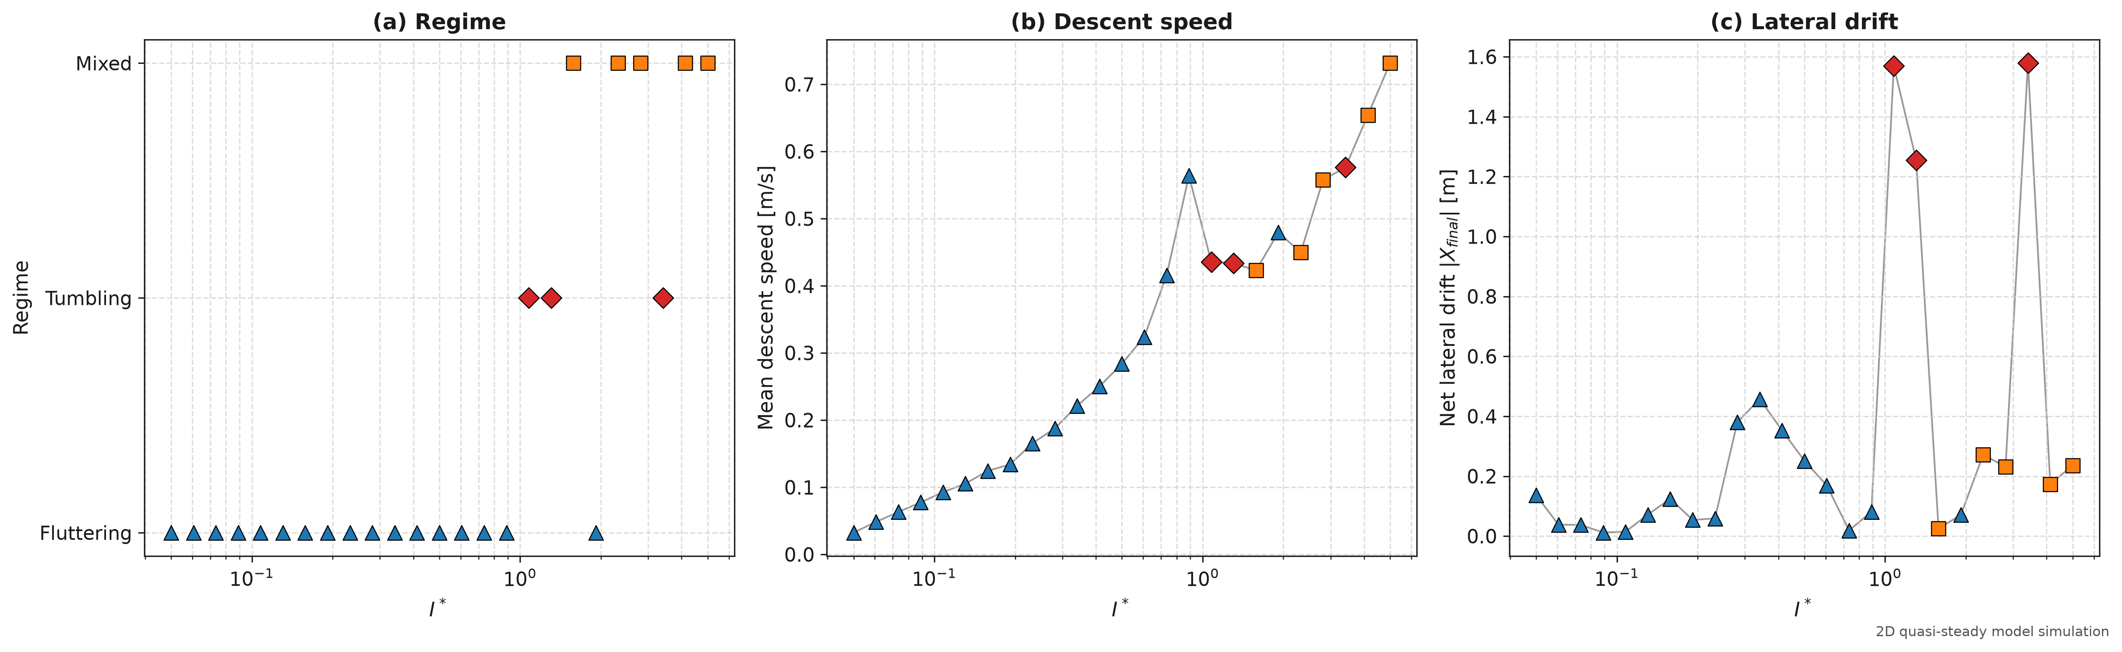
Figure 3. Mean descent speed and sideways drift over a 25-point logarithmic sweep of I*. Both jump in the tumbling window.
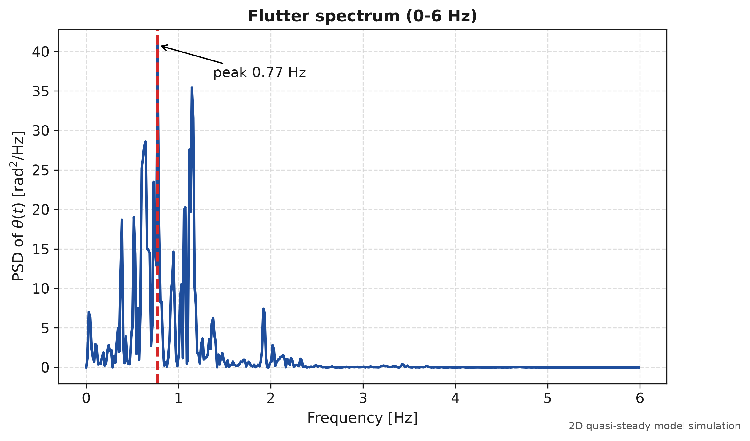
Figure 4. Power spectrum of θ(t) for a fluttering plate from the initial point of the parametric sweep (I* = 0.05, L = 24 mm, h = 0.96 mm, θ0 = 5°). The fundamental frequency peak is at 0.77 Hz, with secondary harmonics between 1.5 and 2.5 Hz, distinct from the higher-frequency 3.11 Hz flutter observed for the denser reference coin in Section 3.1.

3.3 Regime map over I* and Re
I ran 34 values of I* between 0.05 and 3.50 at four chord lengths (8, 12, 16 and 20 mm), which makes 136 drops. All used μ1 = 0.20, a fall height of 100L, and a release angle of 20° plus a perturbation of 10−3 rad (Figure 5, Table 2). The thickness changes along with I* (h/L runs from 0.04 to 0.175, and the density ratio is capped at 20). In this uniform sweep, fluttering occurs up to I* = 1.20, tumbling from 1.25 to 1.45, and mixed motion from 1.50 to 2.75. At I* = 3.0 to 3.5 the sweep plate has reached its maximum thickness ratio (h/L = 0.175), where the large thickness and added mass stabilize the periodic rocking within 100L under a clean 20° release. In contrast, when thick plates at I* = 3.50 are released near vertical (θ0 = 5°) with velocity perturbations, as in the 50-drop ensemble of Section 3.4, they undergo multiple tumbling reversals and large lateral scatter.
Two points about this map need to be stated plainly. First, Re is not an independent variable in this model. The coefficients do not depend on Re, so for a given I* and h/L the dimensionless motion is identical at every chord length. The four chord lengths only change the scale, and with it Re. This is why all counts in Table 2 are multiples of four. In effect there are 34 distinct runs, and the map shows regimes against I* alone.
Second, none of the 136 drops ended in steady broadside descent. To test whether steady broadside descent has any basin of attraction, I ran drops initiated at microscopic release angles down to θ0 = 10−5°. In every case, the destabilizing Munk pitching moment amplified the infinitesimal tilt into large-amplitude oscillations within 1.5 to 2.5 s, reaching peak-to-peak swings exceeding 68°. This confirms that steady broadside descent is linearly unstable for underwater plates in this parameter regime.
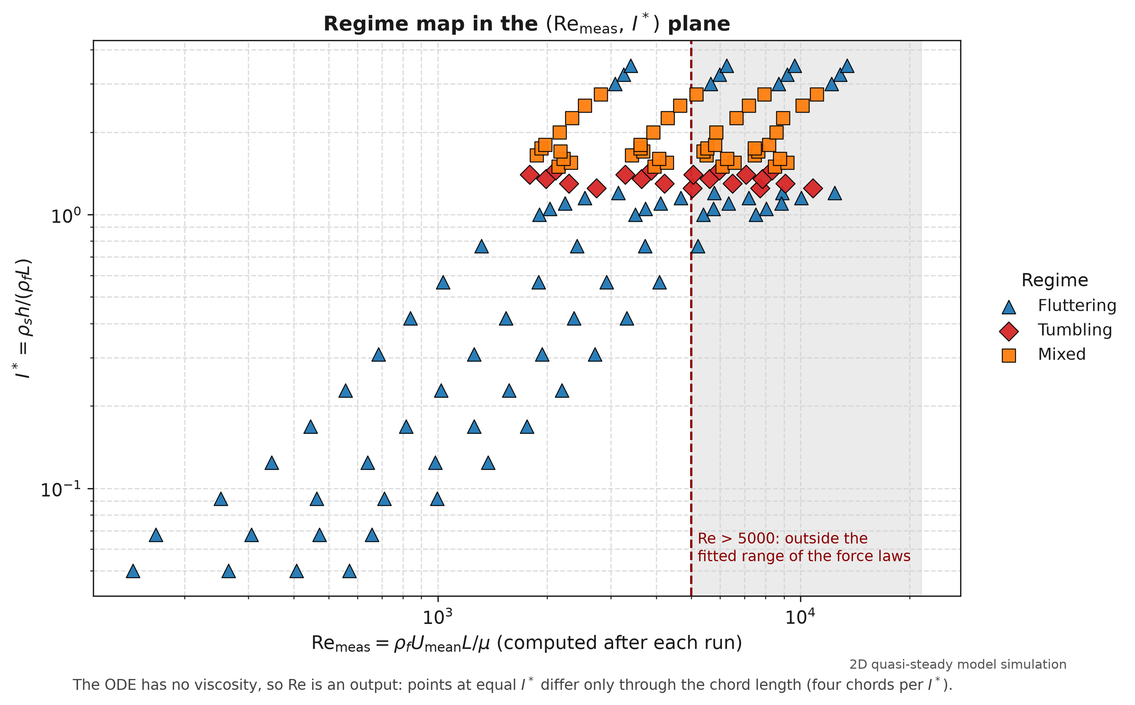
Figure 5. Regime map in (I*, Re) for L = 8, 12, 16 and 20 mm.
Table 2. Regimes found in the 136-drop map (μ₁ = 0.20). The share of drops in each regime depends on how I* was sampled, so I give counts rather than percentages.
Regime | I* range | Drops | Mean descent speed [m/s]
Fluttering | 0.05 to 1.20 and 3.0 to 3.5 | 72 | 0.0180 to 0.6740
Tumbling | 1.25 to 1.45 | 20 | 0.2239 to 0.5419
Mixed | 1.50 to 2.75 | 44 | 0.2346 to 0.5560
Total | 0.05 to 3.50 | 136 | 0.0180 to 0.6740

3.4 Release angle and landing scatter
For release angles from 0° to 90°, the coin settles quickly onto the fluttering cycle at low and intermediate inertia (I* = 0.20 and 0.80; Figure 6). I then dropped 50 coins at each of three values of I*, with small random perturbations (σ_{θ} = 0.5°, σ_{v} = 10⁻⁴ m/s), and recorded where they landed (Figure 7, Table 3).
At I* = 0.80 the landing positions spread by σX = 15.3 mm. The motion is a periodic cycle, so the spread is set mostly by the phase of the cycle at landing, which gives an arcsine-shaped histogram. At I* = 3.50 (modeled with h/L ≈ 0.219, h = 5.25 mm, and ρs ≈ 15,968 kg/m³ for L = 24 mm), the spread reaches σX = 714 mm, which is 46.5 times larger. This dramatic broadening arises because near-vertical release (θ0 = 5°) near the separatrix causes different drops to execute varying numbers of complete flips before transitioning between fluttering and tumbling, scattering landing positions widely across the bottom.
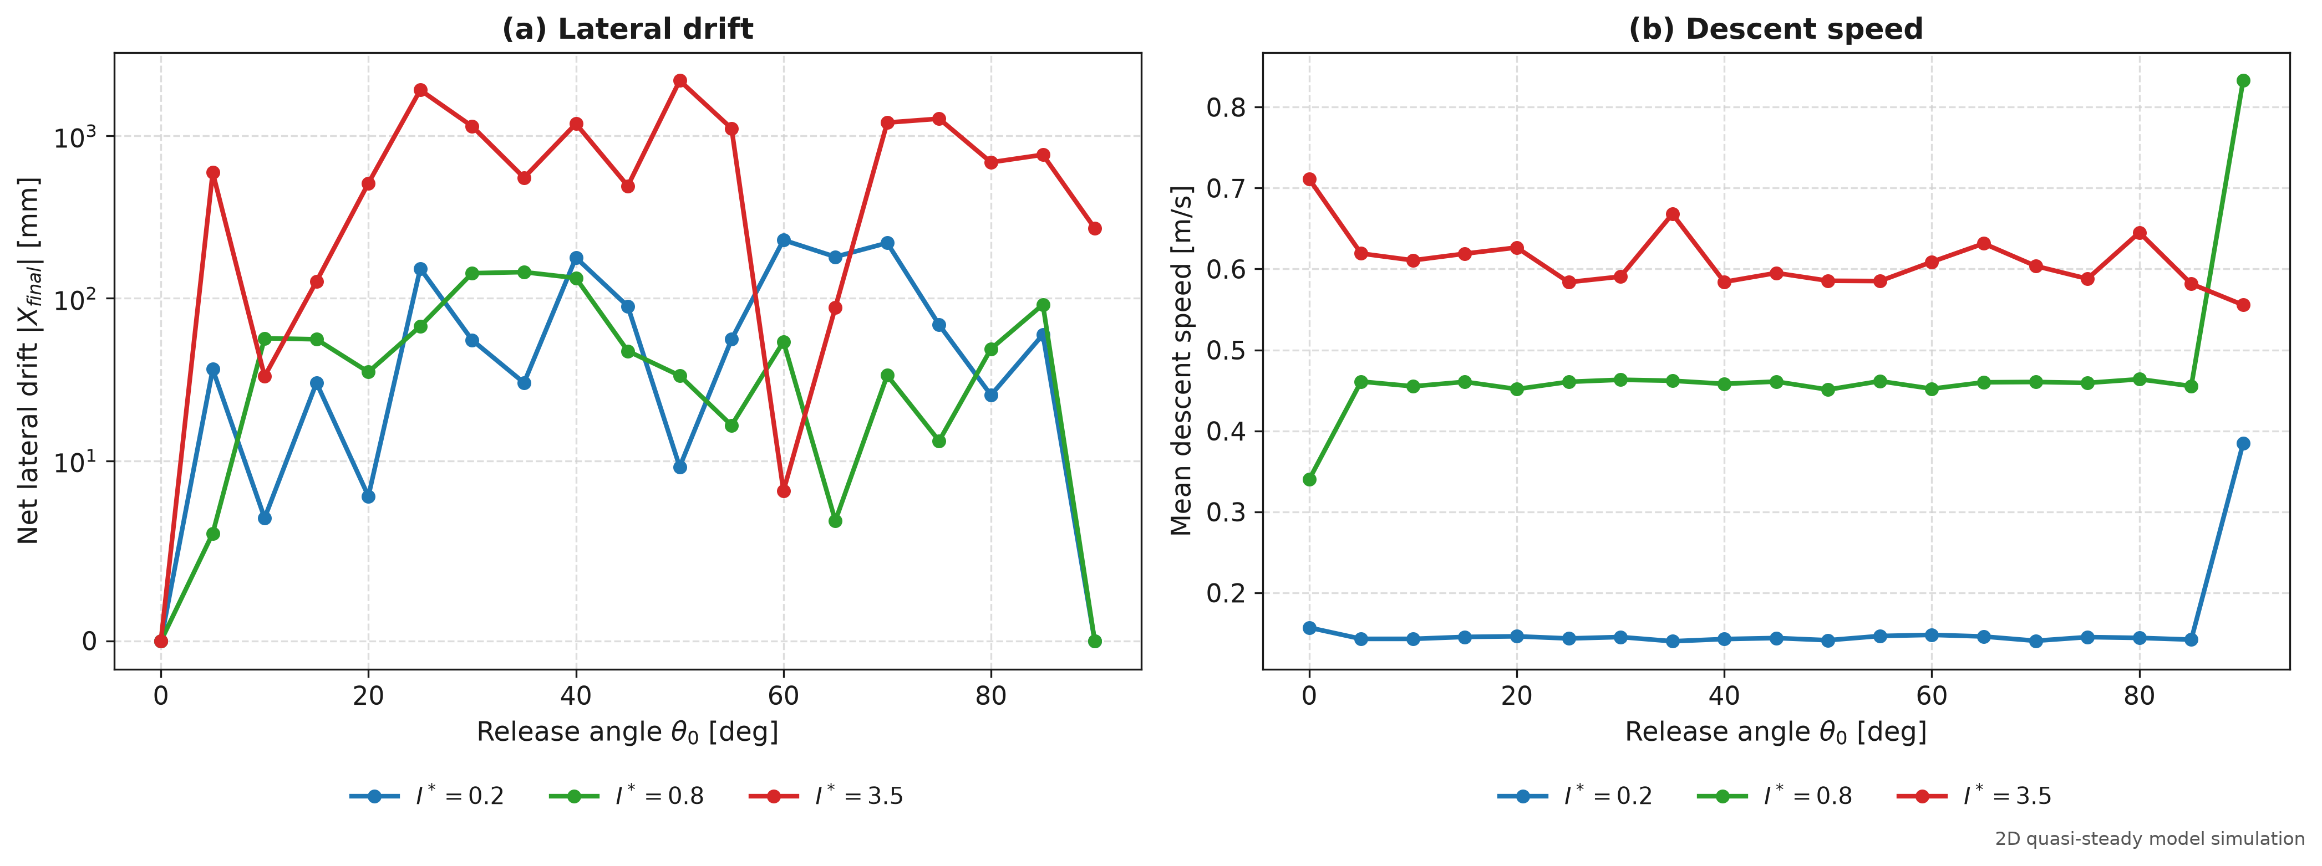
Figure 6. Sensitivity to the release angle θ₀ from 0° to 90° at I* = 0.20, 0.80 and 3.50.
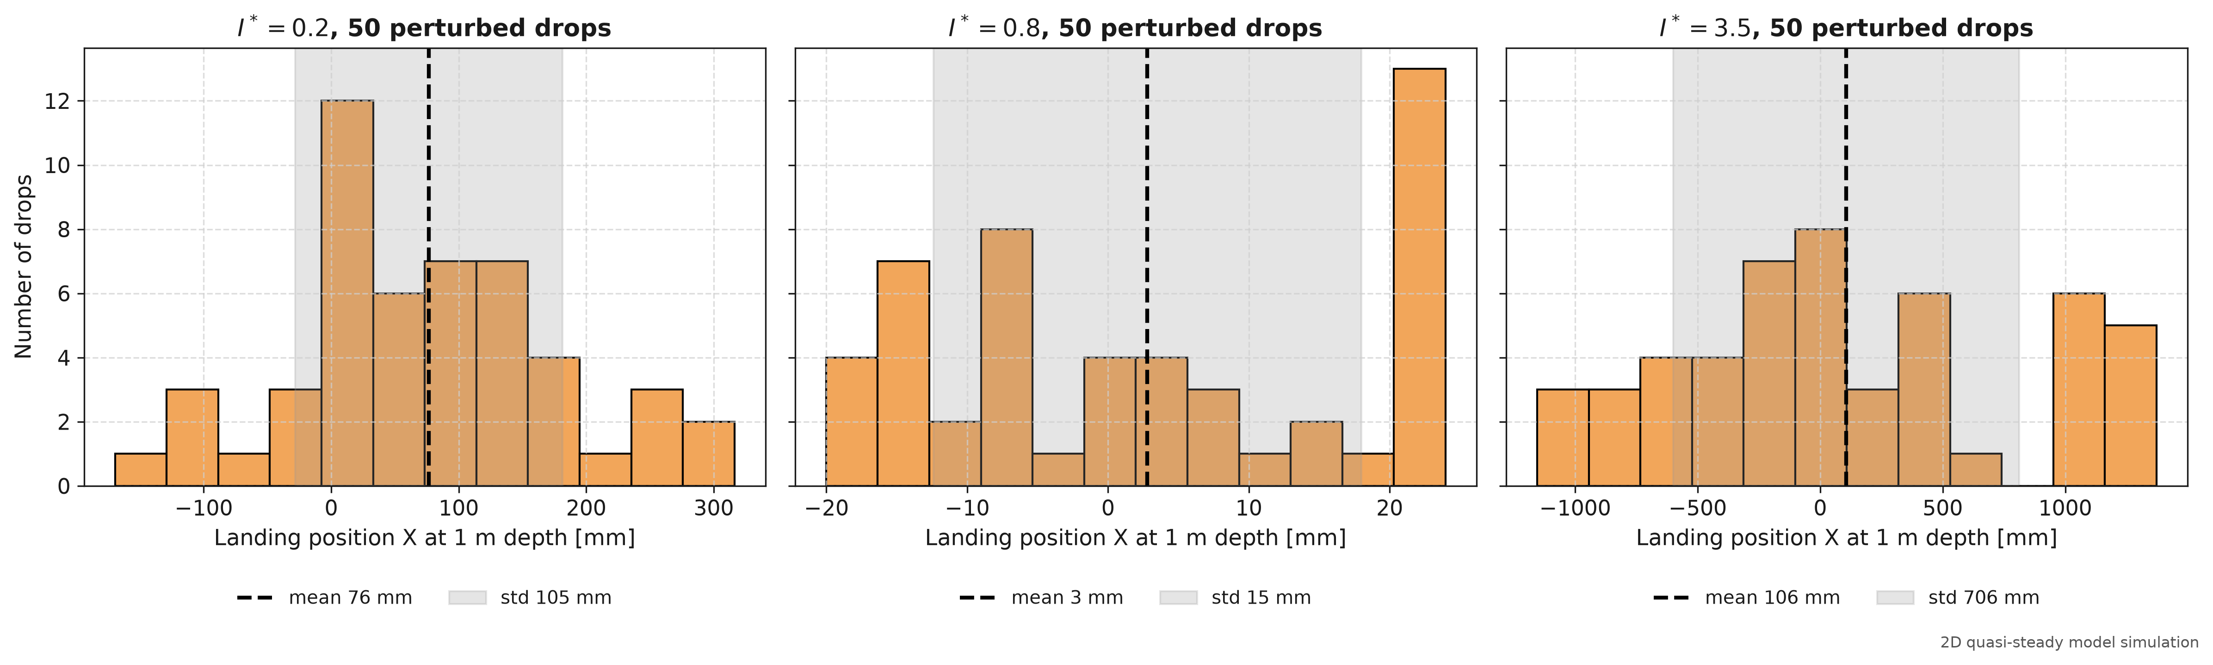
Figure 7. Landing-position histograms from 50-drop ensembles. At I* = 3.50 the sample standard deviation is 714 mm; the legend shows the population value, 706 mm.
Table 3. Landing scatter in the 50-drop ensembles (σ_{θ} = 0.5°, σ_{v} = 10⁻⁴ m/s). Sample σ_{X} is given first, population σ in brackets.
Case | I* | Mean X [mm] | σ_{X} [mm] | Min / Max X [mm] | Span [mm] | Ratio
Low inertia | 0.20 | +76.47 | 105.83 (104.8) | −169.53 / +316.31 | 485.84 | 6.90×
Mid inertia (limit cycle) | 0.80 | +2.80 | 15.34 (15.2) | −20.02 / +23.97 | 43.99 | 1.00× (baseline)
High inertia (mixed) | 3.50 | +105.92 | 713.64 (706) | −1155.16 / +1372.85 | 2528.00 | 46.52×

3.5 Nine example coins
Finally I applied the model to nine coins (Table 4, Figure 8). Two are real Pakistani circulation coins, the Rs 10 and the Rs 5. The other seven are hypothetical design coins in different metals. The lighter coins, including both Pakistani coins, flutter. A 24 × 3.0 mm brass coin flutters at μ₁ = 0.20 but tumbles at μ₁ = 0.01, and a 24 × 3.5 mm brass coin tumbles at both. The steel, lead and tungsten coins move irregularly. Each coin has its own h/L, which differs from the 0.075 used in Section 3.2 (the 3.5 mm brass coin has h/L = 0.146, for example), so their position relative to the threshold in Table 1 is not a direct comparison.
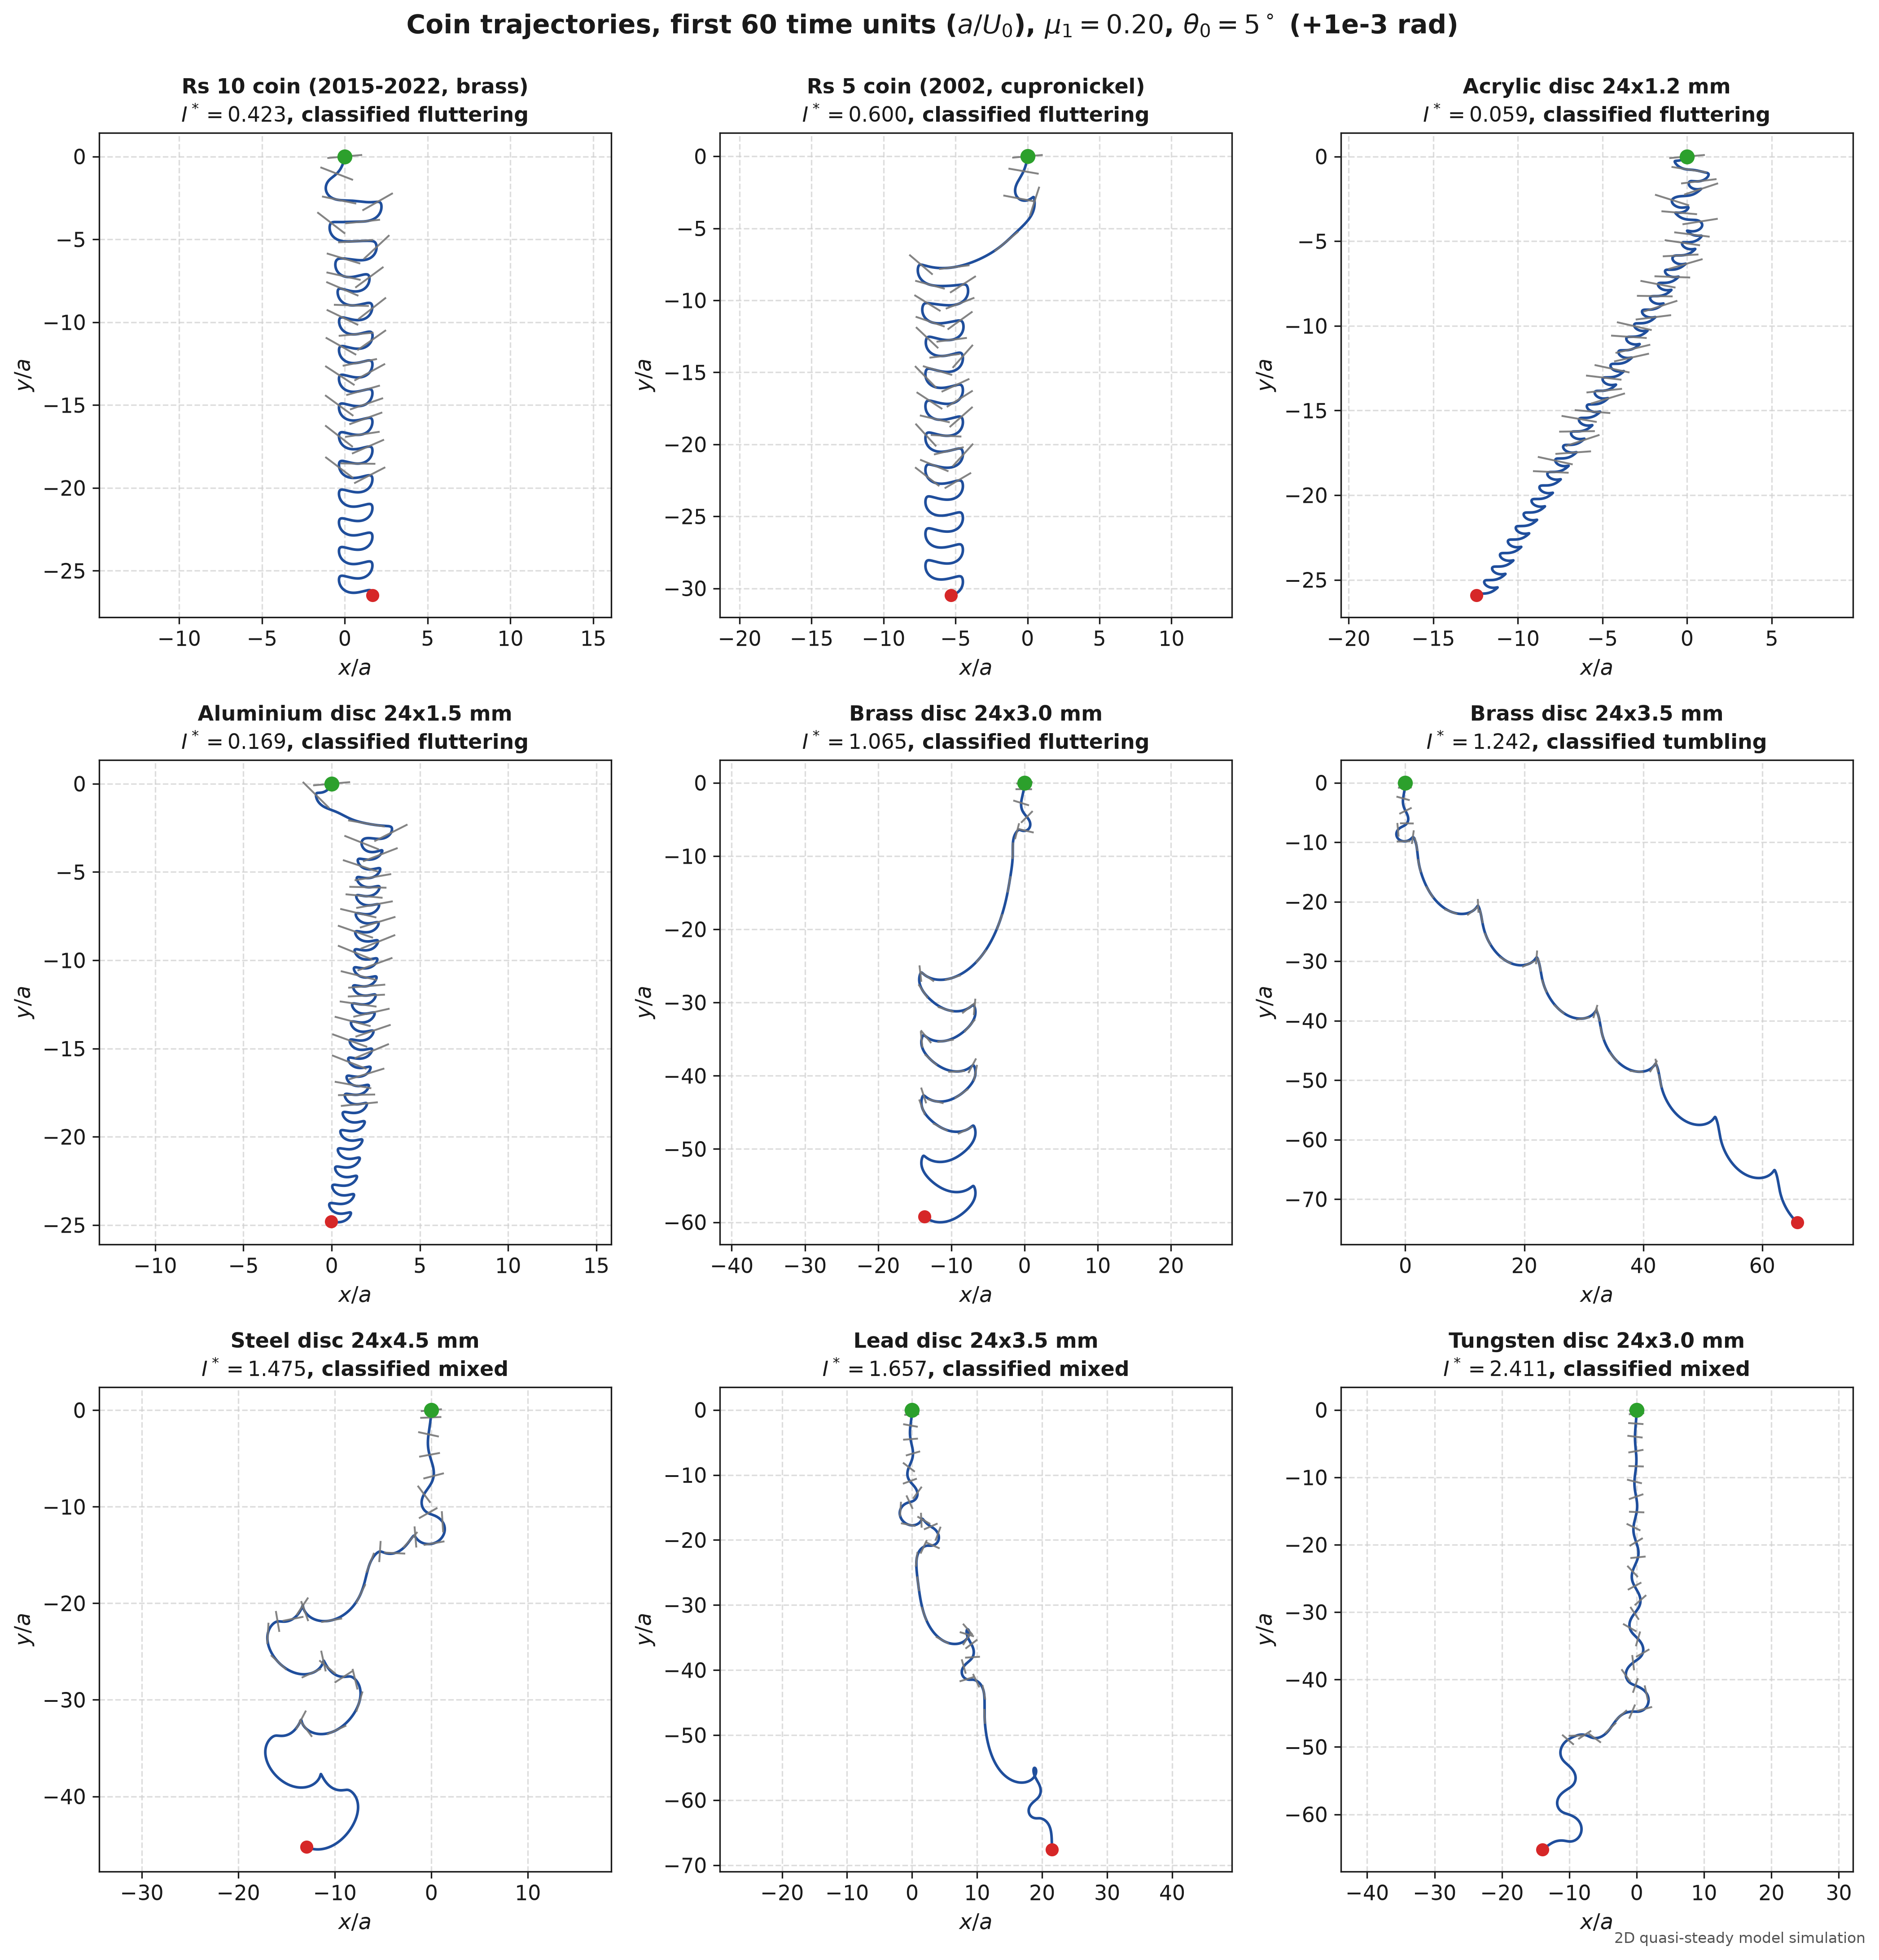
Figure 8. Trajectories of the nine coins over the first 60 dimensionless time units (a/U₀), with μ₁ = 0.20 and θ₀ = 5° (plus 10⁻³ rad). Acrylic, aluminium and both Pakistani coins flutter, and so does the 3.0 mm brass coin. The 3.5 mm brass coin tumbles. Steel, lead and tungsten move irregularly.
Table 4. The nine example coins, released at 5°, 20°, 45° and 90°, with μ₁ = 0.20 and 0.01.
Coin | I* | ρ_{s}/ρ_{f} | Regime (μ₁ = 0.20) | Regime (μ₁ = 0.01) | Effect of damping
design_acrylic_24x1.2 | 0.0591 | 1.18 | fluttering | undetermined at 5°, fluttering otherwise | Run too short at 5°
design_aluminium_24x1.5 | 0.1691 | 2.71 | fluttering | fluttering | None
pk_rs10 | 0.4232 | 7.19 | fluttering | fluttering | None
pk_rs5_2002 | 0.5999 | 6.86 | fluttering | fluttering | None
design_brass_24x3.0 | 1.0646 | 8.52 | fluttering | tumbling | Flutter to tumble
design_brass_24x3.5 | 1.2421 | 8.52 | tumbling | tumbling | None
design_steel_24x4.5 | 1.4748 | 7.87 | mixed | mixed | None
design_lead_24x3.5 | 1.6571 | 11.36 | mixed | mixed | None
design_tungsten_24x3.0 | 2.4111 | 19.29 | mixed | mixed | None

4. Comparison with the literature and the SPH study

4.1 Literature
The threshold of 1.213 lies within the experimental value of 1.20 ± 0.10 reported by Andersen et al. (2005b). The flutter Strouhal number falls from 0.776 to 0.154 as I* increases, passing through the 0.18 to 0.22 band of Belmonte et al. (1998) near I* = 0.75 (Figure 9). The reference coin in Section 3.1 yields St = fL/⟨|V|⟩ ≈ 0.265 (with f = 3.11 Hz, L = 20 mm, and ⟨|V|⟩ = 0.235 m/s), which aligns closely with both the experimental range and the parametric trend. Differences from 3D coin experiments (Field et al., 1997) and from the 3D tracking data in the ondrej-cloud repository are expected, because of tip vortices and rotation out of the plane. A direct comparison with that dataset is left for future work.
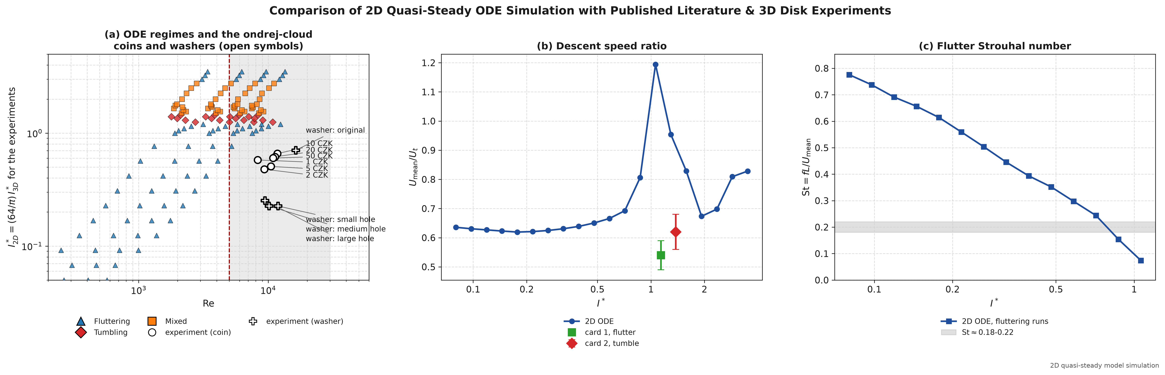
Figure 9. Model predictions compared with the descent-speed ratios U_{mean}/U_{t} of Andersen et al. (2005b) and the Strouhal band 0.18 to 0.22 of Belmonte et al. (1998).

4.2 SPH results
The SPH solver resolves the Navier–Stokes flow directly, so it can show something the ODE cannot: the effect of fluid viscosity. Figure 10 compares the tilt θ(t) over the first 0.5 s for a fluttering plate (I* = 0.68) and a tumbling plate (I* = 1.35). The SPH runs reproduce the start of the motion, the first pitching swing and the turnaround, but numerical dissipation then reduces the amplitude. Figure 11 varies the inlet Reynolds number at I* = 0.65 (Re_{in} = 25, 100, 300 and 800). At Re_{in} = 25, viscosity damps the pitching into a smooth glide at about −60°. At Re_{in} of 100 or more, the plate keeps shedding vortices and its pitch keeps reversing.
Figure 12 summarises a seven-test verification ladder. The solver does well on the basic tests. The Wendland kernel sums to one (Test 1). Hydrostatic balance and Archimedes buoyancy are reproduced to 0.0012% (Test 2). Couette flow is within 0.23%, and the Taylor–Green vortex decays at 0.907 of the true viscosity (Test 3). A very light plate (I* = 0.05) stays stable (Test 6). It does badly on thin bodies. The drag on a fixed cylinder is about five times too high (C_{D} = 10.96 at Re = 20 and 8.11 at Re = 40), and the grid study (Test 7) shows a 23.2% change in descent speed between the L/16 and L/20 grids, because the plate is only 0.9 to 1.5 particles thick.
These results limit what the SPH study can claim. The direction of the viscosity trend in Figure 11 is plausible, but with drag overestimated and no grid convergence I cannot separate physical viscous damping from numerical damping. I use the SPH results only as a qualitative demonstration that high viscosity suppresses pitching oscillations.
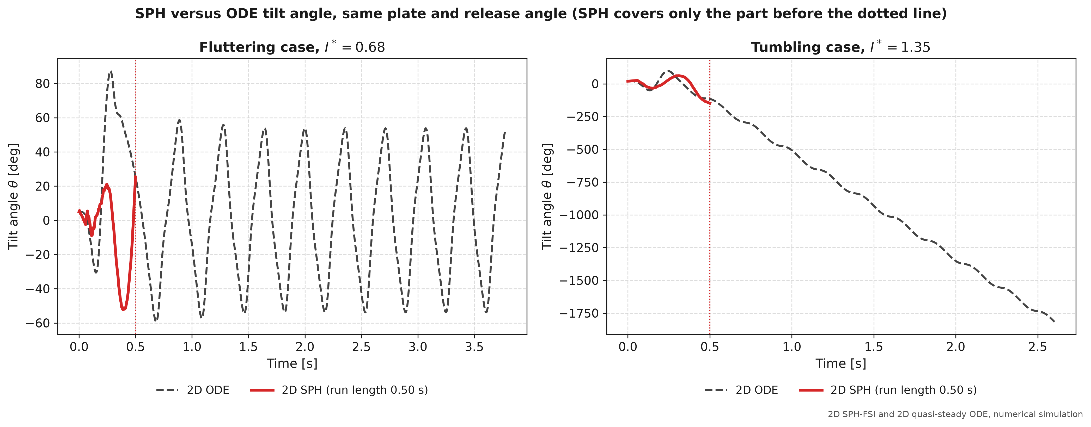
Figure 10. Tilt θ(t) from the 2D SPH solver and the 2D ODE over the first 0.50 s of the drop.
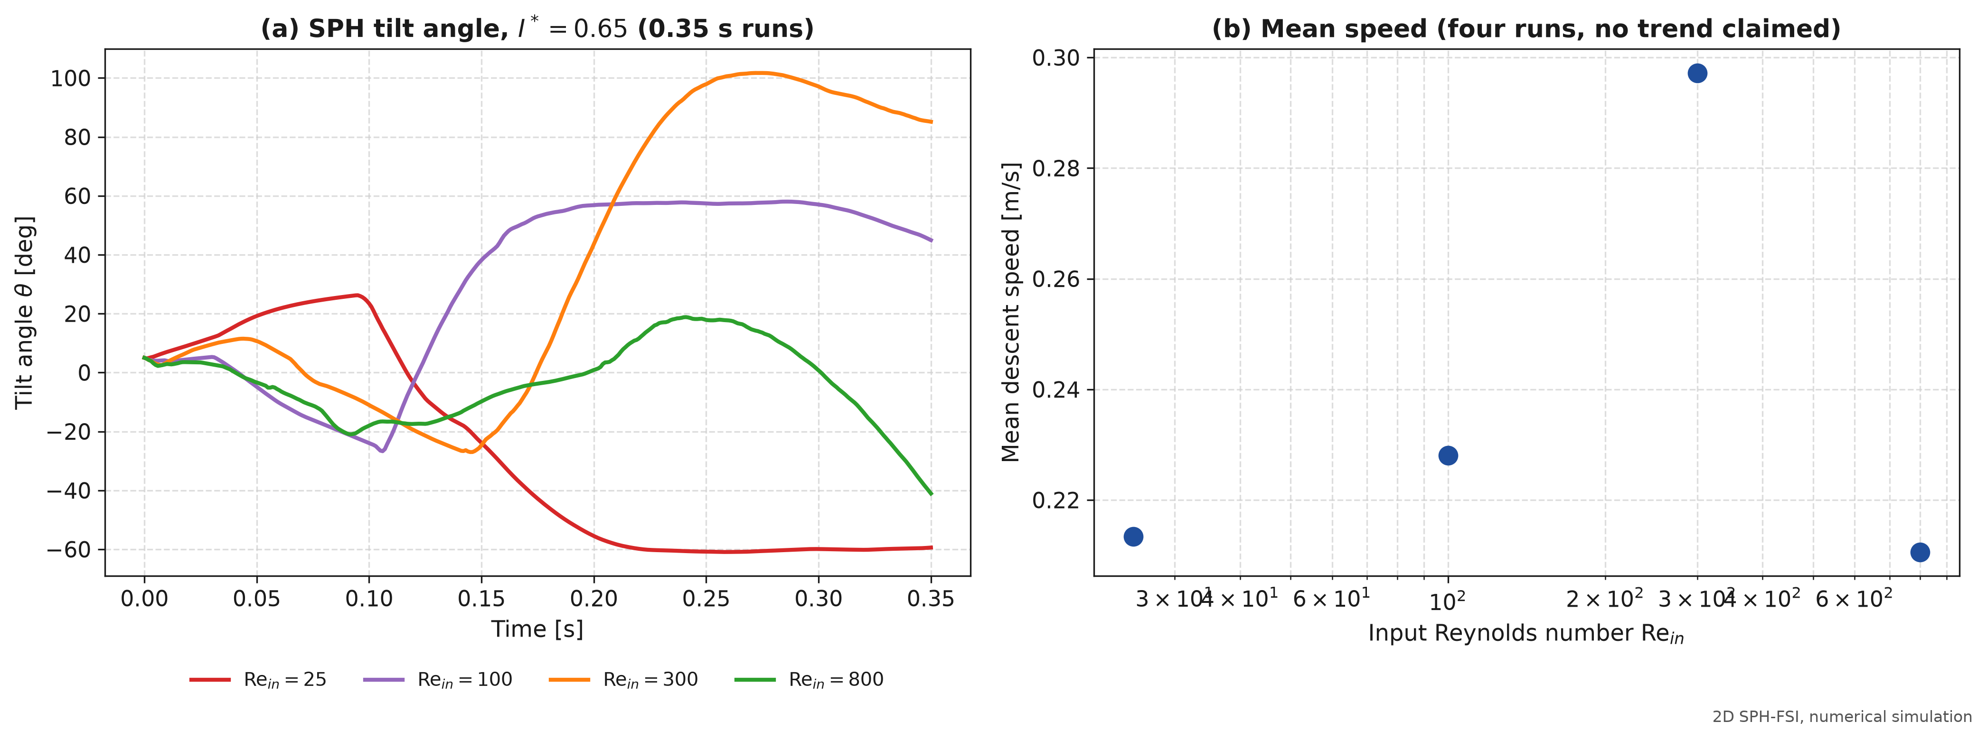
Figure 11. SPH viscosity sweep at I* = 0.65 for Re_{in} = 25, 100, 300 and 800. At Re_{in} = 25 the plate settles into a glide at about −60°.
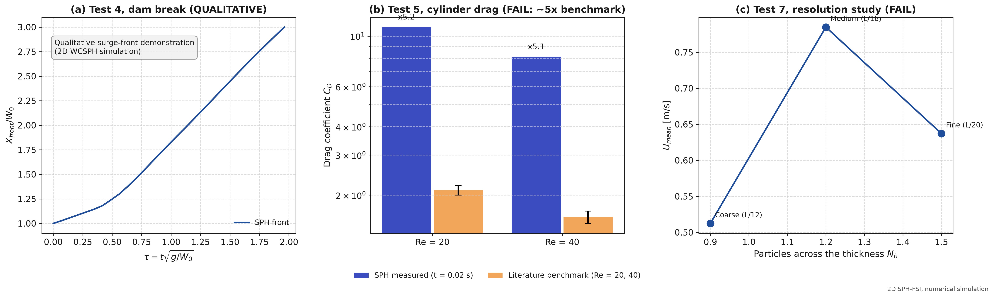
Figure 12. SPH benchmarks: (a) Test 4, dam-break surge front; (b) Test 5, drag on a fixed cylinder at Re = 20 and 40, where drag is over-predicted; (c) Test 7, grid convergence (23.2% change between L/16 and L/20).

5. Limitations
- Two dimensions. The model describes a long plate, not a disk. Coins also have tip vortices and out-of-plane rotation, which can shift the regime boundaries.
- No dependence on Re. The coefficients are constant, so the model cannot show how the regimes change with Reynolds number. That needs a flow solver.
- No experiments of my own. All validation is against published data. The nine-coin catalogue is simulated only.
- Calibrated damping. The agreement of I*_{c} with experiment depends on the value of μ₁.
- SPH accuracy. The SPH solver is not grid-converged and over-predicts drag on thin bodies, so its results are qualitative.

6. Conclusion
- Inertia sorts the motion. In the model, low I* gives fluttering, I* from 1.25 to 1.45 gives tumbling, and I* from 1.5 to 2.75 gives irregular motion. For h/L = 0.075 and θ₀ = 20° the flutter-to-tumble threshold is near I* = 1.2.
- Damping matters. With μ₁ = 0.20 the threshold agrees with experiment within its uncertainty. With μ₁ = 0.01 it falls by about 19%, to 0.97.
- Sensitivity grows with inertia. No drop released at 20° reached steady descent. Landing scatter rises from 15 mm at I* = 0.80 to 714 mm at I* = 3.50, consistent with sensitive dependence on initial conditions.
- Viscosity damps pitching. The SPH solver shows that high viscosity (Re_{in} = 25) suppresses pitching oscillations, but its boundary-layer resolution is not yet good enough for quantitative results.

References
1. S. B. Field, M. Klaus, M. G. Moore and F. Nori, “Chaotic dynamics of falling disks,” Nature 388, 252–254 (1997). https://doi.org/10.1038/40817
2. A. Belmonte, H. Eisenberg and E. Moses, “From flutter to tumble: Inertial drag and Froude similarity in falling paper,” Phys. Rev. Lett. 81, 345–348 (1998). https://doi.org/10.1103/PhysRevLett.81.345
3. U. Pesavento and Z. J. Wang, “Falling paper: Navier–Stokes solutions, model of fluid forces, and center of mass elevation,” Phys. Rev. Lett. 93, 144501 (2004). https://doi.org/10.1103/PhysRevLett.93.144501
4. A. Andersen, U. Pesavento and Z. J. Wang, “Unsteady aerodynamics of fluttering and tumbling plates,” J. Fluid Mech. 541, 65–90 (2005a). https://doi.org/10.1017/S002211200500594X
5. A. Andersen, U. Pesavento and Z. J. Wang, “Analysis of transitions between fluttering, tumbling and steady descent of falling cards,” J. Fluid Mech. 541, 91–104 (2005b). https://doi.org/10.1017/S0022112005005847
6. H. Lamb, Hydrodynamics, 6th ed. (Cambridge University Press, Cambridge, 1932).
7. J. P. Morris, P. J. Fox and Y. Zhu, “Modeling low Reynolds number incompressible flows using SPH,” J. Comput. Phys. 136, 214–226 (1997).
8. N. Akinci, M. Ihmsen, G. Akinci, B. Solenthaler and M. Teschner, “Versatile rigid-fluid coupling for incompressible SPH,” ACM Trans. Graph. 31(4), 62 (2012).
9. S. Adami, X. Y. Hu and N. A. Adams, “A generalized wall boundary condition for smoothed particle hydrodynamics,” J. Comput. Phys. 231, 7057–7075 (2012).
10. O. Novotný, V. Přibyl and M. Ambros (Team Olomoucké srnky), "autumn-coin: 3D stereo tracking and quasi-steady simulation of coins falling through water," GitHub repository (MIT License), https://github.com/ondrej-cloud/autumn-coin (2024).

