# **Functional and Non-Functional requirements**

Overall, the app will allow the user to signup and have alcohol delivered to their homes. The background colour will be white while the buttons and text will follow a blue colour palette scheme. It will be mobile based which will be able to support multiple mobile operating systems.

## Slides 1-3

When the user clicks on the app icon for “Drinks2you”, the app opens, and the user is taken to the welcome screen. The app opens at an optimal speed since it is lightweight.

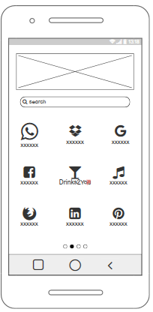

## Slides 3-5

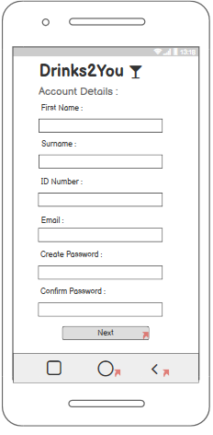The welcome page will allow the user to either **sign-in** or **sign-up.** If the user needs to sign-in then an email address and password needs to be inputted in. Signing up takes the user to a separate screen where they will have to enter their “Account Details”. The account details will prompt the user to enter their First and last name, ID number, email, and password for the account.

The user will then also be required to enter their address in the follow-up screen before being able to create their account. During all this their will be a green progress bar that indicates how far the user is in the signing-up process.

## Slides 6-9

The home screen has a search bar where the user can input the name of a specific type of drink the user is looking for. The best-sellers and daily-deals will also be on the home screen, and the user will be able to **add** these items to their cart if they want to. The icons at the bottom will follow a blue colour scheme.

If the browse button is selected the system will take the user to the “Browse screen”, where there are multiple categories of alcohol for the user to choose from. The system should not take long to load this page as it is only the categories being displayed. Every alternate category will have a dark colour scheme than the next.

## Slides 10-12

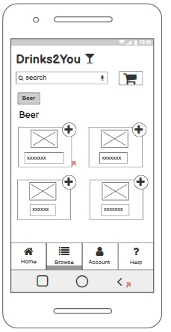Once a category is selected, the system will take the user to a separate page where only the selected type of drink will be displayed. The user will be able to add these products by clicking on it. Once an item is selected, a small pop-up menu will be displayed in the centre of the screen, where the user can choose the **quantity** of the product, add to cart, or cancel their selection. This menu will also display the price and update it as the user increases the quantity.

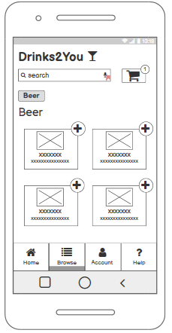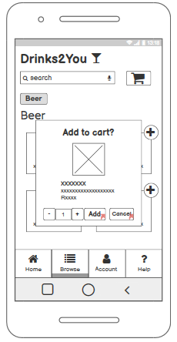

Once added, the product will be instantly added to the cart and a notification will be displayed on the cart icon in the top-right corner of the screen. Each time another product is added, the number of items in the cart will be updated.

## Slides 13-15

If the name of a drink is inputted in the search bar, the system will display a list of this type of product shortly after. The drinks will be displayed with a short description and the price. This will be in a list type of format

The user can cancel their selection in the search bar by clicking the “X” icon which will lead them back to the previous category.

## Slides 16-18

Once the shopping cart icon has been selected, the system will take the user to a screen with all the items that the user added. The system will display the price and quantity of the selected products on this screen. At the bottom, the user may choose to either select the “Edit Cart” button, or the “Proceed to checkout”, button. By selecting the edit cart button, the system will take the user back to the screen where they can choose to increase/decrease the quantity or cancel which also removes the item from their cart.

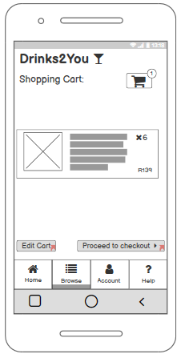

Choosing to proceed to checkout, the system would take the user to a screen where their name, and address needs to be inputted. There are buttons that allows the user to **edit** these details. These buttons would be slightly darker than the rest. At the bottom of the screen there is another button that when clicked, the system would take the user to the payment screen.