Student Affairs Service Management System
Software Engineering

1. Problem Title
Student Affairs Service Management System

2. Introduction
Problem Statement
Students often need to visit the Student Affairs office to ask about services, submit requests, provide documents, and check their application status. Handling these processes manually can cause long waiting times, repeated visits, difficulty tracking requests, and delays in communication between students and staff.

Proposed Solution
Our proposed solution is a Student Affairs Service Management System, a web-based application that allows students to view available services, submit requests, upload required documents, and track their request status online. Employees will be able to review requests, update their status, and approve or reject them with a reason when necessary. An administrator will manage users and available services.
The initial version will focus on services such as requesting a statement of student status, an enrollment certificate, and submitting inquiries. Additional features, including appointment booking, notifications, complaint management, and reports, can be added in the future.

3. Team Members and Roles in the System
1 | Sara Mohsen  Role: Student Module  Responsible for the student features, including viewing available services, submitting requests, uploading required documents, and tracking request status.
2 | Mona Ibrahim  Role: Student Affairs Employee Module  Responsible for the employee features, including viewing submitted requests, reviewing information and documents, updating request statuses, and approving or rejecting requests.
3 | Zainab El Sayed  Role: Request Management Module  Responsible for managing the request workflow, including handling request updates, tracking request progress, and ensuring that requests move through the correct statuses.
4 | Aya El Desokey  Role: Requirements Analysis and System Design  Responsible for identifying the problem, gathering functional and non-functional requirements, preparing user stories and use cases, and documenting system workflows.
5 | Ahmed Shams El Din  Role: Database and Data Management  Responsible for planning the database structure for students, employees, services, requests, and request statuses, and defining the relationships between them.
6 | Hossam Hamada  Role: Testing and System Integration  Responsible for preparing test cases, checking the main system functions, verifying that the modules work together correctly, and identifying software defects.

4. Functional Requirements
Agile User Stories & Acceptance Criteria — Structuring Functional Requirements
1. User Authentication
User Story:
As a student, Student Affairs employee, or administrator,
I want to log in to the system using my credentials,
So that I can securely access the functions available to my role.

Acceptance Criteria:
- The system must allow users to log in using valid credentials.
- The system must display an error message when invalid credentials are entered.
- The system must restrict access according to the user's role.
- The system must allow users to log out securely.

2. View Available Services
User Story:
As a student,
I want to view the available Student Affairs services and their requirements,
So that I can understand the procedures and documents needed before submitting a request.

Acceptance Criteria:
- The system must display the available services.
- The system must show the required information and documents for each service.
- The system must allow students to select a service to view its details.

3. Submit Service Requests
User Story:
As a student,
I want to submit service requests online and upload the required documents,
So that I can access university services without repeatedly visiting the Student Affairs office.

Acceptance Criteria:
- The system must allow students to select an available service.
- The system must provide a form for entering the required information.
- The system must allow students to upload supporting documents.
- The system must validate mandatory fields before accepting a submission.
- The system must confirm successful submission and assign a request reference number.

4. Track Request Status
User Story:
As a student,
I want to track the status of my submitted requests,
So that I can know the progress of each request without contacting Student Affairs repeatedly.

Acceptance Criteria:
- The system must display the student's submitted requests.
- The system must show the current status of each request.
- The system must display relevant request details and status updates.
- The system must reflect status changes made by authorized employees.

5. Manage Student Requests
User Story:
As a Student Affairs employee,
I want to review student requests and update their statuses,
So that I can process applications efficiently and keep students informed.

Acceptance Criteria:
- The system must allow authorized employees to view submitted requests.
- The system must display request details and uploaded documents.
- The system must allow employees to update request statuses.
- The system must allow employees to add comments when necessary.
- The system must save status updates accurately.

6. Notifications and Communication
User Story:
As a student,
I want to receive notifications when my request status changes,
So that I can stay informed about the progress of my application.

Acceptance Criteria:
- The system must notify students when their request status changes.
- The system must display the updated status and relevant information.
- Notifications must be associated with the correct student and request.

7. Request History
User Story:
As a student,
I want to view my previous service requests and their final statuses,
So that I can review my application history whenever needed.

Acceptance Criteria:
- The system must maintain a history of submitted requests.
- The system must allow students to view their previous requests.
- The system must display the final status and relevant details of each request.
- Students must only be able to access their own request history.

8. Manage Users and Services
User Story:
As an administrator,
I want to manage user accounts and the available Student Affairs services,
So that only authorized people can access the system and students always see up-to-date services.

Acceptance Criteria:
- The system must allow administrators to create, update, and deactivate user accounts.
- The system must allow administrators to assign a role (student, employee, or administrator) to each user.
- The system must allow administrators to add, edit, and enable or disable services and their required documents.
- The system must show students only the services that are available.
- The system must restrict user and service management to administrators only.

5. Non-Functional Requirements
1. Security
- The system must protect student information and uploaded documents from unauthorized access.
- The system must enforce role-based access control.
- The system must handle authentication credentials securely.

2. Performance
- The system must respond to normal user actions within an acceptable time under expected operating conditions.
- The system must process request submissions and status updates without unnecessary delays.

3. Usability
- The system must provide a clear, intuitive, and user-friendly interface.
- The interface must make it easy for students, employees, and administrators to complete their tasks.

4. Reliability and Availability
- The system must process and store request information accurately.
- The system must remain available during designated service hours, except during planned maintenance or unexpected outages.

5. Compatibility
- The system must support commonly used modern web browsers.
- The interface must adapt to desktop, tablet, and mobile screen sizes.

6. Maintainability
- The system must use an organized structure that supports future updates, bug fixes, and maintenance.

7. Data Integrity
- The system must validate required information before accepting requests.
- The system must maintain accurate and consistent request statuses and records.

8. Privacy
- The system must restrict access to personal information to authorized users.
- The system must handle student data according to applicable university policies and data protection requirements.

6. Actors and Use Cases
A use case is a goal that an actor achieves with the system. It describes WHAT the system does for the user, not HOW it does it. The tables below show who the actors are and which use cases each of them takes part in.

6.1 Actors
Actor | Type | Use cases
Student | Primary | Log In / Log Out, View Available Services, Submit Service Request, Track Request Status, View Request History
Student Affairs Employee | Primary | Log In / Log Out, Review Student Requests, Update Request Status
Admin | Primary | Log In / Log Out, Manage Users, Manage Services
All three actors are primary actors: they start the interaction to reach their own goal. The current requirements contain no secondary (external system) actors.

6.2 Main Use Cases
ID | Use Case | Actor | Goal
UC-01 | Log In / Log Out | Student, Employee, Admin | Access the system securely according to the user’s role.
UC-02 | View Available Services | Student | See the available services and what each one requires.
UC-03 | Submit Service Request | Student | Send a service request online with the required information and documents.
UC-04 | Track Request Status | Student | Follow the progress of a submitted request.
UC-05 | View Request History | Student | Review previous requests and their final statuses.
UC-06 | Review Student Requests | Employee | Open submitted requests and examine their details and documents.
UC-07 | Update Request Status | Employee | Move a request to a new status and keep the student informed.
UC-08 | Manage Users | Admin | Create and update user accounts and assign their roles.
UC-09 | Manage Services | Admin | Add and update services, their required documents, and their availability.

7. Use Case Diagram
The diagram shows the system boundary (the rectangle), the actors outside it, and the main use cases inside it. A solid line connects an actor to a use case that the actor takes part in. Log In / Log Out is shared by all three actors.
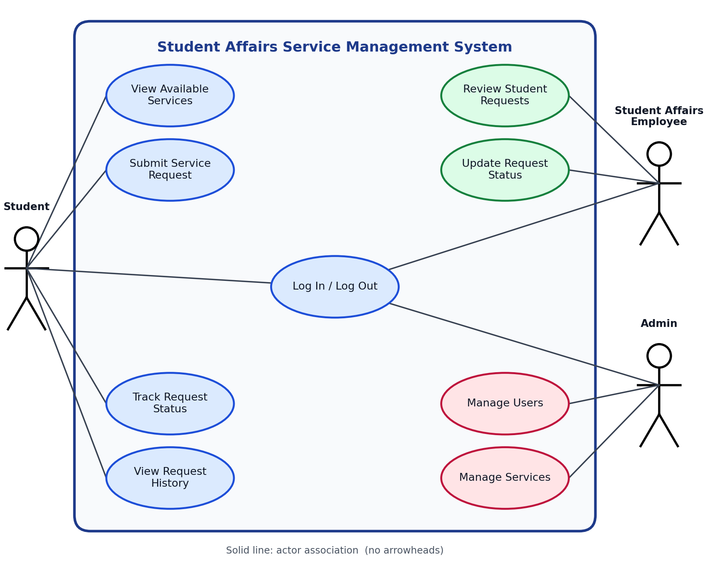

8. Include and Extend Relationships
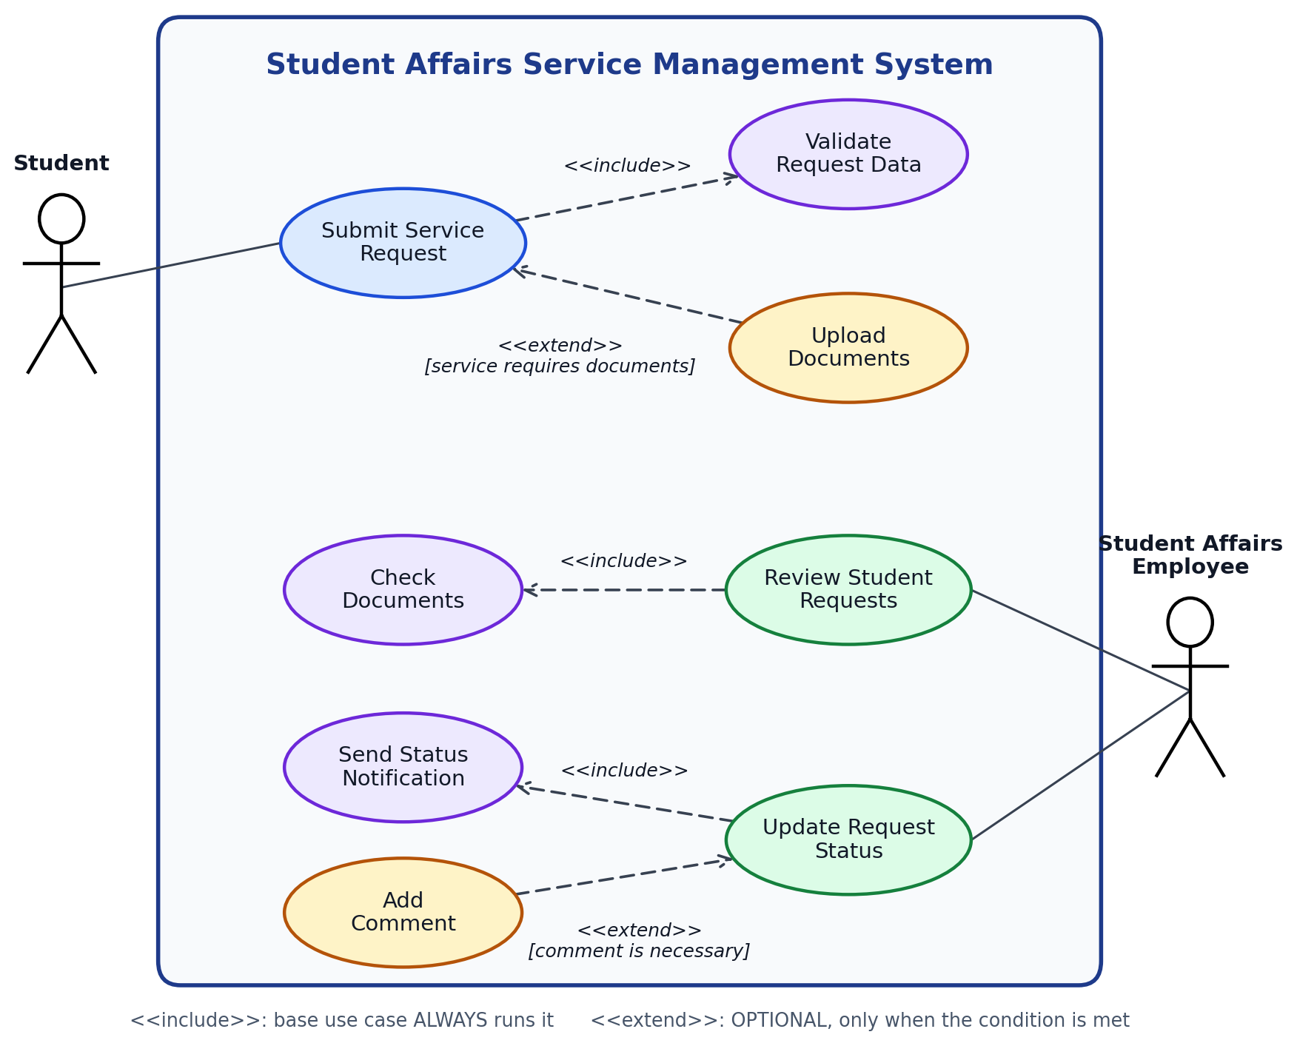

9. Use Case Descriptions
The diagram gives the overview; the description gives the details. We selected the two most important use cases in the system: UC-03 Submit Service Request (the student’s main goal) and UC-07 Update Request Status (the employee’s main goal).

9.1 UC-03: Submit Service Request
Field | Description
Primary Actor | Student
Goal | Submit a Student Affairs service request online with the required information and supporting documents.
Pre-Conditions | 1. The student has an active account.  2. The student is logged in.  3. The requested service is available.
Post-Conditions | 1. The request is saved successfully.  2. A unique request reference number is generated.  3. The initial status is Pending.  4. A confirmation is displayed to the student.
Main Success Scenario | 1. The student selects “View Available Services.”  2. The system displays the available services and their requirements.  3. The student selects a service.  4. The system displays the request form.  5. The student enters the required information.  6. The student uploads the required documents, if the service requires them.  7. The student submits the request.  8. The system validates the information and the document requirements.  9. The system saves the request and generates a unique reference number.  10. The system sets the status to “Pending.”  11. The system displays a submission confirmation and the reference number.

9.2 UC-07: Update Request Status
Field | Description
Primary Actor | Student Affairs Employee
Goal | Update the status of a student’s request (Under Review, Approved, or Rejected) and keep the student informed.
Pre-Conditions | 1. The employee is logged in with the employee role.  2. At least one submitted request exists.  3. The employee has opened a request (UC-06 Review Student Requests).
Post-Conditions | 1. The new status is saved with the date of the update.  2. The student is notified of the change.  3. The student sees the updated status when tracking the request.  4. Any comment added by the employee is saved with the request.
Main Success Scenario | 1. The employee selects “Review Student Requests.”  2. The system displays the submitted requests with their current statuses.  3. The employee selects a request.  4. The system displays the request details and the uploaded documents.  5. The employee reviews the information and checks the documents.  6. The employee chooses a new status: Under Review, Approved, or Rejected.  7. The employee adds a comment if necessary, such as the reason for a rejection.  8. The employee confirms the update.  9. The system validates and saves the new status.  10. The system notifies the student of the status change.  11. The system displays a confirmation and the updated status in the requests list.

10. Class Diagram
The class diagram shows the static structure of the system: the classes, their attributes (with access modifiers), their methods, and the relationships between them. It is derived from the functional requirements (Section 4), the actors and use cases (Section 6) and the use case descriptions (Section 9).
Access modifiers: - private, + public.

10.1 Classes
Class | Purpose | Attributes | Methods
User (abstract) | Common data and behaviour of every system user | -userId: int  -fullName: String  -email: String  -passwordHash: String | +login(): boolean  +logout(): void
Student | Student who requests services (UC-02 to UC-05) | -studentCode: String  -level: int | +viewServices()  +submitRequest()  +trackRequest()  +viewHistory()
Employee | Student Affairs employee who processes requests (UC-06, UC-07) | -employeeCode: String  -jobTitle: String | +reviewRequests()  +updateStatus()
Admin | Administrator who manages users and services (UC-08, UC-09) | (inherited only) | +manageUsers()  +manageServices()
Faculty | Faculty the student belongs to | -facultyId: int  -name: String | -
Service | A Student Affairs service (statement of student status, enrollment certificate, inquiry) | -serviceId: int  -name: String  -description: String  -isAvailable: boolean | -
RequiredDocument | A document that a service requires | -docId: int  -name: String  -isMandatory: boolean | -
Request | A service request submitted by a student | -requestId: int  -referenceNumber: String  -details: String  -submittedAt: Date  -status: RequestStatus | +changeStatus()
UploadedDocument | A file uploaded by the student with a request | -documentId: int  -fileName: String  -filePath: String  -uploadedAt: Date | -
StatusUpdate | One entry in the status history of a request | -updateId: int  -oldStatus: RequestStatus  -newStatus: RequestStatus  -comment: String  -updatedAt: Date | -
Notification | Message sent to a student when a request status changes | -notificationId: int  -message: String  -isRead: boolean  -createdAt: Date | +markAsRead()
RequestStatus (enumeration) | Allowed request statuses | Pending  UnderReview  Approved  Rejected | -

10.2 Relationships
# | Relationship | Type | Multiplicity | Justification
1 | User, Student | Inheritance | - | A student is a user and inherits login data and behaviour
2 | User, Employee | Inheritance | - | An employee is a user
3 | User, Admin | Inheritance | - | An administrator is a user
4 | Faculty, Student | Aggregation | 1 to * | A faculty groups students, but a student is an independent object
5 | Student, Request | Association (submits) | 1 to * | A student can submit many requests; each request belongs to one student
6 | Service, Request | Association (requested in) | 1 to * | A service can be requested many times; each request is for one service
7 | Service, RequiredDocument | Composition (requires) | 1 to * | Required documents belong to one service and are deleted with it
8 | Request, UploadedDocument | Composition (contains) | 1 to * | Uploaded files exist only as part of a request
9 | Request, StatusUpdate | Composition (history) | 1 to * | The status history exists only as part of a request
10 | Employee, StatusUpdate | Association (makes) | 1 to * | Every status change is made by one employee
11 | Admin, Service | Association (manages) | 1 to * | The administrator manages the available services; every service is managed by one administrator
12 | Student, Notification | Association (receives) | 1 to * | Notifications are sent to the right student
13 | Request, Notification | Association (triggers) | 1 to * | A notification is linked to the request whose status changed
14 | UploadedDocument, RequiredDocument | Association (fulfills) | * (UploadedDocument) to 0..1 (RequiredDocument) | An uploaded file may fulfill at most one required document; a required document can be fulfilled by many uploaded files (one per request)
15 | Request, RequestStatus | Dependency (uses) | - | The request status takes its value from the enumeration

10.3 Class diagram
The diagram below shows all classes and relationships listed above.
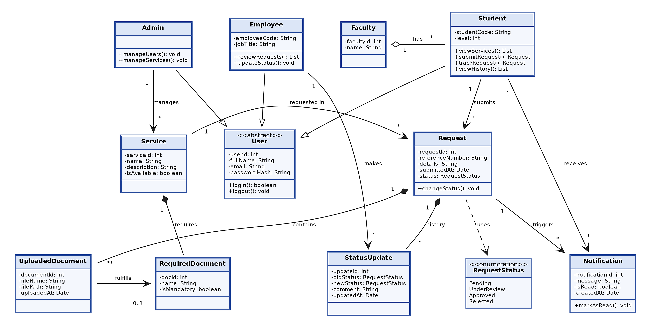
Figure: Class diagram

11. Mapping the Class Diagram to the Relational Model
The table below shows which relational table each class is mapped to. Inheritance uses one table for the parent and one for each child (the child primary key is also a foreign key to the parent); the enumeration becomes a CHECK constraint; methods are not mapped because they are behaviour, not stored data.
Class | Table | Notes
User | users | Includes a role column (Student, Employee, Admin)
Student | students | PK user_id is also a FK to users
Employee | employees | PK user_id is also a FK to users
Admin | admins | PK user_id is also a FK to users
Faculty | faculty | -
Service | services | FK managed_by to admins
RequiredDocument | required_documents | FK service_id to services (composition)
Request | requests | FKs student_id and service_id; status checked against the enumeration
UploadedDocument | uploaded_documents | FK request_id (composition); optional FK doc_id
StatusUpdate | status_updates | FK request_id (composition); FK employee_id
Notification | notifications | FKs student_id and request_id
RequestStatus | CHECK constraint | Values: Pending, UnderReview, Approved, Rejected

12. Relational Database Schema
PK = Primary Key, FK = Foreign Key.

12.1 Tables
Table | Columns | Keys
faculty | faculty_id, name | PK faculty_id
users | user_id, full_name, email, password_hash, role | PK user_id
students | user_id, student_code, level, faculty_id | PK user_id; FK user_id, faculty_id
employees | user_id, employee_code, job_title | PK user_id; FK user_id
admins | user_id | PK user_id; FK user_id
services | service_id, name, description, is_available, managed_by | PK service_id; FK managed_by
required_documents | doc_id, service_id, name, is_mandatory | PK doc_id; FK service_id
requests | request_id, reference_number, student_id, service_id, details, status, submitted_at | PK request_id; FK student_id, service_id
uploaded_documents | document_id, request_id, doc_id, file_name, file_path, uploaded_at | PK document_id; FK request_id, doc_id (nullable)
status_updates | update_id, request_id, employee_id, old_status, new_status, comment, updated_at | PK update_id; FK request_id, employee_id
notifications | notification_id, student_id, request_id, message, is_read, created_at | PK notification_id; FK student_id, request_id

12.2 Entity-Relationship diagram
Each table is shown with its columns (right-aligned) and key markers: PK = primary key, FK = foreign key, UK = unique. Line ends use crow’s foot notation: a single bar means exactly one, a crow’s foot means many, and a circle means optional.
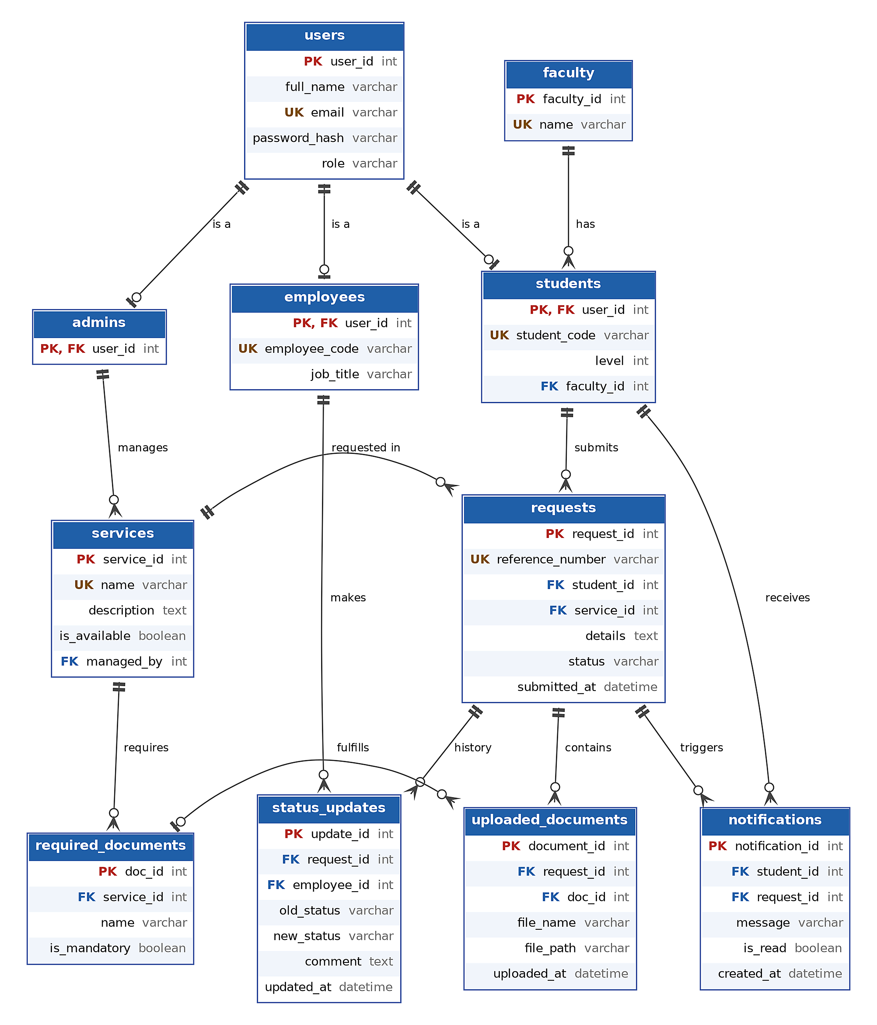

12.3 Constraints and their source in the requirements
Constraint | Table.column | Requirement it supports
UNIQUE users.email | users.email | Secure login (Requirement 1)
CHECK role IN (Student, Employee, Admin) | users.role | Role-based access control
UNIQUE requests.reference_number | requests.reference_number | Unique reference number for each request (Requirement 3)
CHECK status IN (Pending, UnderReview, Approved, Rejected) | requests.status  status_updates.old_status  status_updates.new_status | Consistent request statuses (Data Integrity)
DEFAULT 'Pending' | requests.status | Initial status is Pending (UC-03)
NOT NULL | Mandatory columns (e.g. requests.student_id, requests.service_id, students.level, services.managed_by) | Validate mandatory fields before submission; every service must be managed by an administrator (UC-09 Manage Services)
CHECK new_status <> 'Rejected' OR comment IS NOT NULL | status_updates | A rejection must have a reason (UC-07)
CHECK level BETWEEN 1 AND 7 | students.level | Academic level; the upper bound of 7 covers programs of up to seven academic years (e.g. medicine)
UNIQUE | services.name, students.student_code, employees.employee_code | No duplicate services or users
Students see only their own requests | requests.student_id (enforced in the application) | Request history privacy (Requirement 7)
Role consistency (enforced in the application or by a trigger) | users.role vs. students / employees / admins | A user must exist in exactly one child table, the one matching the role value. This is a known limitation of the table-per-subclass mapping and cannot be expressed with a simple CHECK constraint

