First_Model_Integrated

Usage
This decision support system is designed for satellite operators to effectively manage conjunction risks in space. It utilizes machine learning and reinforcement learning to minimize false alarms and optimize maneuver decisions, thereby enhancing safety and operational efficiency.

Main Features
- Data-Driven Alert Generation: Real-time assessment of Conjunction Data Messages for timely collision alerts.
- Intelligent Alert Filtering: Machine learning classifiers reduce false alarms and improve alert credibility.
- Cost-Optimized Maneuver Recommendations: Provides maneuver suggestions balancing safety with operational costs.
- Reinforcement Learning Framework: A conceptual framework for future autonomous decision-making in maneuver optimization.

Idea
The core idea is to develop an integrated decision support system that leverages advanced AI techniques to categorize risks associated with satellite conjunctions. By assessing collision probabilities and alert credibility, the system aims to automate and refine the decision-making process for satellite maneuvers.

Steps
- Data Collection: Utilize Conjunction Data Messages (CDMs) in CCSDS format.
- Feature Engineering: Create new features to enhance predictive capability, including time metrics and object characteristics.
- Model Development: Train a RandomForestRegressor for collision probability prediction and a RandomForestClassifier for alert credibility.
- Maneuver Optimization: Implement simulation functions to assess the impact of proposed maneuvers.
- Reinforcement Learning: Define state and action spaces for further development of autonomous optimization policies.

Accuracy & Results
- Alert Credibility Classification: The RandomForestClassifier achieves an F1-score of 0.9663, with high precision (96.45%) and recall (96.80%).
- Collision Probability Prediction: The RandomForestRegressor records an R² score of 0.5922, indicating a robust ability to explain variance in collision probabilitie
- Classifier accuracy: 0.9573
- The estimated alert reduction percentage is -0.37%.

- Visualization Analysis
The 3D spatial visualizations (Images 1-2) depict conjunction geometry at Time of Closest Approach:
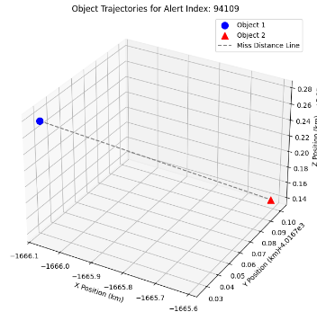
Image 1 (Alert 94109): Shows substantial spatial separation (~0.2 km in z-axis) with miss distance connecting the two objects. The geometry suggests a relatively low-risk conjunction with adequate clearance.
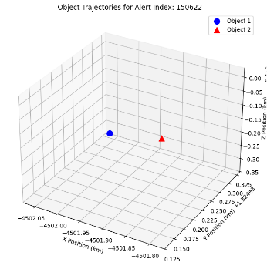
Image 2 (Alert 150622): Demonstrates closer proximity in the y-z plane with smaller spatial separation. The nearly co-planar trajectories indicate higher collision risk requiring careful monitoring.These visualizations provide operators with intuitive spatial context for decision-making, complementing quantitative risk assessments.
- Feature Correlation Analysis
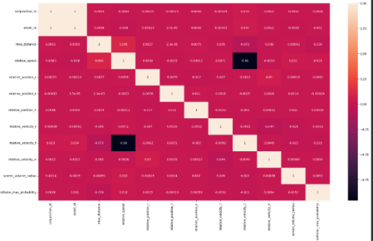
- Image 3 presents the correlation heatmap for key numerical features:
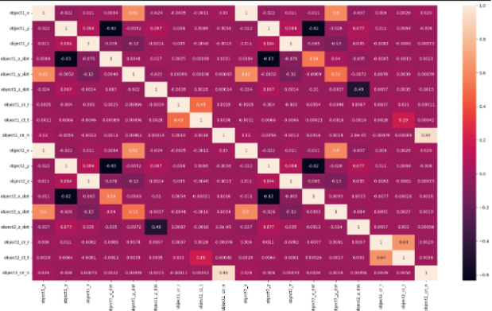
Image 4 shows extended correlation matrix including engineered features:

