Cairo University  
Faculty of Computers and Information



**CS251**

**Software Engineering I**

Code Brain

Software Design

Esraa Ragab

Esraa Gamal

Aya Fawky

Alaa Adel

12/2016

Contents

Instructions [To be removed] 3

Team 3

Document Purpose and Audience 3

System Models 3

I. Class diagrams 3

Important Algorithm 5

II. Sequence diagrams 5

Class - Sequence Usage Table 7

Ownership Report 8

Policy Regarding Plagiarism: 8

References 8

Authors 8

Team

|  |  |  |  |
| --- | --- | --- | --- |
| **ID** | **Name** | **Email** | **Mobile** |
| 20140065 | Alaa Adel Abd El-Hafiz | Alaa.adel255@gmail.com | 01150249993 |
| 20140052 | Esraa Gamal Ragab | Asraagamal22@yahoo.com | 01222839476 |
| 20140053 | Esraa Ragab Abd El-satar | Esraaragab016@gmail.com | 01285883082 |
| 20140086 | Aya Fawky Abd El-Atty | ayafawky@gmail.com | 01060865439 |

# Document Purpose and Audience

This document will describe the **class diagram and sequence diagram** . we will see that the sequence diagram shows that how the behavior of a use case (or scenario) is distributed among its participating objects. And class diagram Find terms that developers or users need to clarify in order to understand the flow of events and Identify interface artifacts. This document to developers in team, project managers.

# System Models

## I. Class diagrams

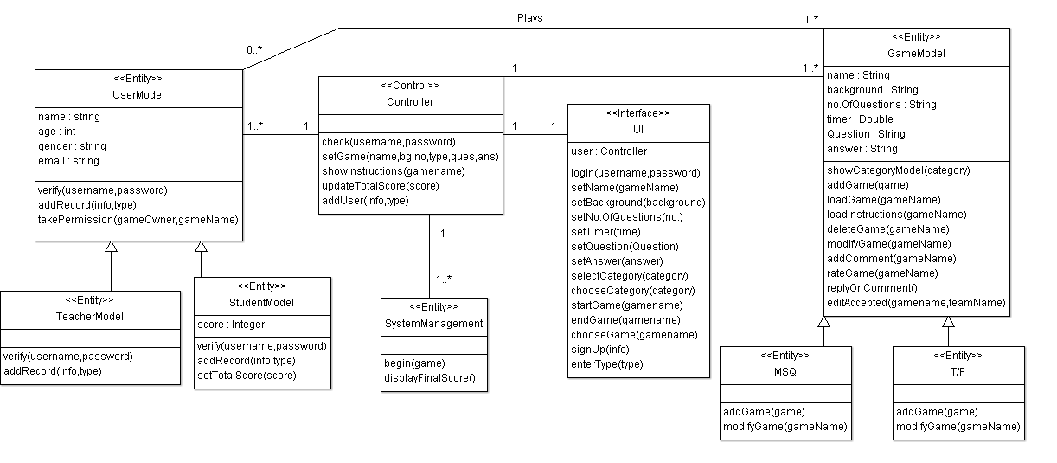

| **Class ID** | **Class Name** | **Description & Responsibility** |
| --- | --- | --- |
| 1 | UI | **Description:**  The usage of this class is the interface between user and our system.  **Responsibility:**  Show the form of login, contains methods to set a new game and select categories of game. |
| 2 | Game model | **Description:**  We use this class to add all information we need to add game and store new game inside it.  **Responsibilities:**  Responsible for adding new game and show description for each one. |
| 3 | User model    "abstract class" | **Description:**  Contains the information user like name, age email, and gender.  **Responsibilities:**  It verify username and password of user is valid or not to add this valid information as a user record in user model (DB). |
| 4 | System management | **Description:**  It manages features of the system as a whole.  **Responsibilities:**  Responsible for be beginning game and update and display score for each user. |
| 5 | Controller | **Description:**  It an intermediate layer that connect user interface and database or user model.  **Responsibilities:**  This class checks the validation of the user to add it and updated last version of game (set game) to store it in game model and show instruction of each game. |
| 6 | Teacher model | **Description:**  It stores all data that related to teacher.  **Responsibilities:**  Verify information of teacher to add it on teacher model. |
| 7 | Student model | **Description:**  It stores all information that related to student**.**  **Responsibilities:**  Verify student information to add it in student model |

### Important Algorithm

//This function allows the student or another teacher edit the game if he isn't the owner

takePermission(String GameOwner,String GameName){

Boolean flag=EditAccepted(GameName,String GameOwer);

If(flag==true)

Print Accepted;

Else

Print rejected;

}

## II. Sequence diagrams

**Add game->1**

**Play game->2**

**Registration->3**

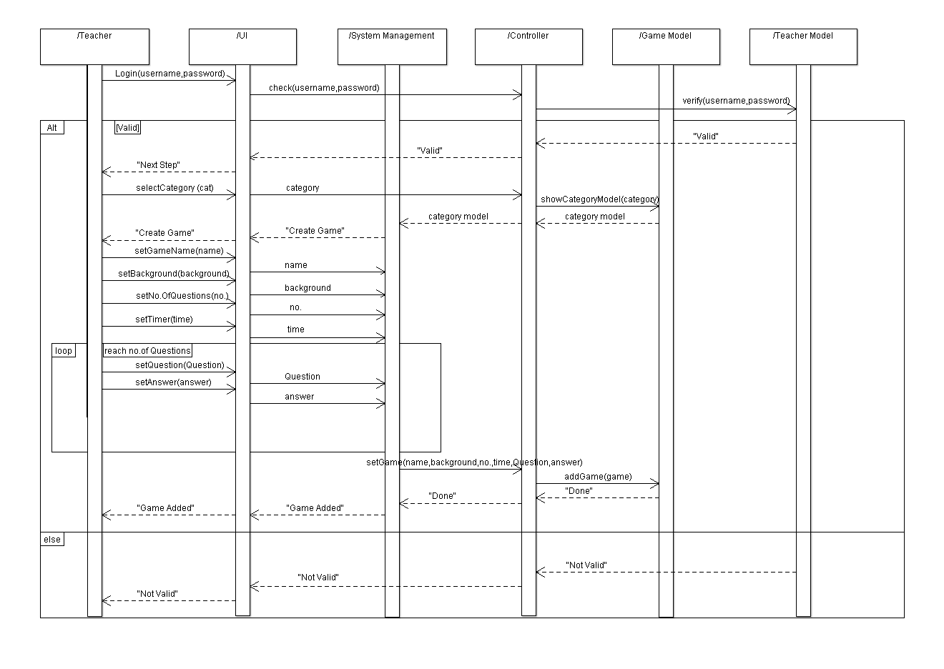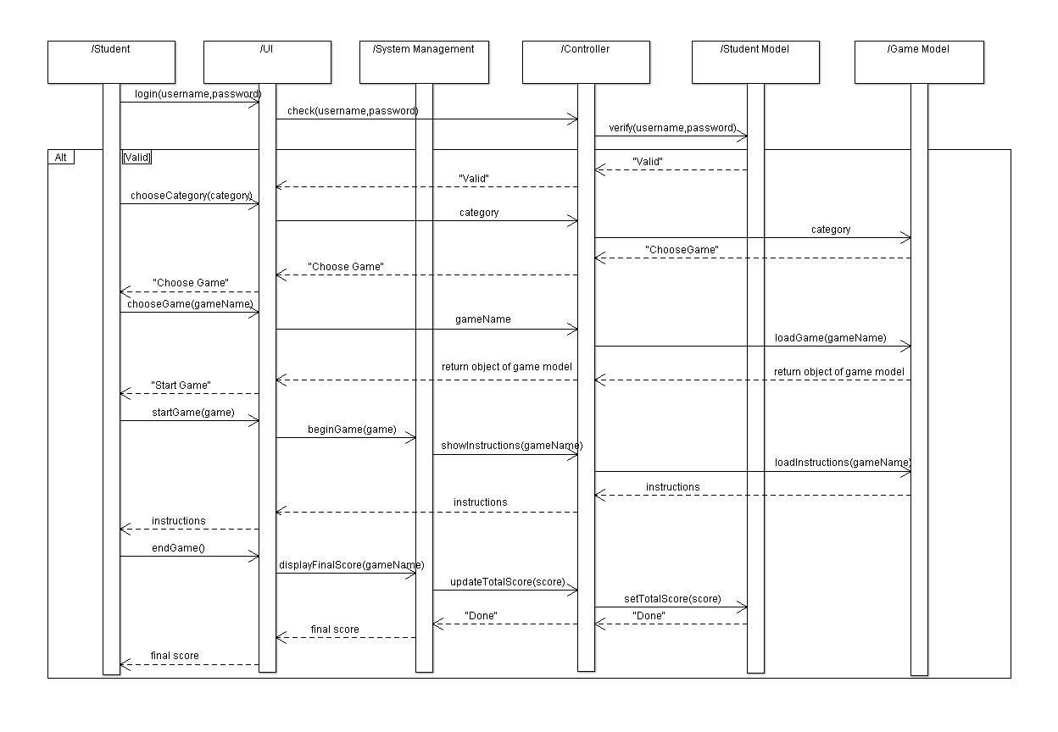

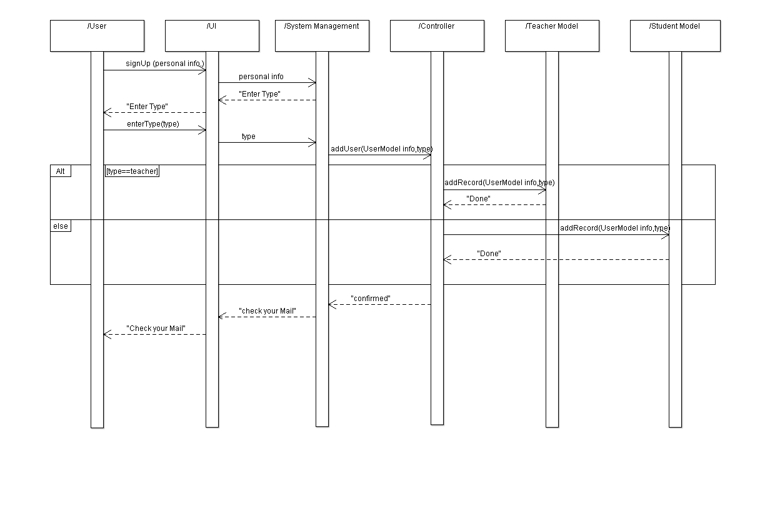

### Class - Sequence Usage Table

**Assume:**

**Add game->1**

**Play game->2**

**Registration->3**

| **Class Name** | **Sequence Diagrams** | **Overall used methods** |
| --- | --- | --- |
| UserModel | abstract class | Verify , AddRecord |
| UI | 1,2,3 | Login , SetGameName ,  SetBackgroundname ,  SetNoofQuest , SetTimer,SetQue. , SetAnswer , SelectCat , ChooseCat , StartGame , ChooseGame , EndGame , SignUp , EnterType |
| SystemManagement | 1,2,3 | BeginGame , DisplayFinalScore |
| GameModel | 1,2 | ShowCatModel , AddGame , LoadGame , LoadInstruction |
| TeacherModel | 1,3 | Verify , AddRecord |
| StudentModel | 2,3 | Verify , SetTotalScore , AddRecord |
| Controller | 1,2,3 | Check , SetGame , ShowInstructions , UpdateTotalScore , AddUser |

# Ownership Report

All team members worked on all components.

Alaa Adel 20140065 IS G 1

Aya Fawky 20140086 IS G 2

Esraa Ragab 20140053 IS G 1

Esraa Gamal 20140052 IS G 1

# 

# Policy Regarding Plagiarism:

**Students have collective ownership and responsibility of their project. Any violation of academic honesty will have severe consequences and punishment for ALL team members.**

1. تشجع الكلية على مناقشة الأفكار و تبادل المعلومات و مناقشات الطلاب حيث يعتبر هذا جوهريا لعملية تعليمية سليمة
2. ساعد زملاءك على قدر ما تستطيع و حل لهم مشاكلهم فى الكود و لكن تبادل الحلول غير مقبول و يعتبر غشا.
3. أى حل يتشابه مع أى حل آخر بدرجة تقطع بأنهما منقولان من نفس المصدر سيعتبر أن صاحبيهما قد قاما بالغش.
4. قد توجد على النت برامج مشابهة لما نكتبه هنا أى نسخ من على النت يعتبر غشا يحاسب عليه صاحبه.
5. إذا لم تكن متأكدا أن فعلا ما يعد غشا فلتسأل المعيد أو أستاذ المادة.
6. فى حالة ثبوت الغش سيأخذ الطالب سالب درجة المسألة ، و فى حالة تكرار الغش سيرسب الطالب فى المقرر.

# References

* http://www.mhhe.com/engcs/compsci/pressman/graphics/Pressman5sepa/common/cs1/design.pdf

# Authors

* Mostafa Saad and Mohammad El-Ramly (Edited by Mohamed Samir)