CS352 Assignment 1
openGL init

Ayush Agrawal
180001011
01-04-2021

Q1. Bresenham Line - Code

#include <iostream>
#include <GL/glut.h>
#include <vector>
// #include <utility>
using namespace std;

const double WIDTH = 600;
const double HEIGHT = 600;

vector<pair<int,int>> points;

#define inRange(x1,x,x2) ((x>min(x1,x2))&&(x<max(x1,x2)))

vector<pair<int,int>> makeBresenham(int x1, int y1, int x2, int y2){
vector<pair<int,int>> points;
points.push_back({x1,y1});

int dx = x2-x1;
int dy = y2-y1;

bool mInv = 0;

if(abs(dy) > abs(dx)){
mInv = 1;
swap(x1, y1);
swap(x2, y2);
swap(dx, dy);
}

int stepX = (dx > 0);
int stepY = (dy > 0);

if(dx < 0) {
stepX = -1;
dx = -dx;
}
if(dy < 0) {
stepY = -1;
dy = -dy;
}

int x = x1;
int y = y1;

int p = 2*dy-dx;

while( x != x2 ){
if(p >= 0){
y += stepY;
p -= 2*dx;
}

// cout<<x<<" "<<y<<"\n";
if(mInv){
points.push_back({y,x});
} else {
points.push_back({x,y});
}
p += 2*dy;
x += stepX;
}

return points;
}

void initBresenham(){
cout<<"Enter the coordinates of the line - x1 y1 x2 y2\n";
cout<<"For the sake of viewing, keep the points in the range -600,600\n";

int x1 = -400, y1 = 50;
int x2 = 400, y2 = 200;

cin>>x1>>y1>>x2>>y2;

points = makeBresenham(x1, y1, x2, y2);
}

void drawBresenham(){
glClear(GL_COLOR_BUFFER_BIT);

glBegin(GL_LINES);
glVertex2f(-1, 0);
glVertex2f(1, 0);
glEnd();

glBegin(GL_LINES);
glVertex2f(0, -1);
glVertex2f(0, 1);
glEnd();

glBegin(GL_POINTS);
for(auto &point: points)
glVertex2f((double)point.first/WIDTH, (double)point.second/HEIGHT);
glEnd();

glFlush();
}

int main(int argc, char** argv){
initBresenham();
// GLute init and create window
glutInit(&argc, argv);
glutInitDisplayMode(GLUT_SINGLE);
glutInitWindowSize(WIDTH,HEIGHT);
glutInitWindowPosition(100,100);
glutCreateWindow("Bresenham Line");

// Register display callback
glutDisplayFunc(drawBresenham);

// Glut main Loop
glutMainLoop();
}

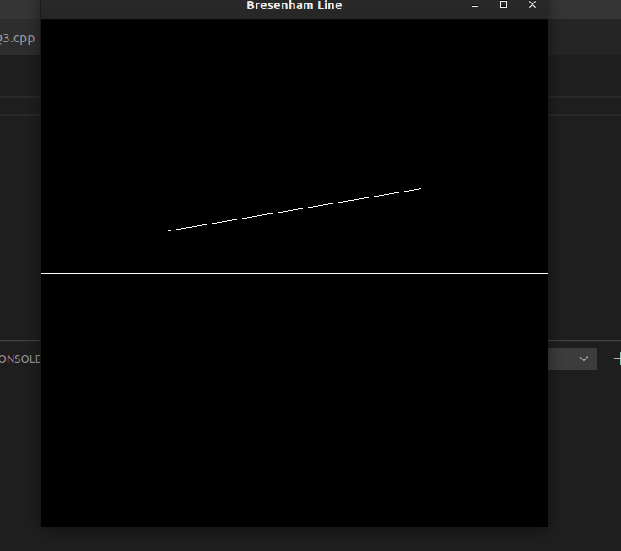

Q2. Polygon with Bresenham - Code
#include <iostream>
#include <GL/glut.h>
#include <vector>
// #include <utility>
using namespace std;

const double WIDTH = 600;
const double HEIGHT = 600;

vector<vector<pair<int,int>>> edges;

vector<pair<int,int>> makeBresenham(int x1, int y1, int x2, int y2){
vector<pair<int,int>> points;
points.push_back({x1,y1});

int dx = x2-x1;
int dy = y2-y1;

bool mInv = 0;

if(abs(dy) > abs(dx)){
mInv = 1;
swap(x1, y1);
swap(x2, y2);
swap(dx, dy);
}

int stepX = (dx > 0);
int stepY = (dy > 0);

if(dx < 0) {
stepX = -1;
dx = -dx;
}
if(dy < 0) {
stepY = -1;
dy = -dy;
}

int x = x1;
int y = y1;

int p = 2*dy-dx;

while( x != x2 ){
if(p >= 0){
y += stepY;
p -= 2*dx;
}

// cout<<x<<" "<<y<<"\n";
if(mInv){
points.push_back({y,x});
} else {
points.push_back({x,y});
}
p += 2*dy;
x += stepX;
}

return points;
}

void initBresenham(){
cout<<"For the sake of viewing, keep the points in the range -600,600\n";

cout<<"Enter the Number of vertices\n";
int n;cin>>n;
if(n < 3) {
cout<<"Atleast 3 vertices\n";
}
edges.resize(n);
vector<pair<int,int>> points = vector<pair<int,int>>(n);

cout<<"Enter Each vertice one by one\n";

for(int i=0;i<n;i++){
cin>>points[i].first>>points[i].second;
}
for(int i=0;i<n;i++){
int x1 = points[i].first;
int y1 = points[i].second;

int x2 = points[(i+1)%n].first;
int y2 = points[(i+1)%n].second;

cout<<"Edge from: "<<x1<<","<<y1<<" to "<<x2<<","<<y2<<"\n";
edges[i] = makeBresenham(x1,y1,x2,y2);
}

}

void drawBresenham(){
glClear(GL_COLOR_BUFFER_BIT);

glBegin(GL_LINES);
glVertex2f(-1, 0);
glVertex2f(1, 0);
glEnd();

glBegin(GL_LINES);
glVertex2f(0, -1);
glVertex2f(0, 1);
glEnd();

glBegin(GL_POINTS);
for(auto &edge: edges){
for(auto &point: edge)
glVertex2f((double)point.first/WIDTH, (double)point.second/HEIGHT);
}
glEnd();

glFlush();
}

int main(int argc, char** argv){
initBresenham();

// GLute init and create window
glutInit(&argc, argv);
glutInitDisplayMode(GLUT_SINGLE);
glutInitWindowSize(WIDTH,HEIGHT);
glutInitWindowPosition(100,100);
glutCreateWindow("Bresenham Polygon");

// Register display callback
glutDisplayFunc(drawBresenham);

// Glut main Loop
glutMainLoop();
}

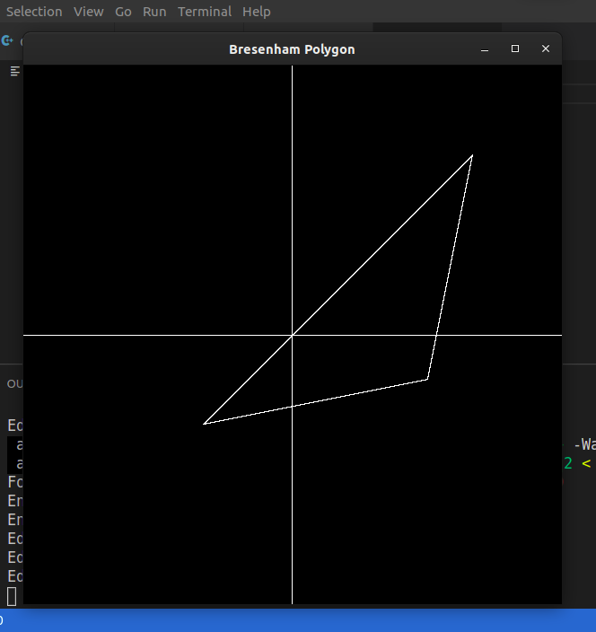

Q3. Circle using mid-point algo - Code.

#include <iostream>
#include <GL/glut.h>
#include <vector>
// #include <utility>
using namespace std;

const double WIDTH = 600;
const double HEIGHT = 600;

vector<pair<int,int>> points;

#define inRange(x1,x,x2) ((x>min(x1,x2))&&(x<max(x1,x2)))

void push_octant(int x, int y, int xc, int yc){
points.push_back({xc+x,xc+y});
points.push_back({xc+y,xc+x});
points.push_back({xc+y,xc-x});
points.push_back({xc+x,xc-y});
points.push_back({xc-x,xc-y});
points.push_back({xc-y,xc-x});
points.push_back({xc-y,xc+x});
points.push_back({xc-x,xc+y});
}

void makeCircle(int xc, int yc, int r){
int i=0;
int x = 0, y = r;
int P = 5-4*r;
while(x<y) {
x++;i++;
if(P<=0) {
P = P+8*x+12;
} else {
y=y-1;
P = P+8*(x-y)+20;
}
push_octant(x,y, xc, yc);
}
}

void initCircle(){
cout<<"Enter the dim of circle - x_center y_center radius\n";
cout<<"For the sake of viewing, keep the points in the range -600,600\n";

int x0 = 200, y0 = 200;
int r = 200;

cin>>x0>>y0>>r;

makeCircle(x0,y0,r);
}

void drawCircle(){
glClear(GL_COLOR_BUFFER_BIT);

glBegin(GL_LINES);
glVertex2f(-1, 0);
glVertex2f(1, 0);
glEnd();

glBegin(GL_LINES);
glVertex2f(0, -1);
glVertex2f(0, 1);
glEnd();

glBegin(GL_POINTS);
for(auto &point: points)
glVertex2f((double)point.first/WIDTH, (double)point.second/HEIGHT);
glEnd();

glFlush();
}

int main(int argc, char** argv){
initCircle();
// GLute init and create window
glutInit(&argc, argv);
glutInitDisplayMode(GLUT_SINGLE);
glutInitWindowSize(WIDTH,HEIGHT);
glutInitWindowPosition(100,100);
glutCreateWindow("Mid point Circle");

// Register display callback
glutDisplayFunc(drawCircle);

// Glut main Loop
glutMainLoop();
}

