CS352 Assignment 2
openGL Rotate Translate scale

Ayush Agrawal
180001011
01-04-2021

Q1. Make rectangle using inbuild function: Code -

#include <iostream>
#include <GL/glut.h>
#include <vector>

using namespace std;

// Set window height and width.

const double WIDTH = 500;
const double HEIGHT = 500;

int x0,yy0,x2,y2;

// take user input
void initPoints(){
cout<<"Enter the coordinates of the vertices in order.\n";
cout<<"For the sake of viewing, keep the points in the range -600,600\n";
cin>>x0>>yy0>>x2>>y2;
}

// main drawing function for glut
void drawObject(){
glClear(GL_COLOR_BUFFER_BIT);

// Draw the X-axis
glBegin(GL_LINES);
glVertex2f(-50, 0);
glVertex2f(50, 0);
glEnd();

// Draw the y-axis
glBegin(GL_LINES);
glVertex2f(0, -50);
glVertex2f(0, 50);
glEnd();

// draw rectangle
glRecti(x0, yy0, x2, y2);
glFlush();
}

void myInit (void){
// Reset background color with black (since all three argument is 0.0)
glClear(GL_COLOR_BUFFER_BIT);
glClearColor(0.0, 0.0, 0.0, 1.0);

// Set width of point to one unit
glMatrixMode(GL_PROJECTION);
glLoadIdentity();

// Set window size in X- and Y- direction
gluOrtho2D(-50, 50, -50, 50);
}

int main(int argc, char** argv){
initPoints();
// GLute init and create window
glutInit(&argc, argv);
glutInitDisplayMode(GLUT_SINGLE);
glutInitWindowSize(WIDTH,HEIGHT);
glutInitWindowPosition(600,100);
glutCreateWindow("Rectangle");

myInit();
glutDisplayFunc(drawObject);
glutMainLoop();
}
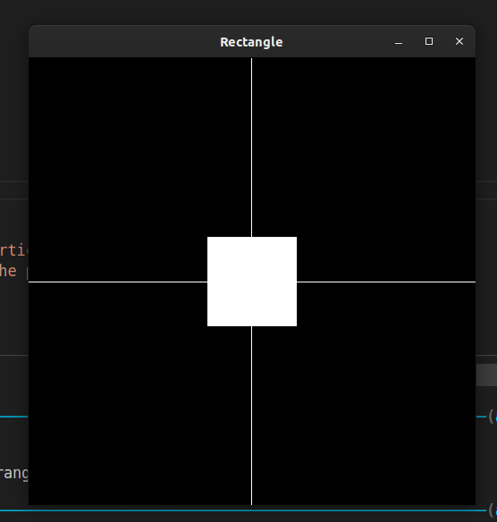

Q2. Scale Rotate Translate Sheer the polygon while running.

#include <iostream>
#include <GL/glut.h>
#include <vector>
#include <unistd.h>
// #include <utility>
using namespace std;

const double WIDTH = 500;
const double HEIGHT = 500;

int x0,yy0,x2,y2;

bool wantTranslate = false;
bool wantScale = false;
bool wantRotate = false;
bool wantSheer = false;

char inp;

// key inputs for transformation;
char TRANSLATE = 't';
char SCALE = 's';
char ROTATE = 'r';
char SHEER = 'x';

// take input from user;
void initPoints(){
cout<<"Enter the coordinates of the vertices in order.\n";
cout<<"For the sake of viewing, keep the points in the range -50,50\n";
cin>>x0>>yy0>>x2>>y2;
}

// main drawing loop;
void drawObject(){
glClear(GL_COLOR_BUFFER_BIT);

// use by default functions to scale, rotate, translate

if(wantTranslate){
cout<<"wantTranslate: "<<wantTranslate<<"\n";
glTranslatef(2, 2, 0);
}

// if scaled was pressed then scale.
if(wantScale){
cout<<"wantScale: "<<wantScale<<"\n";
glScalef(0.5, 0.5, 1);
} else {
// glPopMatrix();
}
if(wantRotate){
glRotatef(45, 0, 0, 1);
cout<<"wantRotate: "<<wantRotate<<"\n";
}
if(wantSheer){
// not available by default so using matrix multiplication

GLfloat m[16] = {
1.0f, 0.0f, 0.0f, 0.0f,
2.0f, 1.0f, 0.0f, 0.0f,
0.0f, 0.0f, 1.0f, 0.0f,
0.0f, 0.0f, 0.0f, 1.0f
};
glMultMatrixf(m);
cout<<"wantSheer: "<<wantSheer<<"\n";
}

glRecti(x0, yy0, x2, y2);

glFlush();
}

void parseInput(unsigned char inp, int x, int y){
wantTranslate = (inp == TRANSLATE);
wantRotate = (inp == ROTATE);
wantScale = (inp == SCALE);
wantSheer = (inp == SHEER);

drawObject();
}

void myInit (void){
// Reset background color with black (since all three argument is 0.0)
glClear(GL_COLOR_BUFFER_BIT);
glClearColor(0.0, 0.0, 0.0, 1.0);

// Set width of point to one unit
glMatrixMode(GL_PROJECTION);
glLoadIdentity();

// Set window size in X- and Y- direction
gluOrtho2D(-50, 50, -50, 50);
}

void reshape(int w,int h){
glClear(GL_COLOR_BUFFER_BIT);
glClearColor(0.0, 0.0, 0.0, 1.0);

// Set width of point to one unit
glMatrixMode(GL_PROJECTION);
glLoadIdentity();

// Set window size in X- and Y- direction
gluOrtho2D(-50, 50, -50, 50);
}

int main(int argc, char** argv){
initPoints();
// GLute init and create window
glutInit(&argc, argv);
glutInitDisplayMode(GLUT_SINGLE);
glutInitWindowSize(WIDTH,HEIGHT);
glutInitWindowPosition(600,100);
glutCreateWindow("Interactive Display");
myInit();

// Register display callback
glutDisplayFunc(drawObject);
glutReshapeFunc(reshape);
glutKeyboardFunc(parseInput);

glutMainLoop();
}

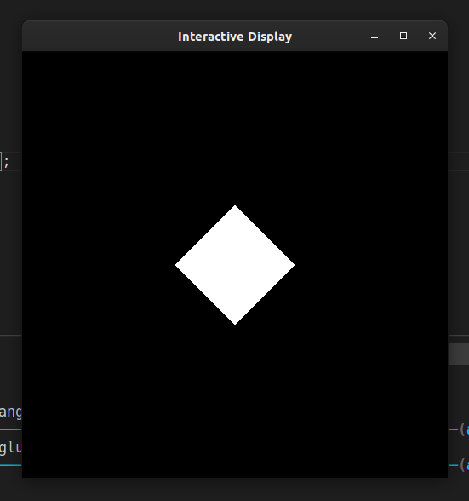
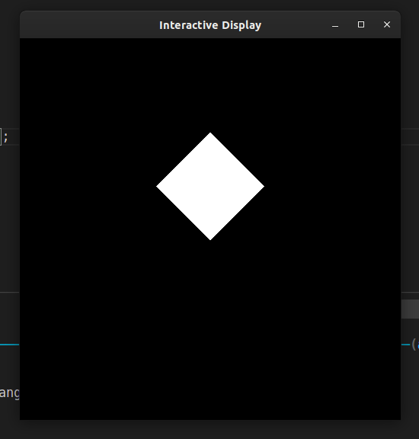

A rectangle was first rotated(1) then scaled + translated(2)

Q3. Apply Sheer on the polygon. - Code

#include <iostream>
#include <GL/glut.h>
#include <vector>
#include <unistd.h>
// #include <utility>
using namespace std;

const double WIDTH = 500;
const double HEIGHT = 500;

int x0,yy0,x2,y2;

char inp;

void initPoints(){
cout<<"Enter the coordinates of the vertices in order.\n";
cout<<"For the sake of viewing, keep the points in the range -40,40\n";

cin>>x0>>yy0>>x2>>y2;
}

void drawObject(){
glClear(GL_COLOR_BUFFER_BIT);

// not available by default so using matrix multiplication

GLfloat m[16] = {
1.0f, 0.0f, 0.0f, 0.0f,
2.0f, 1.0f, 0.0f, 0.0f,
0.0f, 0.0f, 1.0f, 0.0f,
0.0f, 0.0f, 0.0f, 1.0f
};
glMultMatrixf(m);

glRecti(x0, yy0, x2, y2);

glFlush();
}

void myInit (void){
// Reset background color with black (since all three argument is 0.0)
glClear(GL_COLOR_BUFFER_BIT);
glClearColor(0.0, 0.0, 0.0, 1.0);

// Set width of point to one unit
glMatrixMode(GL_PROJECTION);
glLoadIdentity();

// Set window size in X- and Y- direction
gluOrtho2D(-50, 50, -50, 50);
}

int main(int argc, char** argv){
initPoints();
// GLute init and create window
glutInit(&argc, argv);
glutInitDisplayMode(GLUT_SINGLE);
glutInitWindowSize(WIDTH,HEIGHT);
glutInitWindowPosition(600,100);
glutCreateWindow("Sheer Rectangle");
myInit();

// Register display callback
glutDisplayFunc(drawObject);

glutMainLoop();
}
