CS352 Assignment 3
Filling Algorithms

Ayush Agrawal
180001011
08-05-2021

Q1. Boundary Fill
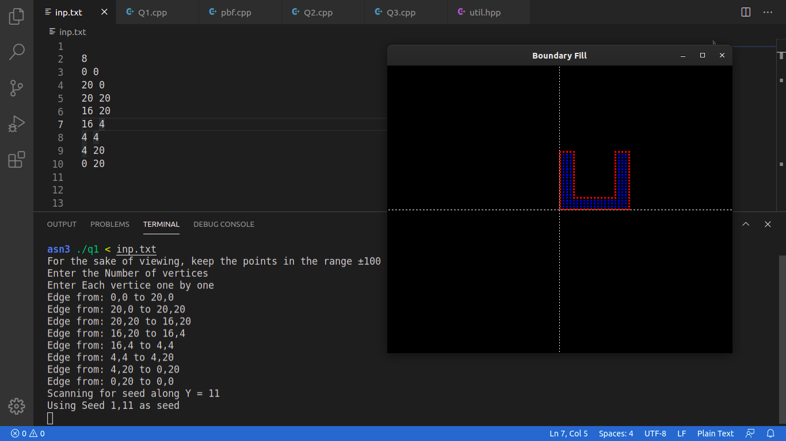

Q2. Flood Fill
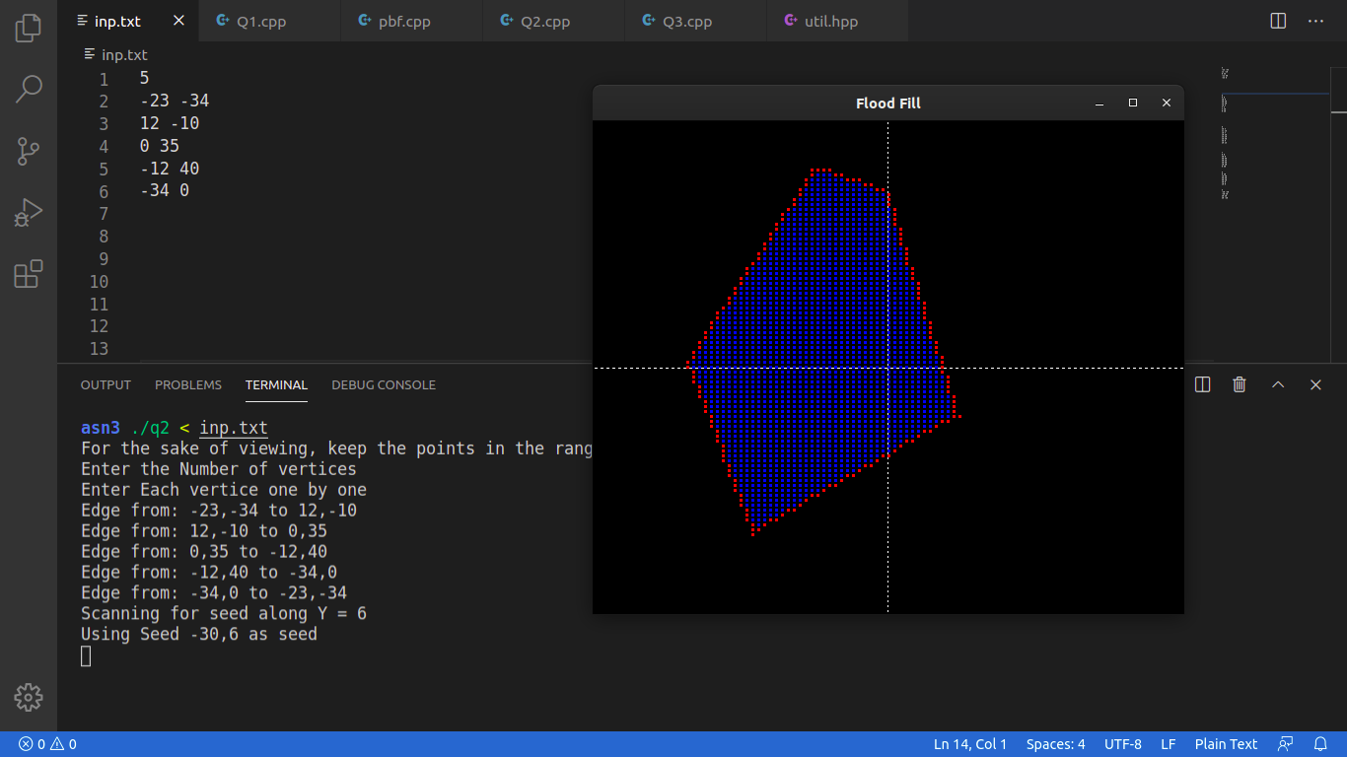

Q3. Scanline Seed Fill: -
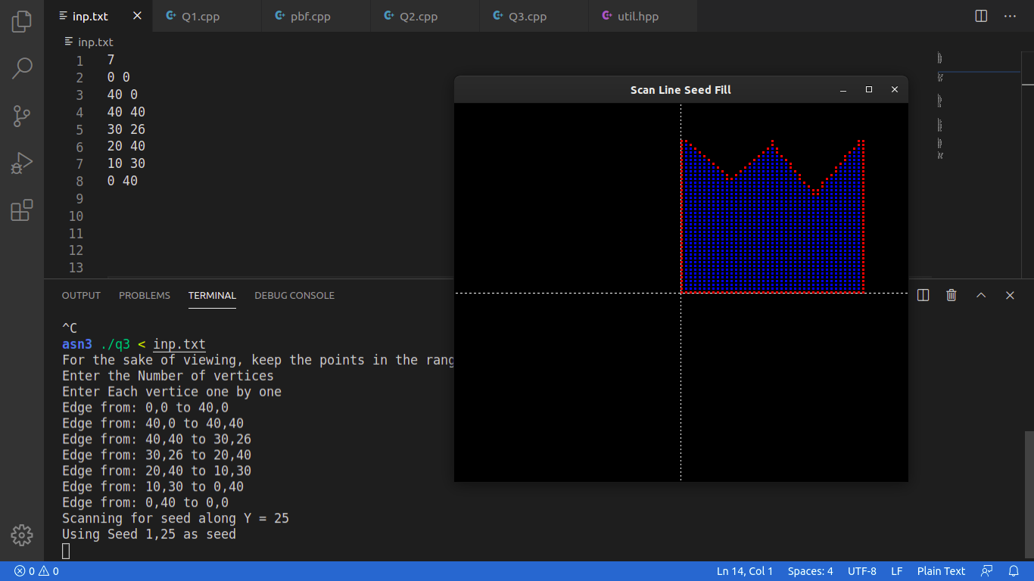

----------- Codes -----------
Common Header file (used in all 3 questions.)

contains boundary making, polygon initialization (input and drawing), glDisplayFunction, and constants.

Each question specific file just uses this header and has a colouring function of its own.

File ‘util.hpp’
#include <iostream>
#include <GL/glut.h>
#include <vector>
#include <unistd.h>
// #include <utility>

using namespace std;

typedef pair<int,int> pii;

const int WIDTH = 600;
const int HEIGHT = 500;

const int WC = 250;
const int HC = 250;

const float PIXEL_SIZE = 3;

const int BG = 0;
const int BOUNDARY = 1;
const int INSIDE = 2;

int xc = 0, yc = 0;

const int numColors = 5;

double colors[numColors][3] = {
{0, 0, 0},
{1, 0, 0},
{0, 0, 1},
{0, 1, 0},
{0.5, 0.5, 0.5},
};

int screen[WIDTH + 1][HEIGHT + 1];

void printScreen(){
for(int i=0;i<HEIGHT;i++){
for(int j=0;j<WIDTH;j++){
cout<<screen[j][i]<<" ";
}
cout<<"\n";
}
}

void fetchSeed(int ys){
// we'll scan for the seed along y = ys;
for(int i=1;i<WIDTH;i++){
if((screen[i-1][ys] == BOUNDARY) && ((screen[i][ys] != BOUNDARY))){
xc = i;
yc = ys;
break;
}
}
}

void setBoundary(int x1, int y1, int x2, int y2){
screen[x1 + WC][y1 + HC] = BOUNDARY;

int dx = x2-x1;
int dy = y2-y1;

bool mInv = 0;

if(abs(dy) > abs(dx)){
mInv = 1;
swap(x1, y1);
swap(x2, y2);
swap(dx, dy);
}

int stepX = (dx > 0);
int stepY = (dy > 0);

if(dx < 0) {
stepX = -1;
dx = -dx;
}
if(dy < 0) {
stepY = -1;
dy = -dy;
}

int x = x1;
int y = y1;

int p = 2*dy-dx;

while( x != x2 ){
if(p >= 0){
y += stepY;
p -= 2*dx;
}

if(mInv){
screen[y + WC][x + HC] = BOUNDARY;
} else {
screen[x + WC][y + HC] = BOUNDARY;
}

p += 2*dy;
x += stepX;
}
}

void initPolygon(){
cout<<"For the sake of viewing, keep the points in the range ±100\n";

cout<<"Enter the Number of vertices\n";
int n;cin>>n;
if(n < 3) {
cout<<"Atleast 3 vertices\n";
}
vector<pair<int,int>> points = vector<pair<int,int>>(n);

cout<<"Enter Each vertice one by one\n";

for(int i=0;i<n;i++){
cin>>points[i].first>>points[i].second;

xc += points[i].first;
yc += points[i].second;
}

xc /= n; yc /= n;

for(int i=0;i<n;i++){
int x1 = points[i].first;
int y1 = points[i].second;

int x2 = points[(i+1)%n].first;
int y2 = points[(i+1)%n].second;

cout<<"Edge from: "<<x1<<","<<y1<<" to "<<x2<<","<<y2<<"\n";
setBoundary(x1,y1,x2,y2);
}
cout<<"Scanning for seed along Y = "<<yc<<"\n";
fetchSeed(yc + HC);

cout<<"Using Seed "<<xc-WC<<","<<yc-HC<<" as seed\n";
}

void drawObject(){
glClear(GL_COLOR_BUFFER_BIT);

glBegin(GL_LINES);
glVertex2d(-50, 0);
glVertex2d(50, 0);
glVertex2d(0, -50);
glVertex2d(0, 50);
glEnd();

glBegin(GL_POINTS);
for(int i=0;i<HEIGHT;i++){
for(int j=0;j<WIDTH;j++){
glColor3dv(colors[screen[j][i]]);
glVertex2i(j - WC, i - HC);
}
}
glEnd();
glFlush();
}

void myInit (void){
// Reset background color with black (since all three argument is 0.0)
glClear(GL_COLOR_BUFFER_BIT);
glClearColor(0.0, 0.0, 0.0, 1.0);

// Set width of point to one unit
glMatrixMode(GL_PROJECTION);
glLoadIdentity();

glPointSize(PIXEL_SIZE);
// Set window size in X- and Y- direction
gluOrtho2D(-50, 50, -50, 50);
}

Q1. Boundary Fill Algorithm:
#include "util.hpp"

void Boundary(int x, int y){
if( (screen[x][y] != BOUNDARY) && (screen[x][y] != INSIDE)){
screen[x][y] = INSIDE;

if(x+1 < WIDTH) Boundary(x+1, y);
if(y+1 < HEIGHT) Boundary(x, y+1);

if(x > 0) Boundary(x-1, y);
if(y > 0) Boundary(x, y-1);
}
}

int main(int argc, char** argv){
initPolygon();
Boundary(xc, yc);

// GLute init and create window
glutInit(&argc, argv);
glutInitDisplayMode(GLUT_SINGLE);
glutInitWindowSize(WIDTH,HEIGHT);
glutInitWindowPosition(600,100);
glutCreateWindow("Boundary Fill");
myInit();

// Register display callback
glutDisplayFunc(drawObject);

glutMainLoop();
}

Q2. Flood Fill:

#include "util.hpp"

void FloodFill(int x, int y){
if( screen[x][y] == BG ){
screen[x][y] = INSIDE;

if(x+1 < WIDTH) FloodFill(x+1, y);
if(y+1 < HEIGHT) FloodFill(x, y+1);

if(x > 0) FloodFill(x-1, y);
if(y > 0) FloodFill(x, y-1);
}
}

int main(int argc, char** argv){
initPolygon();
FloodFill(xc, yc);

// GLute init and create window
glutInit(&argc, argv);
glutInitDisplayMode(GLUT_SINGLE);
glutInitWindowSize(WIDTH,HEIGHT);
glutInitWindowPosition(600,100);
glutCreateWindow("Flood Fill");
myInit();

// Register display callback
glutDisplayFunc(drawObject);

glutMainLoop();
}

Q3. Scan line Seed fill -

#include "util.hpp"
#include <stack>

void pushUnfilledRight(int xl, int xr, int y, stack<pii> &seed){
for(bool span=0;xr>=xl;xr--){
if((screen[xr][y] != BOUNDARY) && (screen[xr][y] != INSIDE)){
if(!span){
seed.push({xr,y});
span = 1;
}
} else {
span = 0;
}
}
}

void scanLineSeedFill(int x, int y){
stack<pii> seeds;
seeds.push({x,y});

while(!seeds.empty()){
pii p = seeds.top();
seeds.pop();

x = p.first;
y = p.second;

// cout<<"Seed: ("<<x<<","<<y<<")\n";
if(screen[x][y] == INSIDE){
// Already painted by some other seed.
continue;
}
screen[x][y] = INSIDE;

int xr,xl;

// filling left
for(xl=x-1;xl>=0;xl--){
if((screen[xl][y] == BOUNDARY)) break;

screen[xl][y] = INSIDE;
} xl++;

// filling left
for(xr=x+1;xr<WIDTH;xr++){
if((screen[xr][y] == BOUNDARY)) break;

screen[xr][y] = INSIDE;
} xr--;

// cout<<"xL: "<<xl - WC<<", xR: "<<xr - WC<<", y: "<<y<<"\n";

if(y+1 < HEIGHT) pushUnfilledRight(xl, xr, y+1, seeds);
if(y > 0) pushUnfilledRight(xl, xr, y-1, seeds);
}
}

int main(int argc, char** argv){
initPolygon();
scanLineSeedFill(xc, yc);

// GLute init and create window
glutInit(&argc, argv);
glutInitDisplayMode(GLUT_SINGLE);
glutInitWindowSize(WIDTH,HEIGHT);
glutInitWindowPosition(600,100);
glutCreateWindow("Scan Line Seed Fill");
myInit();

// Register display callback
glutDisplayFunc(drawObject);

glutMainLoop();
}

