CS352 Assignment 3
3D Textured cube with Camera rotation and Lighting

Ayush Agrawal
180001011
11-05-2021

ScreenShots:
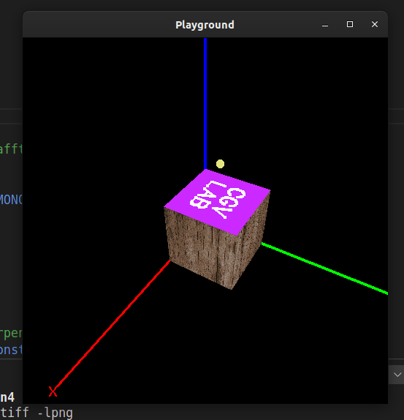

Initial View of Cube.
X,Y,Z axis are labelled.

Yellow Dot represents
Light Source

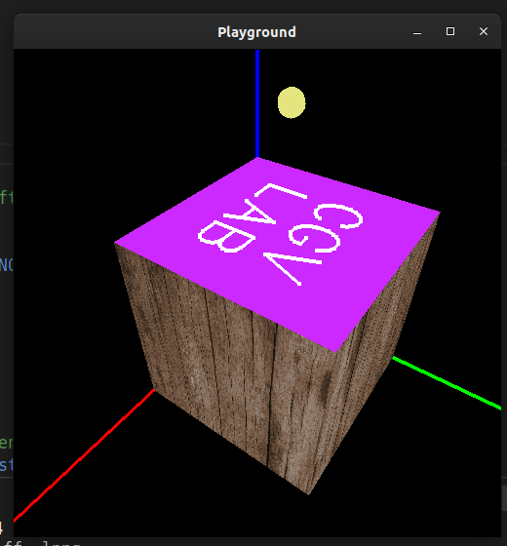

Zoomed – in view

Yellow Dot represents
Light Source

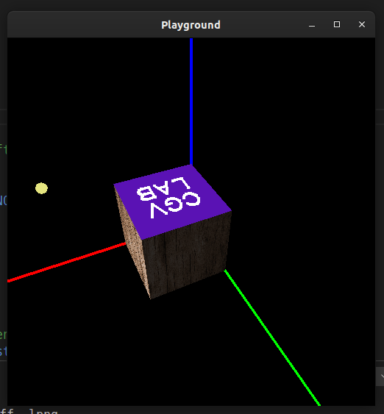

When Light Source is in

X-Direction, the corresponding
Face is lit up and the other
Y-axis (green) is dimmed.

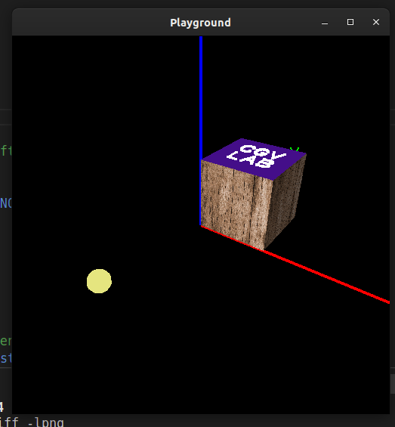

When Light moves far away,
The top surface also dims

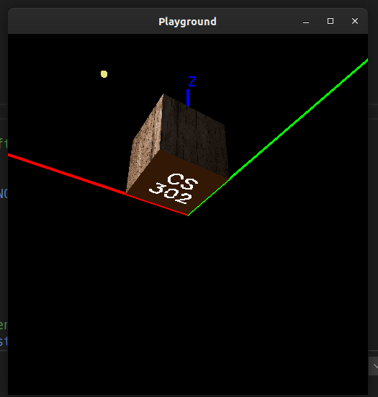

When Light is in over Z axis
The Lower face is dim

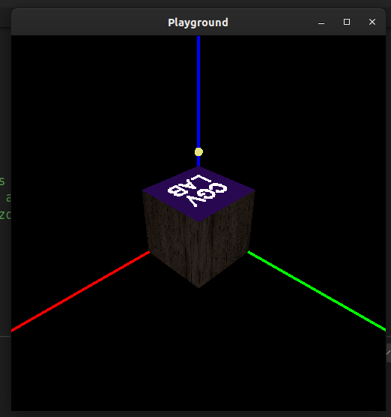

One with minimum Light
Intensity (Brightness)

Code:-
Broken into 3 files,
imageio.h and imageio.cpp - Sir Shared these files, so I have not pasted the code here.

Last file is Q1.cpp:

#include <GL/glut.h>
#include <cmath>
#include <iostream>
#include "imageio.h"

using namespace std;

// Window Properties
const double WIDTH = 500;
const double HEIGHT = 500;

// For Keyboard (x,y,z) key Rotations
int rotate_x = 0;
int rotate_y = 0;
int rotate_z = 0;

// Position of eye in glLookAt function
double eyeX = 3;
double eyeY = 3;
double eyeZ = 3;

// Will be used to calculate mouse-drag distance.
int old_x = 0;
int old_y = 0;
int valid = 0;

// The distance of eye from origin.
// when moving the camera, this remains constant.
double viewRadius = sqrt(27);

// 3d coords govern the movement of camera.
// drag distance is converted to angle.
double theta = 45;
double azimuthal = 45;
// then new eye positions are calculated.

// Position of light.
GLfloat light_x = 0.5;
GLfloat light_y = 0.5;
GLfloat light_z = 1.5;

// Intensity of diffused light
GLfloat light_intensity = 0.5;

// how much does light remain strong
GLfloat light_attenuate = 1.0;

// window ID
int window;

// List of the 8 vertices of the cube
double vertices[8][3] = {
{0, 0, 0},
{0, 0, 1},
{1, 0, 1},
{1, 0, 0},
{0, 1, 0},
{0, 1, 1},
{1, 1, 1},
{1, 1, 0},
};

// array of frequently used colors.
GLfloat colors[8][3] = {
{0.0,0.0,0.0}, // black
{1.0,0.0,0.0}, // red
{0.0,1.0,0.0}, // green
{0.0,0.0,1.0}, // blue
{1.0,1.0,0.0}, // yellow
{1.0,0.0,1.0}, // pink
{0.0,1.0,1.0}, // cyan
{1.0,1.0,1.0}, // white
};

// List of vertex that constitute a particular face
int ffront[4] = {1, 2, 6, 5};
int fback[4] = {0, 3, 7, 4};
int ftop[4] = {4, 5, 6, 7};
int fbottom[4] = {0, 1, 2, 3};
int fleft[4] = {0, 1, 5, 4};
int fright[4] = {2, 3, 7, 6};

// The normals of each face.
// Used for reflection of light
float nfront[4] = {0, 0, 1};
float nback[4] = {0, 0, -1};
float ntop[4] = {0, 1, 0};
float nbottom[4] = {0, -1, 0};
float nright[4] = {1, 0, 0};
float nleft[4] = {-1, 0, 0};

// number of textures, and respective files.
// Wooden texture covers 4 sides.
const int nTextures = 1;
char files[nTextures][37] = {"images/wood_hd.png"};
GLuint handles[nTextures];

// Hold the size of png opened.
int texImageWidth, texImageHeight;

// Constants that will be written on back face.
char bTextL1[] = "CS";
char bTextL2[] = "302";

// Constants that will be written on back face.
char fTextL1[] = "CGV";
char fTextL2[] = "LAB";

// Helper function.
double deg2rad(double deg){
return (deg * M_PI)/(double)180;
}

// Opens png files, and returns the pixel matrix.
GLubyte *makeTexImage( char *loadfile ) {
int i, j, c, width, height;
GLubyte *texImage;

texImage = loadImageRGBA( (char *) loadfile, &width, &height);
texImageWidth = width;
texImageHeight = height;

return texImage;
}

// Recalculate Eye position after mouse drag.
void rotateEyes(double dx, double dy){
azimuthal += dx;
theta += dy;

if( azimuthal >= 360 ) azimuthal -= 360;
if( theta >= 360 ) theta -= 360;

// 3D coordinate formalae.
eyeX = viewRadius * cos(deg2rad(azimuthal)) * sin(deg2rad(theta));
eyeY = viewRadius * sin(deg2rad(azimuthal)) * sin(deg2rad(theta));
eyeZ = viewRadius * cos(deg2rad(theta));
}

// can also rotate using arrow keys.
void specialKeys( int key, int x, int y ) {
if (key == GLUT_KEY_RIGHT)
rotate_y += 5;
else if (key == GLUT_KEY_LEFT)
rotate_y -= 5;
else if (key == GLUT_KEY_UP)
rotate_x += 5;
else if (key == GLUT_KEY_DOWN)
rotate_x -= 5;
glutPostRedisplay();
}

// All keyboard keys handler.
// Handles rotation from keys x,y,z & X,Y,Z
// Handles light movement from keys i,j,k & I,J,K
// Handles light intensity from keys +,-
// Handles light attenuation from keys <,>
// Exit window using esc key.
void keyboard_func(unsigned char key, int x, int y ) {

switch(key) {
case 'x':
rotate_x = ( rotate_x + 3 ) % 360;
break;
case 'X':
rotate_x = ( rotate_x - 3 ) % 360;
break;
case 'y':
rotate_y = ( rotate_y + 3 ) % 360;
break;
case 'Y':
rotate_y = ( rotate_y - 3 ) % 360;
break;
case 'z':
rotate_z = ( rotate_z + 3 ) % 360;
break;
case 'Z':
rotate_z = ( rotate_z - 3 ) % 360;
break;

case 'j':
light_y += 0.1;
break;
case 'k':
light_z += 0.1;
break;
case 'i':
light_x += 0.1;
break;

case 'J':
light_y -= 0.1;
break;
case 'K':
light_z -= 0.1;
break;
case 'I':
light_x -= 0.1;
break;

case '+':
light_intensity = min(light_intensity + 0.1, 1.0);
break;
case '-':
light_intensity = max(light_intensity - 0.1, 0.0);
break;

case '<':
light_attenuate /= 0.9;
break;
case '>':
light_attenuate *= 0.9;
break;

case 27: /* escape */
glutDestroyWindow(window);
exit(0);
}
glutPostRedisplay();
}

// Draw Quadrilateral with given bg color, and texture vertices mapping.
void drawTextureFace(int verts[], float normal[], int cId){
// Apply white colors so that does not mess with texture.
glColor3fv(colors[cId]);
glBegin(GL_QUADS);
glNormal3fv(normal);
glTexCoord2f(0.0, 0.0); glVertex3dv(vertices[verts[0]]);
glTexCoord2f(1.0, 0.0); glVertex3dv(vertices[verts[1]]);
glTexCoord2f(1.0, 1.0); glVertex3dv(vertices[verts[2]]);
glTexCoord2f(0.0, 1.0); glVertex3dv(vertices[verts[3]]);
glEnd();
}

// Draw Quadrilateral with given bg color, without texture vertices mapping.
void drawColorFace(int verts[], float normal[], int cId){
glColor3fv(colors[cId]);
glBegin(GL_QUADS);
glNormal3fv(normal);
glVertex3dv(vertices[verts[0]]);
glVertex3dv(vertices[verts[1]]);
glVertex3dv(vertices[verts[2]]);
glVertex3dv(vertices[verts[3]]);
glEnd();
}

// Write text, starting at specified position.
// the text plain is parallel to xy plane.
void strokef(GLfloat x, GLfloat y, GLfloat z, char *format, ...) {
if(z == 1) z += 0.01;

// Handle variable arguments (printf like functionality)
va_list args;
char buffer[200], *p;

va_start(args, format);
vsprintf(buffer, format, args);
va_end(args);

// Save the current config.
glPushMatrix();
glTranslatef(x, y, z);
//
if(z == 0) {
glRotatef(180, 0, 1, 0);
z = -0.01;
}
// Used to adjust font size.
glScalef(0.002, 0.002, 0.002);
glPointSize(4);
glLineWidth(4);

// Write text in white color
glColor3fv(colors[7]);

// disable lighting so that is does not afftect font color.
glDisable(GL_LIGHTING);
for (p = buffer; *p; p++){
glutStrokeCharacter(GLUT_STROKE_MONO_ROMAN, *p);
}
glEnable(GL_LIGHTING);

// Reload the initial configuration
glPopMatrix();
}

// Write bitMap text, that always remains perpendicular to camera
void drawString(float x, float y, float z, const char* string) {
glRasterPos3f(x, y, z);
glColor3fv(colors[7]);
for (const char* c = string; *c != '\0'; c++) {
glutBitmapCharacter(GLUT_BITMAP_HELVETICA_18, *c); // Updates the position
}
}

void display() {
glClearColor( 0, 0, 0, 1 );
// Enable 2d textures.
glEnable(GL_TEXTURE_2D);

// Use MODULATE instead of GL_DECAL so that light also affects texture faces.
glTexEnvf(GL_TEXTURE_ENV, GL_TEXTURE_ENV_MODE, GL_MODULATE);

glClear(GL_COLOR_BUFFER_BIT|GL_DEPTH_BUFFER_BIT);

// Use wooden texture and draw the 4 faces.
glBindTexture(GL_TEXTURE_2D, handles[0]);
drawTextureFace(ftop, ntop, 7);
drawTextureFace(fleft, nleft, 7);
drawTextureFace(fright, nright, 7);
drawTextureFace(fbottom, nbottom, 7);
glDisable(GL_TEXTURE_2D);

// Constants needed to adjust reflectivity
GLfloat polished[] = { 100.0 };
GLfloat dull[] = { 0.0 };

GLfloat light_position[] = {light_x, light_y, light_z, 1.0 };

// Ambient light also depends upon intensity
GLfloat light_ambient[] = {light_intensity, light_intensity, light_intensity, 1.0};

const GLfloat white[] = {1.0, 1.0, 1.0, 0.5 };
const GLfloat blue[] = {0.5, 0.1, 1.0, 0.5 };
const GLfloat orange[] = {1.0, 0.5, 0.1, 0.5 };

glMaterialfv(GL_FRONT, GL_SHININESS, polished);

glMaterialfv(GL_FRONT, GL_SPECULAR, orange);
glMaterialfv(GL_FRONT, GL_AMBIENT_AND_DIFFUSE, orange);
drawColorFace(fback, nback, 7);
strokef(0.7, 0.55, 0, bTextL1);
strokef(0.8, 0.25, 0, bTextL2);
// Text start positions are hard coded.

glMaterialfv(GL_FRONT, GL_SPECULAR, blue);
glMaterialfv(GL_FRONT, GL_AMBIENT_AND_DIFFUSE, blue);
drawColorFace(ffront, nfront, 7);
strokef(0.2, 0.55, 1, fTextL1);
strokef(0.2, 0.25, 1, fTextL2);

// So that light does not affect other drawings.
glMaterialfv(GL_FRONT, GL_AMBIENT_AND_DIFFUSE, white);
// It also prevents from colouring the textured faces.

// Add one light source
glMatrixMode(GL_MODELVIEW);
glPushMatrix();
glTranslatef(light_x, light_y, light_z);

// Vary attenuation value to ~change intensity
glLightf(GL_LIGHT0, GL_CONSTANT_ATTENUATION, light_attenuate);

// Increase ambient light to simulate ~brightness functionality.
glLightfv(GL_LIGHT0, GL_AMBIENT, light_ambient);
glLightfv(GL_LIGHT0, GL_POSITION, light_position);

glDisable(GL_LIGHTING);
glColor3d(0.9, 0.9, 0.5);
// Add a sphere that indicates position of light source
glutSolidSphere(0.05, 10, 10);
glEnable(GL_LIGHTING);
glPopMatrix();
glEnable(GL_LIGHT0);

// Set Projection as perspective.
glMatrixMode( GL_PROJECTION );
glLoadIdentity();

gluPerspective( 60, WIDTH / HEIGHT, 0.1, 100 );

glPushMatrix();
glMatrixMode( GL_MODELVIEW );

// Draw axis in light-disable mode to show full r,g,b colors.
glDisable(GL_LIGHTING);
glColor3d(1, 0, 0);
glBegin(GL_LINES);
glVertex3d(0, 0, 0);
glVertex3d(3, 0, 0);
glEnd();
drawString(3.1, 0, 0, "X");
glEnable(GL_LIGHTING);

glDisable(GL_LIGHTING);
glColor3d(0, 1, 0);
glBegin(GL_LINES);
glVertex3d(0, 0, 0);
glVertex3d(0, 3, 0);
glEnd();
drawString(0, 3.1, 0, "Y");
glEnable(GL_LIGHTING);

glDisable(GL_LIGHTING);
glColor3d(0, 0, 1);
glBegin(GL_LINES);
glVertex3d(0, 0, 0);
glVertex3d(0, 0, 3);
glEnd();
drawString(0, 0, 3.1, "Z");
glEnable(GL_LIGHTING);

glLoadIdentity();

// LookAt position updates with mouse drag.
gluLookAt (
eyeX, eyeY, eyeZ,
0, 0, 0,
0, 0, 1
);

// Do keyboard rotations.
glRotatef( rotate_x, 1.0, 0.0, 0.0 );
glRotatef( rotate_y, 0.0, 1.0, 0.0 );
glRotatef( rotate_z, 0.0, 0.0, 1.0 );

glutSwapBuffers();
glFlush();
}

// Triggered when mouse-clicks. Stores initial x,y and whether it was RMB/LMB
void mouse_func (int button, int state, int x, int y) {
old_x=x;
old_y=y;

if(button == 2){
valid = 2;
} else {
valid = state == GLUT_DOWN;
}
}

// Triggered during drag motion. calculates dx,dy.
// if LMB then updates theta and azimuthal angles.
// otherwise update camera radius to give zooming effect.
void motion_func (int x, int y) {
if(valid == 2){
double dx = old_x - x;
viewRadius += dx/50;

rotateEyes(0, 0);
glutPostRedisplay();
}
if (valid == 1) {
int dx = old_x - x;
int dy = old_y - y;

double rx = (double)dx/10;
double ry = (double)dy/10;

rotateEyes(rx, ry);
glutPostRedisplay();
}
old_x = x;
old_y = y;
}

// Maps the png images to texture handles.
void initTexture(){
glShadeModel(GL_FLAT);

glEnable(GL_DEPTH_TEST);

glPixelStorei(GL_UNPACK_ALIGNMENT, 1);
//handles is global
glGenTextures(nTextures, handles);

// Go over every image, and map the texture to its handle.
for(int i=0;i<nTextures;i++){
GLubyte *texImage = makeTexImage(files[i]);

if(!texImage) cout<<"Error opening "<<files[i]<<"\n";

glBindTexture(GL_TEXTURE_2D, handles[i]); //map it to variable
// Enable
glTexParameteri(GL_TEXTURE_2D, GL_TEXTURE_WRAP_S, GL_REPEAT);
glTexParameteri(GL_TEXTURE_2D, GL_TEXTURE_WRAP_T, GL_REPEAT);
glTexParameteri(GL_TEXTURE_2D, GL_TEXTURE_MAG_FILTER, GL_NEAREST);
glTexParameteri(GL_TEXTURE_2D, GL_TEXTURE_MIN_FILTER, GL_NEAREST);

glTexImage2D(GL_TEXTURE_2D, 0, GL_RGBA,
texImageWidth, texImageHeight,
0, GL_RGBA, GL_UNSIGNED_BYTE,
texImage
);
delete texImage; //free memory holding texture image
}
}

int main( int argc, char **argv ){
glutInit( &argc, argv );
glutInitDisplayMode( GLUT_RGBA | GLUT_DEPTH | GLUT_DOUBLE );
glutInitWindowSize( WIDTH, HEIGHT );
glutCreateWindow( "Playground" );
initTexture();

glutDisplayFunc( display );
glutSpecialFunc( specialKeys );
glutKeyboardFunc( keyboard_func );

glutMouseFunc( mouse_func );
glutMotionFunc( motion_func );

glutMainLoop();
return 0;
}

