**Step 1: Downloading Android Studio for Windows**

Download android studio from official website



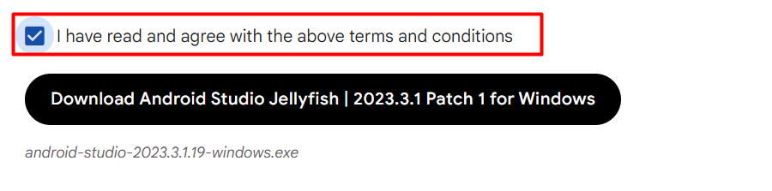

**Step 2: Start the Installer**

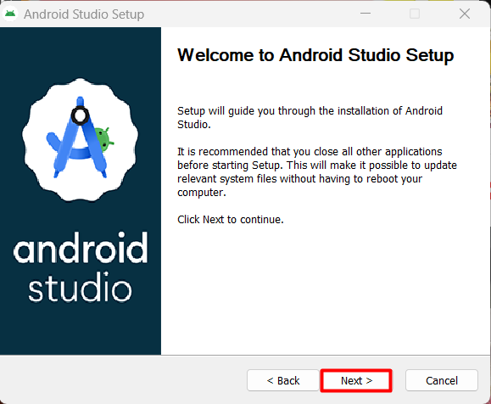

**Step 2: Choose Components**

The first step in the installation wizard is to Choose Components. By default, the only component selected is the Android Virtual Device, which is required for running and testing your Android apps on an emulator:

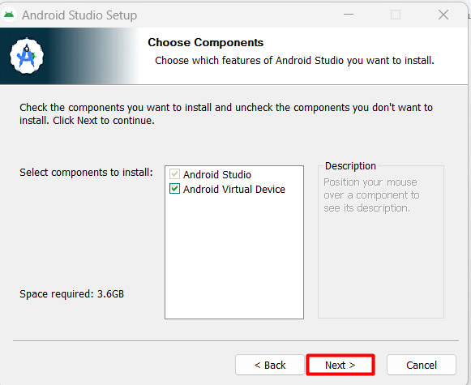

**Step 3: Choose the Installation Location and click next**

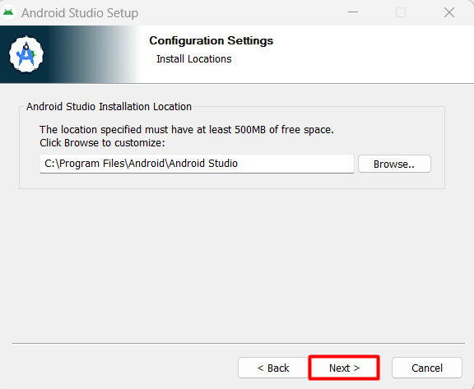

**Step 4: Choose the Start Menu Folder and Install**

**Click install**

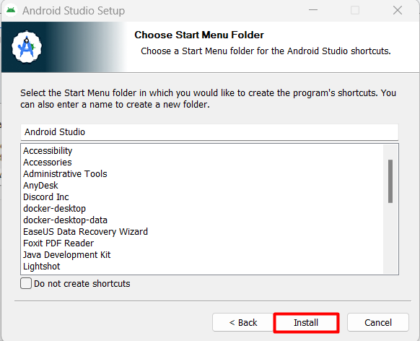

**Step 5: Complete the Installation**

**Click Finish**

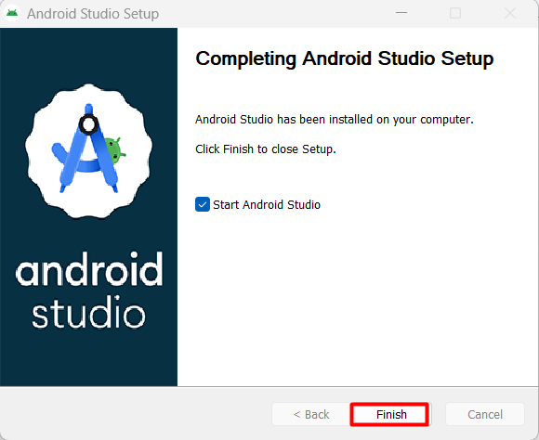

**Step 6: Import Android Studio Settings**

Select Do not import settings

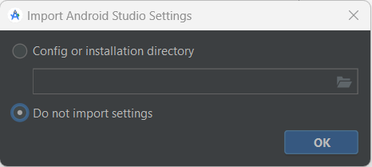

**Step 7: Choose Settings**

**Select standard and click on next**

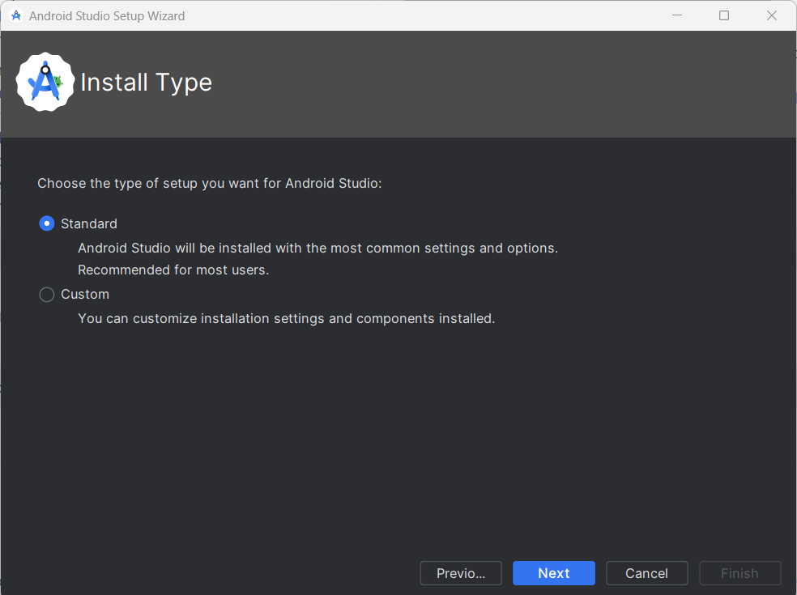

**Step 8: Accept License Agreement**

At the bottom of the screen, you’ll see a Finish button which will only be enabled if you accept the license agreement. Once you click Finish, the installation process will be complete, and Android Studio will be ready for use.

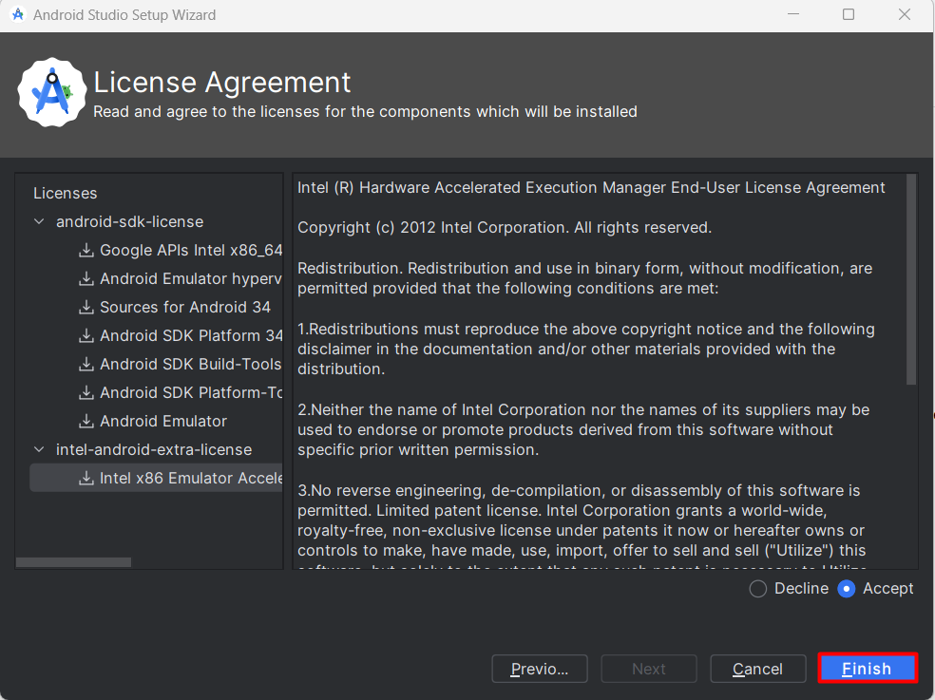

Project 1: Hello Universe!

activity_main.xml

<?xml version="1.0" encoding="utf-8"?>

<androidx.constraintlayout.widget.ConstraintLayout xmlns:android="http://schemas.android.com/apk/res/android"

xmlns:app="http://schemas.android.com/apk/res-auto"

xmlns:tools="http://schemas.android.com/tools"

android:id="@+id/main"

android:layout_width="match_parent"

android:layout_height="match_parent"

tools:context=".MainActivity">

<TextView

android:layout_width="wrap_content"

android:layout_height="wrap_content"

android:text="Hello Universe!"

app:layout_constraintBottom_toBottomOf="parent"

app:layout_constraintEnd_toEndOf="parent"

app:layout_constraintStart_toStartOf="parent"

app:layout_constraintTop_toTopOf="parent" />

</androidx.constraintlayout.widget.ConstraintLayout>

MainActivity.java

package com.example.hellouniverse;

import android.os.Bundle;

import androidx.activity.EdgeToEdge;

import androidx.appcompat.app.AppCompatActivity;

import androidx.core.graphics.Insets;

import androidx.core.view.ViewCompat;

import androidx.core.view.WindowInsetsCompat;

public class MainActivity extends AppCompatActivity {

@Override

protected void onCreate(Bundle savedInstanceState) {

super.onCreate(savedInstanceState);

EdgeToEdge.enable(this);

setContentView(R.layout.activity_main);

ViewCompat.setOnApplyWindowInsetsListener(findViewById(R.id.main), (v, insets) -> {

Insets systemBars = insets.getInsets(WindowInsetsCompat.Type.systemBars());

v.setPadding(systemBars.left, systemBars.top, systemBars.right, systemBars.bottom);

return insets;

});

}

}

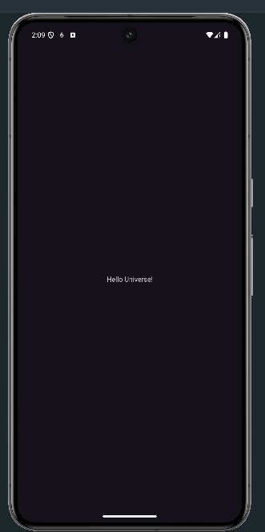Output: -

Project 2: Basic form

activity_main.xml

<?xml version="1.0" encoding="utf-8"?>

<androidx.constraintlayout.widget.ConstraintLayout xmlns:android="http://schemas.android.com/apk/res/android"

xmlns:app="http://schemas.android.com/apk/res-auto"

xmlns:tools="http://schemas.android.com/tools"

android:id="@+id/main"

android:padding="20dp"

android:layout_width="match_parent"

android:layout_height="match_parent"

tools:context=".MainActivity">

<TextView

android:id="@+id/heading"

android:layout_width="wrap_content"

android:layout_height="wrap_content"

android:text="Login Activity"

android:textSize="30dp"

android:textFontWeight="1000"

android:padding="15dp"

app:layout_constraintBottom_toBottomOf="parent"

app:layout_constraintEnd_toEndOf="parent"

app:layout_constraintHorizontal_bias="0.499"

app:layout_constraintStart_toStartOf="parent"

app:layout_constraintTop_toTopOf="parent"

app:layout_constraintVertical_bias="0.106" />

<EditText

android:id="@+id/email"

android:layout_width="320dp"

android:layout_height="42dp"

android:ems="10"

android:hint="Email"

android:inputType="textEmailAddress"

app:layout_constraintBottom_toBottomOf="parent"

app:layout_constraintEnd_toEndOf="parent"

app:layout_constraintHorizontal_bias="0.498"

app:layout_constraintStart_toStartOf="parent"

app:layout_constraintTop_toBottomOf="@+id/heading"

app:layout_constraintVertical_bias="0.148" />

<EditText

android:id="@+id/password"

android:layout_width="320dp"

android:layout_height="42dp"

android:ems="10"

android:hint="Password"

android:inputType="textPassword"

app:layout_constraintBottom_toBottomOf="parent"

app:layout_constraintEnd_toEndOf="parent"

app:layout_constraintHorizontal_bias="0.498"

app:layout_constraintStart_toStartOf="parent"

app:layout_constraintTop_toBottomOf="@+id/email"

app:layout_constraintVertical_bias="0.03" />

<Button

android:id="@+id/login"

android:layout_width="320dp"

android:layout_height="50dp"

android:text="LogIn"

app:layout_constraintBottom_toBottomOf="parent"

app:layout_constraintEnd_toEndOf="parent"

app:layout_constraintHorizontal_bias="0.49"

app:layout_constraintStart_toStartOf="parent"

app:layout_constraintTop_toBottomOf="@+id/email"

app:layout_constraintVertical_bias="0.227" />

<Button

android:id="@+id/reset"

android:layout_width="320dp"

android:layout_height="50dp"

android:text="Reset"

app:layout_constraintBottom_toBottomOf="parent"

app:layout_constraintEnd_toEndOf="parent"

app:layout_constraintHorizontal_bias="0.509"

app:layout_constraintStart_toStartOf="parent"

app:layout_constraintTop_toBottomOf="@+id/login"

app:layout_constraintVertical_bias="0.052" />

<TextView

android:id="@+id/result"

android:layout_width="wrap_content"

android:layout_height="wrap_content"

android:text=" "

app:layout_constraintBottom_toBottomOf="parent"

app:layout_constraintEnd_toEndOf="parent"

app:layout_constraintStart_toStartOf="parent"

app:layout_constraintTop_toBottomOf="@+id/reset"

app:layout_constraintVertical_bias="0.426" />

</androidx.constraintlayout.widget.ConstraintLayout>

MainActivity.java

package com.example.basic_form;

import android.os.Bundle;

import android.view.View;

import android.widget.Button;

import android.widget.EditText;

import android.widget.TextView;

import androidx.activity.EdgeToEdge;

import androidx.appcompat.app.AppCompatActivity;

import androidx.core.graphics.Insets;

import androidx.core.view.ViewCompat;

import androidx.core.view.WindowInsetsCompat;

public class MainActivity extends AppCompatActivity {

Button login, reset;

EditText email, password;

TextView result;

@Override

protected void onCreate(Bundle savedInstanceState) {

super.onCreate(savedInstanceState);

EdgeToEdge.enable(this);

setContentView(R.layout.activity_main);

login = findViewById(R.id.login);

reset = findViewById(R.id.reset);

email = findViewById(R.id.email);

password = findViewById(R.id.password);

result = findViewById(R.id.result);

login.setOnClickListener(new View.OnClickListener() {

@Override

public void onClick(View view) {

String emailText = email.getText().toString();

String passwordText = password.getText().toString();

result.setText("Email: " + emailText + "\nPassword: " + passwordText);

}

});

reset.setOnClickListener(new View.OnClickListener() {

@Override

public void onClick(View view) {

email.setText("");

password.setText("");

result.setText("");

}

});

ViewCompat.setOnApplyWindowInsetsListener(findViewById(R.id.main), (v, insets) -> {

Insets systemBars = insets.getInsets(WindowInsetsCompat.Type.systemBars());

v.setPadding(systemBars.left, systemBars.top, systemBars.right, systemBars.bottom);

return insets;

});

}

}

Output: -

**Before**  **After**

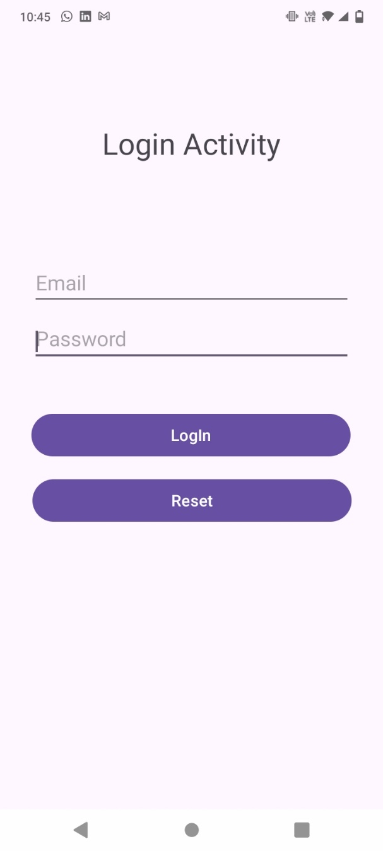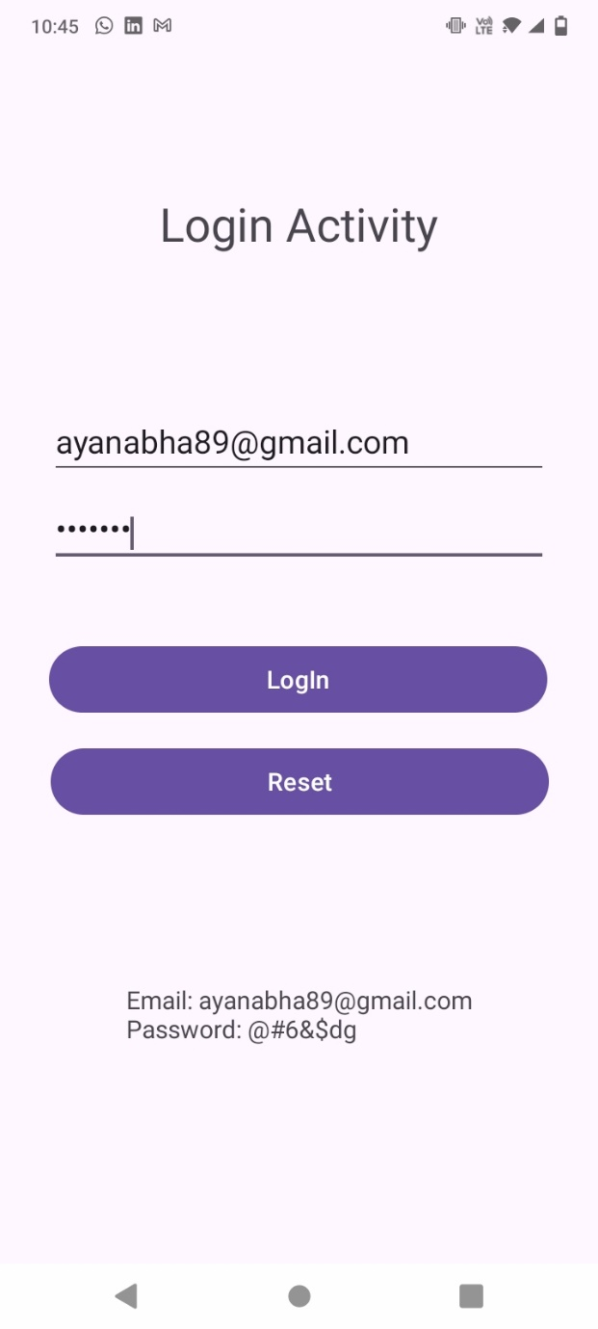

Project 3: Image Layout

activity_main.xml

<?xml version="1.0" encoding="utf-8"?>

<androidx.constraintlayout.widget.ConstraintLayout xmlns:android="http://schemas.android.com/apk/res/android"

xmlns:app="http://schemas.android.com/apk/res-auto"

xmlns:tools="http://schemas.android.com/tools"

android:layout_width="match_parent"

android:layout_height="match_parent"

tools:context=".MainActivity">

<ImageView

android:id="@+id/image"

android:layout_width="409dp"

android:layout_height="289dp"

app:layout_constraintEnd_toEndOf="parent"

app:layout_constraintStart_toStartOf="parent"

app:layout_constraintTop_toTopOf="parent"

tools:srcCompat="@tools:sample/avatars" />

<com.google.android.material.button.MaterialButton

android:id="@+id/s"

android:layout_width="wrap_content"

android:layout_height="wrap_content"

android:layout_marginTop="16dp"

android:text="SHINCHAN"

app:layout_constraintBottom_toTopOf="@+id/J"

app:layout_constraintEnd_toEndOf="parent"

app:layout_constraintStart_toStartOf="parent"

app:layout_constraintTop_toBottomOf="@+id/image" />

<com.google.android.material.button.MaterialButton

android:id="@+id/J"

android:layout_width="wrap_content"

android:layout_height="wrap_content"

android:layout_marginTop="16dp"

android:text="JERRY"

app:layout_constraintBottom_toTopOf="@+id/T"

app:layout_constraintEnd_toEndOf="parent"

app:layout_constraintStart_toStartOf="parent"

app:layout_constraintTop_toBottomOf="@+id/s" />

<com.google.android.material.button.MaterialButton

android:id="@+id/T"

android:layout_width="wrap_content"

android:layout_height="wrap_content"

android:layout_marginTop="16dp"

android:text="TOM"

app:layout_constraintBottom_toTopOf="@+id/linearLayout"

app:layout_constraintEnd_toEndOf="parent"

app:layout_constraintStart_toStartOf="parent"

app:layout_constraintTop_toBottomOf="@+id/J" />

<LinearLayout

android:id="@+id/linearLayout"

android:layout_width="0dp"

android:layout_height="0dp"

android:orientation="vertical"

android:padding="16dp"

app:layout_constraintBottom_toBottomOf="parent"

app:layout_constraintEnd_toEndOf="parent"

app:layout_constraintStart_toStartOf="parent"

app:layout_constraintTop_toBottomOf="@+id/T">

<TextView

android:id="@+id/textView"

android:layout_width="match_parent"

android:layout_height="wrap_content"

android:text="SHINCHAN SCORE" />

<TextView

android:id="@+id/ShinchanClicked"

android:layout_width="match_parent"

android:layout_height="wrap_content"

android:layout_marginTop="8dp"

android:text="0" />

<TextView

android:id="@+id/textView3"

android:layout_width="match_parent"

android:layout_height="wrap_content"

android:layout_marginTop="16dp"

android:text="JERRY SCORE" />

<TextView

android:id="@+id/JerryClicked"

android:layout_width="match_parent"

android:layout_height="wrap_content"

android:layout_marginTop="8dp"

android:text="0" />

<TextView

android:id="@+id/textView5"

android:layout_width="match_parent"

android:layout_height="wrap_content"

android:layout_marginTop="16dp"

android:text="TOM SCORE" />

<TextView

android:id="@+id/Tomclicked"

android:layout_width="match_parent"

android:layout_height="wrap_content"

android:layout_marginTop="8dp"

android:text="0" />

</LinearLayout>

</androidx.constraintlayout.widget.ConstraintLayout>

MainActivity.java

package com.example.imagelayout;

import androidx.appcompat.app.AppCompatActivity;

import android.os.Bundle;

import android.widget.ImageView;import android.widget.TextView;

public class MainActivity extends AppCompatActivity {

ImageView img;

TextView ctTom, ctJerry, ctShinchan;

private int cT = 0;

private int cJ = 0;

private int cS = 0;

@Override

protected void onCreate(Bundle savedInstanceState) {

super.onCreate(savedInstanceState);

setContentView(R.layout.activity_main);

img = findViewById(R.id.image);

ctJerry = findViewById(R.id.JerryClicked);ctTom = findViewById(R.id.Tomclicked);

ctShinchan = findViewById(R.id.ShinchanClicked);

findViewById(R.id.s).setOnClickListener(v -> {

img.setImageResource(R.drawable.img_shinchan);

ctShinchan.setText(String.valueOf(++cS));

});

findViewById(R.id.T).setOnClickListener(v -> {

img.setImageResource(R.drawable.img_tom);

ctTom.setText(String.valueOf(++cT));

});

findViewById(R.id.J).setOnClickListener(v -> {

img.setImageResource(R.drawable.img_jerry);

ctJerry.setText(String.valueOf(++cJ));

});

}

}

Output: -

**Shinchan**  **Jerry Tom**

