Plain RAG vs Corrective RAG
Corrective RAG raised answer accuracy from 81% to 91% on the same 20 questions, documents, answer key and online models, with no question getting worse. The improvement came on multi-part and cross-document questions. It costs about 1.6 times as many API requests.

1. Headline results
Table 1: Plain RAG vs Corrective RAG
Metric | Plain RAG | Corrective RAG | Change
Answer accuracy | 81% (26/32) | 91% (29/32) | +10 points
Hit rate | 94% (15/16) | 100% (16/16) | +6 points
Full-answer coverage | 75% (12/16) | 81% (13/16) | +6 points
MRR | 0.84 | 0.94 | +0.09
Faithfulness | 100% | 100% | No change
Citation accuracy | 95% (19/20) | 100% (20/20) | +5 points*
Refusal accuracy | 100% (4/4) | 100% (4/4) | No change
False refusals (partial) | 2 of 16 (Q1, Q10) | 1 of 16 (Q15) | −1
API requests per question (est.) | 2 | 3.2 | ×1.6
*Partly explained by an extra instruction to cite only [Source N] labels, added after the plain RAG run.

2. What changed between the two systems
Both systems use the same documents, chunks (128 chunks of 300 words), embedding model and answering LLM. Corrective RAG adds a check between search and answer.
Table 2: Pipeline steps
Step | Plain RAG (ask.py) | Corrective RAG (ask_crag.py)
Retrieve | Top 4 chunks by similarity | Top 10 candidate chunks by similarity
Filter | None | Reference lists removed automatically (12+ citation markers per 100 words)
Grade | None: every retrieved chunk goes to the LLM | An LLM grader marks each chunk relevant or not and checks that every part of the question is answered
Correct | None | If a part is missing or a multi-document question misses a document: up to 4 new queries plus a search of each document, then grade again
Answer | LLM answers from the 4 chunks | LLM answers from up to 6 relevant chunks; if none are relevant, "not covered" without calling the LLM

3. Where the improvement came from
Figure 1: Answer accuracy by question type
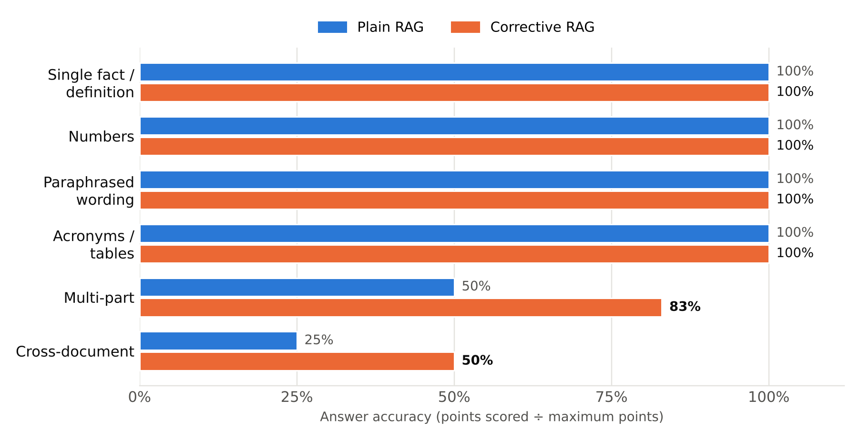
Each type has only 2–4 questions, so one question moves a bar by 17–25 points.
Table 3: Answer accuracy by question type
Question type | Questions | Plain RAG | Corrective RAG | Change
Single fact / definition | Q2, Q5, Q14 | 100% | 100% | —
Numbers | Q3, Q6, Q7, Q12 | 100% | 100% | —
Paraphrased wording | Q4, Q13 | 100% | 100% | —
Acronyms / tables | Q8, Q9 | 100% | 100% | —
Multi-part | Q1, Q10, Q11 | 50% (3/6) | 83% (5/6) | +33 points
Cross-document | Q15, Q16 | 25% (1/4) | 50% (2/4) | +25 points
Unanswerable (refusals) | Q17–Q20 | 100% (4/4) | 100% (4/4) | —

Both systems were already perfect on single facts, numbers, paraphrased questions and tables. All gains are on the two types that failed in plain RAG: multi-part and cross-document questions.
Table 4: The three questions whose score changed
# | Question | Plain RAG | Corrective RAG | Why it changed
Q1 | Which method, and why was it chosen? | 1: method found, reason "not stated" | 2: method and reason | Page 6 was 5th–10th by similarity: outside plain RAG's top 4, inside Corrective RAG's 10 candidates, and kept by the grader
Q10 | How large are the bioreactors and microcarriers? | 1: bioreactor size "not specified" | 2: both sizes | Same reason: the bioreactor passage (page 10) was in the wider candidate set
Q15 | Which documents mention CO2 emissions? | 0: answered from reference lists | 1: cultured meat side correct | 9 of 10 candidates were reference lists and were removed; the real passage (similarity 0.102) was kept. The battery paper's mention was still missed

The gains came from retrieving wider and filtering, not from searching again. 15 of the 16 answerable questions finished in the first round (status CORRECT). The second-round search ran only for Q16 and did not find the missing passage.

4. Findings
- Corrective RAG improved accuracy by 10 points with no regressions. Every question plain RAG answered correctly, Corrective RAG also answered correctly.
- Both multi-part failures were fixed (Q1, Q10). The missing passages were just outside plain RAG's top 4; the grader found them among 10 candidates.
- Removing reference lists matters. In Q15, 9 of the 10 closest chunks were bibliography entries. Removing them let the real passage through, even though its similarity was only 0.102.
- Cross-document questions remain the weak point (50%). The per-document search depends on the grader recognising a multi-document question; in Q15 it did not, so the battery paper's mention was missed.
- Refusals became stricter but less informative. NOT FOUND answers skip the LLM, so they can't invent anything, but for Q17 plain RAG usefully added that only 30–80% charging in 30 minutes is documented.
- The cost is about 1.6 times the API requests (3.2 vs 2 per question), from the grading calls. Free OpenRouter accounts are limited to 50 requests a day, so this is a real constraint.
- One bug was found: when the grader's reply can't be read, the fallback labels the result CORRECTED instead of PARTIAL (Q16). Answers are unaffected.

5. Limitations
20 questions is a small test set, and grading was done by one person. The citation instruction differs between the two runs. Q15–20 were rerun after a bug fix in the per-document search (Q15 scored 1 point before and after). Request counts are estimated from the traces.

6. Next steps
- Separate the two causes: run plain RAG with 10 chunks (--k 10) on Q1–16. If it scores close to 91%, the benefit comes mostly from retrieving more; if lower, the grading is what helped.
- Detect multi-document questions with a simple keyword rule ("documents", "each document", "compare") as well as the grader, so the per-document search always runs.
- Fix the fallback label so an unreadable grader reply gives PARTIAL.
- Repeat with a larger, fresh question set that was not used while building the system, to avoid over-fitting to these 20 questions.

Appendix: Per-question comparison
Rank = position of the first chunk containing the answer among the chunks given to the LLM (0 = not given). Correct: 2 = fully correct, 1 = partly correct, 0 = wrong. *Fallback label; should read PARTIAL.
Table 5: Per-question scores, both systems
# | Question (short) | Type | Plain: rank | Plain: correct | Corrective: status | Corrective: rank | Corrective: correct | Change
1 | Method + why MAUT | Multi-part | 2 | 1 | CORRECT | 1 | 2 | +1
2 | Highest-scoring geometry | Single fact | 1 | 2 | CORRECT | 1 | 2
3 | Blade cost in € | Numbers | 1 | 2 | CORRECT | 1 | 2
4 | Pouch swelling | Paraphrase | 1 | 2 | CORRECT | 1 | 2
5 | Benchmark car | Single fact | 1 | 2 | CORRECT | 1 | 2
6 | Model Y battery cost | Numbers | 1 | 2 | CORRECT | 1 | 2
7 | Licerion / 4680 range | Numbers | 1 | 2 | CORRECT | 1 | 2
8 | Structural designs | Acronyms | 2 | 2 | CORRECT | 2 | 2 | citation fixed
9 | Table 4 weights | Table | 2 | 2 | CORRECT | 2 | 2
10 | Bioreactor + microcarrier size | Multi-part | 1 | 1 | CORRECT | 1 | 2 | +1
11 | Authorities contacted | Multi-part | 1 | 1 | CORRECT | 1 | 1
12 | Mycoplasma | Numbers | 1 | 2 | CORRECT | 1 | 2
13 | Prion tissues | Paraphrase | 1 | 2 | CORRECT | 1 | 2
14 | Novel food definition | Definition | 1 | 2 | CORRECT | 1 | 2
15 | CO2 / greenhouse gas | Cross-doc | 0 | 0 | CORRECT | 1 | 1 | +1
16 | Data gaps | Cross-doc | 1 | 1 | CORRECTED* | 1 | 1
17 | 0–100% charging | Unanswerable | — | Refused | NOT FOUND | — | Refused
18 | Tesla Model Y price | Unanswerable | — | Refused | NOT FOUND | — | Refused
19 | Cultured meat cost/kg | Unanswerable | — | Refused | NOT FOUND | — | Refused
20 | Top lithium producer | Unanswerable | — | Refused | NOT FOUND | — | Refused

