# Brief Architecture

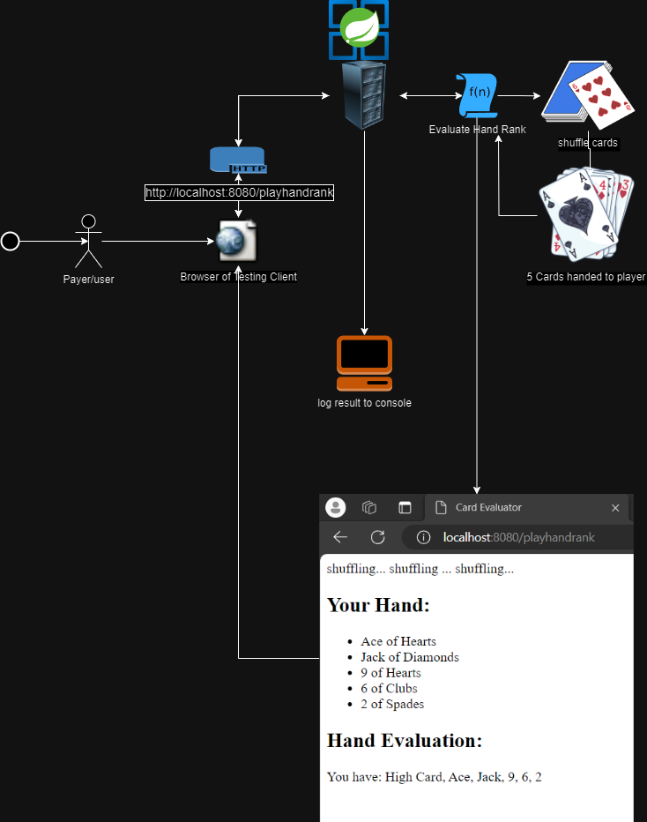**GitHub link:** [**https://github.com/ayahlangagthb/AL-HandRankWebApp.git**](https://github.com/ayahlangagthb/AL-HandRankWebApp.git)

# Please Note:

**If project is failing to build with command “mvn clean install -X”, delete the target folder and try again.**

**You should see>>**

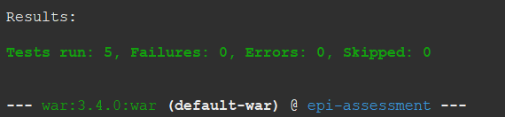

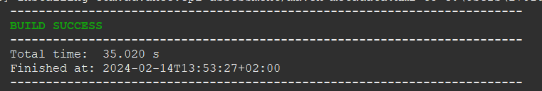

**Endpoint to run at a port of your choice should be:**

**http://{ip}:{port}/playhandrank**

**my local machine was running on.**

[**http://localhost:8080/playhandrank**](http://localhost:8080/playhandrank)

## If you see something like this, it means the micro service is up and running.

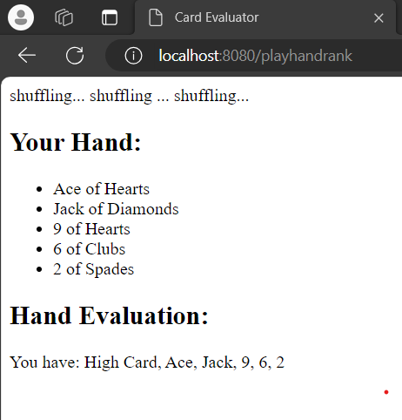

# Console result log.

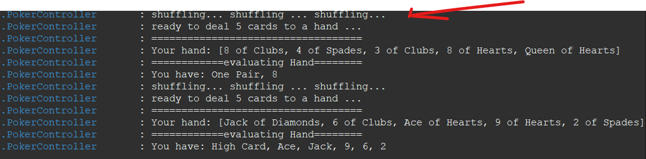

**To understand the rules of the game and implement a function for reference, I used:**

[Poker Rules for Beginners - How to play Poker the Card Game (gamerules.com)](https://gamerules.com/rules/poker-card-game/#:~:text=To%20shuffle%20and%20deal%20in%20poker%20the%20proper,from%20the%20top%20of%20the%20deck.%20More%20items)

# Take away!

**I used this opportunity to build this service the long way so to show my capabilities and expand on the simple concepts of OOP, Solid Principles,**

# The use of:

* **Spring Boot,**
* **MVC,**
* **Junit Jupiter**
* **Property files and**
* **data manipulation,**
* **Tomcat hosting.**
* **jar/war file publishing.**
* **Exception handling**
* **Java 18 (some lambda expressions, String building)**
* **Spring Tool Suit 4 vmware**
* **JDK 18**
* **Tomcat 10**
* **Apache Maven 3.8.8**
* **For dependencies check the pom.xml file**