# Brief Architecture

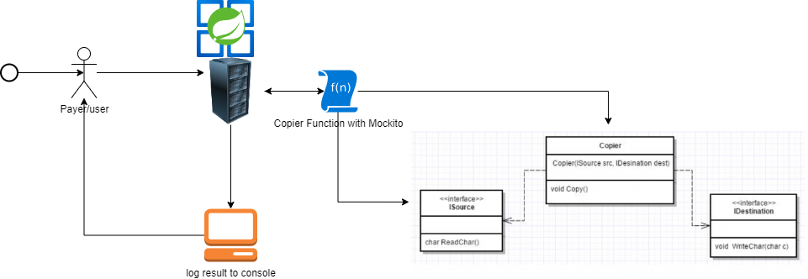**GitHub link: https://github.com/ayahlangagthb/AL_CharacterCopierApp.git**

# Please Note:

**If project is failing to build with command “mvn clean install -X”, delete the target folder and try again.**

**You should see>>**

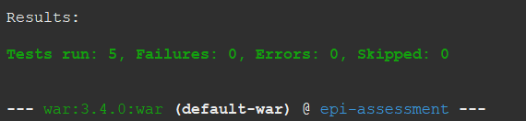

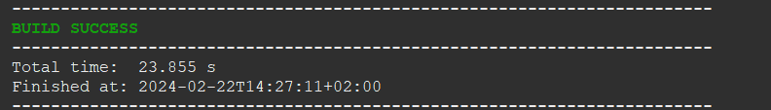

**Then mvn spring-boot:run**

# Console result log.

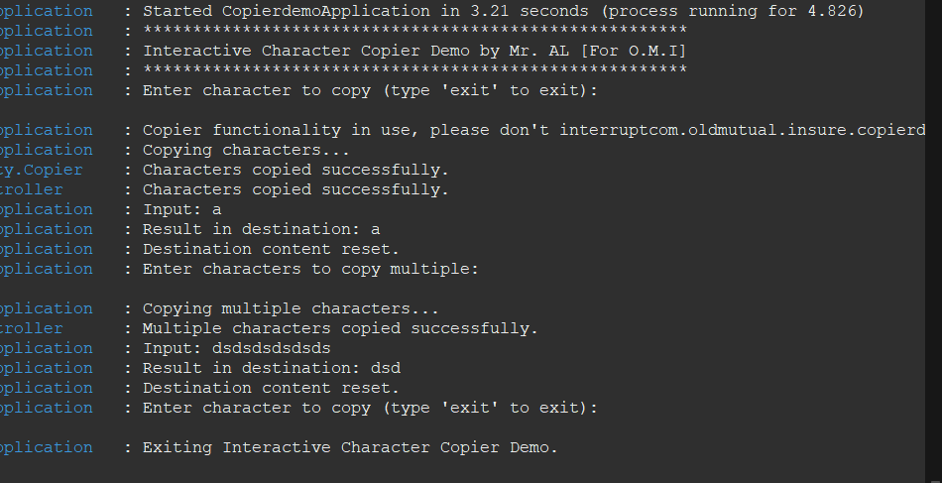

# Take away!

**I used this opportunity to build this service the long way so to show my capabilities and expand on the simple concepts of OOP, Solid Principles, webApps, Console and Mockito.**

# The use of:

* **Spring Boot,**
* **MVC,**
* **Junit Jupiter**
* **Property files and**
* **data manipulation,**
* **Tomcat hosting.**
* **jar/war file publishing.**
* **Exception handling**
* **Java 17 (some lambda expressions, String building)**
* **Spring Tool Suit 4 vmware**
* **JDK 21 on machine**
* **Tomcat 10**
* **Apache Maven 3.8.8**
* **For dependencies check the pom.xml file**