Please create a simple blog using Laravel and VueJS. It is your discretion to separate or combine the Laravel and VueJS into one installation. Personally, I would like the 2 separated but then again it is upto you.

Pages required to build

- Articles page with pagination

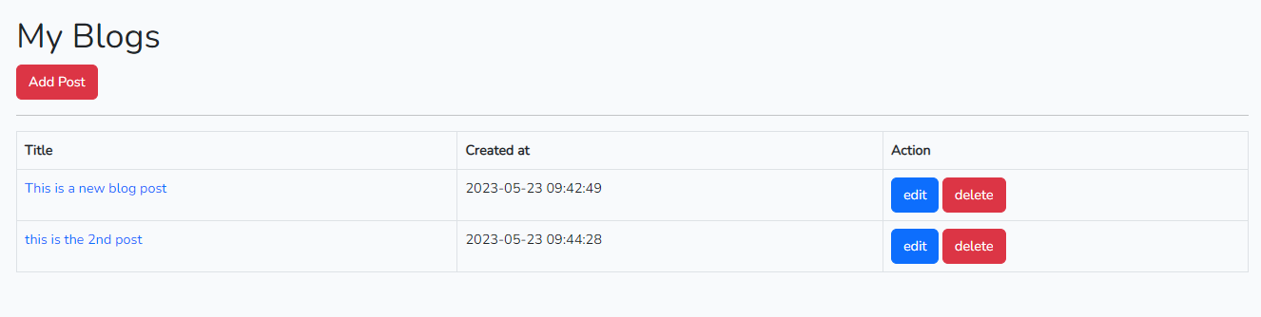

- Article page with comments up to 3 levels

Example

* Comment 1
  + Comment 2
    - Comment 3

- Article submission form

- Article edit form

- Article delete