*Vers 1.20 wbb review JOINT SERVICE REVIEW OPORD/SCRIPT 2019*

1. GENERAL. Oregon State University Reserve Officer Training Corps Units will conduct a combined Awards Ceremony and Pass-In-Review in the Memorial Union Quad on 3 May 2019 at 1000.
   1. Definitions. The following definitions are provided to clarify and simplify the script. The unit designations of the Army/Navy will be used in the script.
   2. Concept of Operation. The Joint Brigade will form east of Milam at 0930. Order will be by battalion (BN): Army ROTC, Naval ROTC and Air Force ROTC. The Color Guard may either be pre-staged on the field north of where the Battalions will be marched to or placed behind the trees, to then march out on the field when “March on the Colors” is called by the Adjutant. Reference **“Pre-Adjutant’s Call”** for a visualization.
   3. Duty Positions.
      1. The Brigade Staff will be composed of 6 Cadets/Midshipmen. Army: 1, Navy: 1, AF: 3. **Two of these Brigade Staff will be the Commander of Troops and the Adjutant, depending on which unit leads. The yearly rotation goes: AF, Navy, Army.**
      2. Brigade Joint Service Color Guard will be a combined detachment under the direction of **MIDN Brian Schrandt**
      3. Contingency Plan. In case of inclement weather, UOD will be changed to NWU, ABU, and ACU. Moderate weather is considered to be between a light rain and a severe downpour / hail.
   4. Required Equipment.
      1. 6 Company guidons, 3 Battalion guidons
      2. 6 Company CC sabers, 3 Battalion CC sabers, 3 Brigade staff sabers, 1 Commander of Troops saber and 1 Adjutant saber.
      3. Joint Color Guard: 1 Army flag, 1 Navy flag, 1 Marine flag, 1 Air Force flag, 1 National flag, 2 rifles. **Air Force: Use either the AF Flag in Commander’s Office or the Ornamental One.**
      4. Generals flag (if required)
      5. Music: Appropriate-number Ruffles and Flourishes (if required), National Anthem (if no choir/singer), Attention, Adjutants Call, Pre-Parade music and Armed Forces Medley.

## - Pre-Adjutant’s Call Visualization:

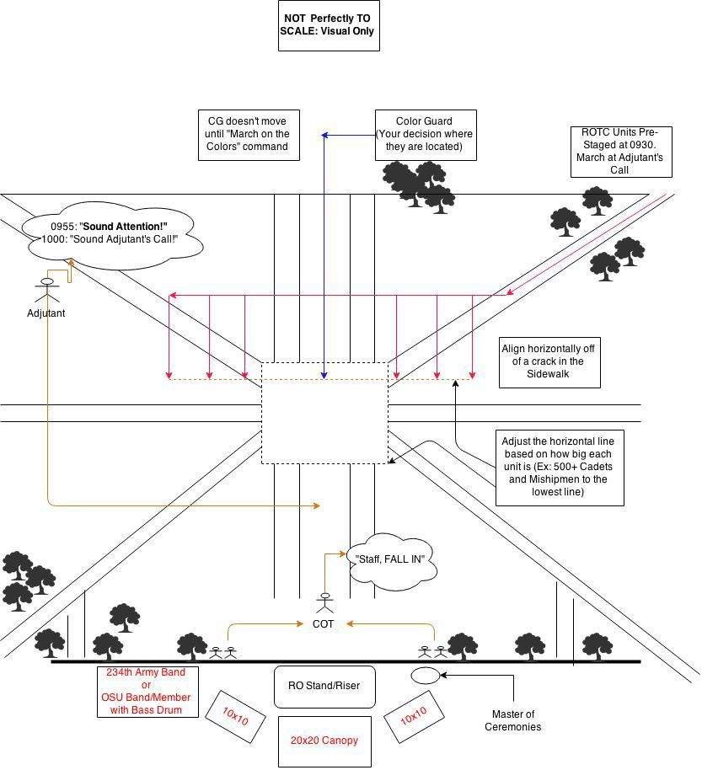

1. PARADE FORMAT: Forming the battalions for Review.
   1. Discussion.
      1. Assembly.
         1. NO LATER THAN, 30 minutes prior to the start time all units will assemble on the east side of Milam in the following order: 2 AROTC Companies, 2 NROTC Companies, and 2 AFROTC Groups. The units will have the tallest cadets in the front as Squad Leaders.
         2. The Adjutant, Brigade Staff, and drummers will be pre-positioned on the Parade Field 15 minutes before start time. **Reference “Pre Adjutant’s Call”**.
         3. The Joint Color Guard will be pre-positioned at the JSR MIDN/Cadet’s discretion. One way is to have them North of the Quad. Alternatively you can have them pre-staged on the Left Flank of the troops in formation, then have them March to the Center. Its up to you.
      2. Formation. The Battalions (BN) will be formed in mass formation with **four squad leaders abreast**. The squad leaders will be preceded by the company commanders and company guidons. The distance between each Company is 6 paces. BN Commanders march 9 paces in front of and centered on their units. Company Commanders march centered and 6 paces in front of their Company. The company guidons march directly in front and centered on the squad leaders. **Reference “Post- Adjutant’s Call” or “JSR- Line of March: Zoom-In of Battalion” for how it should look.**

# Script Format:

**[Person] [Command or M/C Speech]**

[Comments, Explanation] [Audio Officer Cue]

**0945:** Sound check, mic test, check flags and tie downs for DV seating area.

**0955** M/C:

## “LADIES AND GENTLEMEN, THE 2019 JOINT SERVICE REVIEW WILL BEGIN MOMENTARIALY. WE ASK THAT YOU PLEASE BE SEATED AND THAT ALL CELL PHONES AND ELECTRONIC DEVICES BE SILENCED FOR THE DURATION OF THE EVENT.”

**0955 COT “Staff Fall In”**

* The Brigade Staff falls into place in front of the COT.

## 1000 ADJ "SOUND ATTENTION"

* The BN Commanders do an about face and bring their units to attention in sequence at the Assembly Area.

ADJ/(Audio Officer) **"SOUND ADJUTANT’S CALL"**

OSU Band Drums

Drums continue until units are in position on the ready line.

On the adjutant's command, the Adjutant's Call music plays (trumpet) The **Adjutant** then moves to his position at the **center of the field** by the most direct route in **double time**. In the **staging area**, the **three BN commanders** will call their units to **attention** in succession and loud enough for the ADJ to hear. The **BN commanders** will give the command of **Forward March** and the units will marched onto the field.

There will be **no flanking or facing movements** when positioning the troops. The music/cadence will stop playing as soon as all units are in position on the ready line.

Note: Commander of Troops (COT) and staff initially take position facing the line of troops **six paces** in front of the reviewing area before Adjutant's call.

================================ M/C:

## “Ladies and Gentlemen:

**Welcome to the 2019 Oregon State University Reserve Officer Training Corps Joint Service Review. This is the 101st performance and centenary of the Joint Service Review at OSU. This event traces its origins as far back as 1918, when Governor Withycombe, former Dean of the Agricultural School at Oregon Agricultural College, first reviewed the troops during World War One. This tradition has been carried forth throughout the years and has evolved into the ceremony you will witness today. I would like to welcome the commanding officers of each ROTC battalion:**

* + **Navy Captain Trey Sisson**
  + **Air Force Lieutenant Colonel Michael Rue**
  + **and Army Major Joseph Snyder**

**as well as their staffs. Our Reviewing Officer & Guest of Honor for today’s ceremony is the commanding officer of USS Sampson DDG-102 CDR Jerry Jackson, United States’ Navy. Among our distinguished guests in attendance today are…**

* **Introduce VIPs**

**My name is MIDN Parker Wilkin I have the great privilege to be your master of ceremonies throughout today’s Joint Service Review.**

CO CMDRS “**MARKTIME MARCH"**

BN commanders halt themselves and the BN guidon bearer and standby until both company commanders have halted the individual companies.

BN CMDRS **“BATTALION, HALT”**

This is done in succession from right to left.

## BN CMDRS “AT CLOSE INTERVAL DRESS RIGHT, DRESS

Co Commanders of the base Co will verify alignment of their BNs.

BN CMDRS **“Ready, Front”**

In succession from right to left, each BN commander executes an about face, calls cover, does another about face, and orders their sword.

M/C (**After** the last BN CMDR has called the command “**Front”)**

## “The assembled units are now being aligned from left to right in order to place them in their exact positions for the parade.”

**Positions After Adjutant’s Call: (Color Guard may be set there or not on field yet)**

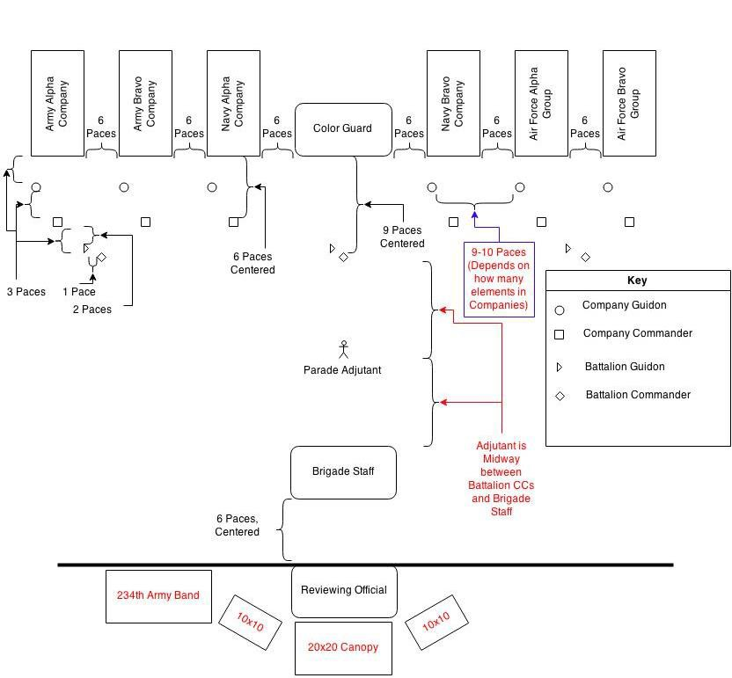

M/C

## “The next portion of the parade will be the invocation led by MIDN Carter Lynn. The presentation of colors will be followed by the singing of our National Anthem, performed by the joint OSU NROTC Choir/OSU Women’s Choir quartet. Please rise for the invocation and remain standing for the National Anthem.”

ADJ **"Bring your units to Parade Rest"**

BN CMDRS **"PARADE REST"** From right to left. COT **“STAFF, PARADE, REST”**

M/C (After ADJ goes to parade rest)

## “MIDN Lynn will now deliver the invocation”.

At “Let us Pray” all Cdts/MIDN bow their heads. At “Amen”, they snap back up to Parade Rest.

**Chaplain “Let us pray.** . . . . . . . . . **Amen**.”

## ADJ “Bring your units to Attention”

BN CMDRS **"BATTALION, ATTENTION"**

From right to left.

## COT “STAFF, ATTENTION”

ADJ **"MARCH ON THE COLORS"**

The **color guard**, coming to the carry, **marches from its position to stop midway** between the **adjutant** and **line of BN**

## Commanders.

ADJ **"Bring your units to Present Arms"**

COT “**STAFF, PRESENT, ARMS”**

BN CMDRS **“BATTALION, PRESENT, ARMS"**

Echoes from Army, then Navy, then AF.

Joint choir sings the National Anthem

## COT “STAFF, ORDER, ARMS”

ADJ **“Bring your units to Order Arms”**

BN CMDRS **"ORDER, ARMS"**

From right to left.

ADJ/OSU Drums **"POST THE COLORS"**

the Joint Color Guard moves to location in center of formation and comes to order arms

M/C

## “Ladies & gentlemen please be seated”.

ADJ **“Bring your units to Present Arms”**

BN CMDRS **"PRESENT, ARMS"**

BN commanders will give their units present arms from right to left. When all units are at present arms the Adjutant executes an about face, salutes and reports to the COT.

## M/C

**“The parade Adjutant now presents the assembled command to the Commander of**

**Troops.”**

ADJ **"Ma’am, the ‘Parade’ is formed"**

COT **"Take your post"**

The adjutant marches around to the right of the COT takes his post on the staff, halts, faces the battalion.

COT “**Draw Swords**”

COT commands draw swords for the brigade staff; staff Executes. COT **"ORDER, ARMS"**

## COT "Receive the report"

The adjutant, passing the troop commander's right, marches to his post (where he was

prior to “Take Your Post”.

ADJ **"REPORT"**

The adjutant stays facing forward, rather than turning to each BN Commander for the report.

## BN CMDRS "XXXX Reserve Officer Training Corps All present”

In succession from right to left, salute and report. The adjutant returns each

salute. After taking the last report the ADJ faces about, salutes, and reports to COT.

## ADJ "Sir, Oregon State University Reserve Officer Training Corps all present"

COT **“Very well,”** COT returns salute. ADJ “**Officers. Center. March”**

Adjutant executes an about face and takes his place in the staff.

## See discussion below.

M/C

## (OSU Band Drums)

**“At the command ‘Center, March’, all unit commanders and guide-on bearers march to the front and center of the formation. Historically, it was at this point that commanding officers would issue orders and instructions to the unit commanders.”**

**Discussion**

On the Adjutant's "Commanding", all guidon bearers come to the carry. On the command "CENTER", all guidons and BN CMDRs face the center. Co CMDRs take 1 step forward and face the center. On the command "MARCH", the drums play “**Army Marching Cadence** A”; officers and guidon bearers close to the center at close interval, halt, and in pairs face the COT. Officers, when closing the center must oblique slightly forward in order to close on a line 4 paces in front of the guides. Guidon bearers close on their own line and take a position behind their own company commanders. As the last individual to reach his position, the last Company guide says “up” only loud enough for the BN Commander to hear.

## NAVY BN CMDR "FORWARD, MARCH" OSU Band Drums until “Officers, Halt”

NAVY BN CMDR **“OFFICERS, HALT”** Halts the formation 6 paces from the COT.

Present arms is executed in 4 counts. COT returns salute.

COT **"CARRY SWORD. POST. MARCH"** At the command POSTS, all officers and guidon

bearers face about. On the command "MARCH", all members step off and return to place in formation.

M/C/OSU Band Drums

## (After the command March)

**“Following the passing of orders, the unit leaders face about, return to their units, and pass the information along to their personnel.”**

COT **"Box the Staff"**

Given in a voice only loud enough for the staff to hear.

This is done as the officers and guidon bearers are returning to their units.

The cadet on the right flank of the staff orders the staff to a left face and forward march and the staff marches around to the other side of the COT and faces towards the audience.

NAVY BN CMDR **"OFFICERS, HALT"** Nine paces from the line of troops. NAVY BN CMDR **"POST, MARCH."**

At the command, **"POST"**, the **officers and guidon bearers** face away from the

center. At the command **"MARCH", officers step off** in **succession at 4 pace intervals**, resume their posts, and execute **order sword** if so armed. **Guides step off with their officers**, resume their posts, and execute order guidon.

The drum cadence stops playing when the last officer has resumed his post. During the execution of officer’s center and officer’s post, except when saluting, the **COT remains at attention.**

## COT "Bring your units to Parade Rest"

## "STAFF, PARADE REST"

**M/C “Ladies and Gentlemen, it is my pleasure to introduce the commanding officer of OSU NROTC, Captain Warren E. Sisson.**

CAPT Sisson

*[introduction of guest speaker]. CDR Jackson...*

**(Cue)Guest Speaker to Take Stage.**

## COT "Bring your units to Present Arms"

|  |  |  |
| --- | --- | --- |
| BN CMDRS | **"PRESENT, ARMS"** | From right to left. |
| COT | **"STAFF, PRESENT, ARMS"** |  |

**// If General/Flag Officer**

234 Army DRUMS (Cue) The COT salutes and the Ruffles and Flourishes music begins. The reviewing officer will stand up "at attention" until the music has stopped.

The COT will stand at attention and render a salute to the guest of honor. Following the exchange of salutes:

## COT "Bring your units to Order arms, and Parade Rest"

## "STAFF, ORDER, ARMS, PARADE, REST"

BN CMDRS **"ORDER, ARMS, PARADE, REST"**

From right to left.

**Upon completion of the GOH’s speech:**

CAPT Sisson

*[thank you to guest speaker]. CDR Jackson...*

**CAPT Sisson hands gift to Guest Speaker, poses for picture, and both return to their seat.**

**M/C “Thank you CDR Jackson for sharing some of your experience with us today. Ladies and Gentlemen, it is now time to present the Command and perform the Pass in Review.”**

R/O (The Adjutant General) if a General Officer

Moves to podium and thanks the Cadets and Midshipmen for their preparation and execution of today’s Ceremony.

R/O **“Commander of Troops, Present the Command”**

## COT "Bring your units to Attention and PRESENT ARMS" "STAFF, ATTENTION, PRESENT ARMS"

BN CMDRS **"BATTALION, ATTENTION, PRESENT ARMS"**

BN commanders give their units attention from right to left.

COT to RO **“Sir, I present the command.”**

COT salutes RO.

R/O (The Brigade Adjutant)**"Pass in Review"**

R/O Salutes

COT

COT drops salute and does an about face

COT “**STAFF, ORDER, ARMS”**

## “Bring your units to Order Arms.”

BN CMDRS **“ORDER ARMS”**

From right to left

## COT "PASS IN REVIEW"

M/C (**Right after COT gives command**)

**“Ladies and Gentlemen, as the National Ensign passes directly in front of you, please stand.”**

COT Staff.

The COT and staff will execute a right turn, march to the front of the command, execute a left turn, march to a line 6 paces in front of the reviewing area and execute a left turn towards the reviewing area. Ensure the COT and staff remain 12 paces in front of the first unit.

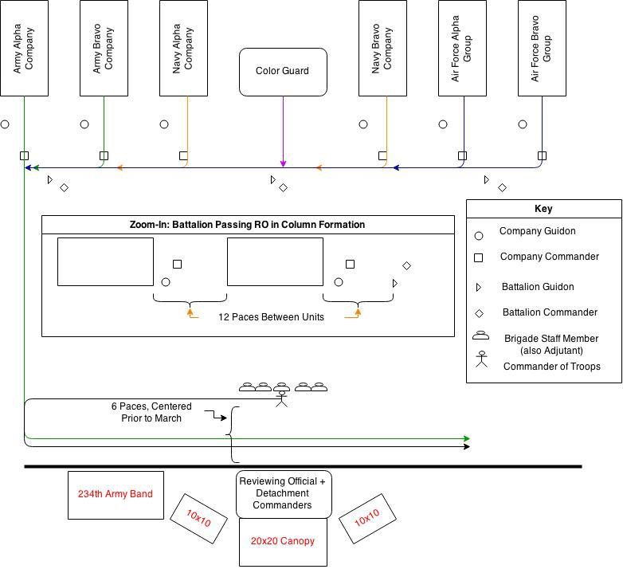

BN CMDRS **“RIGHT TURN, MARCH."**

UNIT CMDRS **“LEFT TURN, MARCH.” X’s 2**

The drums play “rest cadence” while the BN commanders give the order in sequence. When the Army BN commander comes to the corner for the first left turn, the Armed Forces Medley begins.

M/C (As each section passes in front of the audience read the names seen below for the person in charge of each section).

## Ladies and Gentlemen: The Commander of Troops, MIDN Nicole Carlson

## The Army ROTC Battalion Commander, Cadet Dane Borchers

**The Army ROTC Alpha Company Commander, Cadet Tanner Walker**

**The Army ROTC Bravo Company Commander, Cadet Justin Schwarm**

**The Naval ROTC Battalion Commander, MIDN Morgan Craig**

**The Naval ROTC Alpha Company Commander, OC Jacquelyn Brown**

**The Joint Service Color Guard Commanded by: MIDN Brian Schrandt**

**The Naval ROTC Bravo Company Commander, MIDN Paul Foersh**

**The Air Force ROTC Wing Commander, Cadet John Wickwire**

**The Air Force ROTC Alpha Group Commander, Cadet Brendan Powell**

**The Air Force ROTC Bravo Group Commander, Cadet Wyatt Aichele**

2. BN CMDR. Will time their "MARCH" command such that there is **12 paces between units** and they **are in step with the music**. BN CMDRs and guides will march to the review route such that they precede their unit.

UNIT CMDRS **"EYES, RIGHT"**

Discussion 1. COT and Staff. The COT, BN Commanders, their staffs and the company commanders, will execute eyes right and salute 6 paces from the reviewing officer. Eyes right and salutes shall be terminated upon passing 6 paces beyond the reviewing officer. After saluting the reviewing officer, **the COT and staff shall execute 3 right turns and halt on line with and to the right of the reviewing officer**. The COT will **return sword** and order his staff to **return sword**. The COT will order **"Hand, Salute"**, and **"Ready, Two"** at the appropriate times as the **National Color passes in review**. When the **rear element of the command** has passed, the COT faces the reviewing officer and renders a **hand salute**. When the salute has been returned, he and his staff **draw sword and follow their command from the field.**

1. BN CMDR. Each BN CMDR will command, "EYES, RIGHT", 2 paces from the eyes right markers. On the command the company commander salutes, the guidon bearer executes present guidon and the company executes eyes right. No others salute. The commander keeps his eyes right throughout the

command eyes right. All troops except those on the right flank turn their heads 45 degrees to the right. On the command "READY, FRONT", when the last rank is 6 paces past the reviewing officer, the company commander terminates his salute, the guidon bearer executes carry guidon, and all troops turn their head and eyes sharply to the front.

1. Color Guard. Color Guard shall execute eyes right 6 paces from the reviewing officer. Ready front will be executed 6 paces past the reviewing officer.
2. All Personnel. All personnel will salute or render the appropriate courtesy when the National Colors pass.
3. Conclusion. When the last troop unit passes the reviewing officer, the music will cease playing and immediately start into an eight-bar drum cadence. As the units leaves the field, the COT shall turn and salute the reviewing officer, as explained earlier (paragraph 1, above). The Reviewing Officer will face to the right and return salute. This exchange will terminate the ceremony.

M/C (When the COT and R/O have exchanged salutes)

## “Ladies & gentlemen, the Reserve Officer Training Corps Units of Oregon State University wish to thank you for your attendance at the 101st Oregon State ROTC Joint Service Review. We hope that you enjoyed the ceremony. I would like to take a moment to thank our partners who helped make this event possible: the MU Events team for providing all the equipment you see here, Jason Kiff and James Scott from the OSU Marching Band, and OSU grounds-keeping. Lastly, I would like to thank the dozens of Cdts and MIDN who put in many hours of work behind the scenes to make this event possible. Before you leave, please take a moment to say hello to our guest of honor CDR Jackson, distinguished visitors, and veterans. Thank you and have a great day.”