*Vers 1.20 wbb review JOINT SERVICE REVIEW OPORD/SCRIPT 2019*

1. GENERAL. Oregon State University Reserve Officer Training Corps Units will conduct a combined Awards Ceremony and Pass-In-Review in the Memorial Union Quad on 4 May 2018 at 1000.
   1. Definitions. The following definitions are provided to clarify and simplify the script. The unit designations of the Army/Navy will be used in the script.
   2. Concept of Operation. The Joint Brigade will form east of Milam at 0930. Order will be by battalion (BN): Army ROTC, Naval ROTC and Air Force ROTC. The Color Guard may either be pre-staged on the field north of where the Battalions will be marched to or placed behind the trees, to then march out on the field when “March on the Colors” is called by the Adjutant. Reference **“Pre-Adjutant’s Call”** for a visualization.
   3. Duty Positions.
      1. The Brigade Staff will be composed of 6 Cadets/Midshipmen. Army: 1, Navy: 3, AF: 1. **Two of these Brigade Staff will be the Commander of Troops and the Adjutant, depending on which unit leads. The yearly rotation goes: AF, Navy, Army.**
      2. Brigade Joint Service Color Guard will be a combined detachment under the direction of **Cadet Dane Borchers**
      3. Contingency Plan. In case of inclement weather, we will be wearing utility uniforms. Inclement weather is defined as a reasonable chance of rain (>50%) from 0900-1100 on the day of the event. In case of inclement weather, UOD will be changed to NWU/MARPAT, ABU, and ACU.
   4. Required Equipment.
      1. 6 Company guidons, 3 Battalion guidons
      2. 6 Company CC sabers, 3 Battalion CC sabers, 3 Brigade staff sabers, 1 Commander of Troops saber and 1 Adjutant saber.
      3. Joint Color Guard: 1 Army flag, 1 Navy flag, 1 Marine flag, 1 Air Force flag, 1 National flag, 2 rifles.
      4. General’s/Admiral’s flag (if required)
      5. Music: Appropriate-number Ruffles and Flourishes (if required), National Anthem (if no choir/singer), Attention, Adjutant’s Call, Pre-Parade music and Armed Forces Medley.

## - Pre-Adjutant’s Call Visualization:

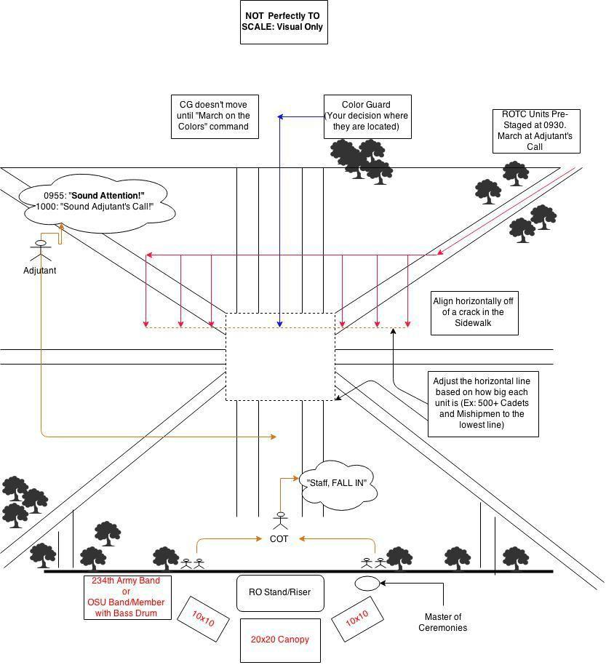

1. PARADE FORMAT: Forming the battalions for Review.
   1. Discussion.
      1. Assembly.
         1. NO LATER THAN, 30 minutes prior to the start time all units will assemble on the east side of Milam in the following order: 2 AROTC Companies, 2 NROTC Companies, and 2 AFROTC Groups. The units will have the tallest cadets in the front as Squad Leaders.
         2. The Adjutant, Brigade Staff, and drummers will be pre-positioned on the Parade Field 15 minutes before start time. **Reference “Pre Adjutant’s Call”**.
         3. The Joint Color Guard will be pre-positioned at the JSR MIDN/Cadet’s discretion. One way is to have them North of the Quad. Alternatively you can have them pre-staged on the Left Flank of the troops in formation, then have them March to the Center. It’s up to you.
      2. Formation. The Battalions (BN) will be formed in mass formation with **four squad leaders abreast**. The squad leaders will be preceded by the company commanders and company guidons. The distance between each Company is 6 paces. BN Commanders march 9 paces in front of and centered on their units. Company Commanders march centered and 6 paces in front of their Company. The company guidons march directly in front and centered on the squad leaders. **Reference “Post- Adjutant’s Call” or “JSR- Line of March: Zoom-In of Battalion” for how it should look.**

# Script Format:

**[Person] [Command or M/C Speech]**

[Comments, Explanation] [Audio Officer Cue]

**0945:** Sound check, mic test, check flags and tie downs for DV seating area.

**0955** M/C:

## “LADIES AND GENTLEMEN, THE 2019 JOINT SERVICE REVIEW WILL BEGIN MOMENTARILY. WE ASK THAT YOU PLEASE BE SEATED AND THAT ALL CELL PHONES AND ELECTRONIC DEVICES BE SILENCED FOR THE DURATION OF THE EVENT.”

**COT “Staff Fall In”**

* The Brigade Staff falls into place in front of the COT.

**COT “Staff draw swords”**

Note: Commander of Troops (COT) and staff initially take position facing the line of troops **six paces** in front of the reviewing area before Adjutant's call.

================================ **1000** M/C:

On MC’s first word, ADJ moves into position at the west side of the MU quad.

## “Ladies and Gentlemen:

**Welcome to the 2019 Oregon State University Reserve Officer Training Corps Joint Service Review. This is the 101st performance of the Joint Service Review at OSU. This event traces its origins as far back as 1918, when Governor Withycombe, former Dean of the Agricultural School at Oregon Agricultural College, first reviewed the troops during World War One. This tradition has been carried forth throughout the years and has evolved into the ceremony you will witness today. I would like to welcome the commanding officers of each ROTC battalion:**

* + **Navy Captain Trey Sisson**
  + **Air Force Lieutenant Colonel Michael Rue**
  + **and Army Major Joseph Snyder**

**as well as their staffs. Our Reviewing Officer & Guest of Honor for today’s ceremony is the commanding officer of USS Sampson DDG-102 CDR Jerry Jackson, United States’ Navy. Among our distinguished guests in attendance today are**

* **COL Miller**
* **COL Little (ret.)**
* **CAPT Dyck (ret.) and his wife**
* **COL Easterday (ret.) and his wife**
* **MAJ Szymkowicz (ret.)**
* **CPT Hayes (ret.)**
* **Mayor Traber**
* **Vice Provost Gitelman**
* **Dean Ashford**

**My name is MIDN Parker Wilkin. I have the great privilege to be your master of ceremonies throughout today’s Joint Service Review.**

================================

ADJ (when MC finishes) **"SOUND ATTENTION"**

* The BN Commanders do an about face and bring their units to attention in sequence at the Assembly Area.

ADJ/(Audio Officer) **"SOUND ADJUTANT’S CALL"**

On the adjutant's command, the Adjutant's Call music plays (trumpet) The **Adjutant** then moves to his position at the **center of the field** by the most direct route in **double time**. In the **staging area**, the **three BN commanders** will call their units to **attention** in succession and loud enough for the ADJ to hear. The **BN commanders** will give the command of **Forward March** and the units will marched onto the field. There will be **no flanking or facing movements** when positioning the troops. The music/cadence will stop playing as soon as all units are in position on the ready line.

BN CMDRS “**Forward March"**

CO CMDRS “**MARKTIME MARCH"**

BN commanders halt themselves and the BN guidon bearer and standby until both company commanders have halted the individual companies.

BN CMDRS **“BATTALION, HALT”**

This is done in succession (Army, Navy, Air Force).

## BN CMDRS “AT CLOSE INTERVAL DRESS RIGHT, DRESS

Co Commanders of the base Co will verify alignment of their BNs.

BN CMDRS **“Ready, Front”**

In succession (Army, Navy, Air Force) each BN commander executes an about face, calls cover, does another about face, and orders their sword.

M/C (**After** the last BN CMDR has called the command “**Front”)**

## “The assembled units are now being aligned from left to right in order to place them in their exact positions for the parade.”

**Positions After Adjutant’s Call: (Color Guard may be set there or not on field yet)**

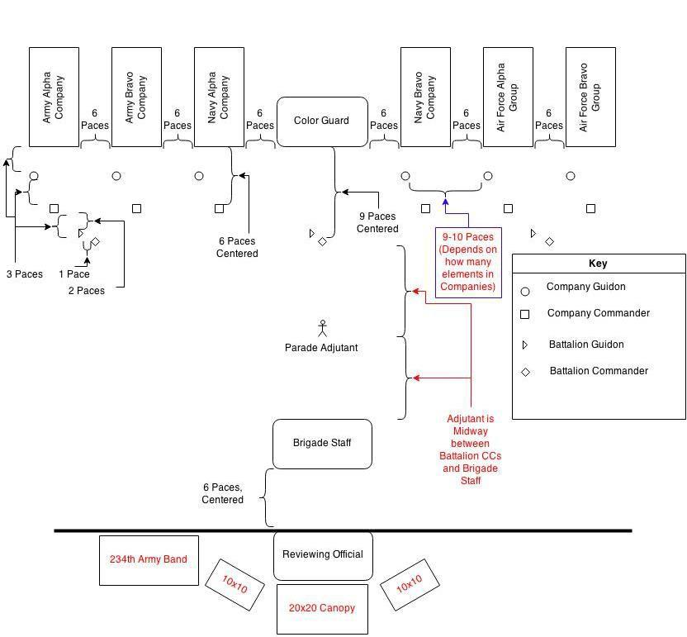

M/C

## “The next portion of the parade will be the invocation led by MIDN Carter Lynn. The presentation of colors will be followed by the singing of our National Anthem, performed by the joint OSU NROTC Choir/OSU Women’s Choir quartet. Please rise for the invocation and remain standing for the National Anthem.”

ADJ **"Bring your units to Parade Rest"**

BN CMDRS **"PARADE REST"** From right to left. COT **“STAFF, PARADE, REST”**

M/C (After ADJ goes to parade rest)

## “MIDN Lynn will now deliver the invocation”.

At “Let us Pray” all Cdts/MIDN bow their heads. At “Amen”, they snap back up to Parade Rest.

**Chaplain “Let us pray.** . . . . . . . . . **Amen**.”

## ADJ “Bring your units to Attention”

BN CMDRS **"BATTALION, ATTENTION"**

From right to left.

## COT “STAFF, ATTENTION”

ADJ **"MARCH ON THE COLORS"**

The **color guard**, coming to the carry, **marches from its position to stop midway** between the **adjutant** and **line of BN Commanders**.

ADJ **"Bring your units to Present Arms"**

COT “**STAFF, PRESENT, ARMS”**

BN CMDRS **“BATTALION, PRESENT, ARMS"**

Echoes from Army, then Navy, then AF.

Joint choir sings the National Anthem

## COT “STAFF, ORDER, ARMS”

ADJ **“Bring your units to Order Arms”**

BN CMDRS **"ORDER, ARMS"**

From right to left.

ADJ/OSU Drums **"POST THE COLORS"**

the Joint Color Guard moves to location in center of formation and comes to order arms

M/C

## “Ladies & gentlemen please be seated”.

ADJ **“Bring your units to Present Arms”**

BN CMDRS **"PRESENT, ARMS"**

BN commanders will give their units the command in succession (Army, Navy, Air Force). When all units are at present arms the Adjutant executes an about face, salutes and reports to the COT.

## M/C

**“The parade Adjutant now presents the assembled command to the Commander of**

**Troops.”**

ADJ **"Ma’am, the ‘Parade’ is formed"**

COT **"Very Well."**

The adjutant remains in center, holding salute until next command.

COT **"ORDER, ARMS"** is given to the brigade.

## COT "Receive the report"

The adjutant, will acknowledge the command via salute, about face, and give the next command.

ADJ **"REPORT"**

The adjutant stays facing forward, rather than turning to each BN Commander for the report.

## BN CMDRS "XXXX Reserve Officer Training Corps All present”

In succession (Army, Navy, Air Force), salute and report. The adjutant returns each

salute. After taking the last report the ADJ faces about, salutes, and reports to COT.

## ADJ "Ma’am, Oregon State University Reserve Officer Training Corps all present"

COT **“Very well,”** COT returns salute. ADJ faces about after cutting

ADJ “**Officers. Center. March”**

Adjutant marches to the rear and takes her place in the staff.

## See discussion below.

M/C

## (OSU Band Drums)

**“At the command ‘Center, March’, all unit commanders and guide-on bearers march to the front and center of the formation. Historically, it was at this point that commanding officers would issue orders and instructions to the unit commanders.”**

**Discussion**

On the Adjutant's "Officers” all guidon bearers come to the carry. On the command "CENTER", Company Commanders take one step forward, immediately followed by Company Commanders and Company Guides facing the center simultaneously. On the command "MARCH", the drums play “**Army Marching Cadence** A”; officers and guidon bearers close to the center at close interval, halt, and in pairs face the COT. Officers, when closing the center must oblique slightly forward in order to close on a line 4 paces in front of the guides. Guidon bearers close on their own line and take a position behind their own company commanders.

## NAVY BN CMDR "FORWARD, MARCH" OSU Band Drums until “Officers, Halt”

NAVY BN CMDR **“OFFICERS, HALT”** Halts the formation 6 paces from the COT.

Present arms is executed automatically after halting. COT returns salute.

COT **"CARRY, SWORD. POST, MARCH"** At the command **“Carry”** all swords cut. On the command **“Sword”** Commanders and Guides return to carry. On the command **“POST”,** all officers and guidon bearers face about. On the command **"MARCH",** all members step off and return to place in formation. **OSU Band drums Army Marching Cadence until “Officers, Halt.”**

## (After the command March)

**“Following the passing of orders, the unit leaders face about, return to their units, and pass the information along to their personnel.”**

COT **"Box the Staff"**

Given in a voice only loud enough for the staff to hear.

This is done as the officers and guidon bearers are returning to their units.

The cadet on the right flank of the staff orders the staff to a left face and forward march and the staff marches around to the other side of the COT and faces towards the audience.

NAVY BN CMDR **"OFFICERS, HALT"** Nine paces from the line of troops.

NAVY BN CMDR **"POST, MARCH."**

At the command, **"POST"**, the **officers and guidon bearers** face away from the

center. At the command **"MARCH", officers step off** in **succession at 4 pace intervals**, resume their posts, and execute **order sword** if so armed. **Guides step off with their officers**, resume their posts, and execute order guidon.

The drum cadence stops playing when the last officer has resumed his post. During the execution of officer’s center and officer’s post, except when saluting, the **COT remains at attention.**

## COT “Parade, Rest"

COT about faces and executes Parade Rest.

## 

**M/C “Ladies and Gentlemen, it is my pleasure to introduce the commanding officer of OSU NROTC, Captain Warren E. Sisson.**

CAPT Sisson

*[introduction of guest speaker]*

*Command is the foundation upon which our Services rest. We are extremely fortunate to have Commander Jerry Jackson as our Reviewing Officer today. He graduated from Oregon State University in 1999 and was commissioned in the Navy through the Naval ROTC program.*

*Commander Jackson is currently in command of the guided-missile destroyer, USS Sampson, an amazing ship with multi-mission capabilities. Like all commanding officers and others in authority, he has proven to be a good example of virtue, honor, and patriotism.*

*And he has been rewarded with the extraordinary responsibilities of command. He is accountable for successful accomplishment of any mission tasked to his ship, ranging from humanitarian assistance to sailing into harm’s way. He is also responsible for the welfare of more than 320 service members under his charge.*

*Our Nation’s interests and security depend on the character and competence of unit commanders and the service members they lead. It is now my honor to introduce one of those commanders. Ladies and gentlemen, Commander Jerry Jackson*

**(Cue)Guest Speaker to Take Stage.**

## COT exchange salutes with GOH, “Good Morning Sir”

**Upon completion of the GOH’s speech:**

CAPT Sisson

*[thank you to guest speaker]. CDR Jackson...*

**CAPT Sisson hands gift to Guest Speaker, poses for picture, and both return to their seat.**

**M/C “Thank you CDR Jackson for sharing some of your experience with us today. Ladies and Gentlemen, it is now time to present the Command and perform the Pass in Review.”**

R/O (The Adjutant General) if a General Officer

Moves to podium and thanks the Cadets and Midshipmen for their preparation and execution of today’s Ceremony.

R/O **“Commander of Troops, Present the Command”**

## COT “Aye Aye sir”

## "Reserve Officer Training Corps, Attention!”

## “Present, Arms!"

COT to RO **“Sir, I present the command.”**

COT salutes RO.

R/O (The Brigade Adjutant)**"Pass in Review"**

R/O Salutes

COT

COT drops salute and does an about face

COT “**ORDER, ARMS”**

## COT "PASS IN REVIEW"

M/C (**Right after COT gives command**)

**“Ladies and Gentlemen, as the National Ensign passes directly in front of you, please stand.”**

COT Staff.

The COT and staff will execute a right turn, march to the front of the command, execute a left turn, march to a line 6 paces in front of the reviewing area and execute a left turn towards the reviewing area. Ensure the COT and staff remain 12 paces in front of the first unit.

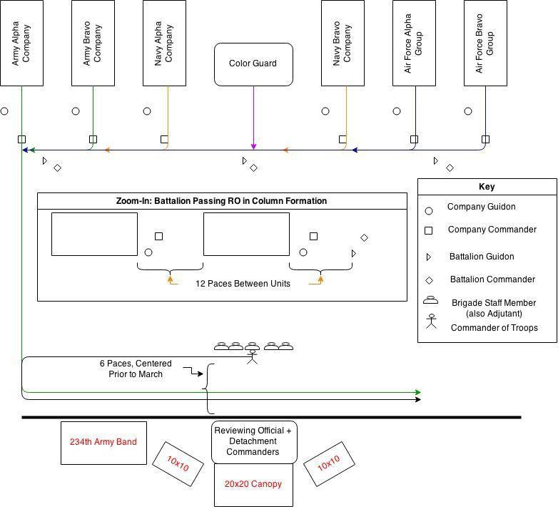

BN CMDRS **“RIGHT TURN, MARCH."**

BN CMDRS **“LEFT TURN, MARCH.” X’s 2**

The drums play “rest cadence” while the BN commanders give the order in sequence. When the Army BN commander comes to the corner for the first left turn, the Armed Forces Medley begins.

M/C (As each section passes in front of the audience read the names seen below for the person in charge of each section).

## Ladies and Gentlemen: The Commander of Troops, MIDN Nicole Carlson

## The Army ROTC Battalion Commander, Cadet Dane Borchers

**The Army ROTC Alpha Company Commander, Cadet Tanner Walker**

**The Army ROTC Bravo Company Commander, Cadet Justin Schwarm**

**The Naval ROTC Battalion Commander, MIDN Morgan Craig**

**The Naval ROTC Alpha Company Commander, OC Jacquelyn Brown**

**The Joint Service Color Guard Commanded by: MIDN Brian Schrandt**

**The Naval ROTC Bravo Company Commander, MIDN Paul Foersh**

**The Air Force ROTC Wing Commander, Cadet John Wickwire**

**The Air Force ROTC Alpha Group Commander, Cadet Brendan Powell**

**The Air Force ROTC Bravo Group Commander, Cadet Wyatt Aichele**

2. BN CMDR. Will time their "MARCH" command such that there is **12 paces between units** and they **are in step with the music**. BN CMDRs and guides will march to the review route such that they precede their unit.

Company CMDRS **"EYES, RIGHT"**

Discussion 1. COT and Staff. The COT, BN Commanders, their staffs and the company commanders, will execute eyes right and salute 6 paces from the reviewing officer. Eyes right and salutes shall be terminated upon passing 6 paces beyond the reviewing officer. After saluting the reviewing officer, **the COT and staff shall turn and halt on line with and to the right of the reviewing officer**. The COT will **return sword** and order his staff to **return sword**. The COT will order **"Hand, Salute"**, and **"Ready, To"** at the appropriate times as the **National Color passes in review**. When the **rear element of the command** has passed, the COT faces the reviewing officer and renders a **hand salute**. When the salute has been returned, he and his staff **draw sword and follow their command from the field.**

1. Co CMDR. Each Co CMDR will command, "EYES, RIGHT", 2 paces from the eyes right markers. On the command the company commander salutes, the guidon bearer executes present guidon and the company executes eyes right. No others salute. The commander keeps his eyes right throughout the command eyes right. All troops except those on the right flank turn their heads 45 degrees to the right. On the command "READY, FRONT", when the last rank is 6 paces past the reviewing officer, the company commander terminates his salute, the guidon bearer executes carry guidon, and all troops turn their head and eyes sharply to the front.

## Eyes Right While Marching

## The command is “Eyes, RIGHT.”

## The preparatory command “Eyes” is given as the right foot strikes the deck.

## As the left foot strikes the deck raise the right hand to the level of and 6 inches in front of the neck. Keep the thumb on the left side of the grip, wrist slightly bent, and inner forearm against the body. The blade should incline forward at a 30-degree angle from vertical. This movement is the same as that made on the preparatory command of “Present.” The left arm continues to swing naturally.

## The command of execution “RIGHT” is given as the right foot strikes the deck.

## As the left foot strikes the deck bring the point down smartly, without whipping, to a position 3 inches above the deck and slightly right of the right foot. Straighten the arm so the acorn is against the trouser seam. The blade is slanted down and to the front, with the true edge to the left. The thumb remains on the left side of the

## grip. At the same time, turn the head and eyes 45 degrees to the right. If in extreme right file, continue looking straight ahead. The right arm does not swing. The left arm continues to swing naturally.

## Carry Sword from Eyes Right (Executed When On The March)

## The command is “Ready, FRONT.” Execution is begun on the preparatory command.

## The preparatory command “Ready” is given as the left foot strikes the deck.

## As the right foot strikes the deck turn the true edge of the sword down.

## The command of execution “FRONT” is given as the left foot strikes the deck.

## As the right foot strikes the deck raise the sword to carry. At the same time, turn the head and eyes to the front.

## The best way to remember the movements of the sword when executing eyes right and ready front while marching is:

## 

## 

## Foot RIGHT LEFT RIGHT LEFT RIGHT LEFT RIGHT LEFT

## Command “Eyes, (UP) RIGHT” (DOWN) “Ready, (DOWN) FRONT” (UP)

## 

1. Color Guard. Color Guard shall execute eyes right 6 paces from the reviewing officer. Ready front will be executed 6 paces past the reviewing officer.
2. All Personnel. All personnel will salute or render the appropriate courtesy when the National Colors pass.
3. Conclusion. When the last troop unit passes the reviewing officer, the music will cease playing and immediately start into an eight-bar drum cadence. As the units leave the field, the COT shall call the staff to fall out. This will terminate the ceremony.

M/C (When the last unit passes, the COT will call staff to fall out concluding the ceremony)

## “Ladies & gentlemen, the Reserve Officer Training Corps Units of Oregon State University wish to thank you for your attendance at the 101st Oregon State ROTC Joint Service Review. We hope that you enjoyed the ceremony. I would like to take a moment to thank our partners who helped make this event possible: the MU Events team for providing all the equipment you see here, Jason Kiff and James Scott from the OSU Marching Band, and OSU grounds keeping. Lastly, I would like to thank the dozens of Cdts and MIDN who put in many hours of work behind the scenes to make this event possible. Before you leave, please take a moment to say hello to our guest of honor CDR Jackson, distinguished visitors, and veterans. Thank you and Have a great day.”