1. **View Medical Records (Doctor)**

* Doctor logs into the system.
* Doctor searches for a specific patient.
* Doctor navigates to the selected patient's profile.
* Doctor views the patient's medical history.
* Doctor adds new medical records based on the latest checkup.

**Sequence Diagram:** The sequence diagram would involve the following entities: Doctor, System, and Database.

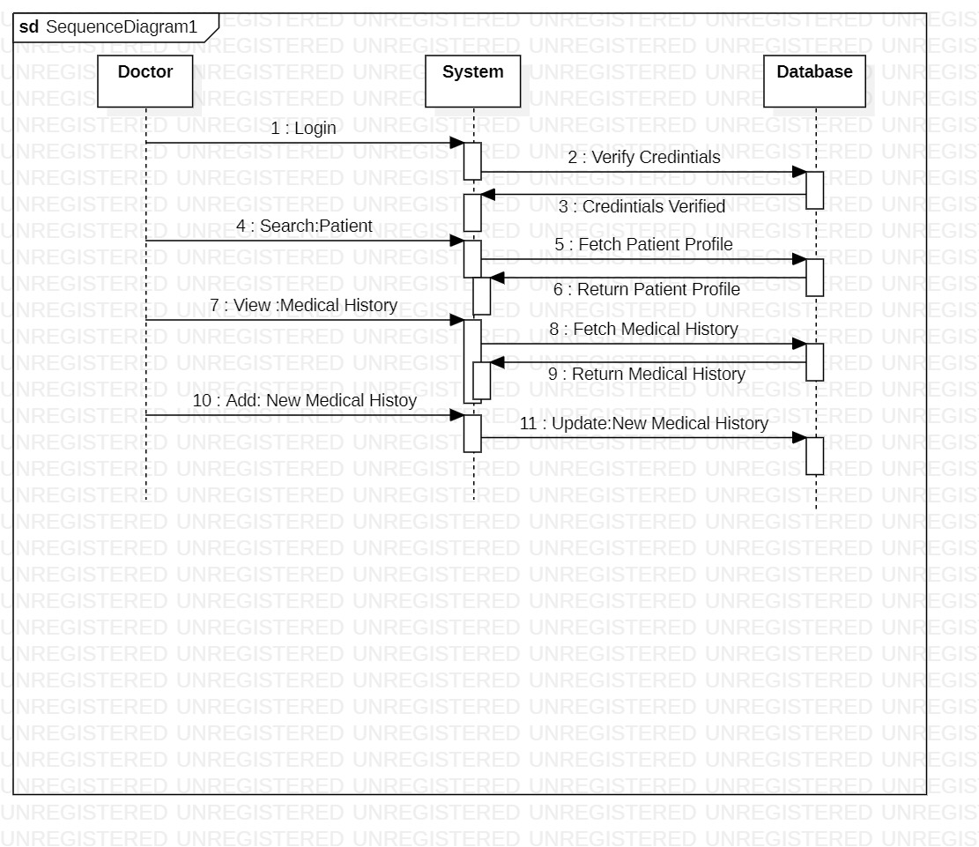

1. **Manage Appointments (Patient)**

* Patient logs into the system.
* Patient navigates to the 'My Appointments' page.
* Patient views all upcoming appointments.
* Patient selects an available time slot to book a new appointment.
* Patient selects an existing appointment and reschedules it to a new time slot.
* Patient selects another existing appointment and cancels it.

**Sequence Diagram:** The sequence diagram would involve the following entities: Patient, System, and Database.

