生物統計 HW#2
數據所 0656704 賴品儒
目的: 學習使用 R 語言做 simple regression analysis

題目: How strong is the linear relationship between the age of a driver and the distance the driver can see? If we had to guess, we might think that the relationship is negative — as age increases, the distance decreases. A research firm collected data on a sample of n = 30 drivers (“age_distance.txt”).

- Please draw stem-leaf plots for “Age” and “Distance” respectively. Comments on the two plots
(這兩個圖可以讓看個別變數的分布狀況)
stem-leaf plos for Age：
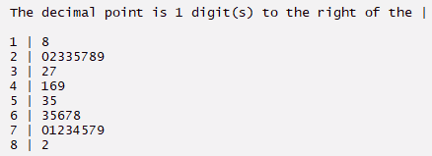
年齡的高峰出現在20和70幾的族群，出現雙峰
stem-leaf plot for Distance：
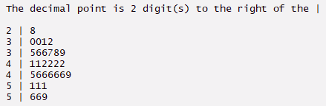
距離大致集中在30、40幾
- Please draw a scatterplot of “Age” (X 軸) and “Distance” (Y 軸). Comments on the plot. Are there any outliers or influential observations?
(這個圖可以讓看兩個變數的關聯性)
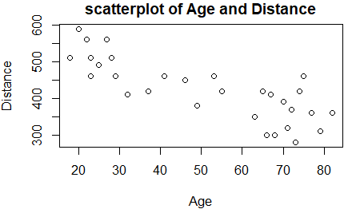
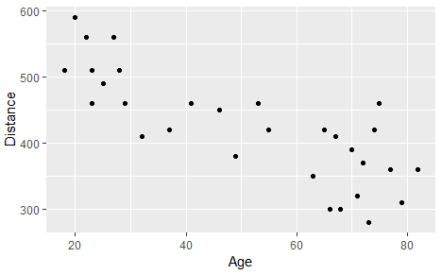
Age和Distance大致呈負相關，年齡越高，所看距離有下降趨勢。
沒有特別明顯的 outliers 及 influential observations。
- For each variable, compute the mean and standard deviation. Then compute the Pearson correlation coefficient.
 | mean | Standard deviation
Age | 51 | 21.77629
Distance | 423.3333 | 81.72002
Pearson correlation coefficient：-0.8012447
- Fit the following linear regression:
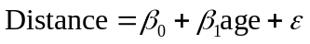.
What are the estimated values of 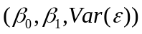?
= (576.6819, -3.0068, 2476.215)
- Draw the residual plot and comment on the plot.
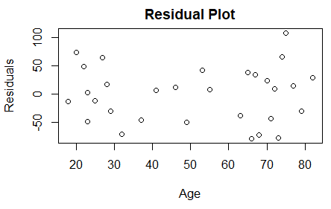
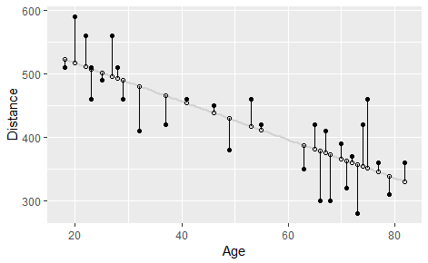
Residual在Age 20~40和60~80 的range較大，40~60 的resudual range較小。
- Draw the normal probability plot. Commet on the plot.
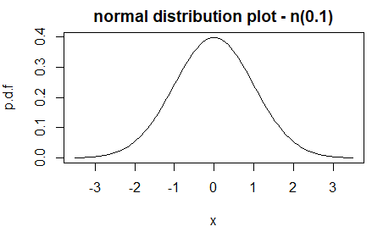
呈鐘形分布，上圖例子為標準常態分佈，平均數為0，標準差為1
- What is the value of 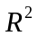? What does this value mean?
=0.641993
為衡量迴歸模式解釋力的側度，解釋response變數之變異的百分比，越大越好，介於0和1之間
=SSR/TSS

Code：https://github.com/ayamisea/Applied-Methods-in-Statistics/blob/master/homework/HW02/HW02.Rmd

