**統計應用方法 Homework 1**

**數據所 姓名：賴品儒 學號：0656704**

**第一題**

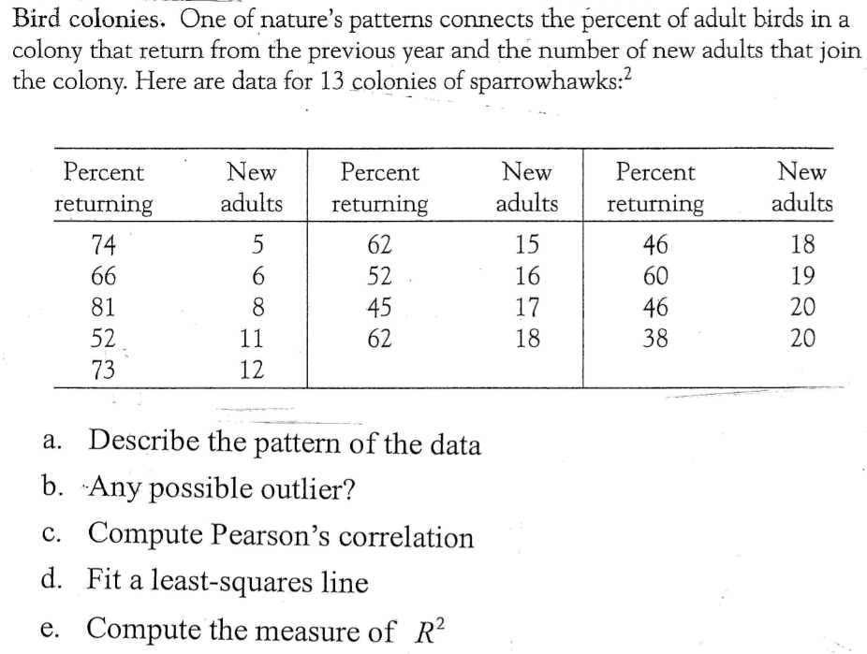

1. 設前年返回棲地成年鳥類百分比為自變數(X，explanatory variable)

設新成年鳥類數目為因變數(Y，response)

以下為前年返回棲地成年鳥類百分比與該棲地新成年鳥類數量之關係圖：

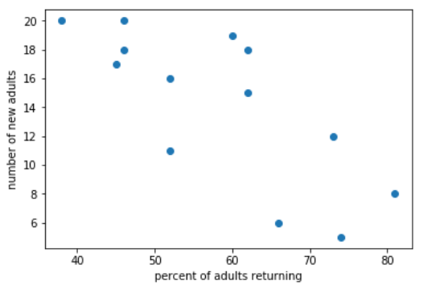

此圖約略呈現前年返回棲地成年鳥類百分比越大，則新成年鳥類數目越小，但是兩者線性關係(relationship)沒有很明顯。

1. 使用Studentized residuals ($r_{i}$)來偵測outliers

式子如下：參考<https://newonlinecourses.science.psu.edu/stat501/node/339/>

MSE=SSE/(n-2)

Hat_matrix= $X{\left(X^{T}X\right)}^{-1}X^{T}$

$r_{i}$ 超過 $±3$ 可視作outlier，這些data會降低model的解釋力 (降低 $R^{2}$)

整理data如下表：

|  |  |  |
| --- | --- | --- |
| Percent of adults returning | Number of new adults | Studentized Residual |
| 74 | 5 | -1.3518 |
| 66 | 6 | -1.6932 |
| 81 | 8 | 0.2306 |
| 52 | 11 | -1.47 |
| 73 | 12 | 0.6821 |
| 62 | 15 | 0.5457 |
| 52 | 16 | -0.0359 |
| 45 | 17 | -0.3735 |
| 62 | 18 | 1.4004 |
| 46 | 18 | 0.015 |
| 60 | 19 | 1.5077 |
| 46 | 20 | 0.6067 |
| 38 | 20 | -0.1224 |

沒有一筆data其Studentized Residual 絕對值大於3，故沒有明顯的outliers

1. Pearson’s correlation

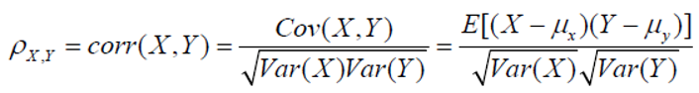

設X：Percent of adults returning

設Y：Number of new adults

Cov(X,Y)= $\sum_{i=1}^{n}{\left(X_{i}-\overline{X}\right)\left(Y_{i}-\overline{Y}\right)}/ n=$-47.6686

$$\overline{X}=58.2308 \overline{Y}=14.2308$$

Var(X)=156.7929 Var(Y)=25.8698

$$r_{X,Y}=-\frac{14.6686}{\sqrt{156.7929*25.8698}}=-0.7485$$

1. 設迴歸線為：

→ (下圖紅線)

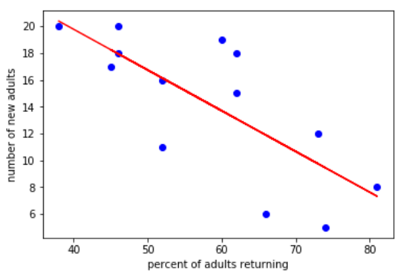

$R^{2}=\frac{SSR}{TSS}=1-\frac{SSE}{TSS}$

$$TSS=\sum_{i=1}^{n}{{\left(Y_{i}-\overline{Y}\right)}^{2}}=336.3077$$

$SSE=\sum_{i=1}^{n}{{\left(Y_{i}-\hat{Y}\right)}^{2}}=$ 147.90701

$R^{2}=1-\frac{147.90701}{336.3077}$ =0.5602

**第二題**

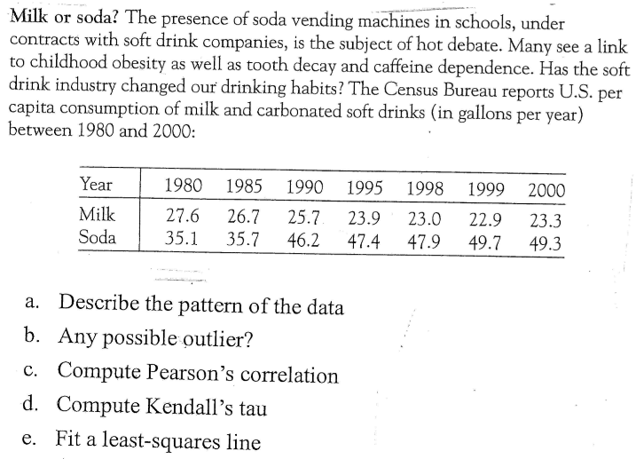

1. 設soda為自變數(X，explanatory variable)

設milk為因變數(Y，response)

以下為soda和milk之關係圖：

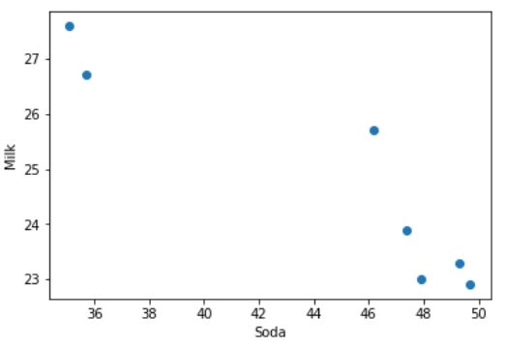

由上圖可發現，當Soda飲用量越多，Milk飲用量會有下降的趨勢

1. 用studentized residual來偵測outlier

|  |  |  |
| --- | --- | --- |
| Soda | Milk | Studentized Residual |
| 35.1 | 27.6 | 0.4116 |
| 35.7 | 26.7 | -0.8667 |
| 46.2 | 25.7 | 2.0023 |
| 47.4 | 23.9 | -0.003586 |
| 47.9 | 23.0 | -1.06867 |
| 49.7 | 22.9 | -0.5179 |
| 49.3 | 23.3 | -0.09652 |

沒有一筆data其Studentized Residual 絕對值大於3，故沒有明顯的outliers，但有一筆資料(soda, milk)=(46.2, 25.7)其Studentized residual為2.0023>2，相較於其他data來的大

1. Pearson’s correlation

設Soda為X (explanatory variable)

設Milk為Y (response)

$Cov\left(X,Y\right)=\sum_{i=1}^{n}{\left(X_{i}-\overline{X}\right)\left(Y_{i}-\overline{Y}\right)}/ n=$-9.6192

$$\overline{X}=44.4714 \overline{Y}=24.7286$$

$$Var\left(X\right)=34.1049 Var\left(Y\right)=3.16204$$

$$r_{X,Y}=-\frac{9.6192}{\sqrt{34.1049*3.16204}}=-0.9263$$

1. Kendall’s tau



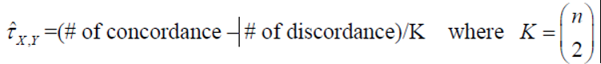

|  |  |
| --- | --- |
| 編號 | Data (soda, milk) |
| 1 | (35.1,27.6) |
| 2 | (35.7,26.7) |
| 3 | (46.2,25.7) |
| 4 | (47.4,23.9) |
| 5 | (47.9,23.0) |
| 6 | (49.7,22.9) |
| 7 | (49.3,23.3) |

|  |  |  |
| --- | --- | --- |
| 編號配對 | Concordant | Discordant |
| (1,2) |  | V |
| (1,3) |  | V |
| (1,4) |  | V |
| (1,5) |  | V |
| (1,6) |  | V |
| (1,7) |  | V |
| (2,3) |  | V |
| (2,4) |  | V |
| (2,5) |  | V |
| (2,6) |  | V |
| (2,7) |  | V |
| (3,4) |  | V |
| (3,5) |  | V |
| (3,6) |  | V |
| (3,7) |  | V |
| (4,5) |  | V |
| (4,6) |  | V |
| (4,7) |  | V |
| (5,6) |  | V |
| (5,7) | V |  |
| (6,7) |  | V |
| Total | 1 | 20 |

1. 設迴歸線： $\hat{Y}=α+βX$

$$β=r_{X,Y}\frac{S_{Y}}{S_{X}}=-0.9263*\frac{1.7782}{5.8399}=-0.2820$$

$$α=\overline{Y}-β\overline{X}=24.7286-\left(-0.2820\right)*44.4714=37.2716$$

$$→ \hat{Y}=37.2716-0.2820X$$

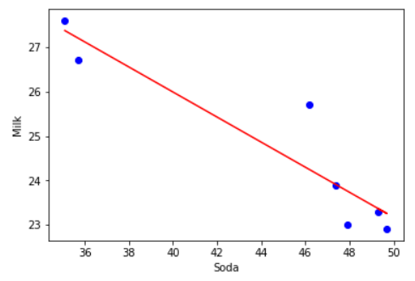

**全部計算過程：**[**https://github.com/ayamisea/Applied-Methods-in-Statistics/blob/master/homework/HW01.ipynb**](https://github.com/ayamisea/Applied-Methods-in-Statistics/blob/master/homework/HW01.ipynb)

**第三題**

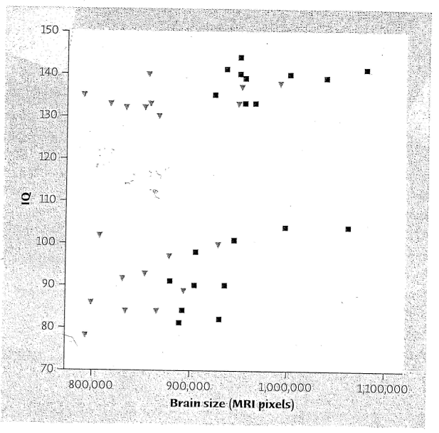

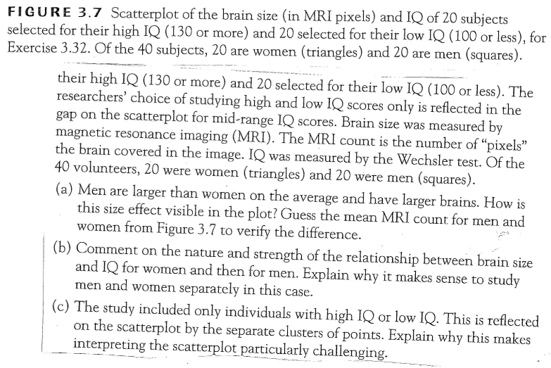

<上課討論>