NTI – Data Analysis Final Project

Team Members
Aya Mohamed Youssef
Farah Khaled Gamal

Data Overview

This project evaluates retail sales performance and profitability using a transactional dataset containing 9,994 order records and 25 fields. The dataset covers key commercial dimensions, including order details, customer segments, geographic locations, product categories, pricing structures, discount tiers, shipping durations, and net profit margins.

Column name | Data type | Description
Order ID | Text | Unique identifier for each order transaction.
Order Date | Date | The date on which the purchase was made.
Customer ID\Name | Text | Identification details of the buyer.
Region\City\Country | Text | Geographical location of the transaction or shipping destination.
Category\Sub-Category | Text | Main and secondary product classifications.
Sales | Decimal | Total revenue generated from the item sold.
Quantity | Integer | Number of units purchased.
Profit | Decimal | Net monetary gain or loss realized from the sale.

Data Cleaning & Transformation

In this phase, the dataset was prepared for analysis by converting raw date text fields into structured datetime formats, enabling precise time-based tracking. Using these dates, we added a custom column as shipping date delay that calculate the difference between the shipping date and the order date to capture operational performance.

Additionally, descriptive statistics were generated to inspect numerical metrics like sales and profit, custom rules were applied to categorize discount tiers and flag orders as profitable or loss-making, and a mathematical profit margin percentage was calculated using safe division logic to ensure accurate financial reporting.

Business Questions & Analysis

​How do sales and profit vary across different product sub-categories?

Why it matters: Higher sales volume doesn't always guarantee high profits. Identifying which specific sub-categories drive gross revenue versus those that generate net losses highlights where to adjust pricing, reduce cost structures, or cut loss-making inventory.

​How does profit vary across different shipment modes?

Why it matters: Premium shipping options like Same Day or First Class keep customers satisfied, but they carry significantly higher operational costs. This analysis shows whether expensive shipping methods are consuming the profit margins on those orders.

​Which top 5 specific products generate the most overall revenue?

Why it matters: Highlights the core products that drive overall revenue so inventory, supply chain management, and vendor relationships can be prioritized to prevent stockouts.

​​Which months or quarters of the year consistently bring in the highest sales spike?

Why it matters: Understanding seasonal demand trends enables better inventory planning, optimized staffing, and properly timed marketing campaigns ahead of peak buying windows.

​Which regions or states are making the least profit?

Why it matters: Pinpoints geographically underperforming locations and loss leaders, allowing management to evaluate regional pricing, localized discounting practices, and shipping logistics.

​Which customer group spends the most per order?

Why it matters: Knowing which customer segment (Consumer, Corporate, or Home Office) yields the highest Average Order Value (AOV) helps focus sales efforts and marketing spend on the most lucrative buyer profiles.

Do bigger discounts actually bring in more sales volume?

Why it matters: Proves whether cutting prices actually forces customers to buy more items, or if we're just giving away money for free.

​Which categories and subcategories generate the most sales and profit?

Why it matters: Provides a complete overview of product performance to guide inventory allocation and promote high-margin product groups.

9. How do sales and profit change over time?

Why it matters: It tracks whether our total sales dollars and profits are going up or down year over year.

10. Which categories and sub-categories generate the most sales and profit?

Why it matters: Shows which overall product groups (like Technology, Furniture, or Office Supplies) bring in the most money so we know what to keep stocking.

11. How does discount level relate to profit?

Why it matters: Proves if offering bigger discount bands cuts directly into our bottom line and lowers our take-home cash.

KPIs

What are the total sales generated by the business?

How many customers were placed by customers?

What is the overall profit margin of the business?

How many products were sold in total (Quantity)?

Dashboard

An interactive Power BI dashboard was created using the cleaned Superstore dataset to analyze sales performance and operational efficiency. The dashboard communicates key business insights through visual KPIs, detailed charts, and dynamic cross-filtering.

The dashboard highlights key metrics including Total Sales ($2.297M), Total Order Count (9.994K), Profit Margin percentage (12.47%), and Total Quantity sold (38K). It breaks down overall performance across product sub-categories, shipment modes, customer segments (Corporate, Consumer, and Home Office), and top revenue-generating products.

Interactive slicers for Year, Segment, and Sub-Category allow users to dynamically filter performance, drill down into specific sub-markets, and gain a clearer understanding of profitability drivers and customer ordering habits.
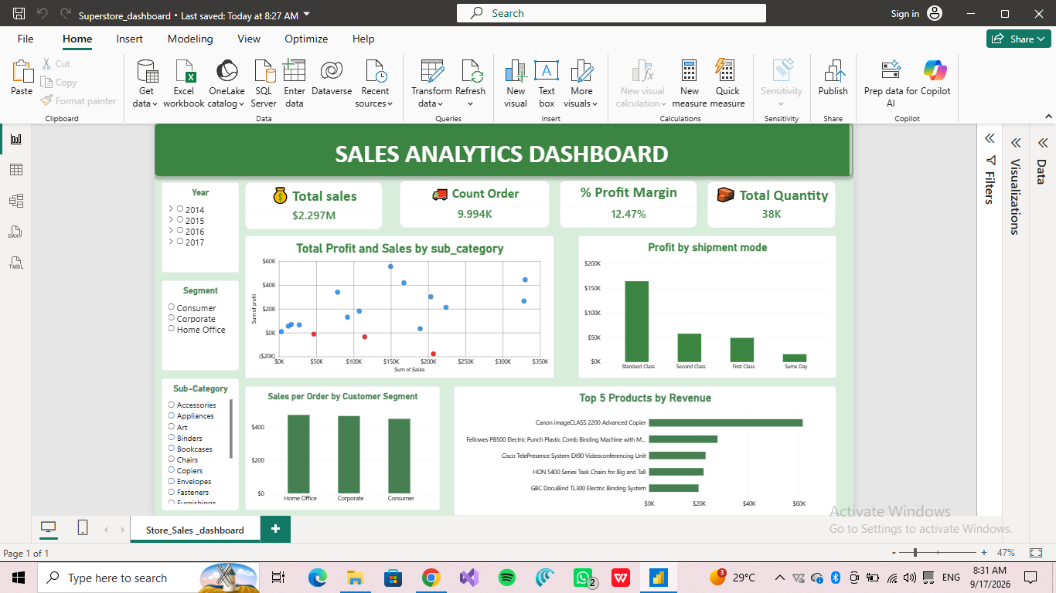

Key Findings & Recommendations

Key Findings

* Technology Drives Overall Profitability: Technology is the most profitable category, generating $145,454.95 in profit with a 17.40% profit margin, led primarily by Copiers (37.20% margin) and Accessories (25.05% margin).

* Furniture Sub-Categories Cause Significant Losses: The Furniture category yields an overall profit margin of only 2.49%, heavily dragged down by net losses in Tables (-$17,725.48) and Bookcases (-$3,472.56).

* Aggressive Discounting Erodes Bottom-Line Margins: Transactions with high discount levels (>20%) result in total losses of -$135,376.06 (-37.32% margin), whereas non-discounted orders generate $320,987.60 in profit (29.51% margin).

* Regional Disparities in Margin Performance: The West region generates the highest sales ($725,457.82) and profit margin (14.95%), while the Central region trails significantly at a 7.92% margin due to frequent local discounting.

Strategic Recommendations

* Cap Discount Thresholds: Restrict promotional discounts to a maximum threshold of 20% across all categories to eliminate negative-margin transactions.

* Restructure Unprofitable Furniture SKUs: Review pricing strategies, vendor procurement costs, and shipping rates for Tables and Bookcases to convert negative margins into profitable transactions.

* Optimize Regional Sales Strategies: Standardize discount policies in the Central region to mirror the pricing governance and higher profit margins observed in the West region.

* Focus Marketing on High-Margin Products: Prioritize promotional efforts and inventory allocation toward top-performing sub-categories such as Copiers, Paper, and Technology Accessories.

Conclusion

This project highlights the key drivers of profitability within the Superstore dataset, demonstrating that high top-line revenue does not always translate to sustainable bottom-line success. While core categories like Technology and Office Supplies consistently maintain healthy profit margins, structural losses in Furniture undermine overall business performance. Furthermore, the analysis proves that huge discounting (>20%) is the primary reason for severe margin loss across all product lines.

By implementing stricter promotional boundaries, re-evaluating underperforming product catalog items, and aligning regional pricing strategies with top-performing markets like the West region, the business can eliminate preventable losses. Ultimately, these data-driven adjustments and the operational insights provided by the interactive Power BI dashboard position the company to optimize revenue growth while securing higher, more predictable profitability.

