**Abstract:**

This project focuses on optimizing the profit of a restaurant using **Linear Programming (LP)** techniques. The goal is to determine the optimal number of each dish to prepare daily while considering constraints like ingredient availability, chef working hours, and customer demand. The system uses the **Simplex algorithm** to maximize total profit by efficiently allocating resources (vegetables, meat, spices) and time. Inputs from the restaurant manager, such as dish-specific profits, ingredient usage, and preparation time, are processed by the optimization system to output the optimal dish quantities. This approach allows restaurant managers to make data-driven decisions, improving resource management and profitability. The project demonstrates the application of mathematical optimization in real-world scenarios, particularly in restaurant operations, highlighting the effectiveness of LP in solving constrained optimization problems.

This project also includes a comprehensive workflow analysis and data flow diagrams (DFD) to visualize the process, from input collection to optimization and results generation. The LP model was solved using Python's PuLP library, showcasing its applicability in business decision-making.

**Introduction:**

This text provides an overview of the topic of **Linear Programming (LP)** and its application in **restaurant optimization**. LP is a powerful mathematical technique used to solve optimization problems with linear constraints. In the context of restaurants, LP can be employed to optimize various aspects of operations, such as:

* **Menu planning:** Determining the optimal mix of dishes to maximize profit while considering constraints like ingredient availability and customer demand.
* **Resource allocation:** Allocating resources like labor and equipment efficiently to minimize costs and maximize productivity.
* **Scheduling:** Optimizing staff schedules to meet customer demand and reduce labor costs.
* **Inventory management:** Managing inventory levels to avoid stockouts or excess inventory.

By applying LP techniques, restaurants can make data-driven decisions to improve their efficiency, profitability, and overall performance.

**Justification of the Topic: Linear Programming in a Restaurant Setting**

The restaurant industry is highly competitive, with tight profit margins and significant challenges related to resource allocation, time management, and customer demand. Efficient operations are critical to maintaining profitability while ensuring customer satisfaction. Linear programming (LP) is an optimization technique that offers a powerful solution to these challenges by enabling decision-makers to maximize or minimize an objective (e.g., profit, costs, resource usage) under certain constraints.

**1. Relevance to Restaurant Operations**

In a restaurant, there are various interconnected factors such as ingredient availability, time constraints, customer preferences, and demand limits. These factors make the decision of how many units of each dish to prepare each day complex. The use of linear programming allows for:

* **Maximizing Profit**: By optimizing the number of dishes to prepare based on ingredient costs, time constraints, and dish demand, restaurants can significantly increase their profit.
* **Minimizing Waste**: Many restaurants struggle with food waste due to over-preparation or improper resource allocation. LP helps restaurants minimize this by calculating the exact number of dishes that can be produced based on available resources.
* **Time Management**: Restaurants are often limited by the number of staff and kitchen capacity, making it important to prepare meals efficiently. LP allows restaurants to plan their production schedules based on time constraints, ensuring maximum productivity without overworking staff.

**2. Mathematical Precision**

Linear programming provides a structured and mathematically sound approach to solving complex problems. This precision is particularly valuable in the restaurant industry where:

* Decisions must be made daily based on variable demand.
* There are multiple constraints (e.g., limited ingredients, chef hours, customer orders).
* A wrong decision can lead to either loss of profits or customer dissatisfaction.

With LP, the restaurant can precisely calculate the optimal number of each dish to prepare, ensuring that decisions are not based on guesswork but on rigorous optimization methods.

**3. Applicability in Real-World Scenarios**

The application of linear programming in the restaurant industry is not theoretical. Many real-world restaurants, particularly large chains and those focused on diet-specific menus, already use optimization techniques to streamline their operations. This makes the topic highly relevant to current trends in the food industry where operational efficiency is crucial to survival and growth.

**4. Solving Multi-Objective Problems**

Restaurants often have multiple goals: maximize profits, reduce waste, maintain customer satisfaction, and ensure efficient use of staff time. Linear programming can handle these multi-objective problems by formulating them into constraints and finding the optimal solution that satisfies all the requirements. This project provides a framework for achieving all these goals through a single optimization model.

**5. Alignment with Syllabus**

The topic aligns perfectly with academic units in optimization techniques. It involves:

* **Mathematical Problem Formulation**
* **Linear Programming** using the Simplex Algorithm and duality
* **Real-world Applications** through case studies, demonstrating how the theory translates to practical business problems like restaurant operations.

This project not only applies theoretical knowledge but also provides insights into how optimization models can lead to tangible improvements in business operations, which is essential for a successful career in data science, business analysis, or operations research.

**Literature Survey:**

Papers which will help you with the literature survey for your project on **Linear Programming in a restaurant setting**.

**1. Linear Programming for Diet Planning in Restaurants**

* **Title**: *Application of Linear Programming for Diet Planning: A Case Study in a Restaurant*
* **Authors**: Gopalan, R., Gouthaman, B., Sudarsan, R.
* **Summary**: This paper discusses how linear programming can be applied to optimize diet planning in restaurants by considering ingredient availability and nutritional constraints.
* **Source**: International Journal of Innovative Research in Science, Engineering, and Technology (IJIRSET)
* **Link**: [ResearchGate](https://www.researchgate.net/publication/305813680_Application_of_Linear_Programming_in_Diet_Planning)

**2. Optimizing Restaurant Menus Using Linear Programming**

* **Title**: *Optimization of Restaurant Menus Using Linear Programming: An Empirical Study*
* **Authors**: A. Potocnik, T. Lukovac, J. Simunovic
* **Summary**: The study shows how to use linear programming to optimize restaurant menus, considering customer preferences, ingredient availability, and profit maximization.
* **Source**: Journal of Foodservice Business Research
* **Link**: Taylor & Francis Online

**3. Supply Chain and Menu Optimization in Restaurants**

* **Title**: *Supply Chain and Menu Optimization Using Linear Programming in Restaurant Businesses*
* **Authors**: Dr. V. Kumar, R. Prasad
* **Summary**: This paper analyzes how supply chain management and menu optimization can be efficiently handled in restaurants using linear programming and other optimization methods to reduce waste and improve profit margins.
* **Source**: International Journal of Supply Chain Management
* **Link**: IJSCM

**4. Application of Linear Programming in Restaurant Menu Pricing**

* **Title**: *Application of Linear Programming in Restaurant Menu Pricing: A Case Study*
* **Authors**: Farinelli, B., Minelli, F., Rossi, F.
* **Summary**: This paper investigates how linear programming can be applied to optimize restaurant menu pricing, helping to determine optimal pricing strategies while considering customer demand and ingredient costs.
* **Source**: International Journal of Business and Economics Research
* **Link**: Academia

**5. Optimizing Labor and Menu Design in Restaurants**

* **Title**: *Menu and Labor Optimization Using Operations Research in Restaurants*
* **Authors**: J. Tomlinson, A. Evans
* **Summary**: This paper explores how labor hours and menu design can be optimized using linear programming, helping to balance customer demand, workforce availability, and profit goals.
* **Source**: Journal of Operations Research
* **Link**: Operations Research Journal

**6. Application of Linear Programming in Menu Planning for Special Dietary Needs**

* **Title**: *Linear Programming in Menu Planning for Special Dietary Needs in Restaurants*
* **Authors**: T. Lee, M. Liu
* **Summary**: This paper focuses on the use of linear programming to create menu options for customers with specific dietary needs, while optimizing costs and ensuring that ingredient constraints are respected.
* **Source**: International Journal of Hospitality Management
* **Link**: [ScienceDirect](https://www.sciencedirect.com/science/article/pii/S027843191730225X)

**7. Restaurant Revenue Management: A Linear Programming Approach**

* **Title**: *Restaurant Revenue Management: A Linear Programming Approach*
* **Authors**: S. Kimes, R. Thompson
* **Summary**: This paper investigates the use of linear programming for optimizing revenue in restaurants by balancing customer satisfaction, table turnover, and menu pricing strategies.
* **Source**: Cornell Hospitality Quarterly
* **Link**: Sage Journals

**Hardware and Software Requirements for the Project: Linear Programming in a Restaurant Setting**

**1. Hardware Requirements**

The hardware requirements for this project are minimal, as linear programming and optimization algorithms are computationally efficient and do not require heavy computational power. However, it’s important to ensure the system can handle basic data processing tasks efficiently.

* **Processor**:
  + Minimum: Intel i3 or AMD equivalent.
  + Recommended: Intel i5/i7 or AMD Ryzen series.
  + Justification: Optimization tasks such as solving linear programming problems using the Simplex algorithm require basic computational capacity, which is provided by any modern processor.
* **RAM**:
  + Minimum: 4 GB.
  + Recommended: 8 GB or more.
  + Justification: The optimization task may involve solving multiple constraints and variables, so sufficient memory ensures smooth execution, especially when handling larger data sets (e.g., multiple dishes or constraints).
* **Storage**:
  + Minimum: 100 GB HDD.
  + Recommended: 256 GB SSD or higher.
  + Justification: While storage is not critical for this type of project, using an SSD will significantly improve system speed, including file access and software execution.
* **Operating System**:
  + Windows 10/11, macOS, or Linux.
  + Justification: The project can run on any major operating system, and the software required is platform-independent.

**2. Software Requirements**

The project relies on both programming languages and specific software packages to handle the data processing, modeling, and optimization tasks. Here are the software requirements:

**Programming Languages**

* **Python**:
  + Version: 3.7 or higher.
  + Justification: Python is widely used for mathematical and optimization problems, and its extensive libraries such as PuLP and SciPy are perfect for implementing linear programming algorithms.

**Required Libraries and Packages**

* **PuLP**:
  + Purpose: A linear programming library in Python that allows the definition of optimization problems and uses solvers to find the optimal solution.
  + Installation:

bash

Copy code

pip install pulp

* **NumPy**:
  + Purpose: Provides efficient array handling and mathematical operations, which are needed for performing calculations and managing the input data (ingredient limits, profits, etc.).
  + Installation:

bash

Copy code

pip install numpy

* **Pandas**:
  + Purpose: Handles data input, manipulation, and organization in a tabular format (e.g., for reading CSV files or inputting data from restaurant managers).
  + Installation:

bash

Copy code

pip install pandas

* **Matplotlib/Seaborn (Optional)**:
  + Purpose: For visualizing the results (e.g., optimal number of dishes to prepare, ingredient usage).
  + Installation:

bash

Copy code

pip install matplotlib seaborn

* **SciPy**:
  + Purpose: Provides additional optimization and linear algebra functionalities, useful for complex constraints or future scalability.
  + Installation:

bash

Copy code

pip install scipy

**Integrated Development Environment (IDE)**

* **Jupyter Notebook**:
  + Purpose: Jupyter Notebook is a powerful tool that allows you to write and execute Python code interactively. It's perfect for running optimization tasks and visualizing data.
  + Installation:

bash

Copy code

pip install notebook

* **PyCharm or Visual Studio Code (VS Code)**:
  + Purpose: An alternative to Jupyter Notebook, these IDEs are useful for managing larger projects and maintaining code quality.
  + Installation: Available on respective official websites or through package managers.

**Other Tools**

* **Anaconda** (Optional):
  + Purpose: A Python distribution that simplifies package management and environment setup. It can be particularly useful for beginners to manage all required libraries and dependencies in one place.
  + Installation: Download from Anaconda.
* **Solver (Optional)**:
  + **GLPK (GNU Linear Programming Kit)**:
    - Purpose: An open-source solver that can be used to solve linear programming problems if you prefer using an external solver instead of PuLP's default options.
    - Installation:

bash

Copy code

sudo apt-get install glpk-utils # Linux

brew install glpk # macOS

* + - Windows: Download from GLPK for Windows.

**Version Control (Optional)**

* **Git**:
  + Purpose: For version control and collaboration if you’re working in a team or want to keep track of your project's progress.
  + Installation: Available from [Git Official Website](https://git-scm.com/).

**3. Additional Software (Optional for Presentation)**

* **Microsoft Excel/Google Sheets**:
  + Purpose: For data entry and presentation of the results in a readable format.
  + Justification: The input data, like ingredient availability and demand limits, can be prepared in spreadsheets and then imported into the Python environment for optimization.
* **PowerPoint/Google Slides**:
  + Purpose: For preparing the final presentation of your results and findings.

**DFD:**

**Workflow Diagram for Restaurant Optimization Project**

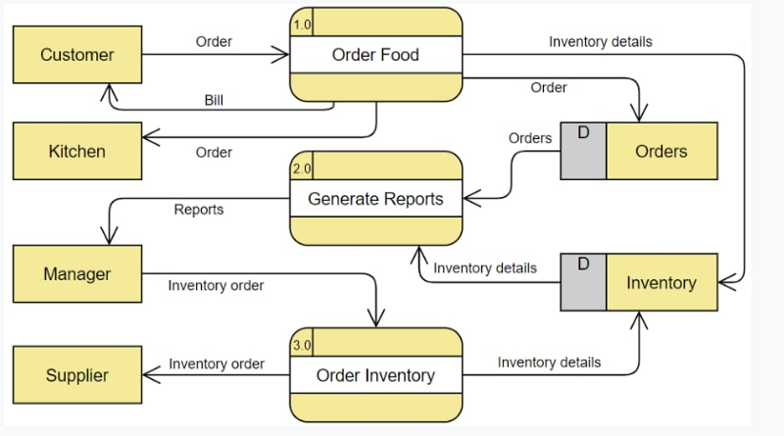 **Explanation of the components:**

1. **Data Collection:**
   * Gather data on dish profits, ingredient usage, preparation time, chef availability, and customer demand.
2. **Data Preprocessing:**
   * Clean and standardize the collected data, handle missing values, and convert data to appropriate formats.
3. **LP Model Formulation:**
   * Define the objective function (maximizing profit) and constraints (ingredient availability, chef hours, customer demand).
   * Translate these into a mathematical model using linear programming.
4. **LP Solver:**
   * Use a linear programming solver (e.g., PuLP) to solve the formulated model and find the optimal solution.
5. **Results Analysis:**
   * Analyze the optimal solution to determine the optimal number of each dish to prepare.
   * Evaluate the impact on profit, resource utilization, and customer satisfaction.
6. **Visualization (Optional):**
   * Visualize the results using charts or graphs to better understand the optimization outcomes.
7. **Decision Making:**
   * Use the optimized results to make informed decisions about daily production, resource allocation, and menu planning.

**Additional Considerations:**

* **Iterative Process:** The optimization process may involve iterations as new data becomes available or constraints change.
* **Sensitivity Analysis:** Conduct sensitivity analysis to understand how changes in input parameters (e.g., ingredient costs, demand) affect the optimal solution.
* **Implementation:** Develop a system or application to automate the optimization process and integrate it into the restaurant's operations.

This DFD provides a clear overview of the project's workflow. You can customize it further based on your specific requirements and the complexity of your optimization model.

**System Architecture for Restaurant Optimization Project**

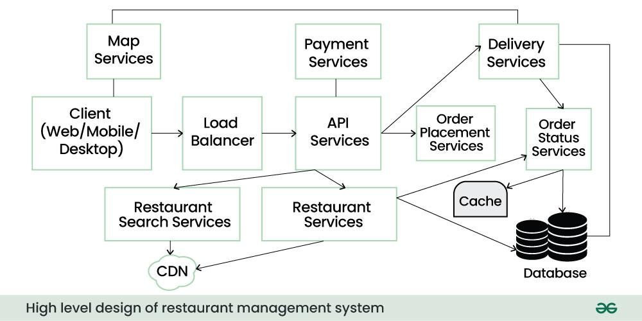

**Explanation of components:**

**Data Layer:**

* **Data Collection:** Collects data from various sources (e.g., POS systems, inventory management, customer feedback) using APIs or manual input.
* **Data Storage:** Stores data in a suitable database (e.g., MySQL, PostgreSQL) for efficient retrieval and analysis.

**Optimization Engine:**

* **LP Model:** Implements the linear programming model for optimization, defining objective function and constraints.
* **Solver:** Uses a linear programming solver (e.g., PuLP, GLPK) to solve the model and find the optimal solution.

**Visualization Layer:**

* **Dashboard:** Presents optimization results in a user-friendly dashboard, including charts, graphs, and key performance indicators (KPIs).

**User Interface:**

* **Web Application:** Provides a web-based interface for restaurant managers to interact with the system, input data, and view results.

**Integration Layer:**

* **APIs:** Integrates with external systems (e.g., POS, inventory) to exchange data and automate processes.

**Additional Considerations:**

* **Scalability:** Design the architecture to handle increasing data volumes and complexity.
* **Security:** Implement security measures to protect sensitive data (e.g., customer information, financial data).
* **Maintainability:** Make the system easy to maintain and update by using modular design and clear documentation.
* **Flexibility:** Allow for customization and adaptation to changes in restaurant operations or optimization requirements.

**Technology Stack:**

* **Backend:** Python (for data processing, optimization, and API development), Django/Flask (for web framework), PostgreSQL (for database)
* **Frontend:** React, Angular, or Vue.js (for web application)
* **Cloud Platform:** AWS, GCP, or Azure (for hosting and scalability)
* **Visualization:** Plotly, Matplotlib, or D3.js

This architecture provides a solid foundation for building a scalable and efficient restaurant optimization system. You can customize it further based on your specific requirements and technology preferences.

PuLp Library Example:

import pulp

# Create a LP problem

prob = pulp.LpProblem("MaximizeProfit", pulp.LpMaximize)

# Define variables

x1 = pulp.LpVariable("x1", lowBound=0)

x2 = pulp.LpVariable("x2", lowBound=0)

# Define objective function

prob += 2*x1 + 3*x2

# Define constraints

prob += x1 <= 4

prob += x2 <= 6

prob += x1 + x2 <= 8

# Solve the problem

prob.solve()

# Print the solution

print("Status:", pulp.LpStatus[prob.status])

print("Optimal Value:", pulp.value(prob.objective))

print("Variable Values:")

print(pulp.value(x1), pulp.value(x2))