Group: Sydney_Group_3

# Group Members:

### Ayan Roy - S388800

### Pronab Sarker - S388867

### Ahmed Zabir Hussain - S387391

### Shashika Mihiranga Puwakdandawe Gam Acharige - S385832

**Question 2:**

Using Microsoft Teams to create a group or channel for your project team. Please follow the Teams Setup on the LearnLine, which under Stage 1: Introduction to Python -> Week 2: Data Types and Expressions -> Week 2 Teams Setup. Have a screenshot to show every group member is discussing in the Teams.

=

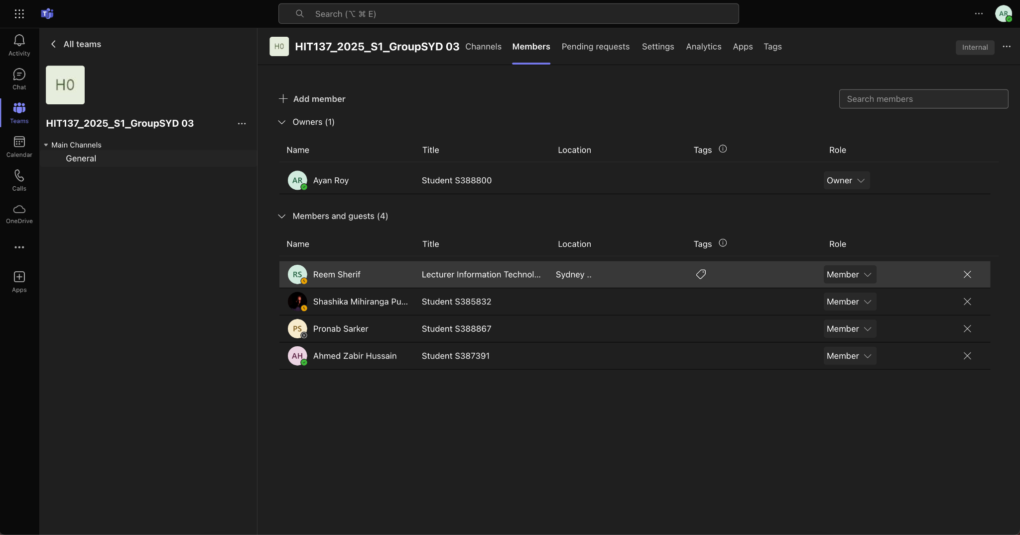

**Question 3:**

Write a short essay to discuss the benefits of working in groups on programming projects and make a group agreement to show your team’s vision and goals for this unit (500-1000 words).

=

The Benefits of Working in Groups on Programming Projects

Complex problems require collaboration in programming. Collaboration in programming projects leads to better problem solving skills, efficient task allocation, exposure to other points of view & more learning. Group work builds cooperation, communication and time management skills that are useful in academic and professional settings. This essay explores working in programming teams and draws up a group agreement on team goals.

Work in groups solves more difficult problems faster. Each player brings ideas and skills that help the team weigh options and decide what to do next. Ideas that never occurred to one person alone often arise during brainstorming sessions. This variety of thought results in creative solutions that improve the project. Group members might test each other's ideas to come up with refined solutions.

Programming jobs might involve database administration, testing/debugging, front-end development, back-end development and security implementation. A group setting assigns work to components of the project based on strengths. This division of tasks increases efficiency and quality of the finished product. It also lets people concentrate on their own specializations while learning from peers in areas where they have little experience.

Those in a group might have different backgrounds or specializations. Collaboration enables sharing best practices, learning from each other and improving coding. Expert programmers might guide beginners in best practices, debugging techniques and optimizing code efficiency. Meanwhile, more experienced programmers might develop mentoring and leadership skills that are important in professional settings. Having this mutual learning ensures that all members develop their technical expertise during the course of the project.

Programs change, and as a result, new frameworks, languages and techniques appear. Members share knowledge & industry trends through group projects. Team members might introduce tools or coding methodologies not known to others. Exposure to different programming paradigms and software development methodologies helps each member understand modern programming techniques.

Besides technical knowledge, group work teaches soft skills like communication, teamwork and time management. Concept discussion, constructive criticism and dispute resolution require communication. Teamwork distributes responsibilities fairly and everyone feels involved in the development. Working within deadlines teaches members time management and organizational skills for professional environments where following schedules is important.

Coding reviews & debugging sessions work better in groups. Bugs may be found early if several people review the code. One person may miss an error that another can find, which leads to cleaner code by collaborative quality assurance. Weekly code review helps teams stay accountable to best practices and coding standards. This likewise improves documentation and version control management, which will help future developers working on similar projects.

Almost all programming jobs in big corporations, tech firms or startups involve developers working in teams and groups. Companies cooperate between large and small teams to develop seamless software solutions. Working in groups on academic projects resembles real work environments and helps students adjust to the collaborative nature of the tech industry. Practice teamwork gives interested programmers experience managing projects, resolving conflicts and achieving common goals - useful assets later in life.

**Group Agreement - Vision & Goals.**

**Vision Statement**

Our group develops well documented software solutions. By organizing programming projects, we want to encourage everyone to contribute, learn and become a developer. By collaborating and sharing knowledge, we improve our technical skills and teamwork.

**Goals**

1. Use team communications tools like Microsoft Teams, Slack or Discord. Assign responsibility based on strengths while allowing room for growth in other areas.

2. Hold meetings about project developments, challenges, solutions.

3. Use coding best practices like documentation, code reviews, version control on GitHub or GitLab.

4. Set milestones and realistic deadlines to ensure steady progress and timely project completion.

5. Support team with mentorship and knowledge exchange.

6. Establish an inclusive learning environment.

7. Handle conflicts constructively by offering solutions and feedback that moves the project forward.

**Conclusion**

Working on programming projects in groups has many advantages: skill development, task efficiency, problem solving. Group work trains people for professional settings that require teamwork, cooperation and communication. Using a structured group agreement with clear vision and goals gives teams the ability to have an organized workflow toward project completion. Teamwork teaches aspiring programmers technical as well as interpersonal skills needed for future collaborative work in the industry. Allowing teamwork on a programming project produces better results and builds a sense of collaboration on the whole.