Name-Ayan Sadhukhan

Regd No-19BEC1448

Arrays

1. *Problem Description:*

*Array Manipulation*

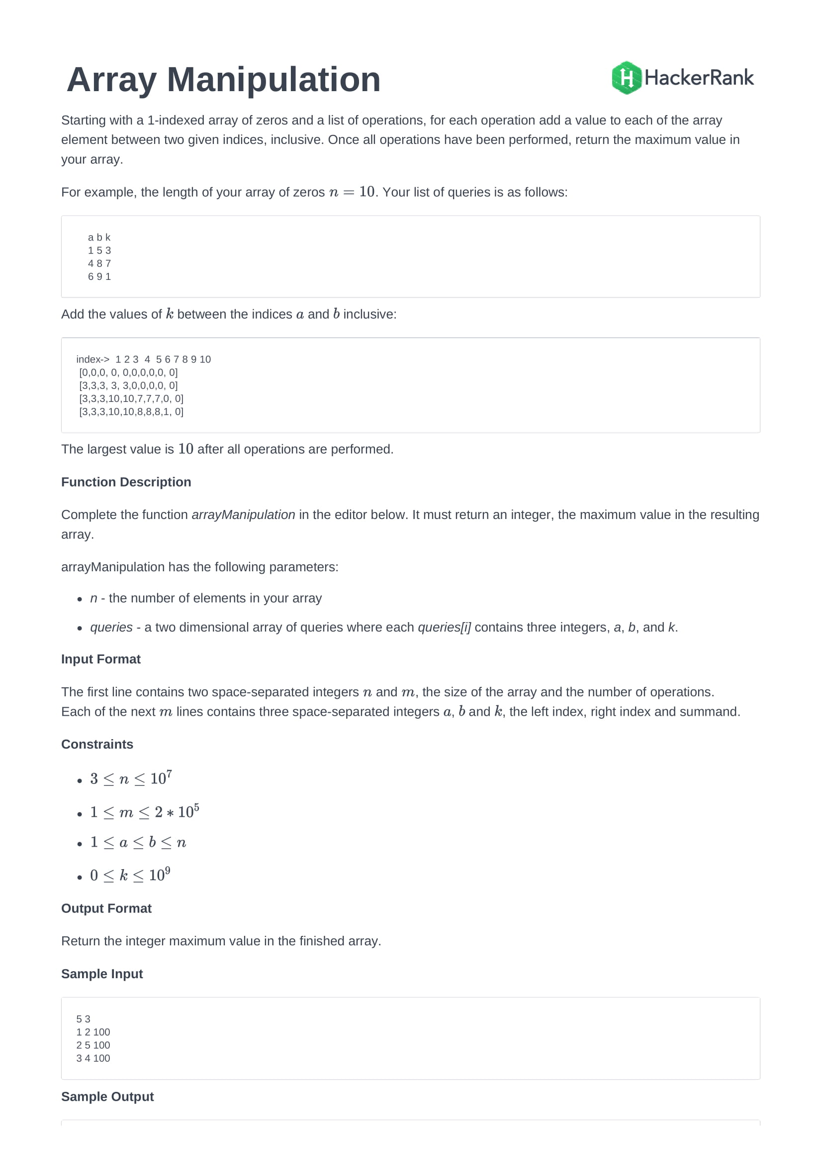

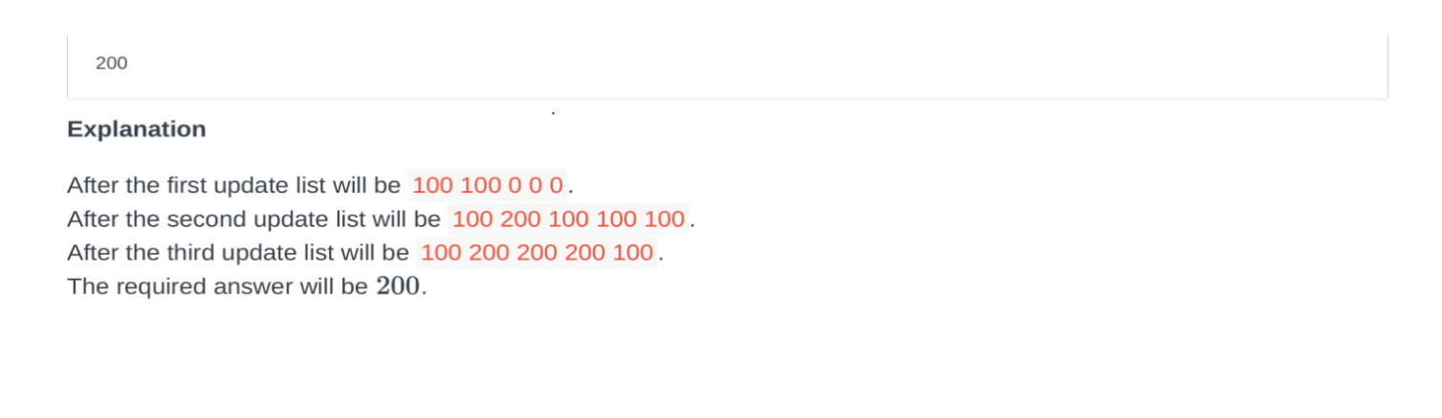

1. *Efficient Data Structure Used:*

Array is used as the efficient data structure for this problem statement.

1. *Algorithm used:*
2. *Pseudocode:*

int main()

{

long int N,K,p,q,sum,i,j,max=0,x=0;

cin>>N>>K;

long int \*a=new long int[N+1]();

for(i=0;i<K;i++)

{

cin>>p>>q>>sum;

a[p]+=sum;

if((q+1)<=N) a[q+1]-=sum;

}

for(i=1;i<=N;i++)

{

x=x+a[i];

if(max<x) max=x;

}

cout<<max;

return 0;

}

1. *Time Complexity:*

O(n)

Stacks

1. *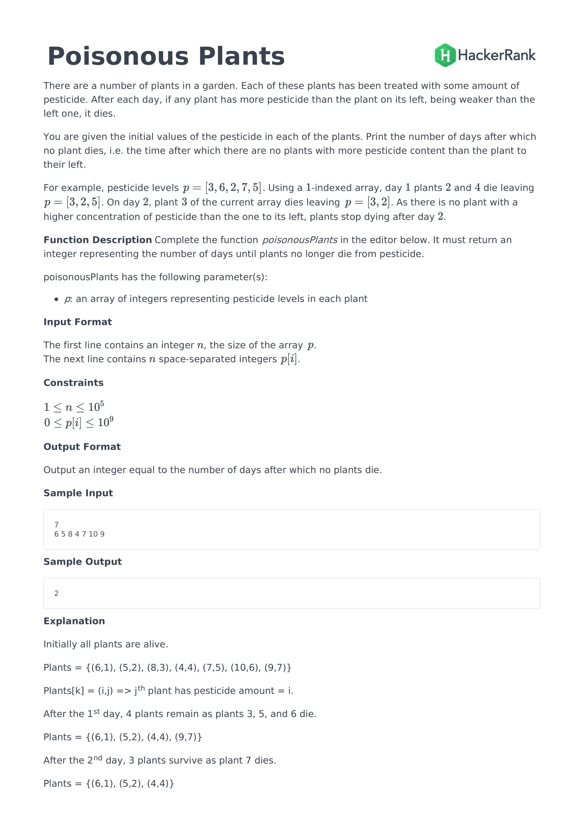Problem Description:*
2. *Efficient Data Structure:*

*3. Algorithm used*

*4. Pseudocode*

*5. Time Complexity*

Queues

1. Problem Description

2. Efficient Data Structure

3. Algorithm used

4. Pseudocode

5. Time Complexity

Linked List

1. Problem Description

2. Efficient Data Structure

3. Algorithm used

4. Pseudocode

5. Time Complexity

Tree

1. Problem Description

2. Efficient Data Structure

3. Algorithm used

4. Pseudocode

5. Time Complexity

Graphs

1. Problem Description

2. Efficient Data Structure

3. Algorithm used

4. Pseudocode

5. Time Complexity

Divide and Conquer

1. Problem Description

2. Efficient Data Structure

3. Algorithm used

4. Pseudocode

5. Time Complexity

Brute Force

1. Problem Description

2. Efficient Data Structure

3. Algorithm used

4. Pseudocode

5. Time Complexity

Dynamic Programming

1. Problem Description

2. Efficient Data Structure

3. Algorithm used

4. Pseudocode

5. Time Complexity