Outputs

**Output 1(Server side) :**

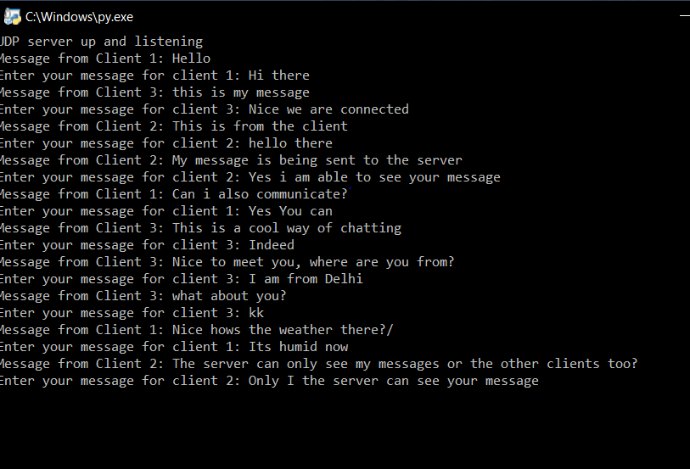

**Output 2(Client1 side):**

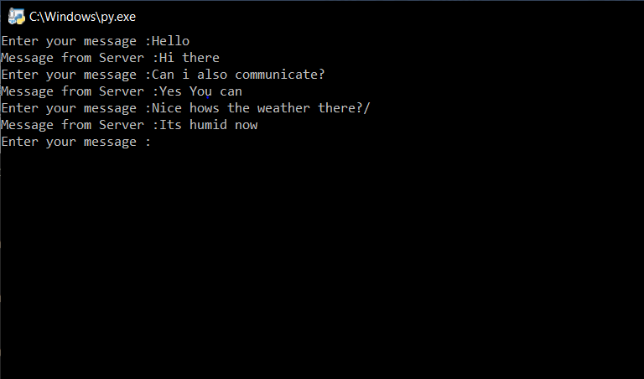

**Output 3(Client 2 Side):**

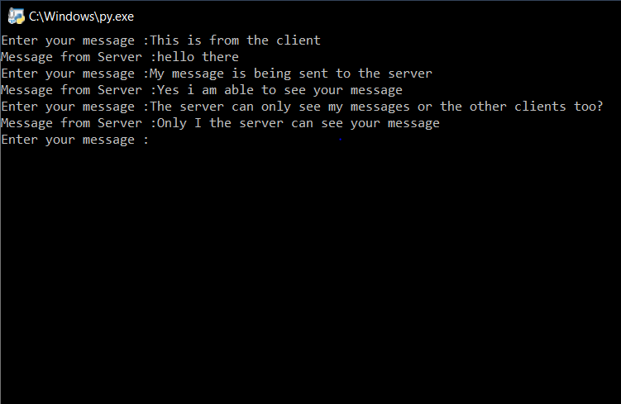

**Output 4(Client 3 Side):**

