**Wilcoxon Sign Test 🡪 To compare 2 paired Samples**

H0 = There is no promotion if years with Current manager is less .

H1 = There is promotion if years with Current manager is less.

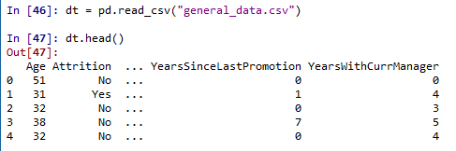



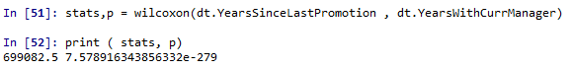

P < 0.05 (7.578916343856332e-279) 🡪 H0 can be rejected , Alternative hypothesis to be accepted.

**Freidman test 🡪 To Compare > 2 Paired Samples**

H0 = There is no promotion if years within the company is less and number of companies worked is less

H1 = There is promotion if years within the company is less and number of companies worked is less.

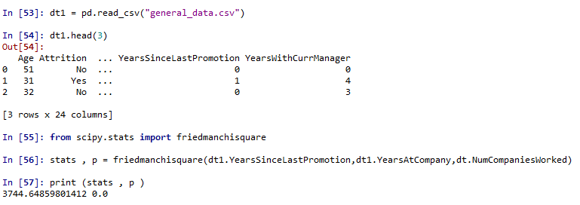

P < 0.05 (0.0) 🡪 H0 can be rejected , Alternative hypothesis to be accepted.

**Mann Whitney test 🡪 To Compare 2 Independent Samples**

HO = There is no significant relationship between Monthly Income and Number of companies worked

HO = There is a significant relationship between Monthly Income and Number of companies worked

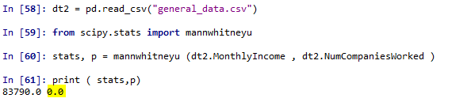

P < 0.05 (0.0) 🡪 H0 can be rejected , Alternative hypothesis to be accepted.

**Khyrskal – Wallis Test – Compare > 2 Independent Samples test**

HO = There is no significant relationship between Monthly Income , Number of Years at company, percentage of Salary hike

H1 = There is significant relationship between Monthly Income , Number of Years at company, percentage of Salary hike



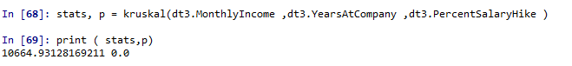

P < 0.05 (0.0) 🡪 H0 can be rejected , Alternative hypothesis to be accepted

**Chi Square Test 🡪 To check dependency of variables , Variables should be categorical**

H0 = There is no dependency between attrition and gender

H1 = There is dependency between attrition and gender





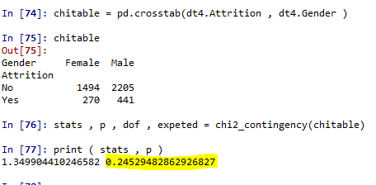

P > 0.05 (0.0) 🡪 H0 can be accepted , Alternative hypothesis to be rejected

**Parametric Tests**

**One Sample Test 🡪 To compare sample mean with Population mean**

H0 =There is no significant difference between mean of monthly income against population mean = 65000

H0 =There is a significant difference between mean of monthly income against population mean = 65000

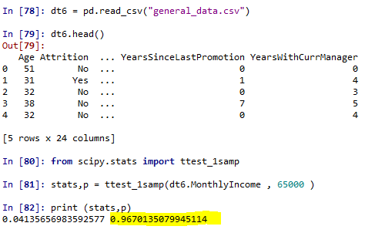

P > 0.05 (1.087893570160242e-26) – hence H0 is accepted , Alternative Hypothesis can be rejected.

**2- Sample Paired T Test -> Mean of two paired samples**

No Paired DataSet

**2- Sample Independent T – Test – To compare mean of 2 independent samples**

H0 = There is no significant difference between mean of salary hike and total working hours

H1 = There is significant difference between mean of salary hike and total working hours



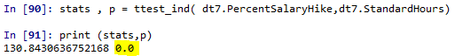

P > 0.05 (0.0) 🡪 H0 can be accepted , Alternative hypothesis to be rejected