Name: Priyanshi Kalra
Class: B. Tech CSE-TY Div.: ‘A’ Roll No.: 150
Experiment -3
Git Workflow
1. Clone repository
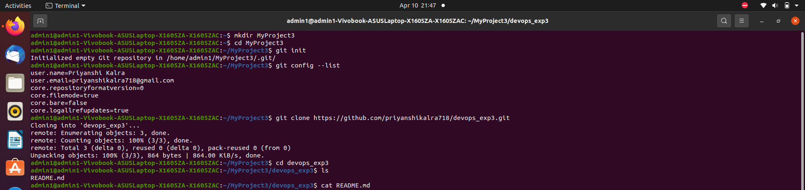
2. git branch
3. git checkout –b develop
4.git branch
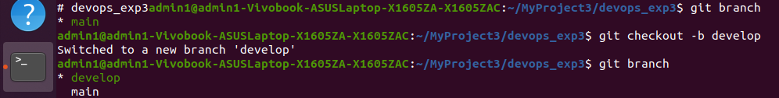

5. create new project and push in GitHub
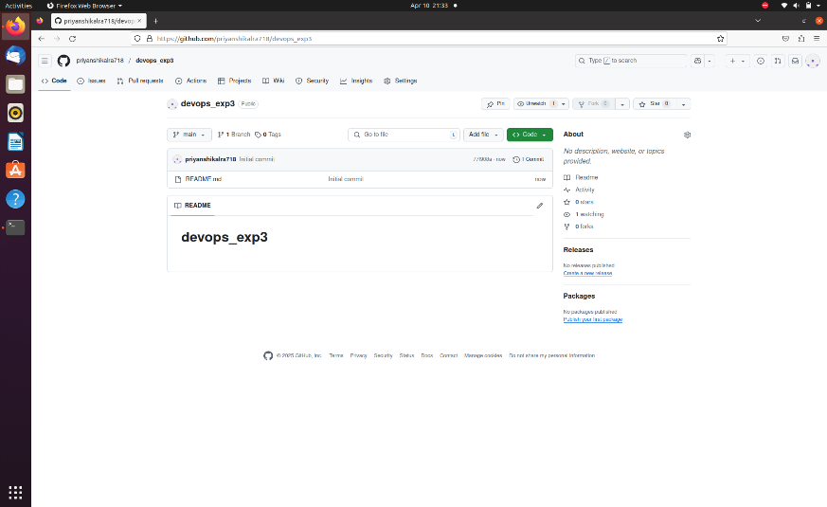

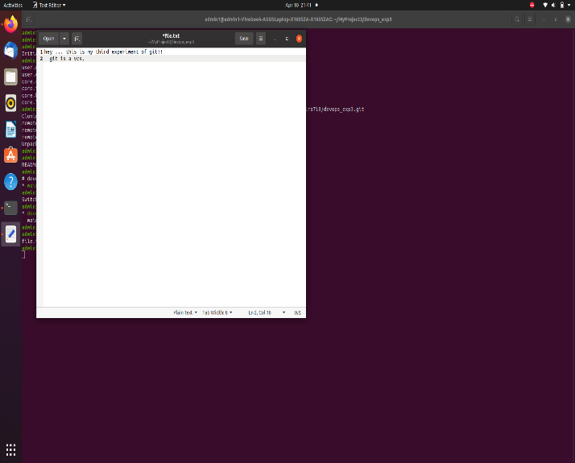

6. git status
7. git add .
8. git commit –m “file commit”
9. git push origin develop
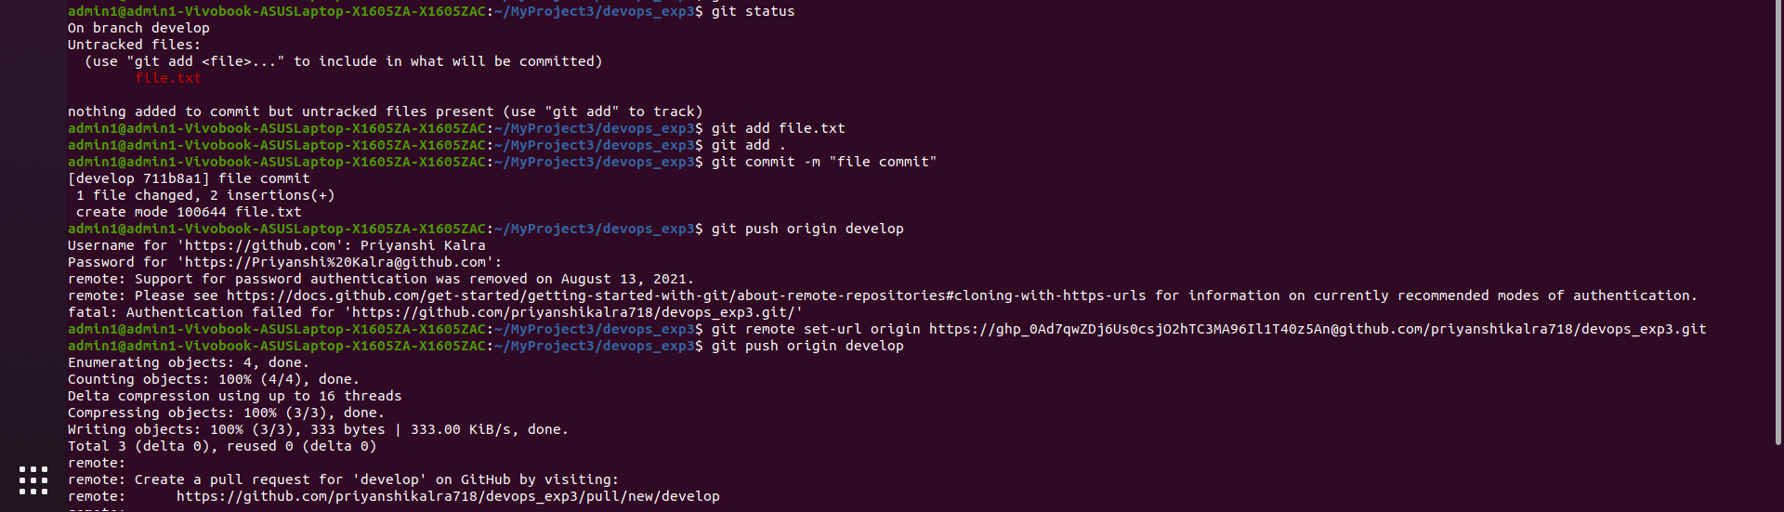

Make changes in project
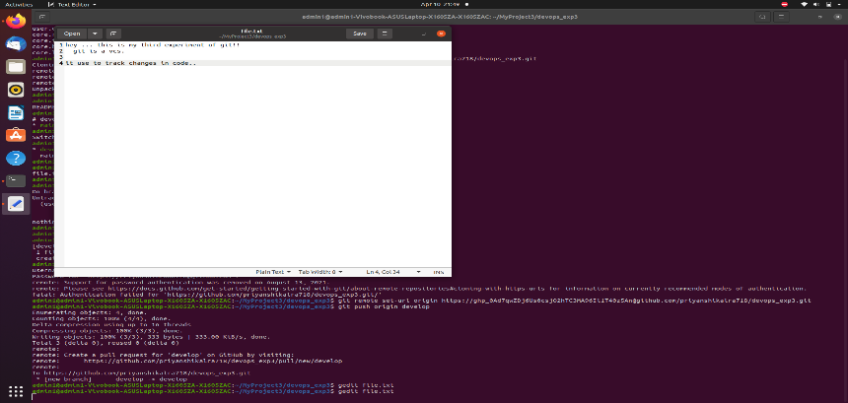

Pull request send to main to develop
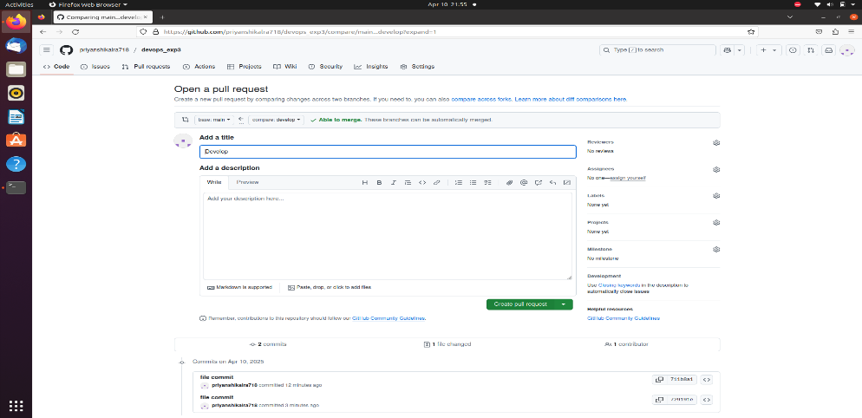

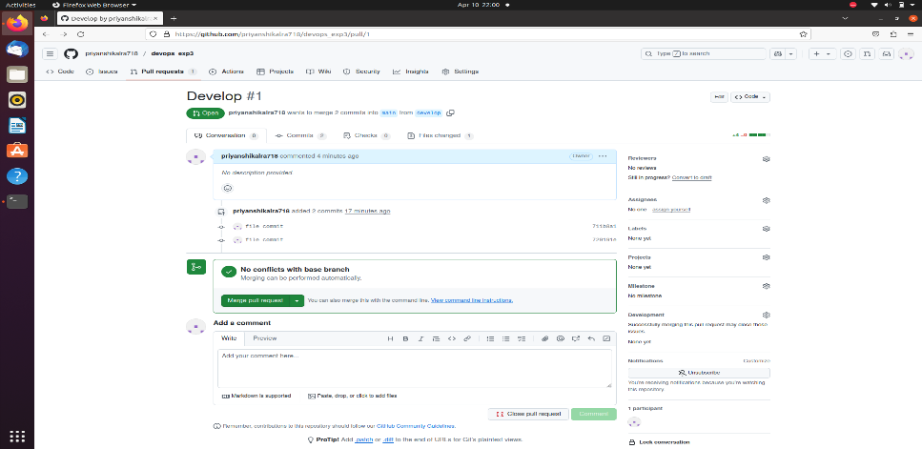

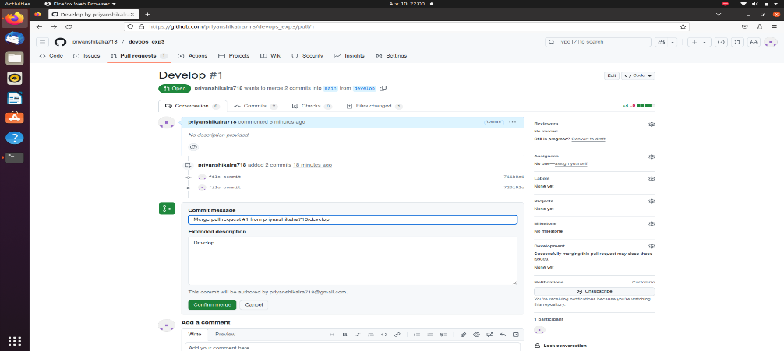

10. git checkout –b feature
git push origin feature
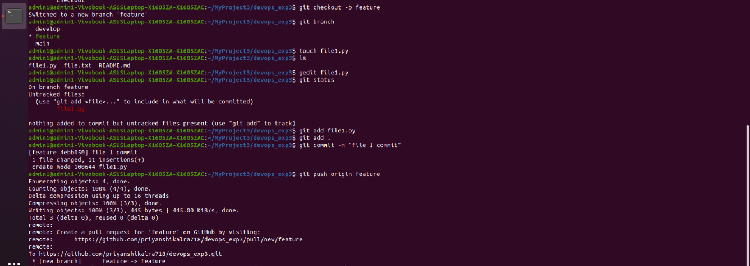
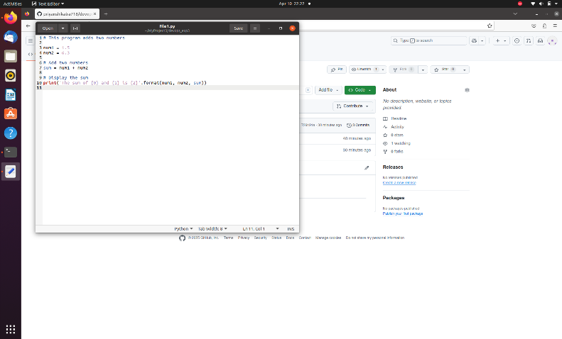

11. Search in branch menu
Create new branch – release v1.0

Send pull request feature to release v1.0
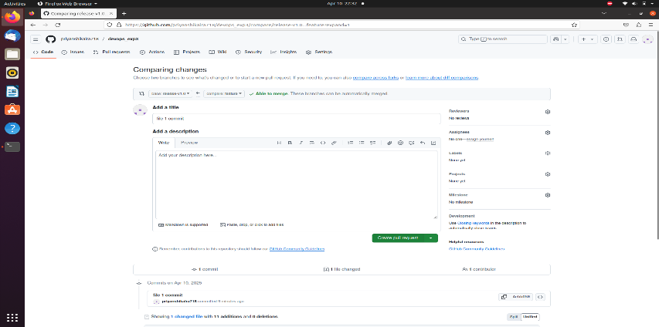

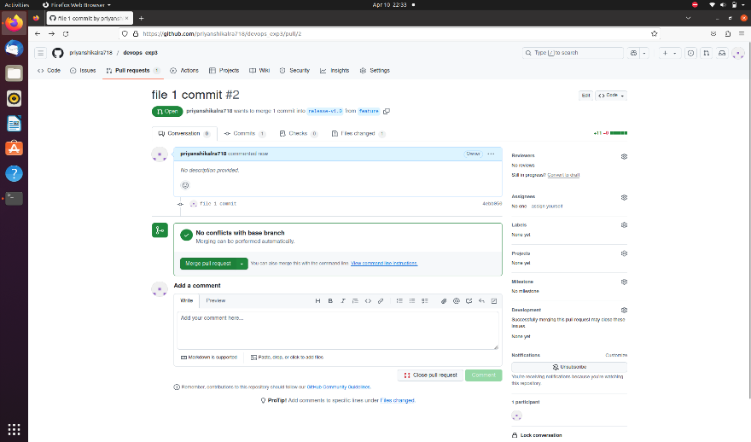

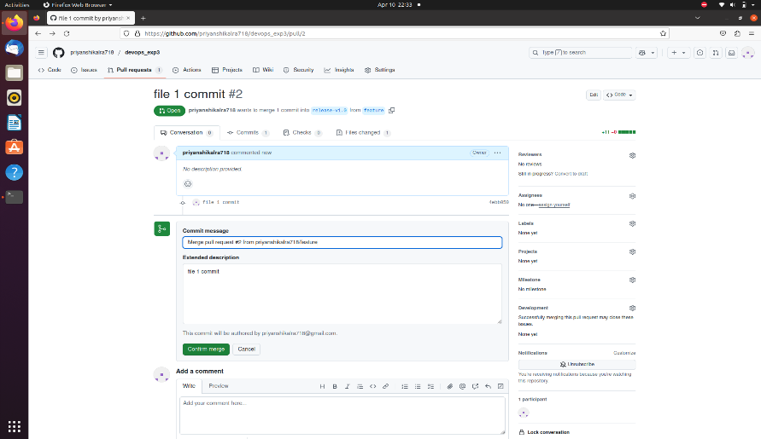

Send pull request main to release v1.0
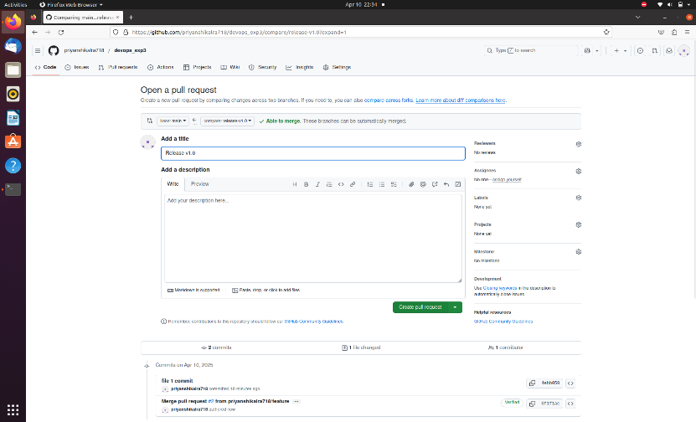

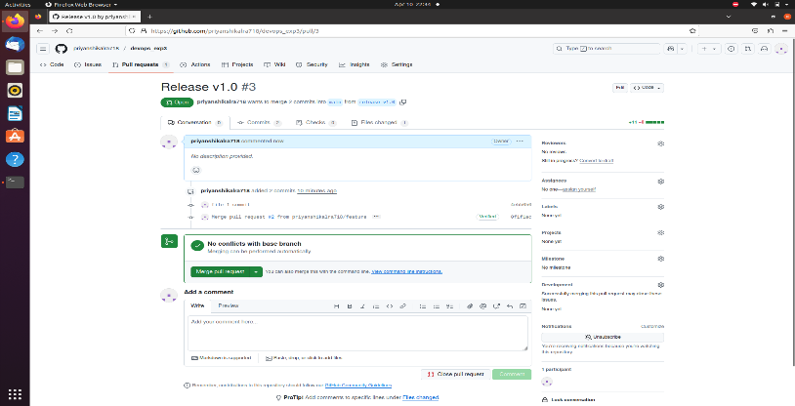

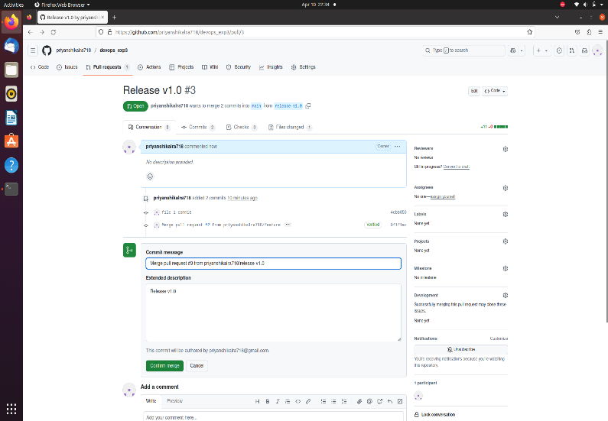

12. git branch
13. git checkout –b hotfix/bug-4
14. git push origin hotfix/bug-4
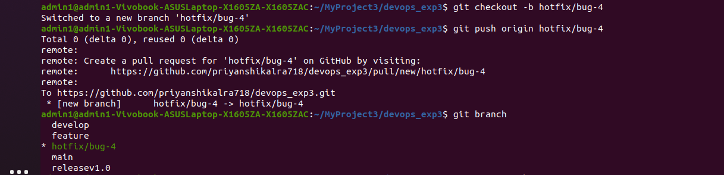
15. git branch
Send pull request main to hotfix/bug-4
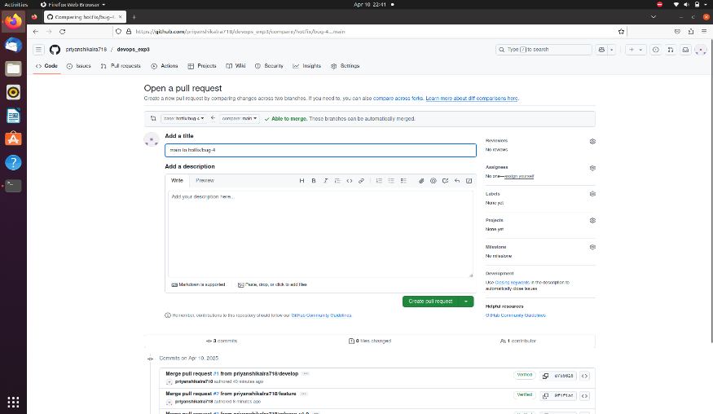
Send pull request develop to hotfix/bug-4
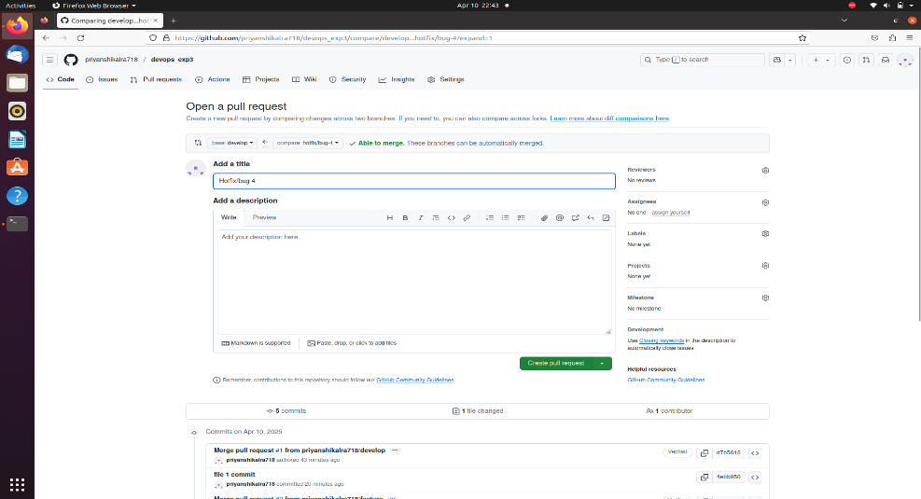
Send pull request feature to hotfix/bug-4
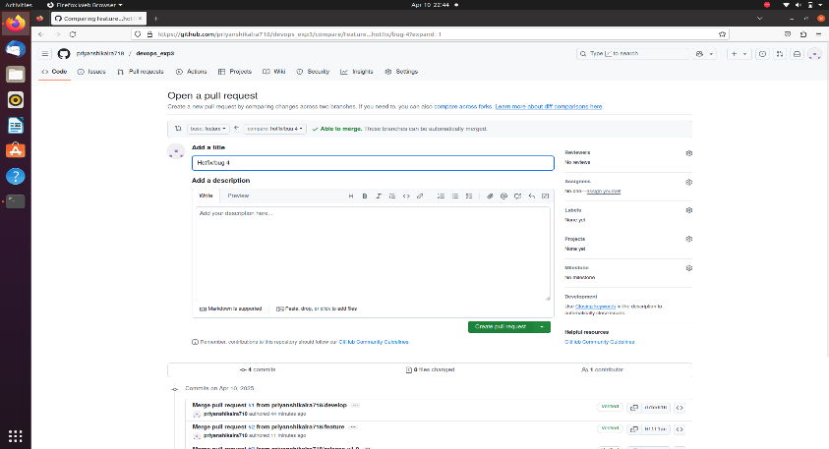

16. choose option write side bottom of GitHub account – create new release
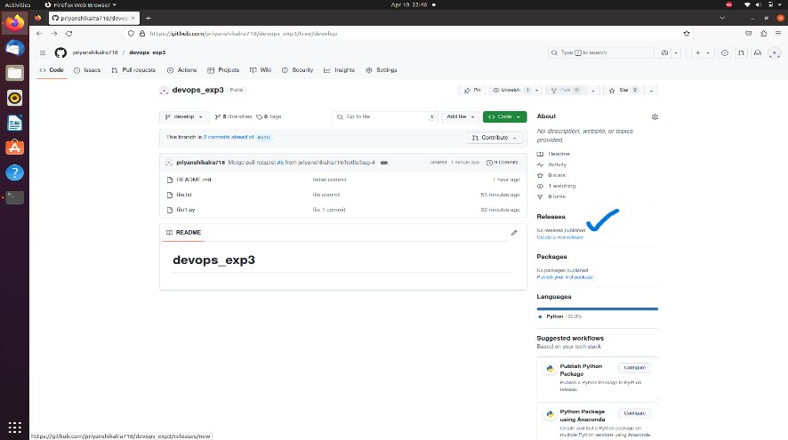
-v1.0 to main
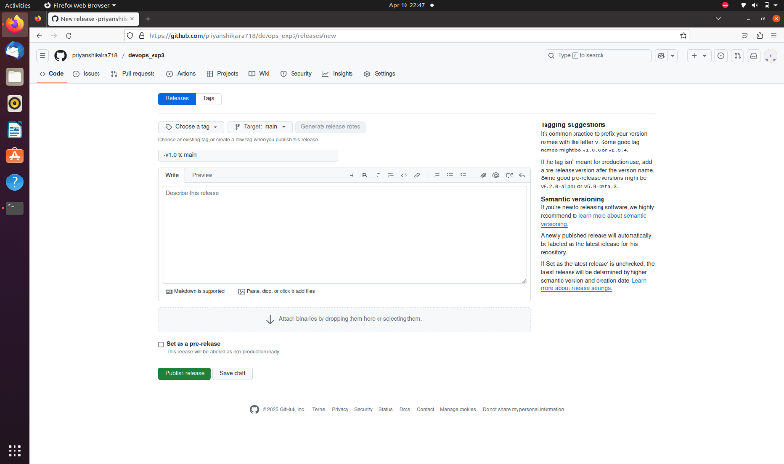

Click publish release and after publish
