Name: Muhammad Ayan Hamdani
Registration ID: 241872

Full Stack Web Development
Lab Task 6 Output

Task 1
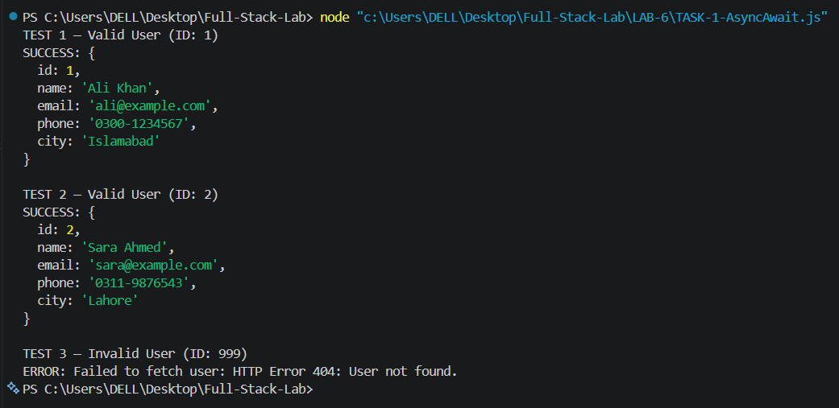

Task 2
