Name: Muhammad Ayan Hamdani
Registration ID: 241872

Full Stack Web Development
Lab 4 Output

Output of codes
Task 1
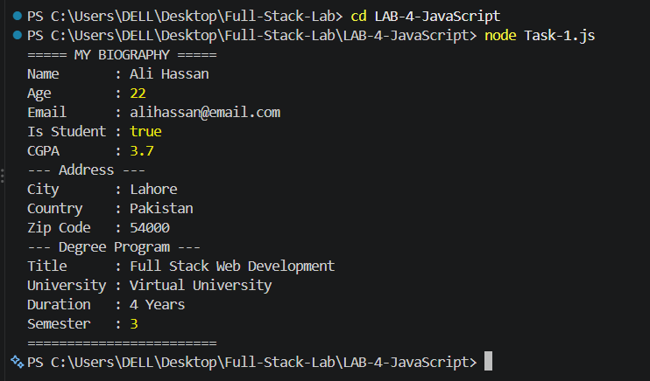

Task 2
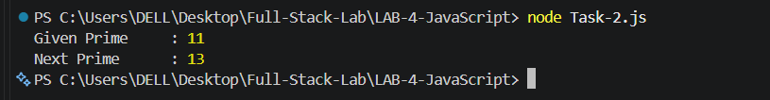

Task 3
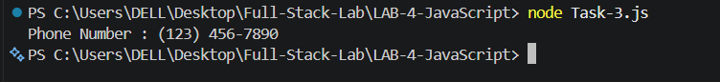

Task 4
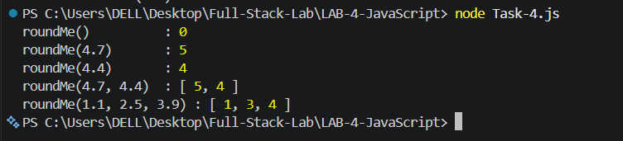

Task 5
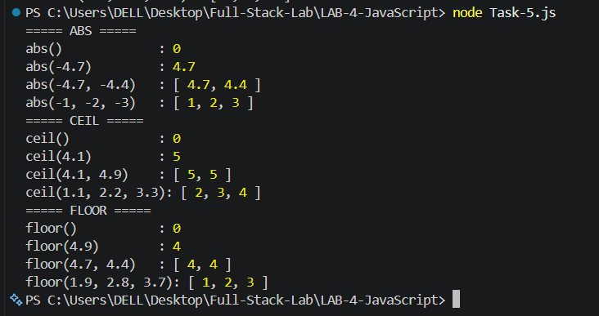

Task 6
