Project Proposal

Project Title
Development of an Information System for Direct Procurement of Agricultural Products from Small-Scale Farms with Transparent Pricing

Team Members and Responsibilities
Ayanat Amangeldi — Backend and Transparent Pricing Module
Responsible for analysing procurement processes, designing the data model and API, and developing order-processing rules, price calculations and price-history functionality.
Dilyara Anetbayeva — Frontend and Procurement Scenarios
Responsible for designing and developing the Flutter interface, including the product catalog, farmer-offer comparison, checkout, order tracking, and farmer and administrator workspaces.
Requirements analysis, architecture decisions, integration, testing, documentation and preparation of demonstrations are shared responsibilities.
Supervisor: Aldiyar Salkenov
Educational Programme: Software Engineering
University: Astana IT University

Problem Statement
Direct agricultural procurement requires buyers to compare more than the advertised product price. Available quantity, minimum order size, location and delivery charges also affect whether an offer meets their needs. When these details are provided separately, buyers must collect and combine the information before making a purchasing decision.
Farmers also need a consistent way to publish offers, update prices and quantities, and manage incoming orders. Changes to an offer create an additional requirement: both parties should be able to distinguish the terms accepted for an existing order from the conditions offered to new buyers.
The project proposes an information system that brings these activities into a shared procurement workflow. The initial problem assumptions will be validated through discussions with farmer and buyer representatives. Improvements in comparison time or price comprehension will be evaluated rather than assumed.

Target Users
The system is intended for three user groups:
- Small-scale farmers who publish agricultural products, specify prices and fulfillment conditions, and manage incoming orders.
- Individual and business buyers who search for products, compare offers from different farms, place orders and track their progress.
- Platform administrators who oversee accounts, product offers and orders, and manage account restrictions and offer visibility.

Project Aim
The aim is to develop and evaluate an information system that supports direct procurement of agricultural products from small-scale farms by enabling offer comparison, clear price calculation and traceable order management.

Project Objectives
- Identify and document functional and non-functional requirements, with priorities and verifiable acceptance criteria.
- Design a data model covering users, farms, products, farmer offers, orders and price changes.
- Develop a Flutter interface supporting buyer, farmer and administrator workflows.
- Enable buyers to compare at least three offers for the same demonstration product using unit price, available quantity, minimum order and delivery conditions.
- Display the item subtotal, delivery charge and final total before order placement, and preserve accepted prices throughout the order lifecycle.
- Record offer-price changes with the previous value, new value, timestamp and responsible farm.
- Verify calculations, quantity constraints, role permissions and order transitions through automated tests and repeatable demonstrations.
- Evaluate task completion and understanding of the final price using representative-user feedback and a defined comparison baseline.

Proposed Solution
The system separates generic products from individual farmer offers. For example, a buyer selects Potatoes from the catalog and then compares offers from several farms. Each offer presents its unit price, available quantity, minimum order, location and pickup or delivery conditions.
After selecting an offer, the buyer enters a quantity and reviews the price breakdown. The system validates the quantity and calculates the total before the order is placed. Accepted quantities, prices and delivery charges are saved with the order so that later offer changes do not alter the agreed terms.
Farmers manage their own offers and incoming orders. The supported order lifecycle progresses from awaiting confirmation to confirmed, ready and completed. Farmers may reject an order before readiness with a recorded reason. Buyers may cancel an order while it is awaiting confirmation.
Administrators can block or unblock buyer and farmer accounts and hide or restore individual offers. Moderation decisions include a reason and timestamp. Existing order records remain available to the appropriate users.

Project Scope
The first-stage prototype covers:
- Local registration, sign-in and role-specific workspaces.
- Product search, category filters and comparison of farmer offers.
- Quantity validation and transparent price breakdowns.
- Demonstration checkout, order history and status tracking.
- Farmer product and offer management.
- Recorded price changes.
- Administrator account restrictions and offer moderation.
The current prototype uses fictional data and stores changes on one device or browser. It demonstrates the main workflows before backend integration.
A subsequent stage will introduce a shared database, API communication and server-side enforcement of authentication, permissions, inventory and order rules. Flutter is the selected client framework. Python/FastAPI and PostgreSQL are backend candidates whose final selection will be justified through a technology comparison.
Online payment processing, automated delivery routing, live logistics tracking and automatic market-price prediction are outside the proposed scope.

Engineering Complexity
The main engineering challenges involve maintaining consistent relationships between products and farmer offers, preventing invalid quantities and order transitions, preserving accepted prices, and applying permissions across several roles.
Backend integration will additionally require handling concurrent purchases and ensuring that stock, order status and price history remain consistent when different users access the system. These requirements make data integrity and business-rule verification central parts of the project.

Expected Outcomes
The project is expected to produce:
- A Flutter application demonstrating complete procurement workflows for buyers, farmers and administrators.
- A documented data model and, at the integration stage, an API connecting the client to shared storage.
- A transparent pricing module with preserved order terms and recorded offer-price changes.
- Automated tests and repeatable scenarios demonstrating whether mandatory requirements are satisfied.
- Project documentation covering requirements, architecture, technology decisions and evaluation results.
The intended practical benefit is clearer comparison of procurement conditions and more traceable communication of agreed prices. The extent of this benefit will be assessed through evaluation.

2.1. Method and Participants
Four interviews were conducted with representatives of the intended user groups: two farmers, one individual buyer, and one business buyer. Each interview covered five open-ended questions about current practices, information needs, pricing, supplier comparison, stock management, and order coordination.
Participants are identified using anonymous codes.
Participant | User group | Profile
F1 | Farmer | Sells agricultural products through regular customers, recommendations, phone calls, and WhatsApp.
F2 | Farmer | Supplies milk and dairy products to individual customers and small shops.
B1 | Individual buyer | Purchases vegetables and dairy products for household consumption in Astana.
B2 | Business buyer | Purchases agricultural products regularly for a small café in Astana.

2.2. Main Findings
Communication and order management. Both farmers receive orders primarily through WhatsApp and phone calls. They use notebooks or phone records to manage orders rather than specialised software. F1 reported difficulties tracking orders across different conversations. Both buyers also described using calls and messages to communicate with suppliers.
Stock availability. F1 reported occasionally forgetting to update available quantities after receiving an order. F2 explained that dairy production varies daily, requiring available quantities to be checked against existing orders. These responses indicate a need to coordinate stock information with order commitments.
Supplier comparison. B1 compares sellers through market visits and sometimes checks advertisements on social media. B2 contacts several suppliers or requests price lists through WhatsApp. Both described difficulties comparing offers when information is incomplete or changes frequently.
Pricing and purchasing conditions. Both buyers reported that delivery charges and minimum order quantities are not always communicated at the beginning of a direct purchase. B2 sometimes calculates the final cost manually to compare suppliers. F1 also noted that updated prices do not always reach every regular customer.
Order confirmation and cancellation. Both farmers identified last-minute cancellations as a problem. F2 explained that cancellations and quantity changes are particularly difficult after perishable products have been prepared. Buyers described receiving confirmations through messages or calls, sometimes needing additional communication to obtain delivery updates.
Factors beyond price. Participants highlighted product quality, freshness, origin, available quantity, and delivery reliability. F2 also mentioned production dates and storage conditions for dairy products, while B2 emphasised consistent supply and the availability of necessary documents.
2.3. Implications for System Requirements
Finding | Supporting interviews | Requirement or design implication
Orders and communications are distributed across calls and messages. | F1, F2, B1, B2 | Provide a central workspace for placing, viewing, and managing orders.
Stock is maintained manually and may become outdated. | F1, F2 | Allow farmers to update available quantities and validate stock when orders are placed.
Comparing suppliers requires gathering information from separate sources. | B1, B2 | Display offers from multiple farmers for the same product using consistent comparison fields.
Delivery charges and minimum quantities may be communicated late. | B1, B2 | Display minimum order quantities, delivery charges, and the final total before order submission.
Updated prices do not always reach customers. | F1 | Maintain current offer prices and preserve the prices accepted in existing orders.
Cancellations and quantity changes complicate preparation. | F1, F2 | Define explicit order states and cancellation rules, recording the agreed quantity and updating stock commitments accordingly.
Buyers consider quality, origin, and fulfilment conditions alongside price. | F1, F2, B1, B2 | Include relevant product descriptions, farmer information, and delivery or pickup conditions.
These requirements are the team’s interpretation of the reported problems. They translate user experiences into proposed system behaviour rather than imply that participants specified the technical solution.

2.4. Interpretation and Limitations
The interviews provide initial qualitative evidence that the proposed system addresses relevant procurement difficulties. In particular, the findings support comparable farmer offers, clear purchasing conditions, stock validation, and traceable order statuses.
Some features remain design decisions requiring further validation. For example, price history is proposed as a mechanism for improving transparency; participants did not explicitly request a historical price log. More specialised needs, such as dairy storage information and business purchasing documents, require further analysis before inclusion in the project scope.
The sample comprises four participants and does not represent all farmers or buyers. The interviews establish reported needs but do not demonstrate that the application reduces purchasing time or costs. Those outcomes, together with usability and administrator workflows, require separate evaluation.

3. Literature Review
3.1. Scope and Approach
This review examines research relevant to developing an information system for direct procurement of agricultural products from small-scale farms with transparent pricing. It addresses four connected topics: short food supply chains, digital agricultural marketplaces, information transparency and trust, and the adoption of digital tools by farmers and buyers.
The review includes ten peer-reviewed journal articles and two institutional publications from FAO and OECD, published between 2022 and 2025. Sources were selected for their relevance to procurement processes, user participation, information exchange, and platform design. The review follows a targeted narrative approach rather than an exhaustive systematic-review protocol.
The analysis distinguishes between reported research findings and their interpretation for this project. Evidence from other countries informs the design but does not establish that the same outcomes will occur in Kazakhstan.
3.2. Short Food Supply Chains and Procurement Coordination
Short food supply chains provide alternatives to conventional distribution arrangements by strengthening connections between producers and consumers. However, reducing the number of intermediaries does not automatically resolve organisational and operational difficulties. Bayir et al. identify challenges across supply-chain processes and show that order management, sourcing, and other operational activities receive less detailed attention than general production and distribution issues. This supports examining the complete procurement workflow rather than treating direct sales as a catalog alone. 1
Cirone et al. approach the problem through coordination between producer capabilities and consumer expectations. Their mixed-method study combines household research, stakeholder discussions, and expert consultation to develop business strategies for an Italian short food supply chain. Its contribution is the joint consideration of supply and demand. However, findings from a specific regional grain supply chain cannot directly determine requirements for all products or purchasing contexts. 2
For the proposed system, these studies motivate connected functions for offer publication, quantity selection, order confirmation, and fulfilment. This is a project design interpretation: the literature supports coordinated processes but does not prescribe the exact screens or order states.
3.3. Information Availability, Trust, and Buyer Decisions
Herzig and Zander’s review of 30 empirical studies identifies information availability, trust, and contextual factors such as accessibility and convenience as important influences on consumer behaviour. Their findings indicate that purchasing decisions cannot be explained through price or demographic characteristics alone. However, the review concerns European Union consumers, which limits its direct transfer to Kazakhstan. 3
Sadeli et al. investigate agricultural purchasing through social commerce in Indonesia. Their model connects information seeking, product knowledge, perceived sustainability, attitudes, and purchasing intentions. The study supports providing meaningful information alongside offers. Nevertheless, associations identified through survey modelling should not be interpreted as proof that adding information to an application will cause higher sales. 4
A more cautious perspective appears in Charatsari et al. Their survey of 211 Greek consumers identifies scepticism about the effects of agricultural digitalisation, particularly its social implications. The study demonstrates that acceptance should be investigated rather than assumed. Its scope includes broader agricultural technologies, so the results cannot be treated as a direct evaluation of a simple procurement application. 5
Together, these sources support displaying farmer identity, product information, purchasing conditions, and understandable prices. They also motivate evaluating whether users understand and trust the information presented.
3.4. Farmer Adoption and Platform Governance
Maina et al. examine participation in the M-shamba digital marketing platform using data from 375 potato farmers in Kenya. Their analysis distinguishes platform use from the proportion of production actually marketed through it. Participation is associated with several economic and household characteristics. This distinction matters because registration or access alone does not demonstrate sustained practical use. The observational, region-specific findings do not establish the effects of the proposed application. 6
Masi et al. investigate anticipated adoption of two digital solutions among 31 farmers participating in Italian short food supply chains. Farmers showed greater willingness to adopt the simpler commercialisation solution. This supports prioritising understandable tasks and limited interaction complexity. However, anticipated adoption is different from observed long-term use, and the small sample limits generalisation. 7
Klingenberg et al. distinguish value creation from value capture in agricultural digitalisation. Their analysis indicates that platforms can create value while the benefits received by farmers depend on competitive dynamics and governance. Consequently, making prices visible should not be equated with guaranteeing fair prices or higher farmer income. 8
For this project, transparency therefore means making recorded purchasing conditions understandable and traceable. It does not imply that the system determines an objectively fair market price.
3.5. Operational Visibility and Inclusive Design
Ušča and Tisenkopfs examine a direct purchasing network in Latvia during the COVID-19 pandemic. Their study connects adaptation with organisational changes, participant relationships, and innovations in the network. Suali et al., studying UK food platforms, similarly highlight information flows and operational flexibility. These studies support considering coordination and visibility alongside marketplace functions. However, pandemic conditions and established distribution networks differ from the operating conditions of an early local prototype. 9, 10
Institutional evidence adds an inclusion perspective. FAO identifies digital literacy, infrastructure, and financial constraints as barriers affecting small-scale producers. OECD highlights costs, usability, skills, relevance, and trust among barriers to agricultural digitalisation. These publications cover technologies beyond procurement platforms, but their findings motivate simple workflows and evaluation with users who have different levels of digital experience. 11, 12
3.6. Structured Analysis of Sources
The limitations below describe boundaries relevant to applying each source to this project.
Source | Method and context | Main contribution | Limitation for this project | Project implication
[1] Bayir et al. (2022) | Systematic review with full-text analysis of 44 studies. | Classifies challenges across short food supply-chain processes and identifies neglected operational activities. | Broad findings do not provide a tested application design. | Model procurement as connected activities, including order management.
[2] Cirone et al. (2023) | Mixed methods: household survey, focus groups, and expert consultation in Italy. | Develops strategies that connect producer capabilities with consumer preferences. | Focuses on a regional ancient-grain supply chain. | Validate workflows with both farmers and buyers.
[3] Herzig and Zander (2025) | Systematic review of 30 empirical studies of EU consumers. | Identifies information, trust, and purchasing context as important behavioural influences. | Geographic and channel differences restrict generalisation. | Evaluate information clarity and purchasing convenience alongside price comparison.
[4] Sadeli et al. (2023) | Consumer survey and structural equation modelling in Indonesian social commerce. | Explains relationships between information seeking, knowledge, attitudes, and purchasing intentions. | Survey associations do not demonstrate causal effects of interface features. | Provide useful product information and test its comprehension.
[5] Charatsari et al. (2024) | Cross-sectional survey of 211 consumers in Greece. | Reveals scepticism about digitalisation and the importance of perceived social effects. | Covers broader digital agriculture, not only online procurement. | Test acceptance without assuming that digitalisation is automatically preferred.
[6] Maina et al. (2024) | Survey of 375 Kenyan potato farmers; probit and Tobit modelling. | Distinguishes platform participation from the extent of commercialisation through it. | Observational evidence from one platform and region. | Evaluate completion of useful selling tasks, not registration alone.
[7] Masi et al. (2025) | Anticipation exercise involving 31 Italian farmers and two digital solutions. | Shows greater willingness to adopt a simpler commercialisation solution. | Expected adoption does not establish sustained use. | Prioritise simple offer and order management.
[8] Klingenberg et al. (2022) | Agricultural value-chain case study supported by secondary evidence. | Distinguishes platform value creation from the distribution of benefits. | Primarily examines upstream agricultural relationships rather than direct buyer checkout. | Define pricing transparency precisely and avoid unsupported income claims.
[9] Ušča and Tisenkopfs (2023) | Latvian direct purchasing network case study using economic data and interviews. | Explains adaptation through organisational and product innovations. | One organic purchasing network during a major disruption. | Support clear order coordination while separately evaluating normal operations.
[10] Suali et al. (2024) | Multiple UK food-platform case studies with expert triangulation. | Connects digital platforms, information exchange, flexibility, and resilience. | UK food services during COVID-19 differ from small-farm procurement in Kazakhstan. | Make order information visible to the relevant participants.
[11] FAO (2022) | Global report drawing on 27 agricultural automation case studies. | Identifies barriers to inclusive adoption, including literacy, infrastructure, and cost. | Automation is broader than marketplace software. | Consider users’ digital skills and access conditions during evaluation.
[12] McFadden et al. (2022) | OECD literature review and analysis of adoption evidence. | Identifies usability, skills, costs, relevance, and trust as adoption barriers. | Covers varied technologies and predominantly OECD settings. | Assess ease of use and practical usefulness with intended users.
3.7. Synthesis and Implications for the Project
The reviewed literature supports three connected design priorities: comparable purchasing information, coordinated procurement processes, and accessible interaction. It also shows why digital access, visible prices, and shorter distribution arrangements should not be treated as sufficient evidence of improved outcomes.
Based on this synthesis, the project adopts the following design decisions:
- Comparable offers. Separate product types from farmer offers and present consistent fields for unit price, available quantity, minimum order, and fulfilment conditions.
- Explicit total cost. Show the product subtotal, delivery charge, and final amount before order submission.
- Preserved purchasing terms. Store the price and quantity accepted when an order is placed so that later offer changes do not alter existing agreements.
- Traceable changes. Record price updates and order transitions with timestamps.
- Role-specific workflows. Provide focused buyer, farmer, and administrator functions.
- Task-based evaluation. Assess whether intended users can compare offers, understand totals, manage offers, and follow order progress.
These decisions are engineering interpretations of the reviewed evidence and the project interviews. In particular, price history and preservation of accepted terms are proposed mechanisms whose usefulness must be evaluated.
The project’s contribution is an integrated implementation and evaluation of these procurement functions in the intended small-farm context. The current prototype demonstrates local workflows. Improvements in income, transaction costs, trust, or operational efficiency remain outcomes to investigate through subsequent evaluation.

3.8. References
- Bayir, B., Charles, A., Sekhari, A., & Ouzrout, Y. (2022). Issues and Challenges in Short Food Supply Chains: A Systematic Literature Review. Sustainability, 14(5), 3029.
- Cirone, F., Masotti, M., Prosperi, P., Bosi, S., Dinelli, G., & Vittuari, M. (2023). Business strategy pathways for short food supply chains: Sharing value between consumers and producers. Sustainable Production and Consumption, 40, 458–470.
- Herzig, J., & Zander, K. (2025). Determinants of consumer behavior in short food supply chains: A systematic literature review. Agricultural and Food Economics, 13, 21.
- Sadeli, A. H., Perdana, T., Deliana, Y., & Onggo, B. S. (2023). Consumers’ purchase behavior in short food supply chains using social commerce in Indonesia. Journal of Cleaner Production, 386, 135812.
- Charatsari, C., Lioutas, E. D., & De Rosa, M. (2024). Going Short and Going Digital: How Do Consumers View the Impacts of Digitalizing Short Food Supply Chains? Sustainability, 16(24), 11241.
- Maina, F., Mburu, J., & Nyang’anga, H. (2024). Drivers of extent of commercialization of potato farming through digital marketing platforms in Nakuru County, Kenya. Frontiers in Sustainable Food Systems, 8, 1307978.
- Masi, M., De Rosa, M., Charatsari, C., Lioutas, E. D., & Vecchio, Y. (2025). Enhancing value creation in short food supply chains through digital platforms. Agricultural and Food Economics, 13, 27.
- Klingenberg, C. O., Antunes Júnior, J. A. V., & Müller-Seitz, G. (2022). Impacts of digitalization on value creation and capture: Evidence from the agricultural value chain. Agricultural Systems, 201, 103468.
- Ušča, M., & Tisenkopfs, T. (2023). The resilience of short food supply chains during the COVID-19 pandemic: A case study of a direct purchasing network. Frontiers in Sustainable Food Systems, 7, 1146446.
- Suali, A. S., Srai, J. S., & Tsolakis, N. (2024). The role of digital platforms in e-commerce food supply chain resilience under exogenous disruptions. Supply Chain Management: An International Journal, 29(3), 573–601.
- Food and Agriculture Organization of the United Nations. (2022). The State of Food and Agriculture 2022: Leveraging agricultural automation for transforming agrifood systems. FAO.
- McFadden, J., Casalini, F., Griffin, T., & Antón, J. (2022). The digitalisation of agriculture: A literature review and emerging policy issues. OECD Food, Agriculture and Fisheries Papers, No. 176. OECD Publishing.

4. Existing System Comparison
4.1. Purpose and Method
This comparison examines existing systems that support agricultural sales, local food distribution, and direct procurement. Its purpose is to identify established approaches and determine which requirements need particular attention in the proposed system.
Four systems were selected:
- Open Food Network: supports producer shops and food hubs selling products from multiple producers. Official overview
- Local Food Marketplace: provides sales, inventory, and distribution software for farms, food hubs, cooperatives, and markets. Official overview
- Local Line: supports farm storefronts, multi-vendor operations, and direct procurement by business buyers. Supplier features, Buyer features
- Barn2Door: supports individual farm businesses managing direct retail and wholesale sales through their own online stores. Seller overview
These systems are relevant functional comparators. Their inclusion does not imply that their services, payment integrations, or operating arrangements have been verified for Kazakhstan.
The assessment uses publicly available official documentation and product descriptions reviewed on 23 October 2026. No authenticated operational testing of the commercial systems was performed. Consequently, documented capabilities are distinguished from unverified features, and no comparative claims about usability, performance, or reliability are made.
4.2. Comparison Criteria
Nine criteria were selected to reflect the project’s procurement scenario and transparency objectives:
- Primary users and operating model.
- Support for multiple producers.
- Comparison of products across suppliers.
- Product and inventory management.
- Price and additional-charge information.
- Order management and fulfilment.
- Payment support.
- Buyer-visible history of offer-price changes.
- Deployment and customisation model.
4.3. Comparison Matrix
ND — not documented in the reviewed sources. Feature availability may depend on configuration, subscription plan, or deployment.
Criterion | Open Food Network | Local Food Marketplace | Local Line | Barn2Door
1. Primary users and operating model | Producer shops and community food hubs. Source | Farms, food hubs, markets, and retail or business customers. Source | Farms, food hubs, and business procurement teams. Sources, buyers | Farm businesses selling directly to retail and wholesale customers. Source
2. Multiple producers | Hubs can sell products from several producers. Source | Multi-producer operations and dedicated producer portals are documented. Source | Connected and managed vendors are supported. Source | Reviewed materials describe separate farm stores; a shared multi-farm catalog is ND. Source
3. Cross-supplier product comparison | Shopfront search and filters are documented; a standard product page grouping competing offers is ND. Source | Multi-producer sales are documented; a dedicated same-product comparison interface is ND. Source | Product search across approved suppliers explicitly supports comparing products from different suppliers. Source | Buyers find farms and browse their individual stores; cross-farm product comparison is ND. Source
4. Product and inventory management | Producer catalogs, variants, and hub-specific prices and stock are documented. Source | Producers can update availability; inventory and harvest-to-order workflows are supported. Source | Product variants, stock controls, and connected-vendor inventory management are documented. Source | Inventory synchronisation, packaging options, and multiple price lists are documented. Source
5. Price and additional-charge information | Customers can inspect product-price components; enterprise and shipping fees are configurable. Sources, shipping | Price lists and invoicing are documented; the exact buyer-facing fee breakdown is ND. Source | Unit prices, supplier subtotals, and cart totals are documented; the reviewed ordering guide does not specify delivery-fee itemisation. Source | Farmers set prices; separate delivery charges are supported. Subscription receipts show delivery fees and taxes separately. Sources, receipts
6. Orders and fulfilment | Order cycles, order editing, delivery, and collection methods are documented. Source | Live orders, packing lists, delivery sheets, and invoices are documented. Source | Supplier-specific orders progress through submitted, scheduled, packed, delivery, and fulfilled states. Source | Order confirmations, delivery or pickup selection, reminders, and farmer-managed order changes are documented. Source
7. Payments | Online payment providers and manually recorded cash or bank-transfer methods are documented; availability varies by instance. Source | Integrated payment processing, scheduled payments, and invoicing are documented. Source | Card, bank-based payments, and supplier payment terms are documented, depending on configuration. Source | Card, ACH, and farmer-approved cash or cheque payments are documented. Source
8. Buyer-visible dated offer-price history | ND. | ND. | ND; order history is documented, which is a different function. Source | ND; customer order history is documented, which is a different function. Source
9. Deployment and customisation | Open-source software under the AGPL-3.0 licence; hosted regional services also exist. Sources, UK service | Commercial service with subscription plans and storefront customisation options. Source | Commercial platform with subscription plans and storefront configuration. Source | Hosted farm stores with subscription plans and website services. Source
4.4. Critical Analysis
Open Food Network
Open Food Network provides a relevant reference for both multi-producer selling and pricing transparency. Its documented price-component display demonstrates that transparency mechanisms already exist in agricultural commerce. Its configurable fees and open-source code also make it a potential adaptation option. Whether adopting it would meet the project’s exact interface and workflow requirements would require a separate fit assessment. Enterprise fees, Source repository
Local Food Marketplace
Local Food Marketplace demonstrates an operationally broader approach, connecting producer availability with packing, distribution, payments, and reporting. These capabilities provide useful references for future development. The proposed project has a narrower initial scope, concentrating on offer selection, explicit purchasing terms, and order progression. The reviewed public materials are insufficient to determine the exact behaviour of its comparison interface or historical price display. Official features
Local Line
Local Line is a close functional comparator because its documentation explicitly describes searching for a product across suppliers and placing supplier-specific orders. Its documented fulfilment states also overlap with the project’s order-management requirements. Therefore, cross-supplier purchasing and order tracking cannot be presented as unique project features. Further investigation would be needed to assess how its configurations match the intended users and operating context. Product comparison, Order workflow
Barn2Door
Barn2Door illustrates a farm-centred sales model, with inventory, fulfilment, and customer communication organised around an individual farm’s store. This is a useful reference for the farmer workspace. The documented buyer journey begins with selecting a farm and entering its store, whereas the proposed application begins with a product type and then presents available farmer offers. Buyer workflow, Inventory features
4.5. Implications for the Proposed System
The comparison shows that existing systems already address substantial parts of agricultural e-commerce. It supports implementing a focused procurement workflow and evaluating its suitability for the intended users.
The proposed system prioritises:
- Product-first navigation: buyers select a product type and inspect offers from several farmers.
- Consistent offer information: unit price in KZT/kg, available quantity, minimum quantity, and delivery or pickup conditions.
- Explicit totals: product subtotal, delivery charge, and final amount before order submission.
- Preserved order terms: later offer edits do not change the price and quantity recorded in an existing order.
- Dated price changes: records identify previous and updated prices and the time of change.
- Connected role workflows: buyers place orders, farmers manage fulfilment, and administrators moderate accounts and offers.
The absence of documented buyer-visible price history in the reviewed materials is an evidence limitation, not proof that the compared systems lack this capability. A stronger differentiation claim would require demonstrations, trial access, or confirmation from the providers.
The current project is a local Flutter prototype using fictional data and device-local persistence. It does not yet provide shared server storage, cross-device synchronisation, or real payment processing. Accordingly, this comparison establishes design references and requirements; it does not demonstrate that the prototype outperforms operational commercial platforms.
The need for the proposed solution is grounded in the reported needs of the interviewed users and the opportunity to implement and evaluate a workflow tailored to those needs. Its practical benefits must be established through subsequent user and system evaluation.

5. Technology Comparison
5.1. Purpose and Selection Criteria
This section compares alternatives for four key technical decisions: the client framework, server framework, shared database, and client–server communication approach.
The comparison is guided by the following project needs:
- Support mobile and browser-based access.
- Maintain consistent buyer, farmer, and administrator workflows.
- Validate prices, quantities, and order transitions.
- Preserve accepted purchasing terms and dated price changes.
- Prevent conflicting stock allocations when several buyers place orders.
- Provide documented interfaces and testable business rules.
- Keep development and maintenance manageable for a two-person team.
Technology capabilities are checked against official documentation. The selection is qualitative: no comparative performance benchmarks or development-time measurements have been conducted. Recommendations therefore represent engineering judgements based on the project requirements.
5.2. Client Framework
The client must support product browsing, offer comparison, checkout, farmer operations, and administrator functions on different screen sizes.
Alternative | Relevant capabilities | Trade-offs for this project | Assessment
Flutter / Dart | Supports Android, iOS, and web, with shared application code and responsive or adaptive layouts. Documentation | Layouts, input methods, browser behaviour, and platform integrations still require separate verification. Flutter web is primarily intended for application experiences rather than text-heavy websites. Web guidance | Selected and already used in the prototype.
React Native with Expo / TypeScript | Supports universal applications targeting Android, iOS, and web from a shared project. Platform-specific files and components can be used where necessary. Documentation | Would require replacing the existing Dart implementation. Shared code would not eliminate platform-specific adjustments and testing. | A suitable alternative, particularly for a project organised around React and TypeScript.
Ionic with Capacitor | Uses web technologies to deliver web applications and packaged Android and iOS applications. Capacitor provides access to native functionality through plugins. Documentation | Native capabilities and browser fallbacks require checking across targets. Adopting it now would require rebuilding the client using a web technology stack. | A suitable alternative for a web-first implementation.
Decision and justification
Flutter is retained because it supports the intended mobile and browser interfaces and provides continuity with the working prototype. Existing catalog, order, pricing, and role workflows can be extended rather than reimplemented.
This decision does not assume that one layout will suit every device. Phone, tablet, and desktop layouts must be adapted and checked individually. Browser accessibility and navigation also require evaluation.
A separate public information website could be considered later if search-engine visibility or extensive editorial content becomes a requirement. It is outside the current procurement application scope.
5.3. Server Framework
The shared system requires an authoritative backend for account permissions, offer updates, order processing, stock allocation, and historical records.
Alternative | Relevant capabilities | Trade-offs for this project | Assessment
FastAPI / Python | Provides request validation through Pydantic, dependency injection, OpenAPI generation, and interactive API documentation. Documentation | Database integration, migrations, account management, and business permissions must be assembled and implemented explicitly. | Recommended for the planned backend.
Django with Django REST Framework / Python | Combines Django’s application and data-management facilities with API serialization, authentication policies, and permissions. Django also provides an internal administration interface. DRF documentation, Django admin | Introduces Django-specific application conventions. Its administration interface would supplement, rather than automatically replace, the planned Flutter administrator workflow. | A strong alternative when integrated administration and Django conventions are priorities.
NestJS / TypeScript | Provides modular server organisation, request-validation mechanisms, access-control guards, and OpenAPI tooling. Validation, Guards, OpenAPI | Requires a TypeScript backend and separate choices for database access, migrations, and authentication integration. | A suitable alternative for a TypeScript-based server architecture.
Decision and justification
FastAPI is recommended for an API-focused backend serving the Flutter client. Its validation and generated documentation fit the need to define explicit contracts for offers, quantities, prices, and order actions.
Django REST Framework remains a viable alternative, especially if built-in administrative facilities become a higher priority. NestJS also meets the general API requirements; this comparison does not establish a performance advantage for FastAPI.
Regardless of framework, project-specific rules require implementation. Authentication alone must not allow a farmer to edit another farm’s offers or a buyer to access another buyer’s orders. Framework validation also does not automatically enforce stock availability or permitted order transitions.
5.4. Shared Database
The data model contains relationships between users, farms, product types, offers, orders, and price changes. Several records may need to be updated together when an order is placed or cancelled.
Alternative | Relevant capabilities | Trade-offs for this project | Assessment
PostgreSQL | Provides relational constraints, foreign keys, transactions, and concurrency-control mechanisms. These support connected procurement records and atomic updates. Constraints, Transaction isolation | Requires schema migrations, database operation, backups, and deliberate transaction design. | Recommended for the shared database.
MySQL with InnoDB | Supports transactions, row-level locking, and foreign-key constraints. It can also support the proposed relational model. Documentation | Requires similar operational and transaction-design work. Database-specific behaviour must be considered during implementation. | A technically valid relational alternative.
Cloud Firestore | Stores documents in collections and supports atomic transactions across documents. Data model, Transactions | Relationships and cross-record consistency require document-oriented modelling and explicit validation. Transaction retries and managed-service usage limits must be considered. | A suitable alternative if a managed document-oriented architecture is preferred.
Decision and justification
PostgreSQL is recommended because the project has a clearly relational structure and needs explicit constraints, connected queries, and transactional order processing. It also allows the team to maintain a directly inspectable schema for requirements, diagrams, and integration tests.
MySQL with InnoDB could satisfy the same core requirements. PostgreSQL is a proposed baseline, not a conclusion that MySQL is incapable or slower.
Firestore also supports atomic operations. The reason for preferring PostgreSQL is the fit between the project’s relationships and a relational schema, rather than an assumption that document databases cannot maintain consistency.
For example, placing an order should validate the current offer, reserve the required quantity, and record accepted purchasing terms within a coordinated transaction. Preventing overselling depends on the implemented transaction strategy; choosing PostgreSQL alone does not guarantee it.
5.5. Client–Server Communication
The client needs to retrieve catalog information, submit orders, update offers, and request authorised state changes.
Alternative | Relevant capabilities | Trade-offs for this project | Assessment
REST-style HTTP API with JSON | Resource-oriented endpoints can expose catalog, offer, and order operations. OpenAPI can describe request bodies, responses, and authentication requirements. OpenAPI specification | Response structures, pagination, error handling, and retry behaviour require explicit design. | Recommended for initial integration.
GraphQL | A typed schema allows clients to request selected fields and related data. Queries and mutations support reading and changing application data. Documentation | Requires schema and resolver design, field-level authorisation, and control of query complexity. This adds work for the project’s relatively predictable initial screens. | A reasonable alternative if client data needs become more varied.
gRPC with Protocol Buffers and gRPC-Web | Uses defined service contracts and generated client code. Browser access can use gRPC-Web; the official example includes a proxy between the browser and backend. Documentation | Adds code-generation and browser-integration infrastructure that must be maintained across targets. | A reasonable alternative for strongly service-oriented integration, but not preferred initially.
Decision and justification
A REST-style JSON API over HTTPS is recommended because the initial interactions are explicit and predictable: browse products, inspect offers, place an order, manage offers, and change order status. OpenAPI documentation would support agreement between frontend and backend work and provide a basis for integration tests.
GraphQL and gRPC remain capable alternatives. Their additional flexibility or service tooling is not currently necessary to express the planned workflows.
The API must enforce permissions and business rules on the server. It must also define how repeated order submissions, stale prices, unavailable stock, and conflicting status updates are handled. These behaviours are application responsibilities rather than automatic properties of REST.
5.6. Proposed Technology Baseline and Implementation Status
Area | Technology | Current status
Client application | Flutter / Dart | Implemented in the local prototype; continued use selected.
Server framework | FastAPI / Python | Recommended; not connected to the prototype.
Shared database | PostgreSQL | Recommended; not connected to the prototype.
Client–server interface | REST-style JSON API over HTTPS, documented with OpenAPI | Recommended; not implemented.
Prototype persistence | Local JSON stored through shared_preferences | Implemented for fictional demonstration data.
The current prototype stores accounts, offers, orders, and historical records on one device. This demonstrates workflows but does not provide shared data between users on different devices.
shared_preferences is intended for simple local key-value storage, and its documentation states that it must not be used for critical data. It will therefore not serve as the authoritative store for real procurement transactions. Package documentation
The planned architecture places shared data and authoritative business rules on the backend. Mobile and browser clients would access the same service.
5.7. Validation of the Proposed Choices
The recommended backend stack remains subject to implementation validation. Initial integration should demonstrate that:
- Mobile and browser clients can use the same documented API.
- Permissions restrict access according to account ownership and role.
- Competing orders cannot allocate more stock than is available.
- Later offer changes preserve accepted order terms.
- Price changes and order transitions produce consistent historical records.
These checks will establish whether the proposed technologies have been integrated correctly. Detailed test cases, measurement conditions, and evaluation metrics are specified separately in the verification and evaluation plan.

6. Requirements Specification
6.1. Purpose and Scope
This specification defines the functional and non-functional requirements of the Farm Direct Procurement System. Each requirement has an identifier, priority, and acceptance criteria to support verification.
The target system supports three roles:
- Buyer: browses products, compares farmer offers, places orders, and follows their progress.
- Farmer: manages offers, stock, and incoming orders.
- Administrator: moderates accounts and offers and reviews system records.
The requirements describe the intended shared system. The current Flutter prototype demonstrates most user workflows using fictional data stored on one device. Shared persistence and authoritative server-side enforcement remain planned.
6.2. Priorities and Requirement Sources
Requirements use the following priorities:
Priority | Meaning
Must | Required for acceptance of the intended shared system.
Should | Important but may be deferred without preventing the core procurement workflow.
The specification draws on:
- The reported experiences of the four interview participants.
- Findings from the literature review.
- Documented capabilities of comparable systems.
- The project’s agreed scope and engineering decisions.
Interview findings primarily support offer comparison, clear purchasing conditions, stock coordination, and order management. Roles, moderation, historical records, and retry handling also reflect team design decisions.
Acceptance criteria are proposed verification conditions. They do not represent completed evaluations.
6.3. Business Rules
The initial release uses the following rules:
- Each order concerns one farmer offer. A combined checkout across several farms is outside the initial scope.
- Quantities are whole kilograms. Unit prices and delivery fees are whole KZT.
- Quantities must be positive and must satisfy the offer’s minimum quantity and available stock.
- The item subtotal equals quantity multiplied by the accepted unit price.
- The final total equals the item subtotal plus the disclosed delivery fee. Pickup is free, and no additional platform fee applies.
- Prices and purchasing terms are recorded when an order is placed. Later offer edits do not change existing orders.
- Active orders reserve stock. Cancellation or rejection releases the reservation. Completion consumes the ordered quantity without releasing it for resale.
- Normal order progression is:
Awaiting confirmation → Confirmed → Ready → Completed
- Buyers may cancel orders awaiting confirmation. Farmers may reject orders awaiting confirmation or confirmed orders, providing a reason.
- Hidden offers and offers belonging to blocked farmers are unavailable for new purchases. Moderation does not rewrite existing order terms.
6.4. Functional Requirements
ID | Requirement | Priority | Acceptance criteria
FR-01 | Register buyer and farmer accounts. | Must | Valid registration creates an account with the selected role. Farmer registration creates an associated farm. Duplicate email addresses are rejected. Public registration cannot create an administrator account.
FR-02 | Authenticate users and support logout. | Must | Valid credentials for an active account permit access. Invalid credentials are rejected. Blocked accounts cannot sign in and receive an explanation. Logout removes access to protected actions until authentication is repeated.
FR-03 | Enforce role and ownership permissions. | Must | Buyers access only their own orders. Farmers modify only their own farm’s offers and orders. Administrator actions are unavailable to other roles. In the shared system, unauthorised direct API requests are rejected independently of interface visibility.
FR-04 | Display the available product catalog. | Must | Buyers can browse product types and open their available offers. Hidden offers and offers from blocked farmers are excluded. A product type with no purchasable offers is excluded from the available catalog.
FR-05 | Present comparable farmer offers. | Must | With at least three available offers for one product type, buyers can inspect each farmer, unit price, available quantity, minimum quantity, region, and fulfilment conditions before choosing an offer.
FR-06 | Calculate and display purchasing costs. | Must | Before submission, the interface displays quantity, unit price, subtotal, delivery fee, and total. A test order of 50 kg at KZT 190/kg with KZT 2,500 delivery produces a subtotal of KZT 9,500 and a total of KZT 12,000. Pickup produces a zero delivery fee.
FR-07 | Validate and create orders. | Must | Valid contact and fulfilment details create an order with a unique reference and Awaiting confirmation status. Invalid quantities, insufficient stock, missing required details, and unavailable offers are rejected without creating an order. A stale quote requires the buyer to review updated terms before submission.
FR-08 | Preserve accepted purchasing terms. | Must | An order retains its accepted product and farmer information, quantity, unit price, delivery fee, fulfilment details, and total. Editing or hiding the offer afterwards does not change these recorded terms.
FR-09 | Provide buyer order history and cancellation. | Must | Buyers can view their own order references, details, statuses, and recorded transition times. Cancelling an awaiting order changes its status to Cancelled and releases its stock reservation. Cancellation is refused once the order is confirmed.
FR-10 | Allow farmers to create and edit offers. | Must | A farmer can publish an offer under an existing or new product type and edit its price, stock, minimum quantity, description, region, and delivery conditions. Invalid values and stock below existing commitments are rejected. A published offer’s product type cannot be changed.
FR-11 | Support farmer order processing. | Must | A farmer can view their own incoming orders and perform the permitted confirmation, ready, and completion transitions. Rejection before Ready requires a reason of 5–300 characters, visible to the buyer. Invalid transitions are rejected without changing the order.
FR-12 | Maintain consistent stock commitments. | Must | Placing an order reduces available stock. Cancellation and rejection restore the reserved quantity exactly once. Completion does not make the quantity available again. With 80 kg available and two competing requests for 50 kg, at most one succeeds and the remaining availability is 30 kg.
FR-13 | Record and display offer-price history. | Must | Successful publication records initial terms. Subsequent price or delivery-term changes record previous and new values, the offer and farm identity, and a timestamp. Description-only or stock-only edits create no price-change event. Failed saves create no event. Buyers and the owning farmer can view recorded history; unavailable earlier history is not invented.
FR-14 | Moderate accounts and offers. | Must | Administrators can block or unblock buyer and farmer accounts and hide or restore offers, providing reasons. Administrator accounts cannot be blocked through this workflow. Unblocking does not restore separately hidden offers, and restoring an offer does not override a blocked farmer account.
FR-15 | Provide an administrator overview and moderation records. | Must | Administrators can inspect accounts, offers, orders, and moderation decisions. Each decision records the action, target, administrator, reason, and timestamp. Buyers and farmers cannot create, edit, or delete moderation records.
FR-16 | Share authoritative data across devices. | Must | An offer created by a farmer on one authenticated client becomes available to a buyer on another client after refresh. An order placed by the buyer appears in the farmer’s account. Committed changes remain available after client and server restarts.
FR-17 | Prevent duplicate order creation during retries. | Must | Repeating the same logical submission with the same request identifier creates one order and one stock reservation. Reusing the identifier with different order data is rejected. A client can retrieve the result after a response is interrupted.
FR-18 | Provide search, filtering, and sorting. | Should | Product-name search returns matching products. Category filters restrict the catalog, and offer sorting and delivery filtering update the displayed offers consistently. No-match results display an explanatory empty state.
6.5. Non-Functional Requirements
The numerical thresholds below are initial acceptance targets. They must be evaluated under documented conditions rather than presented as achieved results.
ID | Requirement | Priority | Acceptance criteria
NFR-01 | Platform compatibility | Must | The core buyer and farmer scenarios complete on Android, iOS, and the web version in Chrome and Safari. Tested operating-system and browser versions are recorded. Build success alone does not establish runtime acceptance.
NFR-02 | Responsive and accessible interaction | Must | At reference sizes of 360 × 800 and 1280 × 800, essential controls and purchasing information remain reachable. At 200% text scaling, essential content remains accessible through reflow or scrolling. Core web forms support keyboard operation and visible focus.
NFR-03 | Secure shared access | Must | Deployed clients communicate with the API through HTTPS. Passwords are not stored in plaintext or returned by the API. Unauthenticated and unauthorised requests are rejected. Role, ownership, and blocked-account checks are enforced by the backend.
NFR-04 | Transactional integrity | Must | A simulated failure during order creation leaves neither a partial order nor an unmatched stock reservation. A failed price update leaves both the offer and its history unchanged. Concurrent requests satisfy FR-12 and FR-17.
NFR-05 | Calculation accuracy | Must | Monetary calculations use exact representations rather than binary floating-point arithmetic. Automated tests verify valid totals, boundary values, minimum quantities, pickup, and delivery. Displayed totals match recorded accepted-order totals.
NFR-06 | Data persistence and recoverability | Must | Accepted records survive service restart. A backup can be restored into a separate test environment, preserving selected users, offers, orders, accepted prices, and history. Backup time and restoration results are documented.
NFR-07 | Response time | Should | With 10 concurrent test users and 1,000 seeded offers, at least 95% of catalog and offer API requests complete within two seconds during the documented test run. Hardware, network conditions, errors, and dataset are reported. This target excludes initial application download and image loading.
NFR-08 | Usability | Should | At least five representative participants, including at least two buyers and two farmers, attempt predefined role-appropriate tasks. At least 80% of task attempts succeed without moderator intervention. Buyer tasks include identifying the final total before submission. Results are reported separately by task and role.
NFR-09 | Maintainability and testability | Must | Shared-system code is organised into identifiable client, API, business-logic, and persistence components. Setup and test commands are documented. Each mandatory requirement is mapped to verification evidence; automated tests cover pricing, stock commitments, permissions, order transitions, and price-history rules.
6.6. Current Implementation Status
Requirement area | Current status
Registration, sign-in, and role workflows | Demonstrated locally. Trusted server authentication and authorisation remain planned.
Catalog, comparison, pricing, checkout, and order history | Demonstrated using fictional local data.
Farmer offer management and order lifecycle | Demonstrated locally, including validation, rejection reasons, and stock accounting.
Price history and moderation | Demonstrated locally. Historical records are not a server-authenticated audit trail.
Cross-device shared data — FR-16 | Not implemented. Requires the backend and shared database.
Retry-safe network submissions — FR-17 | Not implemented as a server API requirement.
Platform acceptance — NFR-01 | Some build and browser checks exist; the complete device and browser runtime matrix remains pending.
Production security, database integrity, recovery, performance, and usability targets | Require implementation or evaluation in the shared system.
Existing prototype tests provide evidence for local behaviour. They do not establish compliance with server concurrency, cross-device consistency, or production security requirements.
6.7. Acceptance and Traceability
Each requirement will be linked to its implementation work, YouTrack task, and verification evidence. Evidence may include automated tests, recorded manual scenarios, API responses, screenshots, or evaluation results.
A requirement is accepted only when its stated criteria have been checked in the relevant environment. Demonstrating a workflow with local data is sufficient evidence for that prototype behaviour, while shared-system requirements require verification against the implemented backend.
6.8. Excluded from the Initial Release
The initial shared-system release excludes:
- Real online payment processing and settlement.
- Combined checkout across several farms.
- Automatic market-price prediction or price negotiation.
- Delivery-route optimisation and live courier tracking.
- Recurring procurement subscriptions.
- Product image uploads and public review or rating systems.
These exclusions keep the initial scope focused on offer comparison, transparent purchasing terms, and reliable order coordination.

7. Architecture and Diagrams
7.1. Architectural Overview
The proposed system follows a client–server architecture comprising a Flutter client, a FastAPI backend, and a PostgreSQL database. The client targets Android, iOS, and web and communicates with the backend through a REST-style JSON API over HTTPS.
The backend is planned as a modular monolith: one deployed application containing separate modules for identity and access, catalog management, procurement, pricing history, and moderation. This structure provides identifiable responsibilities while keeping deployment manageable for the project team.
The architecture distinguishes the intended shared system from the current implementation. The existing prototype uses Flutter screens, a shared OrderStore, and local JSON persistence through shared_preferences. The backend, shared database, and network integration remain planned.
7.2. System Context Diagram
Figure 7.1 identifies the system boundary and its three external user roles.
Buyers discover products, compare offers, and place orders. Farmers publish offers and manage fulfilment. Administrators moderate accounts and offers and review relevant records.
Client applications, backend modules, and persistence belong inside the system boundary. Payment processors and courier services are excluded from the initial integration scope.
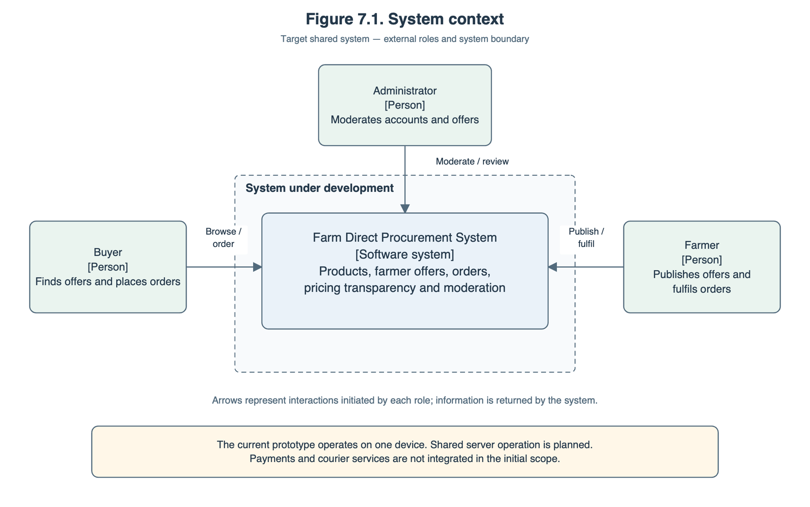

7.3. Use Case Diagram
Figure 7.2 presents the main user goals. Buyer use cases cover offer comparison, price-history inspection, order placement, and management of existing orders. Farmer use cases cover offer management, price-history inspection, order progression, and rejection with a reason. Administrator use cases cover account restrictions, offer visibility, and record inspection.
The «include» relationship indicates that placing an order includes calculation and disclosure of its total. Authentication and role or ownership checks are preconditions for protected operations.
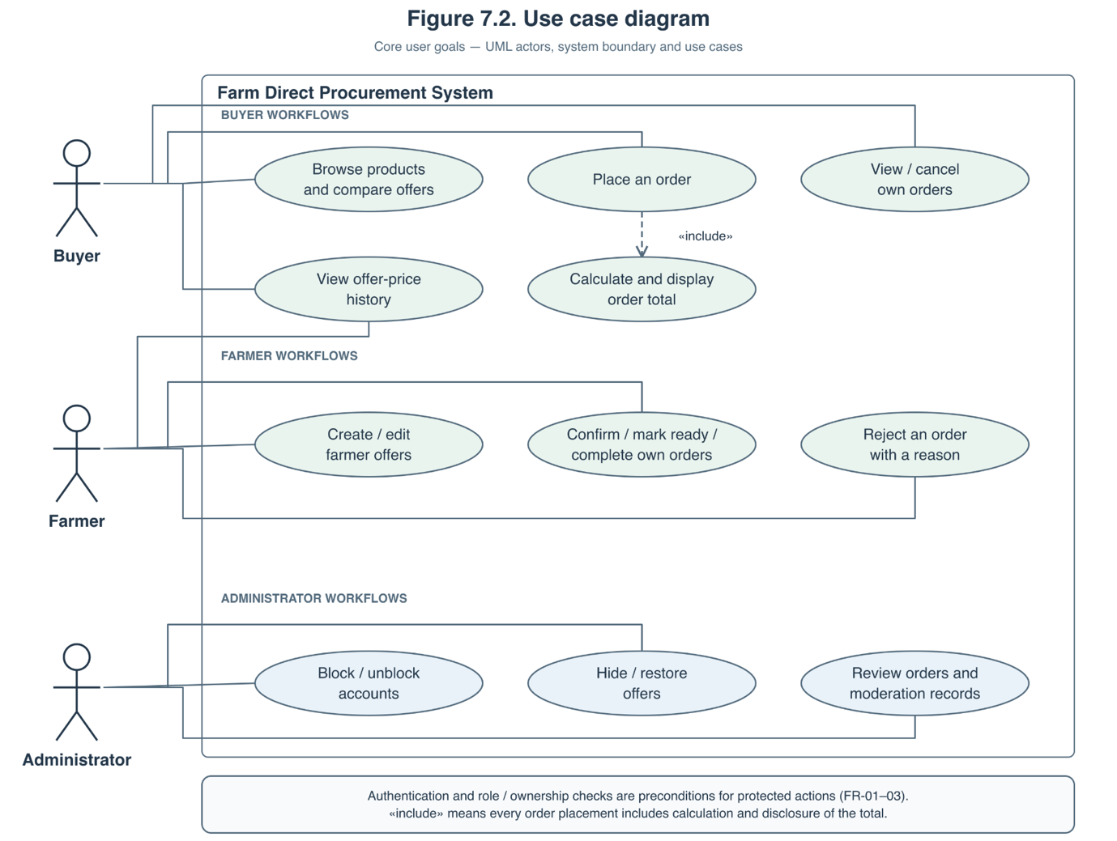

7.4. Component Diagram
Figure 7.3 shows the proposed components and their dependencies. The Flutter client separates user interfaces, application state, and API communication. Client validation supports interaction, while the server remains authoritative for permissions and business rules.
API routes validate incoming requests and coordinate the internal modules. Persistence operations use a transaction boundary to maintain consistency between orders, stock commitments, and historical records.
The diagram describes logical responsibilities. It does not imply that every box is a separate deployed service or an already implemented backend component.
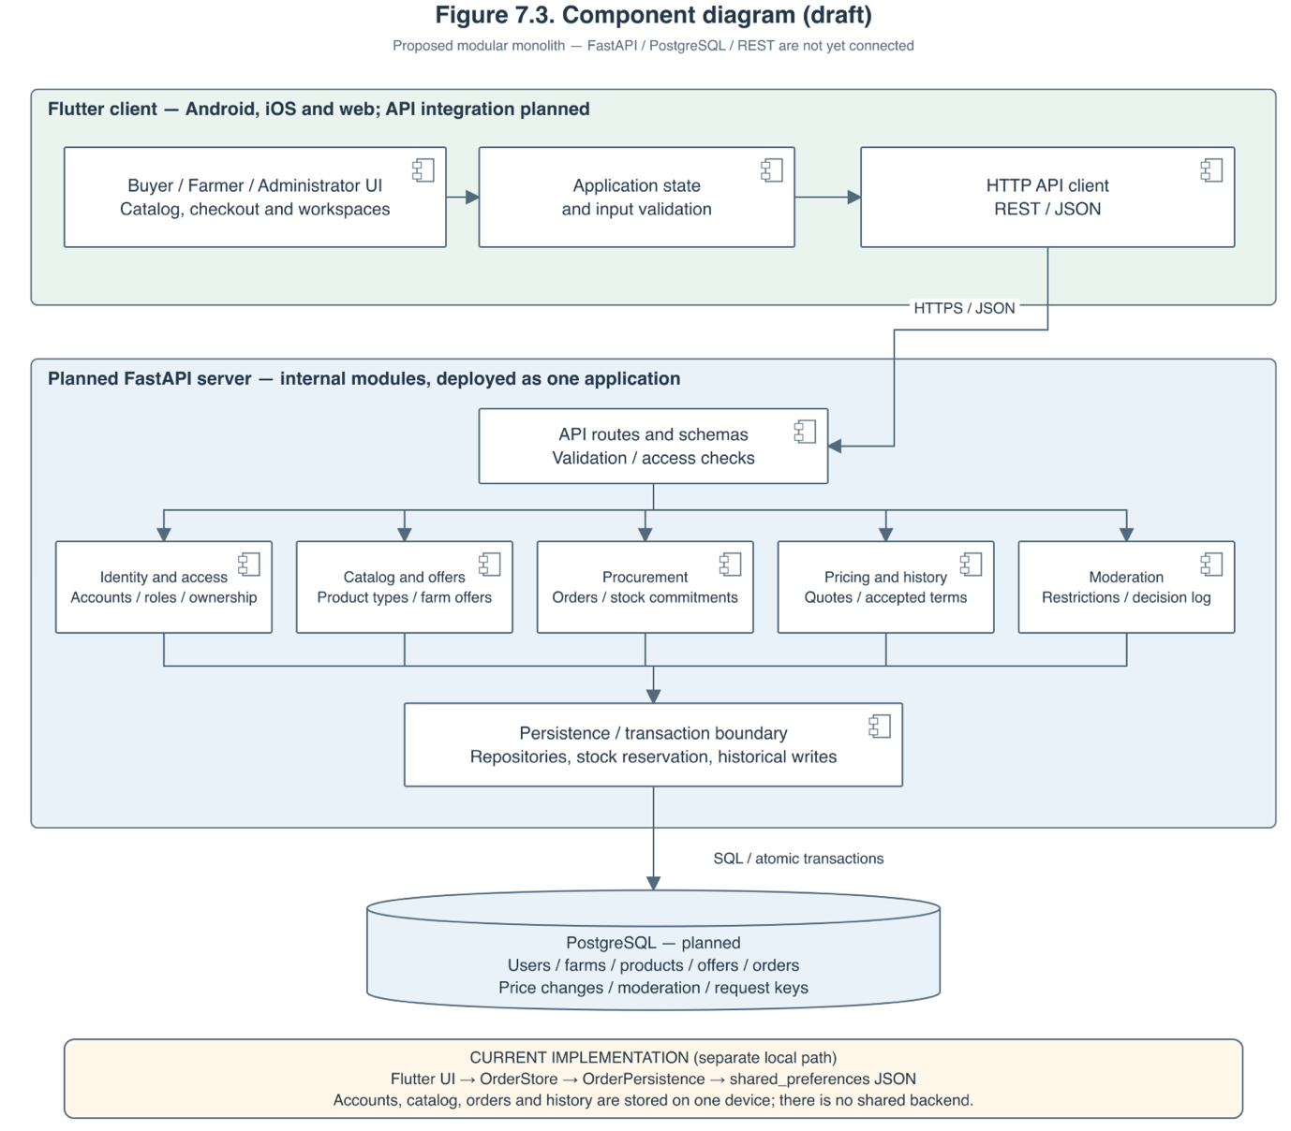

Component | Responsibility
Flutter interfaces and application state | Present role-specific screens, collect input, display quotes and statuses, and manage interaction state.
HTTP API client | Send authenticated requests, interpret responses, and handle validation errors, conflicts, and interrupted submissions.
API routes and schemas | Define request and response contracts and apply validation and access checks.
Identity and access | Manage accounts, authentication, roles, ownership checks, and blocked-account restrictions.
Catalog and offers | Manage product types, farm offers, availability, purchasing conditions, search, and filtering.
Procurement | Manage order creation, stock commitments, permitted transitions, cancellation, rejection, and duplicate-submission handling.
Pricing and history | Calculate quotes, prepare accepted-price snapshots, and record successful changes to pricing and delivery terms.
Moderation | Manage account restrictions, offer visibility, and dated administrator decisions.
Persistence and transaction boundary | Coordinate database reads and atomic writes, including reservations and historical records.
PostgreSQL | Store shared accounts, farms, products, offers, orders, price changes, moderation records, and request identifiers.

7.5. Data Organisation
The planned data model contains the following principal relationships:
- A farmer account is associated with a farm.
- A farm publishes offers.
- Each offer belongs to one product type, allowing offers from different farms to be grouped for comparison.
- Each order belongs to one buyer and references one offer.
- Each order stores accepted purchasing terms separately from the offer’s current values.
- Price-change records reference the relevant offer and farm.
- Moderation records identify the administrator, target, action, reason, and timestamp.
- Request identifiers link repeated submissions to their original result.
The initial order model concerns one offer per order. Combined checkout across several farms is outside the initial release scope.
7.6. Order Placement and Fulfilment Scenario
The planned order-placement scenario proceeds as follows:
- The buyer selects a product, chooses a farmer offer, and enters the quantity and fulfilment details.
- The client displays the subtotal, delivery charge, and total before submission.
- The backend checks the authenticated buyer, offer visibility, current price, minimum quantity, and available stock.
- A coordinated database transaction records the order, its accepted terms, the stock reservation, and the submission identifier.
- The buyer receives the order reference and Awaiting confirmation status. The farmer can retrieve the order through their workspace.
- Authorised farmer actions move the order through Confirmed, Ready, and Completed.
Cancellation or rejection releases the reservation exactly once. Completion consumes the ordered quantity. Later changes to the offer do not rewrite the order’s accepted terms.
For interrupted requests, the backend uses the submission identifier to return the existing result rather than create another order. These shared-system behaviours remain implementation requirements.
7.7. Requirements-to-Architecture Traceability
Requirements | Responsible components
FR-01–FR-03: registration, authentication, and permissions | Identity and access; API access checks; role-specific interfaces.
FR-04–FR-05, FR-18: catalog, comparison, search, and filtering | Catalog and offers; buyer interface.
FR-06, FR-08: calculations and preserved purchasing terms | Pricing and history; procurement; transaction boundary.
FR-07, FR-09, FR-11: order submission, history, cancellation, and fulfilment | Procurement; buyer and farmer interfaces.
FR-10: farmer offer management | Catalog and offers; identity and access; farmer interface.
FR-12: consistent stock commitments | Procurement; database transactions and concurrency controls.
FR-13: dated offer-price history | Pricing and history; persistence; buyer and farmer interfaces.
FR-14–FR-15: moderation and administrator records | Moderation; identity and access; administrator interface.
FR-16: shared data across devices | HTTP API client; backend modules; PostgreSQL.
FR-17: duplicate-submission prevention | HTTP API client; procurement; stored request identifiers.
Platform compatibility and responsive interaction are addressed by the Flutter client. Secure access depends on backend enforcement. Transactional integrity and recoverability depend on the persistence design and database operation. These qualities require verification beyond the diagrams.
7.8. Current Implementation and Transition
The current prototype implements local role workflows, catalog browsing, offer comparison, pricing, order processing, price history, and moderation through OrderStore.
Its local role checks and persistence demonstrate behaviour on one device. They do not provide trusted server authorisation or shared inventory.
The next architectural step is to implement the API and database, introduce the client API layer, and move authoritative permissions, pricing validation, stock commitments, and historical writes to the backend. This transition will be verified against the requirements in Section 6 and the verification plan in Section 9.

8. UX / Prototype
An interactive prototype was developed using Flutter to demonstrate the main user scenarios of the proposed information system. It runs as an iOS application and a web application, adapting the interface to different screen sizes.
The prototype supports three user roles: buyer, farmer, and administrator. Buyers can browse products, compare offers from different farmers, view a detailed price breakdown, place demonstration orders, and track their status. Farmers can manage products, update prices and stock, view price history, and process orders. Administrators can block accounts, hide individual offers, and review moderation decisions.
The following screenshots illustrate these scenarios in iPhone Simulator and a desktop web browser. The prototype uses demonstration data stored locally on each device. Shared backend services, cross-device synchronization, and real payment processing are outside the scope of the current prototype.

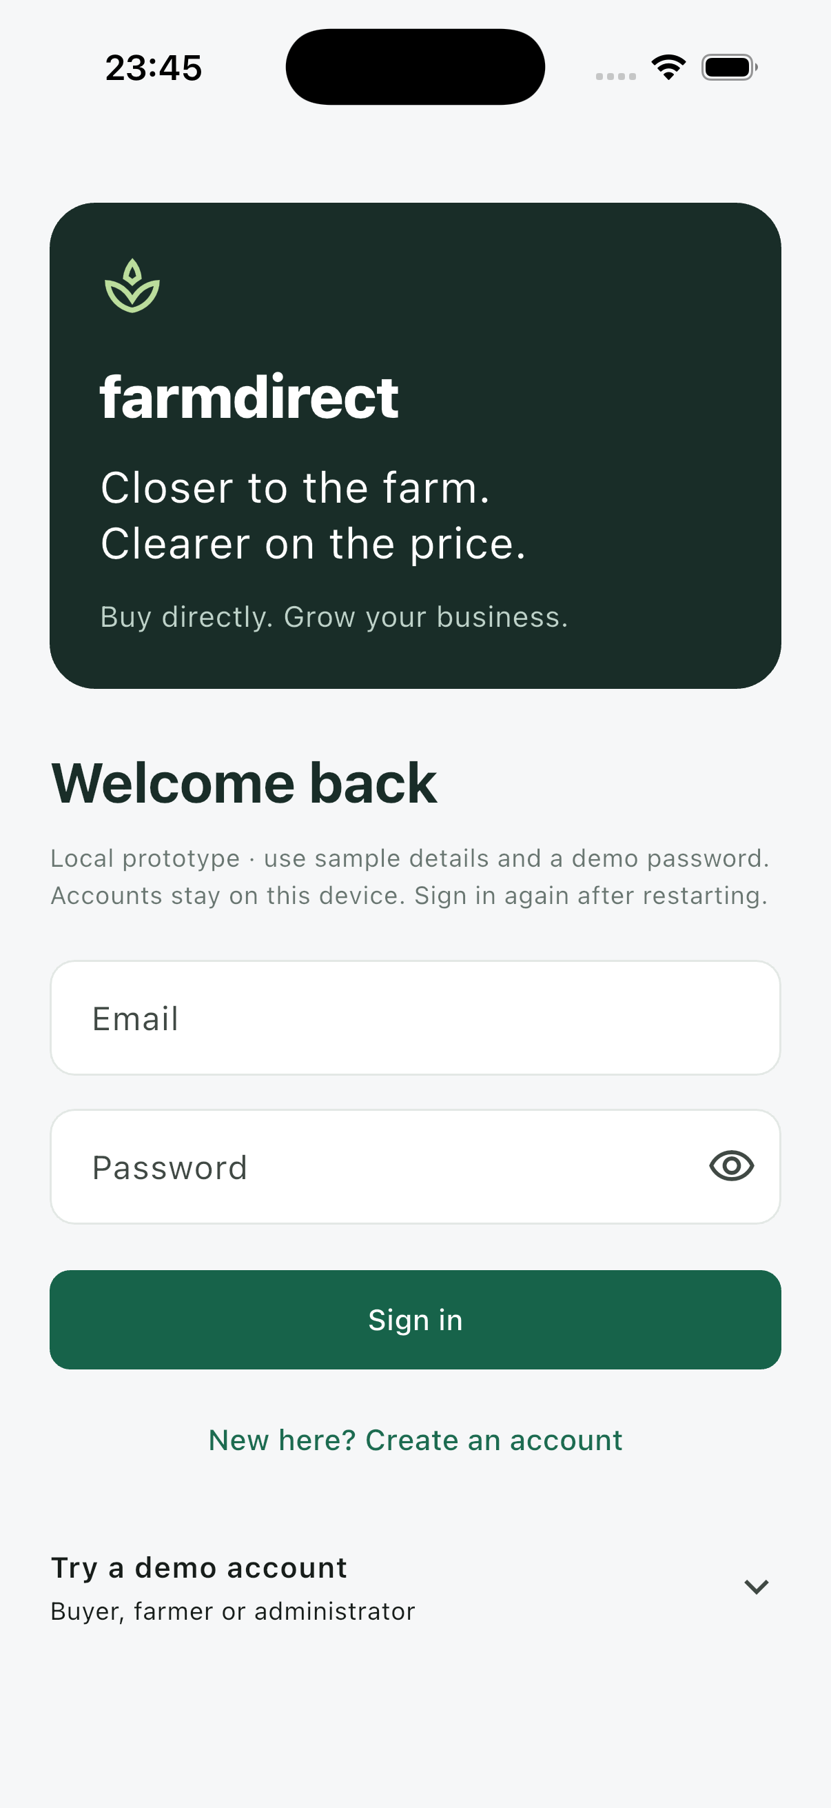  Figure 8.1. Sign-in screen in the mobile application. | 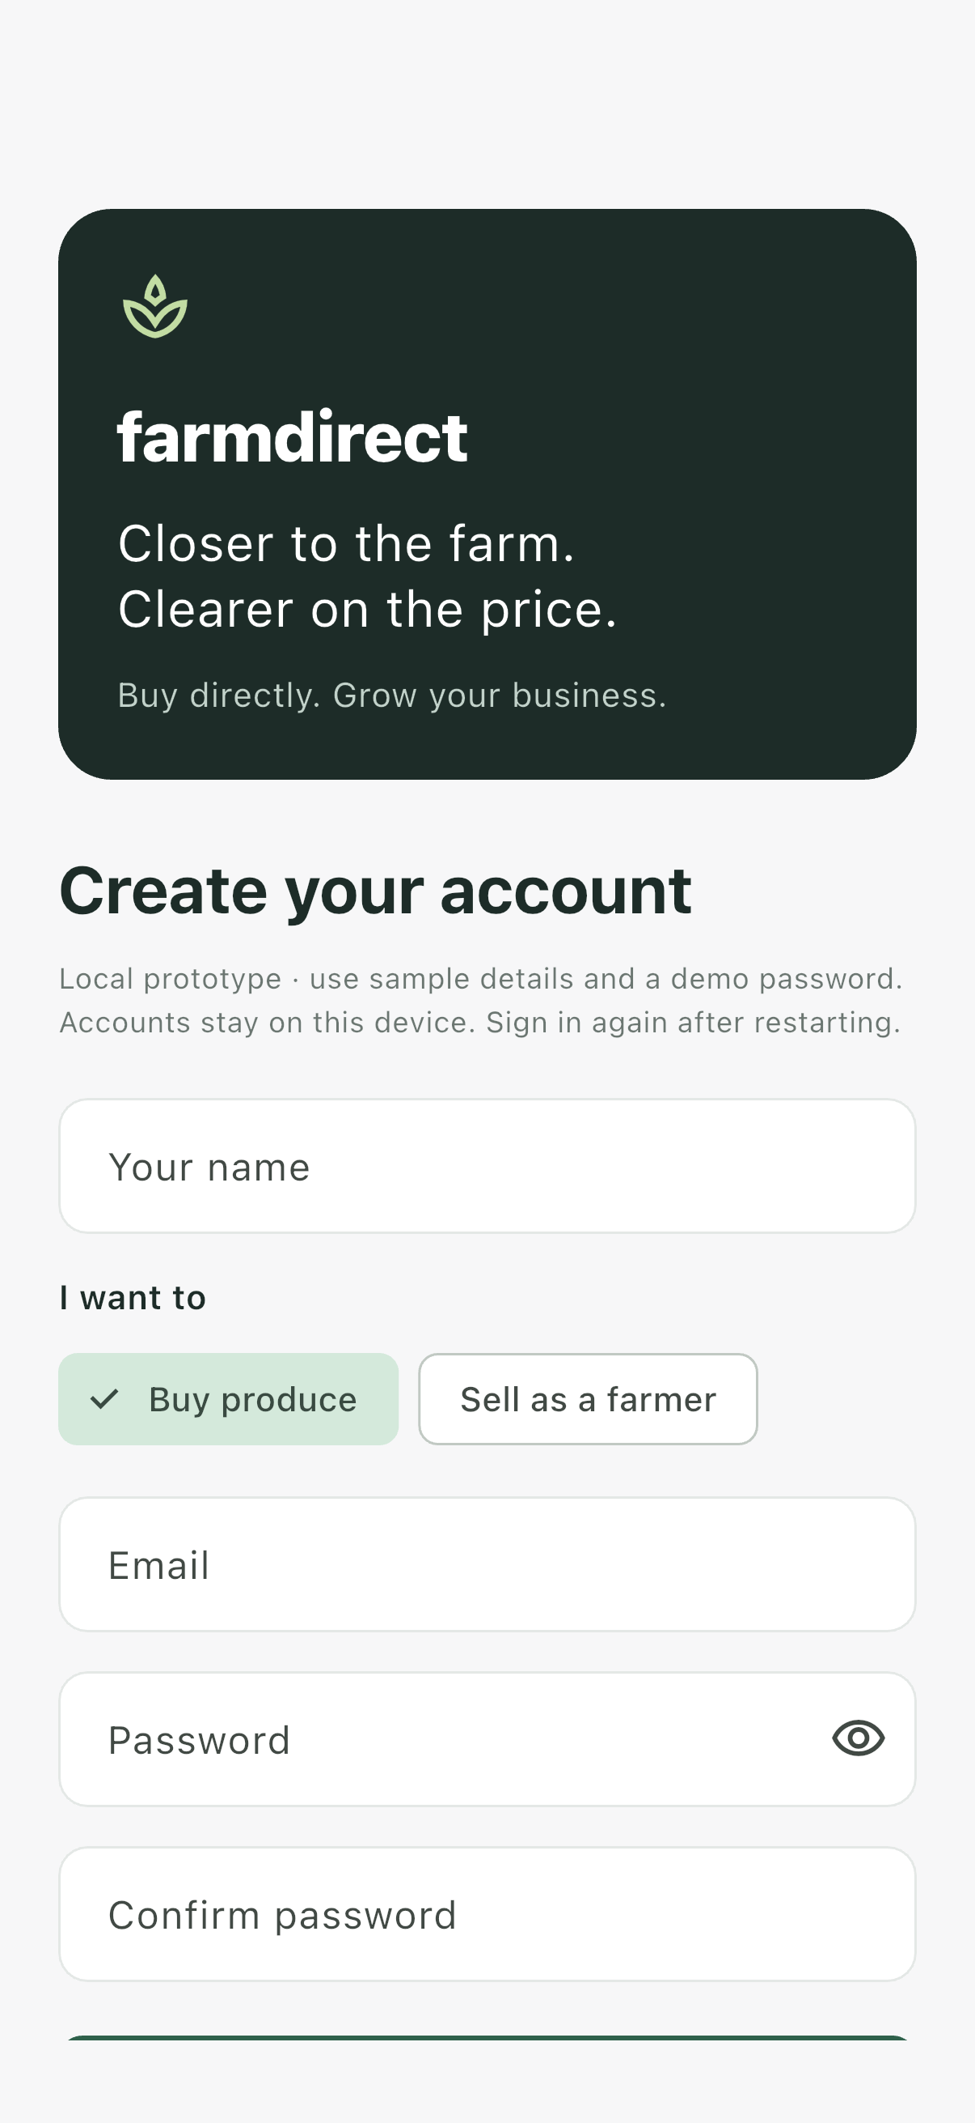  Figure 8.2. User registration with buyer and farmer role selection.

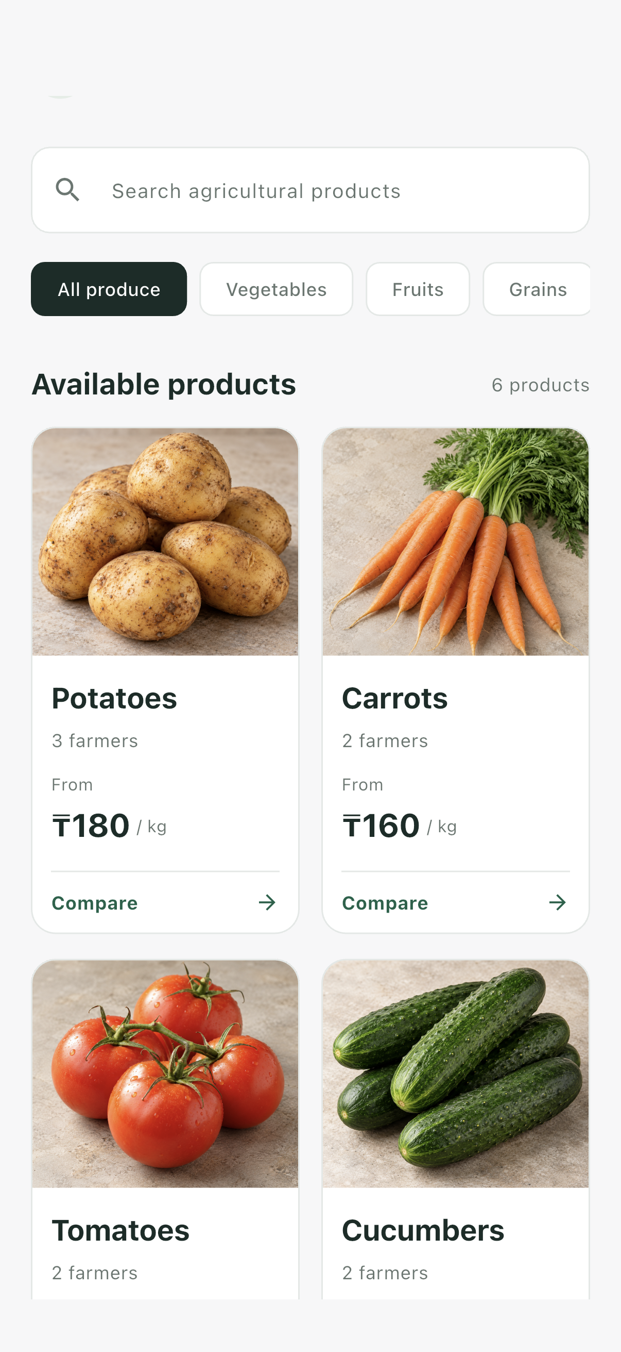  Figure 8.3. Mobile product catalog with search and category filters. | 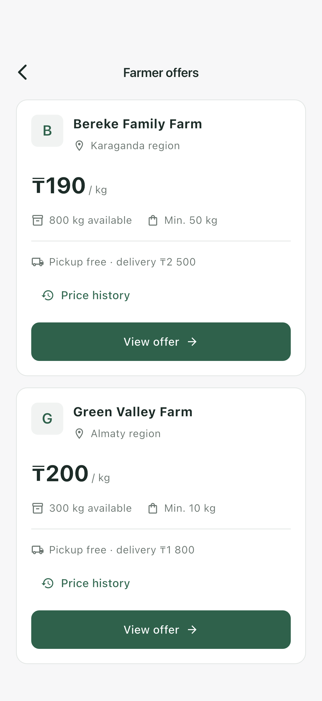  Figure 8.4. Comparison of farmer prices, stock, and delivery terms.

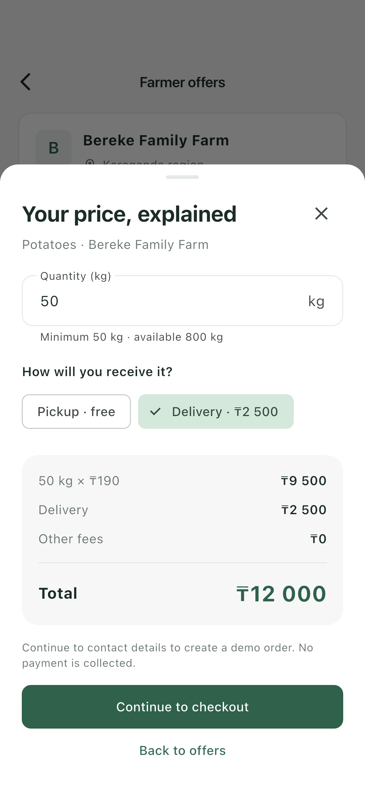  Figure 8.5. Transparent breakdown of product cost, delivery fee, and total. | 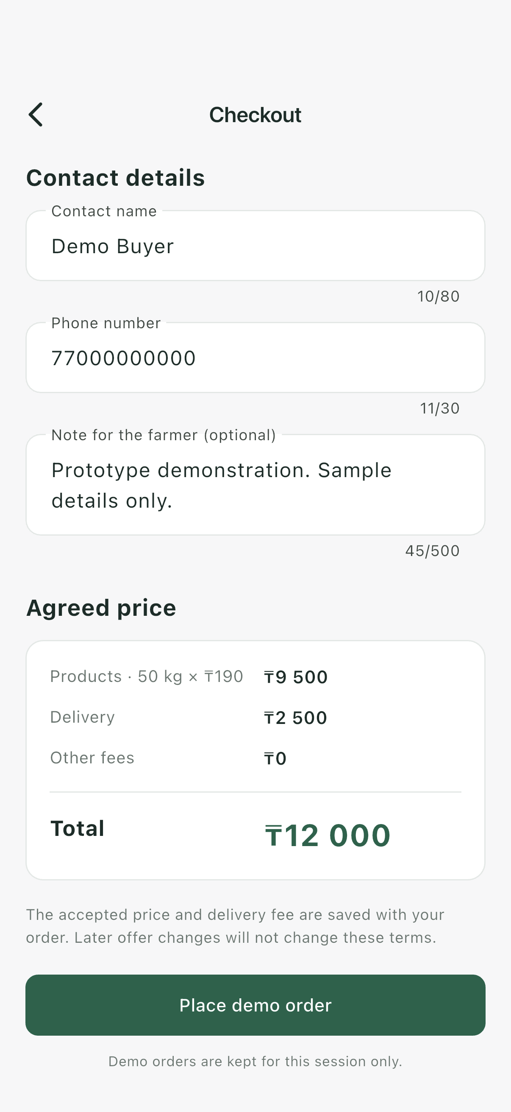  Figure 8.6. Checkout with buyer contact details and the agreed total.

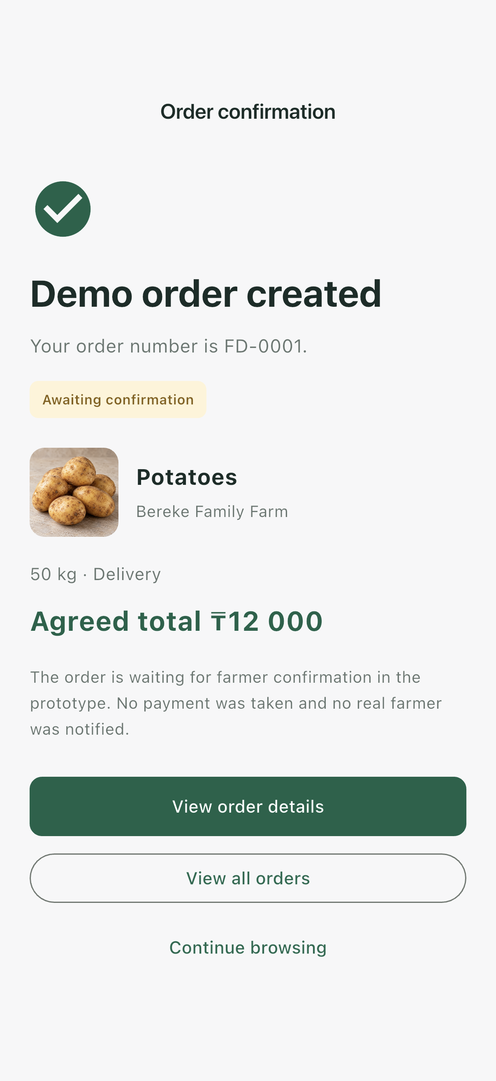  Figure 8.7. Demo order confirmation with the order number and agreed price. | 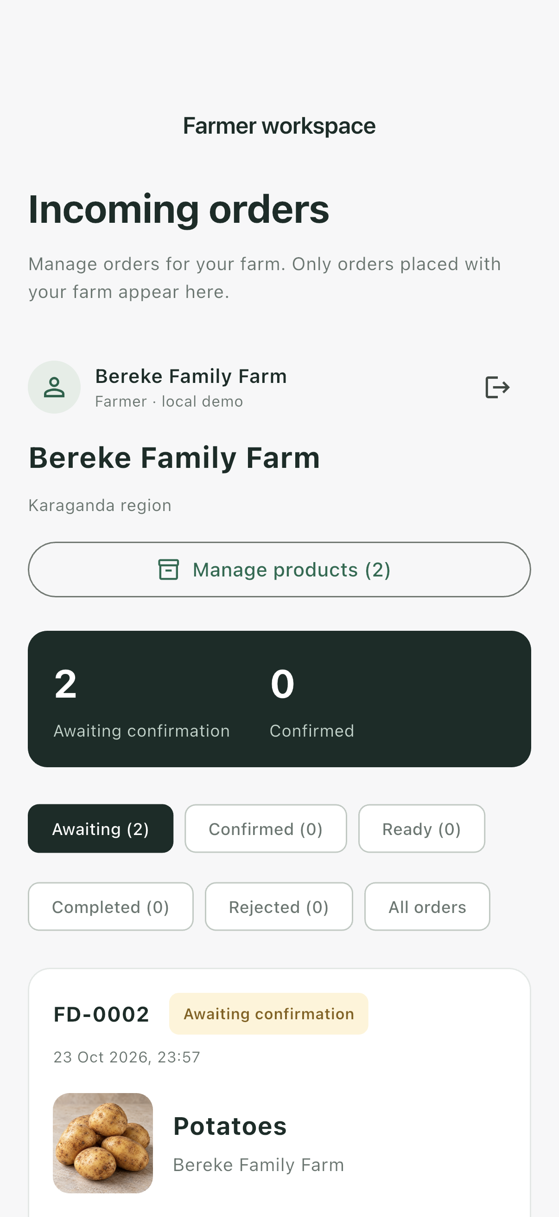  Figure 8.8. Farmer workspace displaying incoming orders.

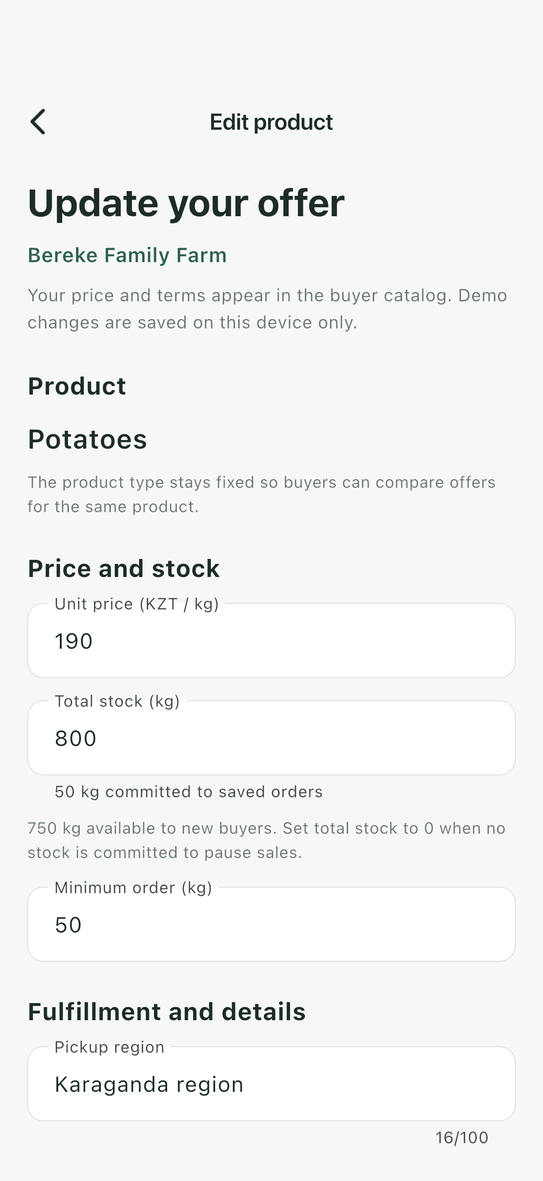  Figure 8.9. Editing product price, stock, and minimum order quantity. | 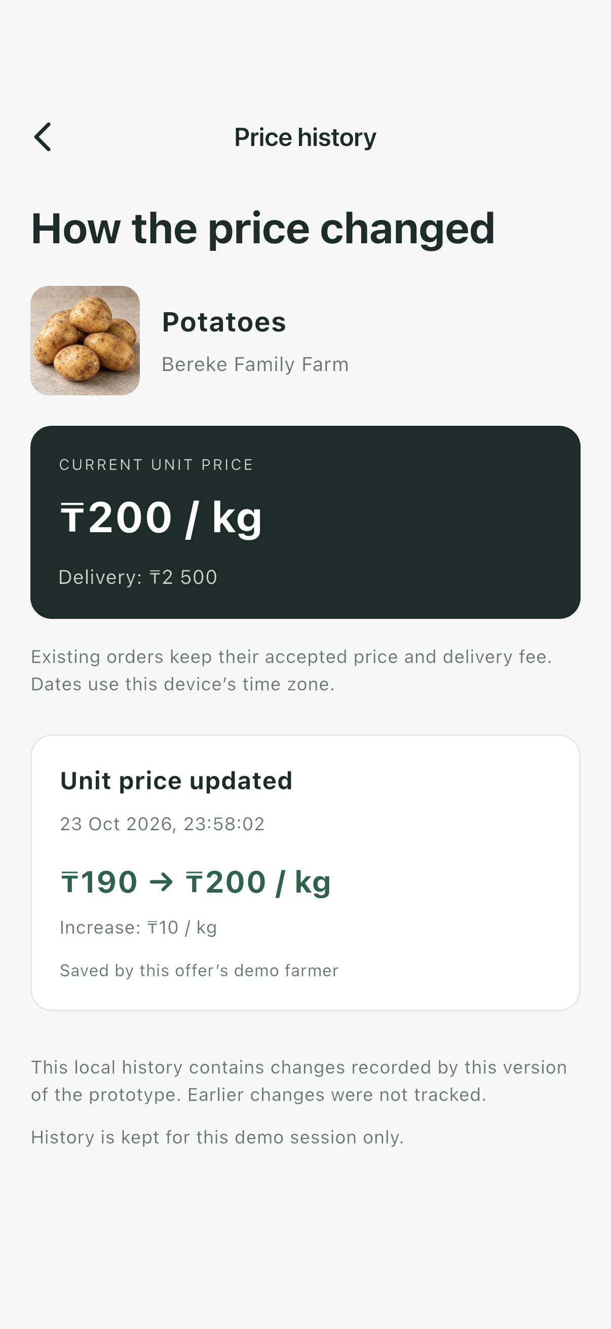  Figure 8.10. Dated history of changes to the farmer’s unit price.

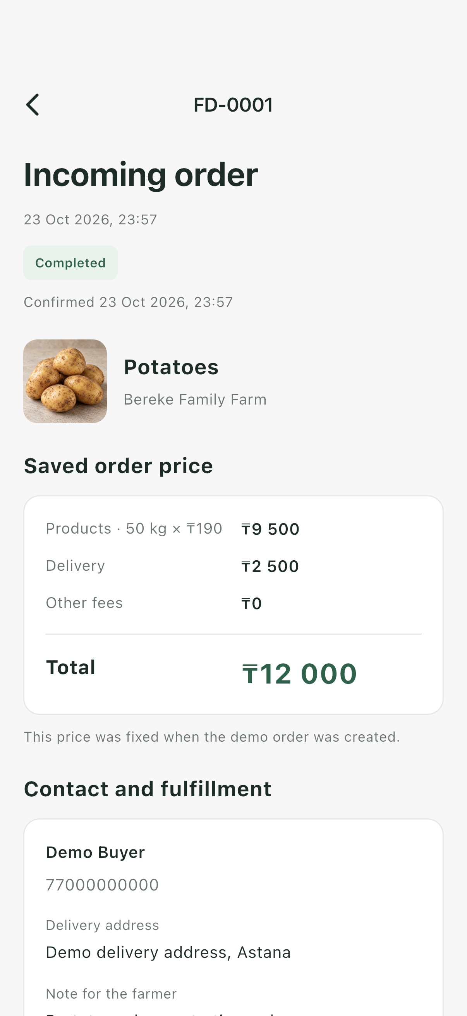  Figure 8.11. Completed order with the original agreed price preserved. | 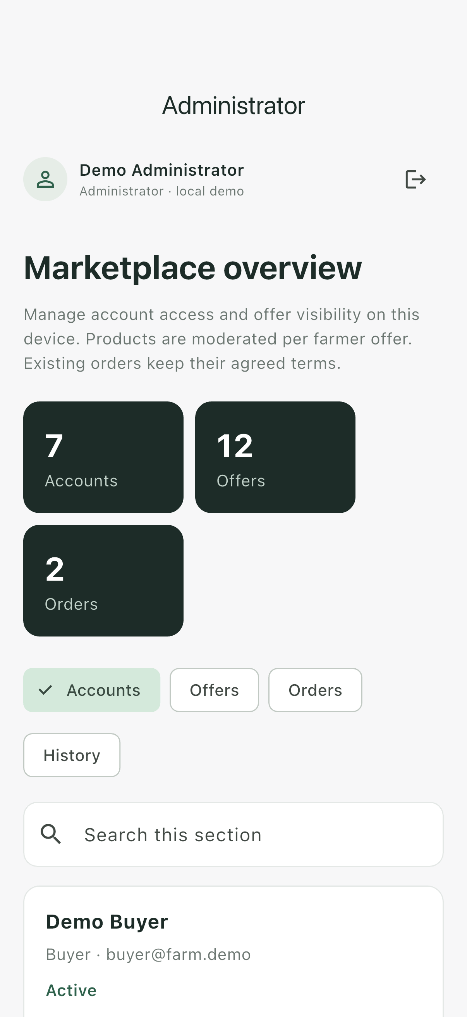  Figure 8.12. Administrator dashboard with marketplace summaries and account controls.

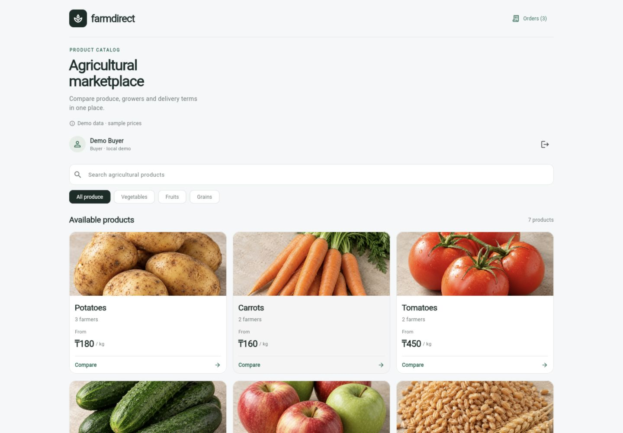
Figure 8.13. Product catalog in the desktop web application.
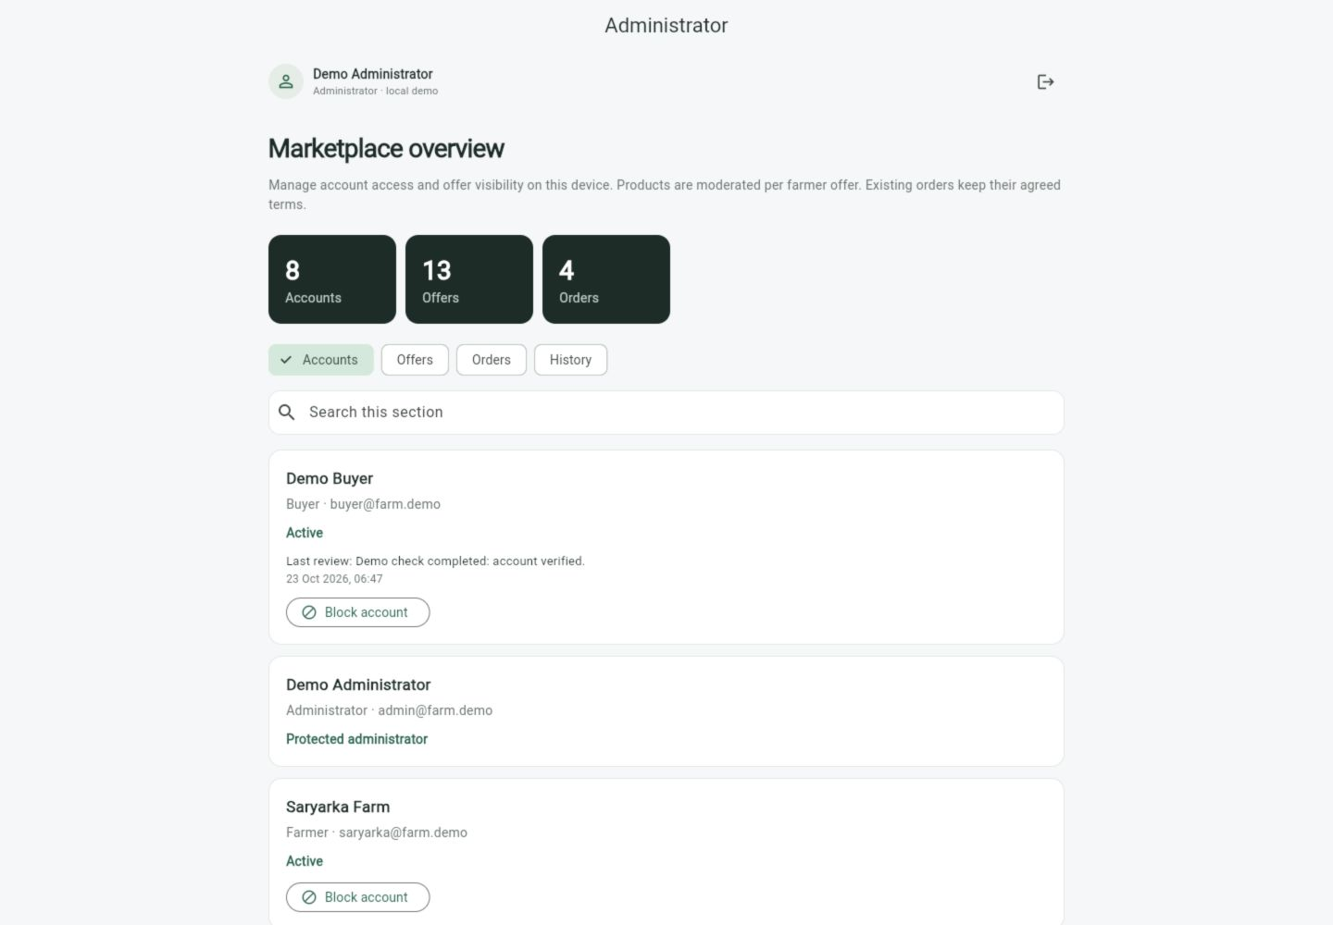
Figure 8.14. Administrator dashboard in the desktop web application.

Key User Scenarios
Buyer scenario. The buyer signs in, browses the product catalog, selects a product, and compares offers from different farmers. After choosing an offer, the buyer specifies the quantity and fulfilment method, reviews the price breakdown, and enters contact details to place a demonstration order. The system displays the order number, agreed total, and current status.
Farmer scenario. The farmer signs in to manage product offers, including prices, available stock, and minimum order quantities. Price changes are recorded in the offer’s history. The farmer reviews incoming orders and can confirm them, mark them as ready, complete them, or reject them with a reason.
Administrator scenario. The administrator reviews marketplace accounts and offers. The administrator can block buyer or farmer accounts and hide individual offers, providing a reason for each moderation action. These decisions are recorded in the moderation history.

9. Verification and Evaluation Plan

9.1. Purpose and Scope
Verification will establish whether the system satisfies the functional and non-functional requirements defined in Section 6. Evaluation will investigate whether the proposed interface helps users compare farmer offers, understand the final purchasing cost, and manage procurement activities.
Testing will distinguish two implementation stages:
- Local prototype: verification of interface behaviour, calculations, order workflows, price history, and moderation using demonstration data.
- Integrated system: verification of API permissions, shared persistence, concurrent purchases, retry handling, security, and recovery after backend integration.
Successful prototype demonstrations will not be treated as evidence that shared-system requirements have been fulfilled.

9.2. Testing Strategy
Test area | Planned checks | Related requirements
Registration and access | Register buyer and farmer accounts; reject duplicate emails and invalid credentials; verify logout, blocked-account restrictions, role permissions, and ownership checks. | FR-01–FR-03; NFR-03
Catalog and comparison | Check product availability, offer details, search, category filters, sorting, and exclusion of hidden offers or offers from blocked farmers. | FR-04–FR-05, FR-18
Pricing and checkout | Verify quantity validation, minimum orders, stock limits, delivery charges, final totals, required contact details, and handling of changed offer terms. | FR-06–FR-08; NFR-05
Order lifecycle | Check order creation, buyer history, permitted cancellation, farmer confirmation, readiness, completion, rejection reasons, and refusal of invalid transitions. | FR-07–FR-09, FR-11
Offer management and history | Create and edit offers; reject invalid values; verify dated price-change records and confirm that stock-only or description-only edits do not create price-change events. | FR-10, FR-13
Stock and concurrent requests | Verify reservations, cancellation and rejection releases, completion, and competing purchases without overselling. | FR-12; NFR-04
Administration | Check account blocking and unblocking, offer hiding and restoration, protected administrator accounts, and complete moderation records. | FR-14–FR-15
Integration and persistence | Verify data exchange between separate clients, persistence after restart, duplicate-submission protection, transaction rollback, and backup restoration. | FR-16–FR-17; NFR-04, NFR-06
Compatibility and interaction | Execute core scenarios on the required platforms; check responsive layouts, text scaling, keyboard operation, and visible focus. | NFR-01–NFR-02
Performance, usability, and maintainability | Measure API response times and task completion; verify documented setup, test commands, and requirement-to-evidence links. | NFR-07–NFR-09
Automated unit tests will cover business rules and calculations. Widget tests will check interface validation and interaction. Integration and API tests will verify communication between components. Manual scenario testing will supplement automated checks for layouts, accessibility, and complete user journeys.

9.3. Test Data and Measurement Conditions
Testing will use fictional accounts and a repeatable dataset containing buyers, farmers, an administrator, product types, farmer offers, orders, and historical records. At least one product type will have three comparable farmer offers.
Reference cases will include:
- Pricing: 50 kg at KZT 190/kg produces a subtotal of KZT 9,500. Adding KZT 2,500 delivery produces a total of KZT 12,000. Pickup produces no delivery charge.
- Stock competition: with 80 kg available, two concurrent requests for 50 kg must produce at most one accepted order, leaving 30 kg available.
- Preserved terms: changing an offer’s price after order placement must not change the accepted order total.
- Retry handling: repeating the same submission identifier must create one order and one stock reservation.
- Failed updates: an interrupted transaction must not leave partial orders, inconsistent stock, or unmatched price-history records.
Each test run will record the application version or commit, platform, operating system, browser version where applicable, dataset, and relevant hardware and network conditions.
Responsive checks will include reference viewports of 360 × 800 and 1280 × 800, together with 200% text scaling. Compatibility testing will cover Android, iOS, and the web application in Chrome and Safari.
Performance testing will use 1,000 seeded offers and 10 concurrent test users against the integrated backend. Request counts, test duration, response times, and errors will be recorded. Initial application download and image loading will be excluded from the API response-time measurement.

9.4. Metrics and Acceptance Targets
Metric | Measurement method | Target
Mandatory requirement coverage | Map every Must requirement to test cases and recorded evidence. | Every Must requirement has verification evidence and satisfies its acceptance criteria before final acceptance.
Calculation accuracy | Compare displayed and stored totals with independently calculated expected values. | All predefined pricing and boundary cases produce the correct result.
Order and inventory consistency | Inspect orders, reservations, and available stock after normal, concurrent, repeated, and failed operations. | No overselling, duplicate reservations, invalid transitions, or partial transactions in the defined cases.
Access-control correctness | Attempt protected actions using unauthenticated users, incorrect roles, blocked accounts, and non-owning accounts. | All predefined unauthorised requests are rejected by the backend.
API response time | Measure catalog and offer request durations under the documented workload. | At least 95% of requests complete within two seconds.
Usability task success | Divide successful task attempts completed without moderator intervention by all task attempts. | At least 80%, with results also reported separately by task and role.
Final-price comprehension | Ask buyers to identify the total before submitting an order; compare their answers with the expected amount. | Record the correct-answer rate and analyse every misunderstanding.
Persistence and recovery | Restart services and restore a backup into a separate test environment. | Selected accounts, offers, orders, accepted prices, and historical records remain correct.
Any failed mandatory criterion will remain unresolved until corrected and successfully retested.

9.5. Baseline for Comparison
The baseline will represent manual offer comparison using separate supplier messages and a simple spreadsheet. This reflects the communication and comparison practices described in the interviews.
Buyers will complete equivalent tasks using the baseline and the prototype:
- Compare three farmer offers.
- Identify offers satisfying a specified quantity and fulfilment requirement.
- Calculate the final purchasing cost, including delivery.
- Select the lowest-total-cost offer among those meeting the stated conditions.
Both conditions will provide equivalent information about prices, stock, minimum quantities, and delivery. The same timing rules and access to a calculator will apply. Task order will be counterbalanced where practical to reduce learning effects.
The comparison will record completion time, calculation errors, offer-selection errors, and requests for assistance. Results will be reported descriptively. Faster completion or fewer errors will be claimed only if supported by the measurements.

9.6. User Evaluation Procedure
At least five representative participants, including at least two buyers and two farmers, will attempt predefined tasks.
Buyer tasks will cover finding a product, comparing offers, identifying the final total, placing a demonstration order, and locating its status. Farmer tasks will cover editing an offer, inspecting price history, and processing an incoming order. Administrator workflows will be checked through separate functional scenarios.
Participants will receive a brief introduction without step-by-step instructions. The evaluator will record task completion, time, errors, and assistance. A task requiring moderator intervention will not count as an independently successful attempt.
Brief follow-up questions will identify confusing terminology, missing information, and navigation difficulties. Participation will be voluntary, and results will use anonymous participant identifiers.
Because the evaluation sample is small, findings will be treated as exploratory rather than representative of all potential users.

9.7. Evidence and Final Assessment
Each test record will include the requirement identifier, preconditions, steps, expected result, actual result, execution environment, and status. Evidence may include automated test reports, screenshots, API responses, database checks, performance logs, and anonymised evaluation notes.
Tests will be marked as Passed, Failed, Blocked, or Not Run. Requirements awaiting backend implementation will not be marked as passed based on local screenshots.
The final assessment will combine requirement verification, baseline comparison, and user-evaluation findings. It will explain which project objectives have been demonstrated, which limitations remain, and what further development is required. Claims about farmer income, long-term trust, or commercial efficiency will require additional field evidence

10. Project Management and Risks

10.1. Project Organisation and Tools
The project is developed by a two-person team. GitHub is used for source-code version control, documentation, and review through pull requests. YouTrack is used to organise tasks, assign responsibilities, track progress, and define upcoming work.
GitHub repository:
https://github.com/ayanat-amangeldi/farm-direct-procurement
YouTrack project:
https://farm-direct-procurement.youtrack.cloud/projects/FARM
Project activities will be traceable through links between requirements, YouTrack tasks, implementation changes, and verification evidence.

10.2. Allocation of Responsibilities
Team member | Primary responsibility | Main activities
Ayanat Amangeldi | Backend and Transparent Pricing Module | Procurement-process analysis; database and API design; backend implementation; pricing calculations; stock commitments; order-processing rules; price-history functionality.
Dilyara Anetbayeva | Frontend and Procurement Scenarios | Flutter interface design and development; responsive mobile and web layouts; product catalog; farmer-offer comparison; checkout; order tracking; farmer and administrator workspaces.
Both team members | Shared project activities | Requirements analysis; architecture decisions; integration; testing; documentation; task planning; review and demonstration preparation.
This allocation defines primary ownership rather than exclusive participation. Tasks involving both interface behaviour and business rules will be coordinated jointly. Completed work and reviews will be recorded according to each member’s actual contribution.

10.3. Task Management and Development Workflow
Implementation work will be divided into manageable YouTrack tasks. Each task should contain:
- A clear description and responsible team member.
- Related requirement identifiers.
- Acceptance criteria and relevant dependencies.
- Links to implementation changes and verification evidence.
- A current status indicating whether work is pending, in progress, under review, or completed.
Changes will be developed in branches and reviewed through pull requests before integration into the main branch. Commit messages and pull-request descriptions should reference the corresponding YouTrack issue where applicable.
A task will be considered complete when its acceptance criteria have been checked, relevant changes have been integrated, and supporting evidence has been recorded. Demonstration of local behaviour will not close tasks that require a shared backend.

10.4. Project Milestones
Milestone | Main deliverables | Completion condition | Current position
M1. Requirements and initial design | Project proposal, relevance evidence, literature review, comparisons, requirements, and draft architecture. | The initial scope and acceptance criteria are documented and reviewed. | Documentation in progress.
M2. Local interactive prototype | Buyer, farmer, and administrator workflows; transparent pricing; order processing; price history; moderation; mobile and web screenshots. | The main scenarios can be demonstrated using local fictional data. | Prototype available for demonstration.
M3. Backend and database foundation | FastAPI service, PostgreSQL schema, authentication, permissions, migrations, and documented API contracts. | Core records and protected operations are available through the backend. | Planned.
M4. Client–server integration | Flutter API integration, shared offers and orders, consistent stock handling, and retry protection. | Buyer and farmer actions work across separate clients and survive service restarts. | Planned.
M5. Verification and user evaluation | Automated tests, compatibility checks, performance measurements, baseline comparison, and usability findings. | Results are assessed against Section 6 and documented using the plan in Section 9. | Planned.
M6. Final delivery | Corrected implementation, final report, setup instructions, and demonstration materials. | Mandatory requirements are verified and remaining limitations are clearly reported. | Planned.
Target dates will be agreed with the supervisor and recorded in YouTrack. Functional tests will be developed alongside implementation rather than postponed until the final milestone.

10.5. Risk Register
ID | Risk | Likelihood | Impact | Mitigation and response
R1 | Additional features expand the scope beyond the available time. | High | High | Prioritise Must requirements. Defer optional features such as online payments, messaging, ratings, and recurring orders. Review proposed additions against the agreed scope.
R2 | Differences between frontend assumptions and API behaviour delay integration. | Medium | High | Agree on request formats, response structures, validation rules, and error handling before integration. Integrate one complete procurement scenario early.
R3 | Concurrent orders or repeated submissions create inconsistent stock or duplicate orders. | Medium | High | Use database transactions, server-side validation, submission identifiers, and automated concurrency and retry tests.
R4 | Incorrect pricing or history handling undermines price transparency. | Medium | High | Use exact monetary representations, centralise pricing rules, preserve accepted order terms, and test successful and failed historical updates.
R5 | Incomplete role or ownership checks expose protected operations. | Medium | High | Enforce permissions on the backend and test unauthenticated, incorrect-role, blocked-account, and non-owning-user requests.
R6 | Platform differences cause layout or interaction problems. | Medium | Medium | Check core scenarios regularly on Android, iOS, Chrome, and Safari, including narrow viewports, text scaling, and keyboard interaction.
R7 | Limited participant availability delays user evaluation. | Medium | Medium | Recruit participants in advance, prepare short role-specific sessions, and allow remote participation where practical. Report any sample limitations.
R8 | Data loss or environment failures interrupt development or evaluation. | Medium | High | Push work regularly, document setup, maintain repeatable test data and database migrations, and verify backup restoration before final evaluation.
R9 | Uneven workload or temporary unavailability delays dependent tasks. | Medium | Medium | Review workload regularly, document implementation decisions, identify critical dependencies, and redistribute tasks when necessary.
Risks will be reviewed during progress meetings and before each milestone. Issues that occur will be recorded as actionable YouTrack tasks with an owner and a response plan.

10.6. Dependencies and Next Steps
Backend implementation depends on agreed data relationships, order-transition rules, pricing rules, and permission requirements. Flutter integration depends on sufficiently stable API contracts. Concurrent-order and recovery testing depends on the shared database and backend being operational.
User evaluation depends on a stable demonstration build, prepared task instructions, and participant availability. Performance evaluation depends on a documented test environment and a repeatable dataset.
The next development steps are:
- Finalise the initial requirements and architecture with the supervisor.
- Define the PostgreSQL schema and API contracts.
- Implement authentication, role permissions, and core backend operations.
- Connect the Flutter catalog and offer screens to the API.
- Integrate order creation, stock commitments, and farmer order processing.
- Integrate price history and administrator moderation.
- Execute the verification and evaluation plan and address identified defects.

