Coursera Capstone Project :IBM Applied Data Science Professional Certificate

FINAL REPORT

Ayanava Dutta

27.01.2020

1. **Introduction**

The Kolkata Suburban Railway is a suburban rail system serving the suburbs surrounding the city of Kolkata. Railways such as these are important and heavily used infrastructure in India. It is the largest suburban railway network in India by track length and number of stations. It has 393 stations and a track length of 1,332 km. The suburban railway operates 1497 EMU services carrying 3.5 million (35 lakhs) people daily. It runs from 4 a.m to 2 a.m. in the night.

In terms of the fare prices, as per the 2013 Indian Railway Budget, the railway increased the Kolkata suburban ticket fare by eight paisa per kilometer, although the railway ministry has hiked it by two paisa per kilometer. The number of slabs has also been reduced to four—Rs.5 (7.2 US cents), Rs.10 (14 US cents), Rs.15 (22 US cents) and Rs.20 (29 US cents)—from the eight slabs earlier. Also, ticket denominations have been rounded off to multiples of Rs.5 (7.2 US cents). As per the revised slab, a person traveling up to 20 km will have to pay Rs.5 (7.2 US cents), between 21 and 45 km Rs.10 (14 US cents), between 46 and 70 km Rs.15 (22 US cents) and between 71 and 100 km Rs.20 (29 US cents).

Train stations are ideal locations for small businesses to set up shops, because they are hubs of human interaction where hundreds or even thousands of people day and night come and go. Each person in this flow of foot traffic is a potential customer who might need a specific item or purchase on impulse while waiting for a train. To succeed with retail at a train station, one must provide an accessible and affordable shopping experience offering merchandise or services that travelers might not quickly find elsewhere en-route while travelling.

1. **Business Problem**

Train passengers as well as station and train employees need to eat breakfast, lunch, dinner and snacks. Although food sales are forbidden in some railway stations, many do offer merchants the opportunity to sell food. Foods that attract busy people on the go include egg sandwiches, fries, pizza, burgers, microwaveable or cold prepared meals. Beverages such as coffee, tea, wraps, bottled water, soda and juice also sell well. Thus, the main objective of the project will be to find ideal spots in the city where fast food retail chains can be put up, aiming at the above demographic, thereby helping the owners of the outlets to extract maximum profits out of them.

1. **Data**

The data for this project has been retrieved and processed through multiple sources, giving careful considerations to the accuracy of the methods used.

* 1. **Neighborhoods**

The data of the neighborhoods in Kolkata can be extracted out by web scraping using Beautiful Soup

library for Python. The neighborhood data is scraped from a Wikipedia webpage.

#! /usr/bin/python

site = ‘https://en.wikipedia.org/wiki/Category:Neighbourhoods_in_Kolkata’ source = requests.get(site).text

csv_file = open(’kolkata.csv’, ’w’) csv_writer = csv.writer(csv_file) csv_writer.writerow([’Neighbourhood’]

soup = BeautifulSoup(source, ’lxml’)

mwcg = soup.find_all(class_ = "mw-category-group") length = len(mwcg)

for i in range(1, length):

lists = mwcg [i].find_all(’a’) for list in lists:

nbd = list.get(’title’) csv_writer.writerow([nbd])

csv_file.close()

Code

* 1. **Geocoding**

The file contents from kolkata.csv is retrieved into a Pandas DataFrame. The latitude and longitude of the neighborhoods are retrieved using Google Maps Geocoding API. The geometric location values are then stored into the intial dataframe.

#! /usr/bin/python

latitudes = [] longitudes = []

for nbd in df["Neighbourhood"] : place_name = nbd + ",Kolkata,India"

url = ‘https://maps.googleapis.com/maps/api/geocode/json?address={}&key={}’

.format(place_name, API_KEY)

obj = json.loads(requests.get(url).text)

results = obj[’results’]

lat = results[0][’geometry’][’location’][’lat’]

lng = results[0][’geometry’][’location’][’lng’]

latitudes.append(lat) longitudes.append(lng)

df[‘Latitude’] = latitudes df[‘Longitude’] = longitudes

Code

* 1. **Venue Data**

From the location data obtained after Web Scraping and Geocoding, the venue data is found out by passing in the required parameters to the FourSquare API, and creating another DataFrame to contain all the venue details along with the respective neighbourhoods.

Code

#! /usr/bin/python explore_df_list = []

for i, nbd_name in enumerate(df[‘Neighbourhood’]):

try :

nbd_name = df.loc[i, ‘Neighbourhood’] nbd_lat = df.loc[i, ‘Latitude’] nbd_lng = df.loc[i, ‘Longitude’]

radius = 1000

LIMIT = 30

url = ‘https://api.foursquare.com/v2/venues/explore?client_id={} \ &client_secret={}&ll={},{}&v={}&radius={}&limit={}’\

.format(CLIENT_ID, CLIENT_SECRET, nbd_lat, nbd_lng, VERSION, radius, LIMIT)

results = json.loads(requests.get(url).text) results = results[’response’][’groups’][0][’items’]

nearby = json_normalize(results)

filtered_columns = [‘venue.name’, ‘venue.categories’, ‘venue.location.lat’, ‘venue.location.lng’]

nearby = nearby.loc[:, filtered_columns]

columns = [‘Name’, ‘Category’, ‘Latitude’, ‘Longitude’] nearby.columns = columns

nearby[‘Category’] = nearby.apply(get_category_type, axis=1) for i, name in enumerate(nearby[‘Name’]):

s_list = nearby.loc[i, :].values.tolist() f_list = [nbd_name, nbd_lat, nbd_lng] + s_list explore_df_list.append(f_list)

except Exception as e: pass

explore_df = pd.DataFrame([item for item in explore_df_list]) explore_df.columns = [‘Neighbourhood’, ‘Neighbourhood Latitude’, ‘Neighbourhood Longitude’, ‘Venue Name’, ‘Venue Category’, ‘Venue Latitude’, ‘Venue Longitude’]

explore_df.head()

1. **Methodology**

A thorough analysis of the principles of methods, rules, and postulates employed g=have been made in order to ensure the inferences to be made are as accurate as possible.

* 1. **Accuracy of the Geocoding API**

In the initial development phase with OpenCage Geocoder API, the number of erroneous results were of an appreciable amount, which led to the development of an algorithm to analyze the accuracy of the Geocoding API used. In the algorithm developed, Geocoding API from various providers were tested, and in the end, Google Maps Geocoder API turned out to have the least number of collisions (errors) in our analysis.

#! /usr/bin/python

col = 0 explored_lat_lng = []

for lat, lng, neighbourhood in zip(df[‘Latitude’], df[‘Longitude’], df[‘Neighbourhood’]):

if (lat, lng) in explored_lat_lng: col = col + 1

else:

explored_lat_lng.append((lat, lng))

print("Collisions : ", col)

Code

* 1. **Folium**

Folium builds on the data wrangling strengths of the Python ecosystem and the mapping strengths of the leaflet.js library. All cluster visualization are done with help of Folium which in turn generates a Leaflet map made using OpenStreetMap technology.

#! /usr/bin/python

kol_lat = 22.5726

kol_lng = 88.3639

map_kolkata = folium.Map(location=[kol_lat, kol_lng], zoom_start=10)

for lat, lng, neighbourhood in zip(df[‘Latitude’], df[‘Longitude’], df[‘Neighbourhood’]):

label = ‘{}’.format(neighbourhood)

label = folium.Popup(label, parse_html=True) folium.CircleMarker(

[lat, lng], radius=5, popup=label, color=‘blue’, fill=True,

fill_color=‘#3186cc’, fill_opacity=0.7, parse_html=False).add_to(map_kolkata)

Code

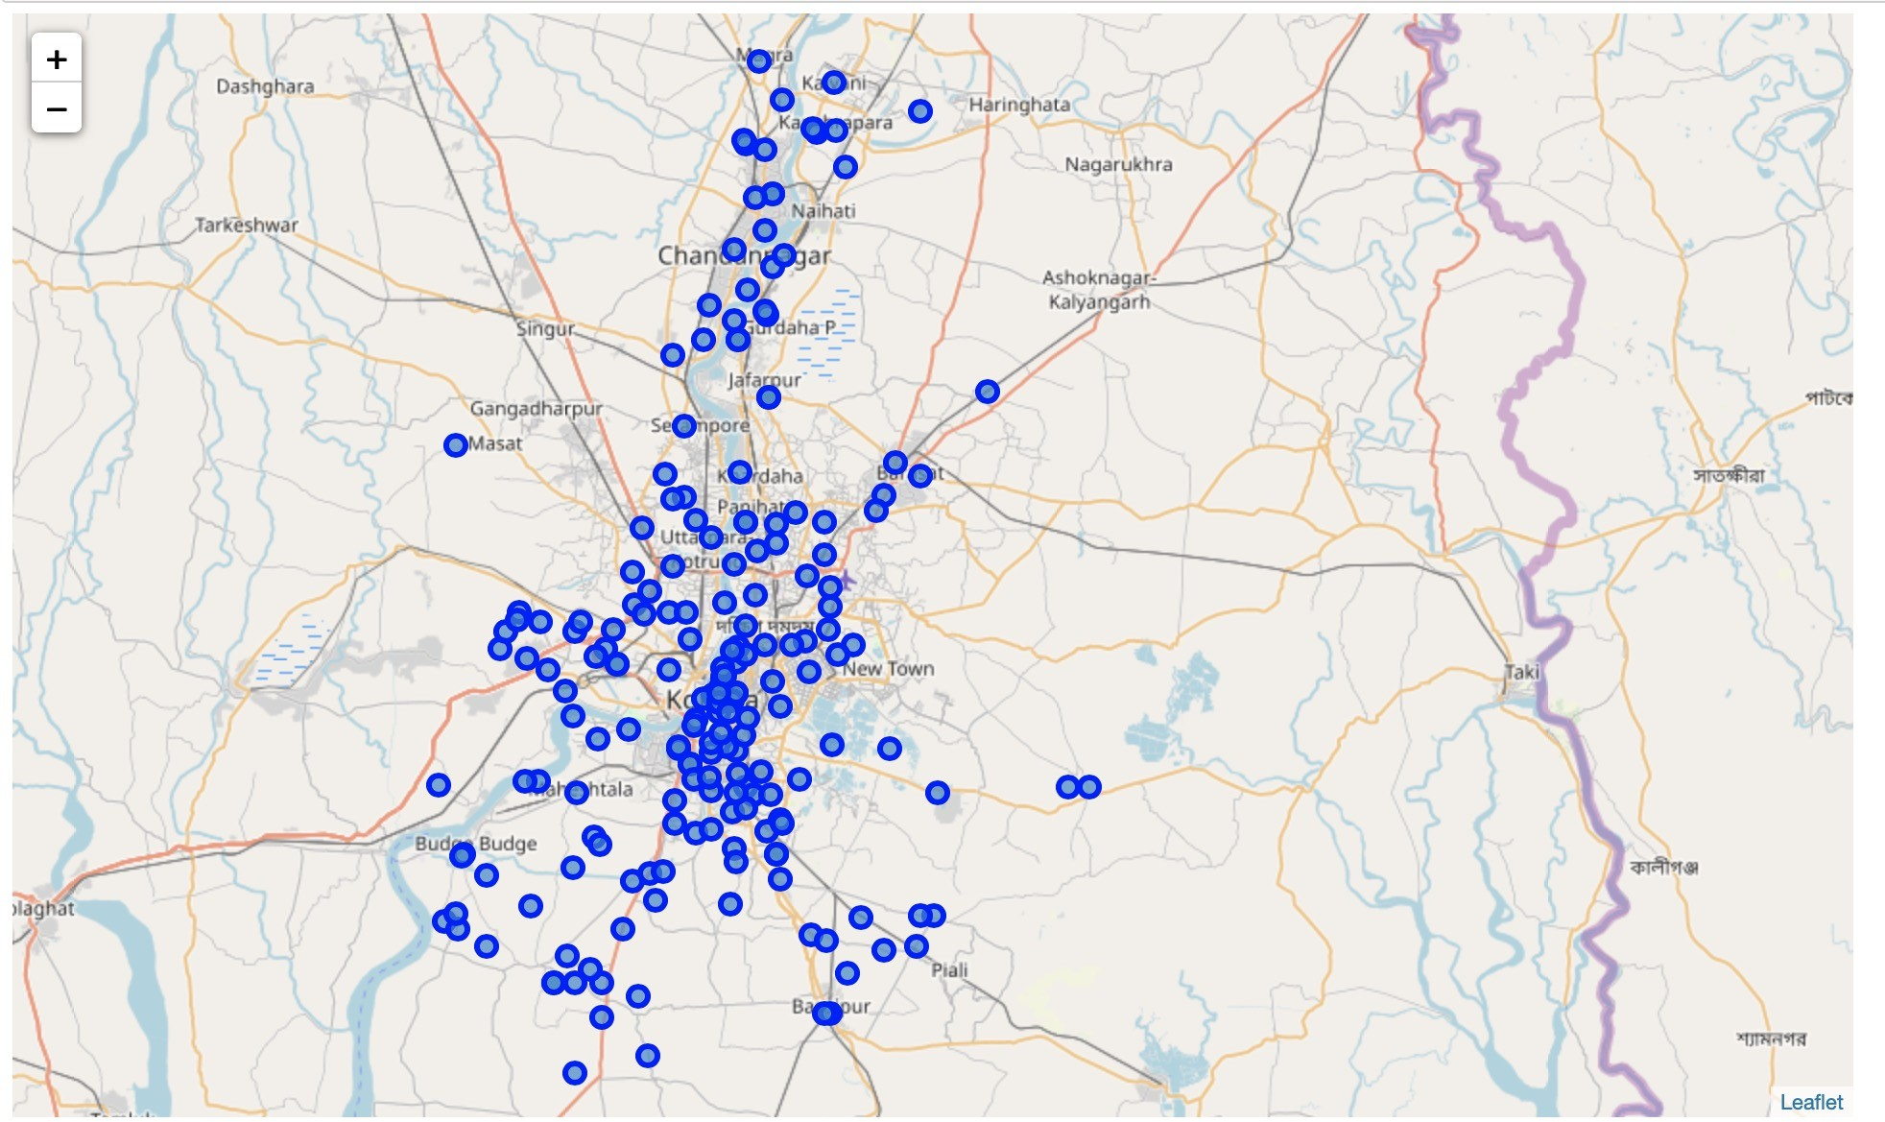

* 1. **One hot encoding**

Figure 1: Neighborhoods of Kolkata.

One hot encoding is a process by which categorical variables are converted into a form that could be provided to ML algorithms to do a better job in prediction. For the K-means Clustering Algorithm, all unique items under Venue Category are one-hot encoded.

#! /usr/bin/python

kolkata_onehot = pd.get_dummies(explore_df[[‘Venue Category’]], prefix="", prefix_sep="")

kolkata_onehot[‘Neighbourhood’] = explore_df[‘Neighbourhood’]

fixed_columns = [kolkata_onehot.columns[-1]] + kolkata_onehot.columns[:-1]. values.tolist()

kolkata_onehot = kolkata_onehot[fixed_columns]

kolkata_grouped = kolkata_onehot.groupby(‘Neighbourhood’).mean().reset_index()

Code

* 1. **Top 10 most common venues**

Due to high variety in the venues, only the top 10 common venues are selected and a new DataFrame is made, which is used to train the K-means Clustering Algorithm.

#! /usr/bin/python

def return_most_common_venues(row, num_top_venues): row_categories = row.iloc[1:]

row_categories_sorted = row_categories.sort_values(ascending=False) return row_categories_sorted.index.values[0:num_top_venues]

num_top_venues = 10

indicators = [‘st’, ‘nd’, ‘rd’]

columns = [‘Neighbourhood’]

for ind in np.arange(num_top_venues): try:

columns.append(‘{}{} Most Common Venue’.format(ind+1, indicators[ind])) except:

columns.append(‘{}th Most Common Venue’.format(ind+1))

neighbourhoods_venues_sorted = pd.DataFrame(columns=columns) neighbourhoods_venues_sorted[‘Neighbourhood’] = kolkata_grouped[‘Neighbourhood’]

for ind in np.arange(kolkata_grouped.shape[0]): neighbourhoods_venues_sorted.iloc[ind, 1:] = return_most_common_venues (kolkata_grouped.iloc[ind, :], num_top_venues)

Code

* 1. **Optimal number of clusters**

Silhouette Score is a measure of how similar an object is to its own cluster (cohesion) compared to other clusters (separation). The silhouette ranges from -1 to +1, where a high value indicates that the object is well matched to its own cluster and poorly matched to neighboring clusters. Based on the Silhouette Score of various clusters below 20, the optimal cluster size is determined.



#! /usr/bin/python

import matplotlib.pyplot as plt matplotlib inline

def plot(x, y, xlabel, ylabel): plt.plot(x, y, ‘o-’) plt.figure(figsize = (20,10)) plt.xlabel("No. of clusters") plt.ylabel("Silhouette Score") plt.show()

Code

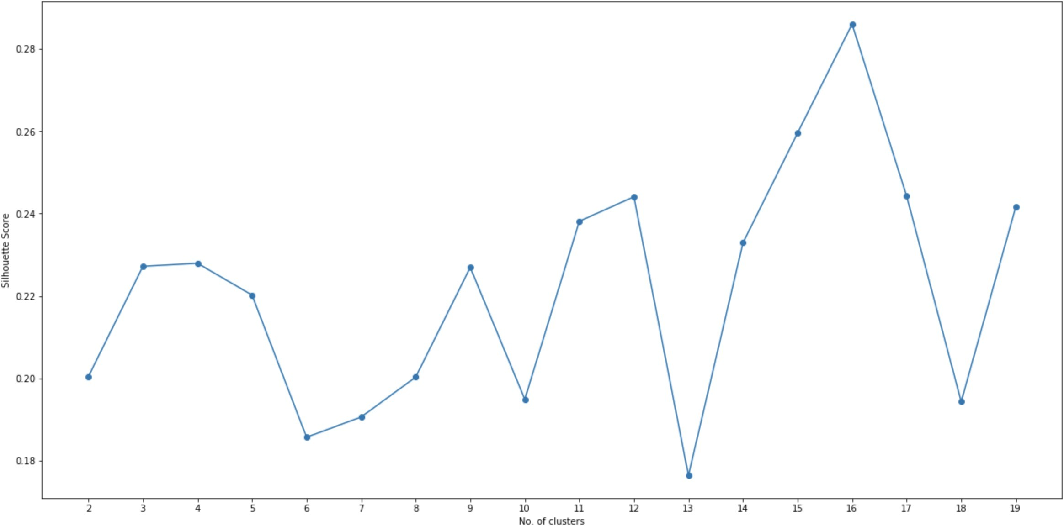

Figure 2: Silhouette score vs No.of clusters.

#! /usr/bin/python

from sklearn.metrics import silhouette_samples, silhouette_score indices = []

scores = []

for kclusters in range(2, 20) :

kgc = kolkata_grouped_clustering

kmeans = KMeans(n_clusters = kclusters, init = ‘k-means++’, random_state = 0).fit_predict(kgc)

score = silhouette_score(kgc, kmeans)

indices.append(kclusters) scores.append(score)

plot(indices, scores)

optimal_value = np.argmax(scores) + 2

Code

* 1. **K-means clustering**

The venue data is then trained using K-means Clustering Algorithm to get the desired clusters to base the analysis on. K-means was chosen as the variables (Venue Categories) are huge, and in such situations K-means will be computationally faster than other clustering algorithms.

#! /usr/bin/python

kclusters = optimal_value

kgc = kolkata_grouped_clustering

kmeans = KMeans(n_clusters = kclusters, init = ‘k-means++’, random_state = 0)

.fit(kgc)

Code

1. **Results**

The neighborhoods are divided into n clusters where n is the number of clusters found using the optimal approach. The clustered neighborhoods are visualized using different colors so as to make them distinguishable.

#! /usr/bin/python

map_clusters = folium.Map(location=[kol_lat, kol_lng], zoom_start=11) x = np.arange(kclusters)

ys = [i + x + (i*x)**2 for i in range(kclusters)] colors_array = cm.rainbow(np.linspace(0, 1, len(ys))) rainbow = [colors.rgb2hex(i) for i in colors_array]

markers_colors = []

for lat, lon, poi, cluster in zip(kolkata_merged[‘Latitude’], kolkata_merged[‘Longitude’], kolkata_merged[‘Neighbourhood’], kolkata_merged[‘Cluster Labels’]):

label = folium.Popup(str(poi) + ‘ (Cluster ’ + str(cluster + 1) + ‘)’, parse_html=True)

map_clusters.add_child( folium.features.CircleMarker( [lat, lon],

radius=5, popup=label,

color=rainbow[cluster-1], fill=True, fill_color=rainbow[cluster-1], fill_opacity=0.7))

Code

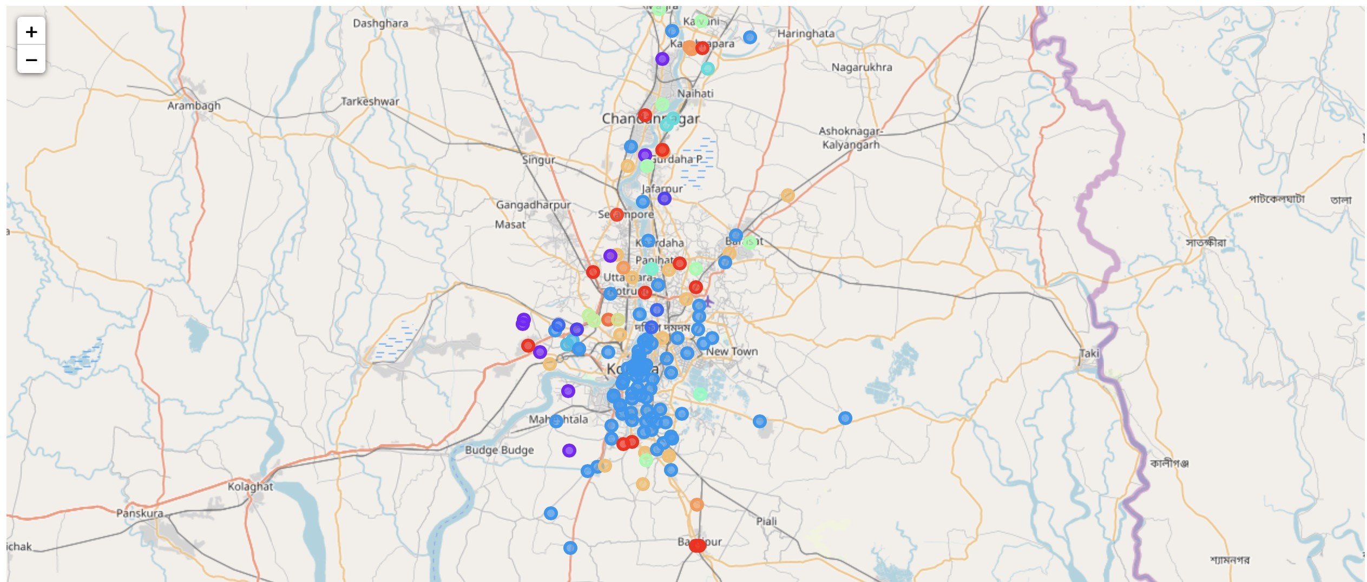

1. **Discussion**

Figure 3: Neighbourhoods of Kolkata (Clustered).

After analyzing the various clusters produced by the Machine learning algorithm, cluster no.14, is a prime fit to solving the problem of finding a cluster with common venue as a train station mentioned before.

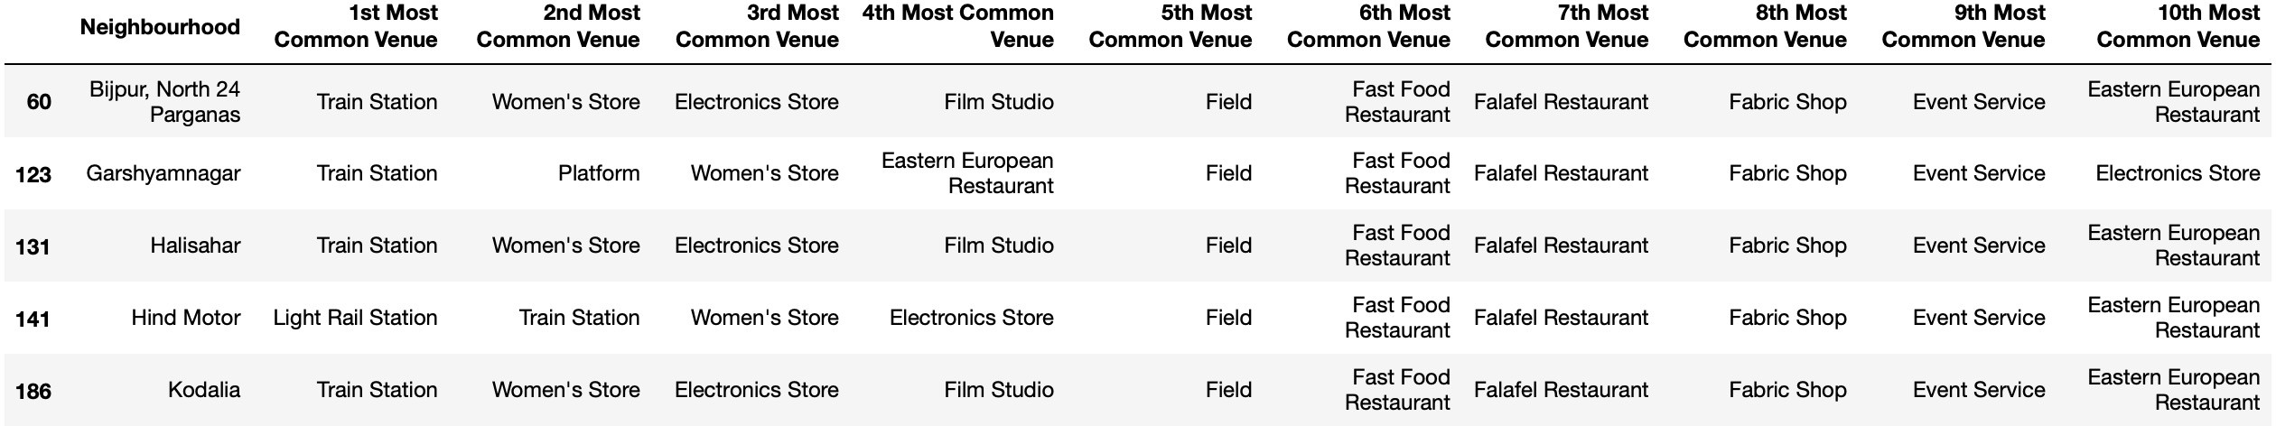

Figure 4: Cluster having Train Station as most common venue

The five places namely Bijpur, Garshyamnagar, Halisahar, Hind Motor and Kodalia fall in the outskirts of the city of Kolkata, hence the demographic of the population in these areas fall under the lower middle class of the society.

According to most organizations, like the World Bank and the Organization for the Economic Coopera- tion and Development (OECD), people living on less than US $2 a day are con- sidered poor. For those in the middle classes, the earnings typically lie in the range of US $10 to $100 per day, as expressed in the 2015 purchasing power parities.

India is expected to see a dramatic growth in the middle class, from 5 to 10 percent of the population in 2005 to 90 percent in 2039, by which time a billion people will be added to this group. In 2005, the mean per capita household expenditure was just US $3.20 per day, and very few households exceeded incomes of US $5 per day. Yet, by 2015, half the population had crossed this threshold. By 2025, half the Indian population is expected to surpass US $10 per day.

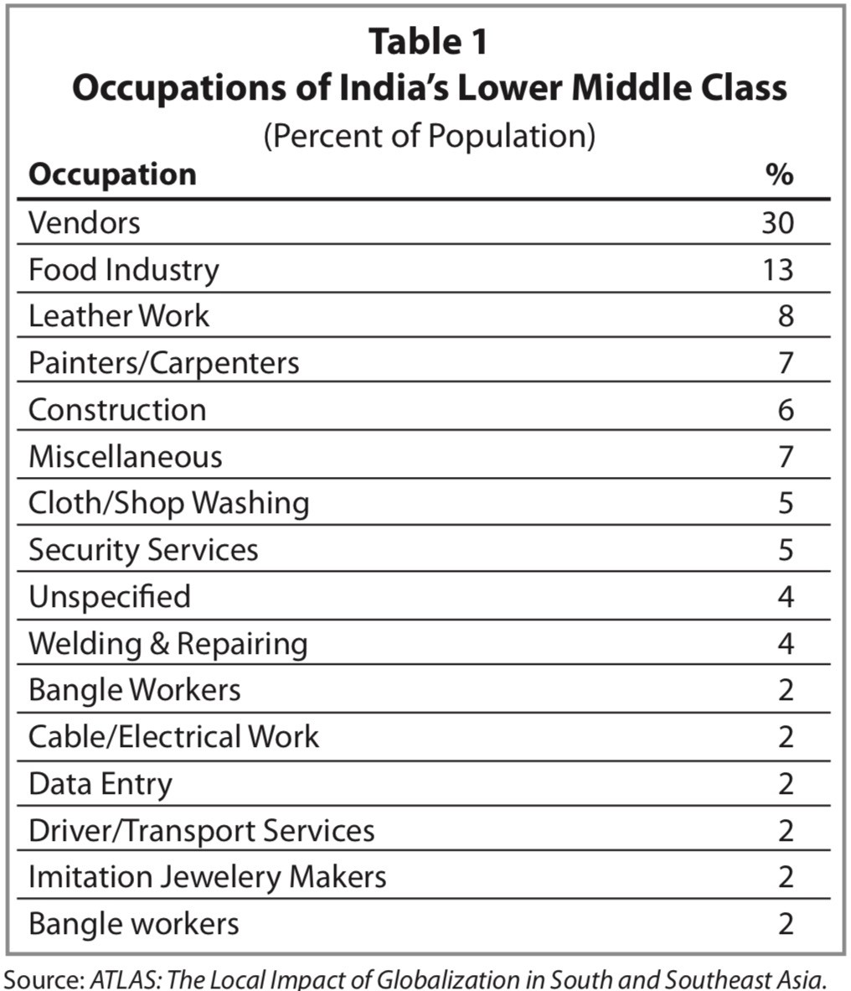

1. **Conclusion**

Figure 5: Occupation of Indian’s Lower Middle Class

As the middle class will grow at a rapid rate in the next upcoming years, opening food outlets catered for that section of the society will see a massive increase in footfall, which would lead to a further increase in business.

If the food outlets have an average rate of US $0.5 equivalent to 15 percent of the per capita household expenditure, for their items, then profits can be expected to be high as the food rates are neither too low or too high for a person of the concerned demographic to spend. Assuming a footfall of 30 people getting off at these stations for each station, 100 trains passing through these stations, and a conversion rate of 20 percent, ordering only one meal, a daily turnover of around US $300 can be expected from these outlets per station.